AWS CI/CD PIPELINE TO HOST A STATIC WEBSITE
Using GitHub, AWS CodePipeline, AWS CodeBuild and Amazon S3

- Aim
To design and implement an automated CI/CD pipeline on Amazon Web Services (AWS) for deploying and hosting a static website using GitHub, AWS CodePipeline, AWS CodeBuild and Amazon S3.
The pipeline automatically detects changes pushed to the GitHub repository, builds the website using AWS CodeBuild, and deploys the updated website to an Amazon S3 bucket.

- Objectives
The objectives of this experiment are:
  - To create a static website using HTML, CSS and JavaScript.
  - To store the website source code in a GitHub repository.
  - To configure an AWS CodeBuild project.
  - To configure AWS CodePipeline for continuous integration and deployment.
  - To connect GitHub with AWS CodePipeline.
  - To automatically build the website whenever changes are pushed.
  - To deploy the website to an Amazon S3 bucket.
  - To enable static website hosting on Amazon S3.
  - To verify automatic deployment after modifying the source code.

- Technologies Used
Technology | Purpose
GitHub | Source code repository
AWS CodePipeline | CI/CD pipeline orchestration
AWS CodeBuild | Build and package the website
Amazon S3 | Website hosting and deployment
AWS IAM | Access and permissions management
Amazon CloudWatch Build log monitoring
Technology | Purpose
HTML | Website structure
CSS | Website styling
JavaScript | Website functionality

- System Architecture
The CI/CD pipeline implemented in this experiment follows the workflow below: Developer
│
│ Push Code
▼
GitHub Repository
│
│ Trigger
▼
AWS CodePipeline
│
│ Build
▼
AWS CodeBuild
│
│ Build Artifact
▼
Amazon S3
│
│ Static Website Hosting
▼
Deployed Website

Pipeline Flow
Code Change
↓
GitHub Push
↓
CodePipeline Trigger
↓
CodeBuild Execution
↓
S3 Deployment
↓
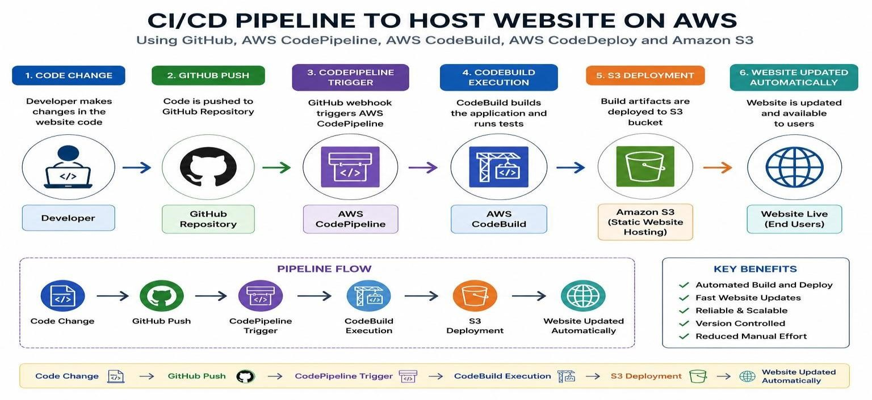
Website Updated Automatically

5. Project Structure
The static website used for this experiment contains the following files: my-cicd-project/
│
├── index.html
│
├── css/
│ └── style.css
│
├── js/
│ └── script.js
│
├── images/
│
└── buildspec.yml
Description
- index.html – Main webpage.
- css/style.css – Styling for the website.
- js/script.js – JavaScript functionality.
- images/ – Directory for website images.
- buildspec.yml – Instructions used by AWS CodeBuild during the build process.

- Buildspec File
The buildspec.yml file is placed in the root directory of the GitHub repository.
version: 0.2

phases: install: commands:
  - echo "Starting AWS CodeBuild..."

pre_build: commands:
  - echo "Preparing website files..."

build: commands:
  - echo "Building static website..."
  - echo "Build completed successfully."

post_build: commands:
  - echo "Preparing deployment artifacts..."

artifacts: files: - '**/*'
The buildspec file defines the commands executed by AWS CodeBuild and specifies the files that are included in the build artifact.

- Procedure
Step 1: Create the Website
Create a static website using HTML, CSS and JavaScript.
The project should contain:
index.html css/style.css js/script.js images/ buildspec.yml
The website can contain a homepage describing the AWS CI/CD pipeline.

Step 2: Create a GitHub Repository Create a new repository on GitHub.
Example repository name:
my-cicd-project
Upload or push the following files:
index.html buildspec.yml css/
js/
images/
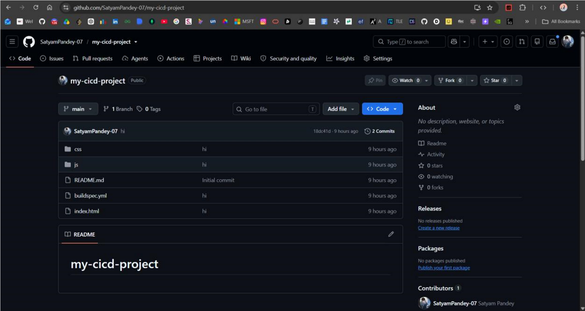
The GitHub repository acts as the source code repository for the CI/CD pipeline.

Step 3: Push the Project to GitHub

Initialize Git in the project directory and push the source code to GitHub.
Example commands:
git init git add .
git commit -m "Add AWS CI/CD website" git branch -M main git remote add origin https://github.com/YOUR_USERNAME/my-cicd-project.git git push -u origin main
After pushing, verify that all project files are visible in the GitHub repository.

8. Create AWS CodeBuild Project
Step 4: Open AWS CodeBuild
Log in to the AWS Management Console.
Search for:
CodeBuild
Open AWS CodeBuild and select:
Build projects → Create build project

Step 5: Configure Project Name Enter the project name.
Example:
my-cicd-project
The project name uniquely identifies the CodeBuild project.
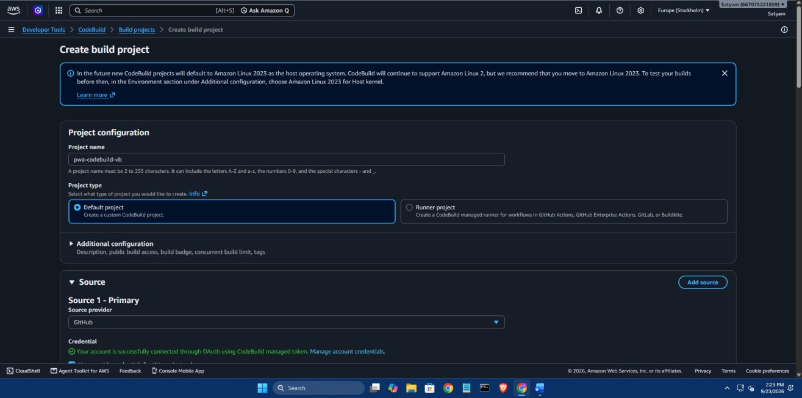
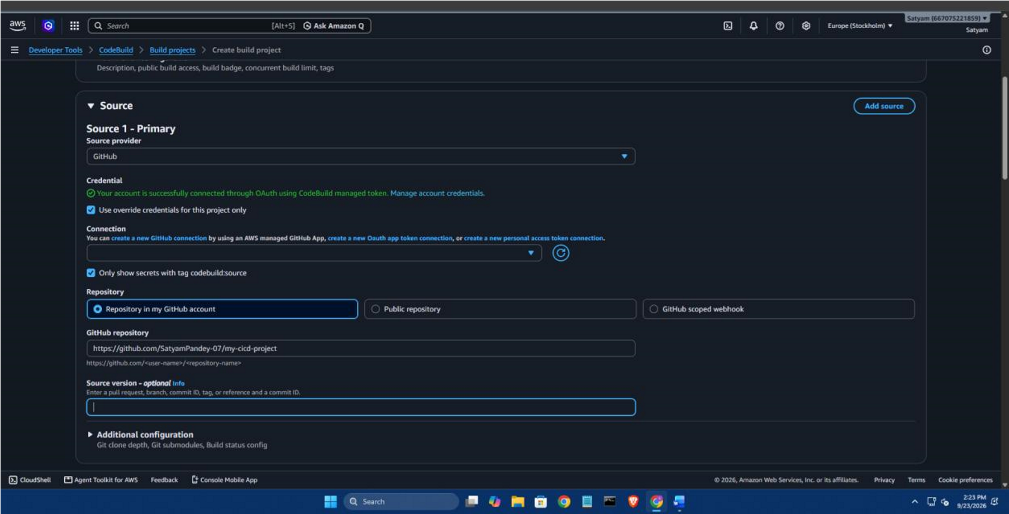

9
. Configure Source

Step 6: Select Source Provider Under the Source section:
Select:
Source provider → GitHub
Connect the GitHub account using the available GitHub authentication/OAuth process.
Authorize AWS CodeBuild when prompted.
The GitHub repository will then become available for selection.

Step 7: Select Repository Select:
Repository in my GitHub account Choose the repository:
my-cicd-project
Select the branch containing the source code.
For example:
main
The selected GitHub repository becomes the primary source for the CodeBuild project.
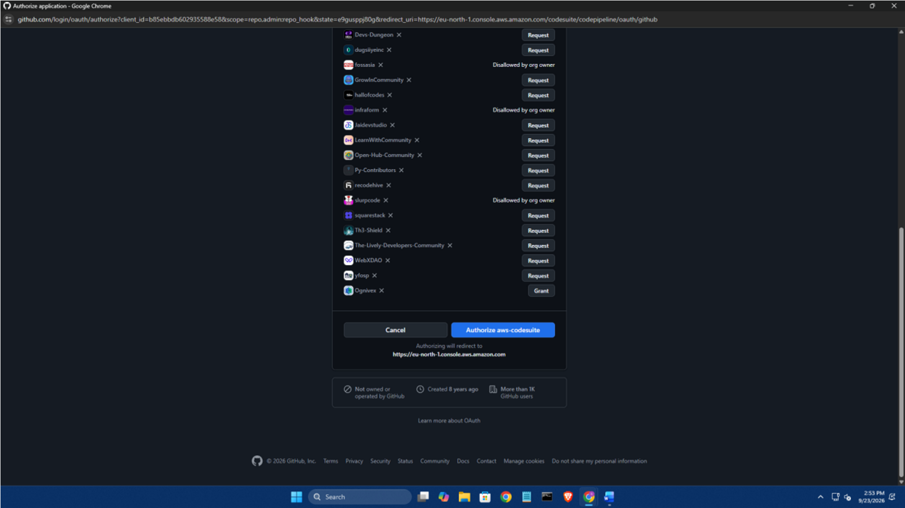

10. Configure Environment Step 8: Configure Build Environment Scroll to the Environment section.
Select:
Environment image:
Managed image Select:
Running mode:
Instance Select:
Operating system:
Amazon Linux
For the runtime, use:
Base
Use the AWS-managed CodeBuild image.

Step 9: Configure Service Role Under Service role, select:
New service role
AWS will automatically create a service role for CodeBuild.
Example: codebuild-my-cicd-project-service-role
The service role allows CodeBuild to interact with the AWS resources required during the build.

- Configure Buildspec Step 10: Select Buildspec File Scroll to the Buildspec section.
Select:
Use a buildspec file Use:
buildspec.yml
The file is already present in the root directory of the GitHub repository.
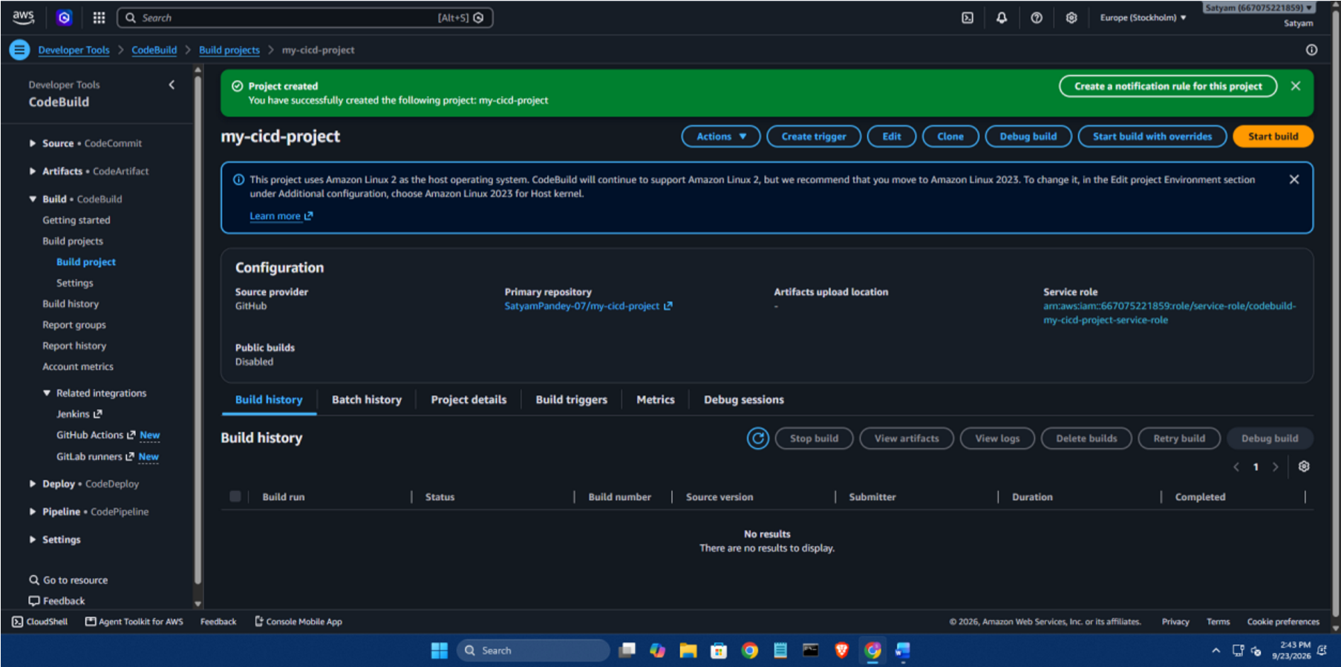
AWS CodeBuild will read the instructions from this file during execution.

- Configure Artifacts Step 11: Configure Artifacts
For this CodeBuild project, select:
No artifacts
The pipeline will handle the artifacts during the CodePipeline workflow.
The buildspec file still specifies the files that can be used as build output when CodeBuild is invoked by CodePipeline.

- Configure Logs
Step 12: Enable CloudWatch Logs Under the Logs section, enable:
CloudWatch logs
The default log group can be used, for example:
/aws/codebuild/my-cicd-project
S3 build logs are not required for this experiment.
After reviewing the configuration, click:
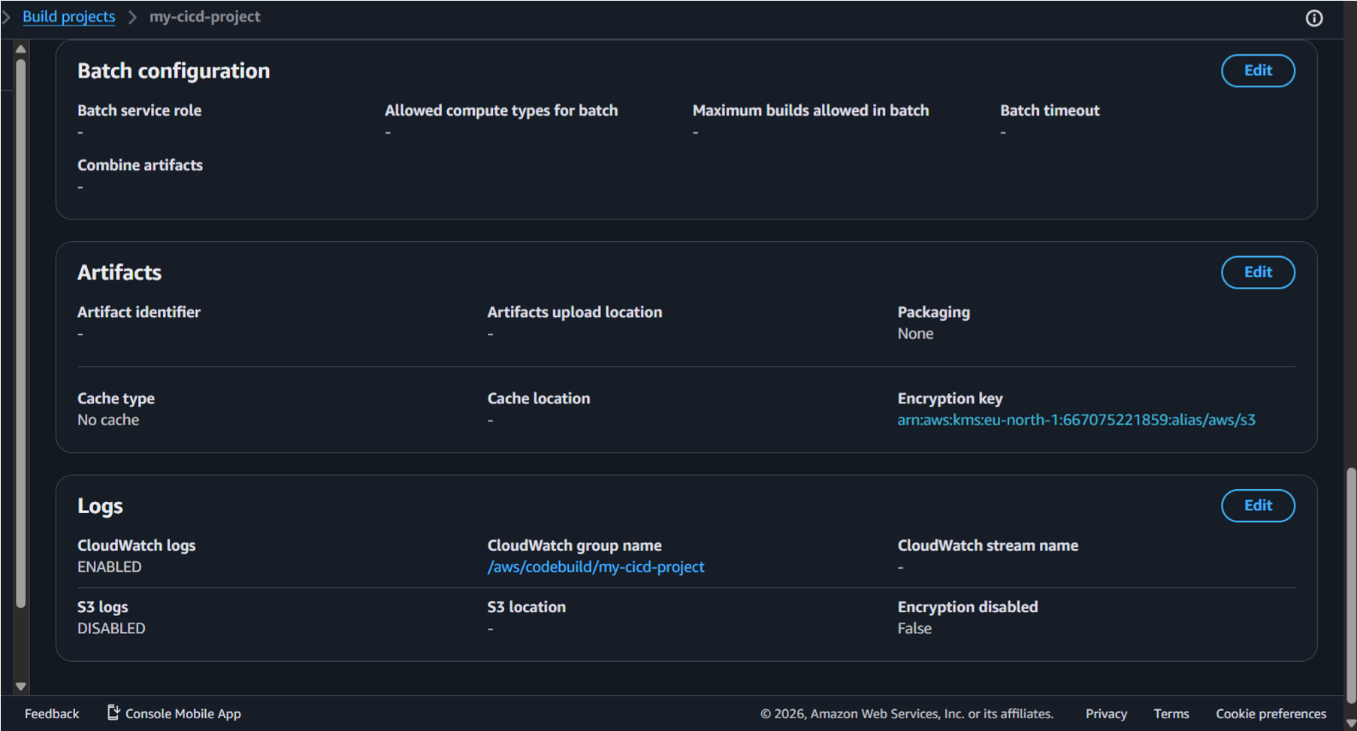
Create build project

- Verify CodeBuild Project
Step 13: Verify Project Creation
After creating the project, AWS CodeBuild displays the project details.
Verify that the project has been successfully created.
The CodeBuild project should show:
Source: GitHub
Environment: Managed Image
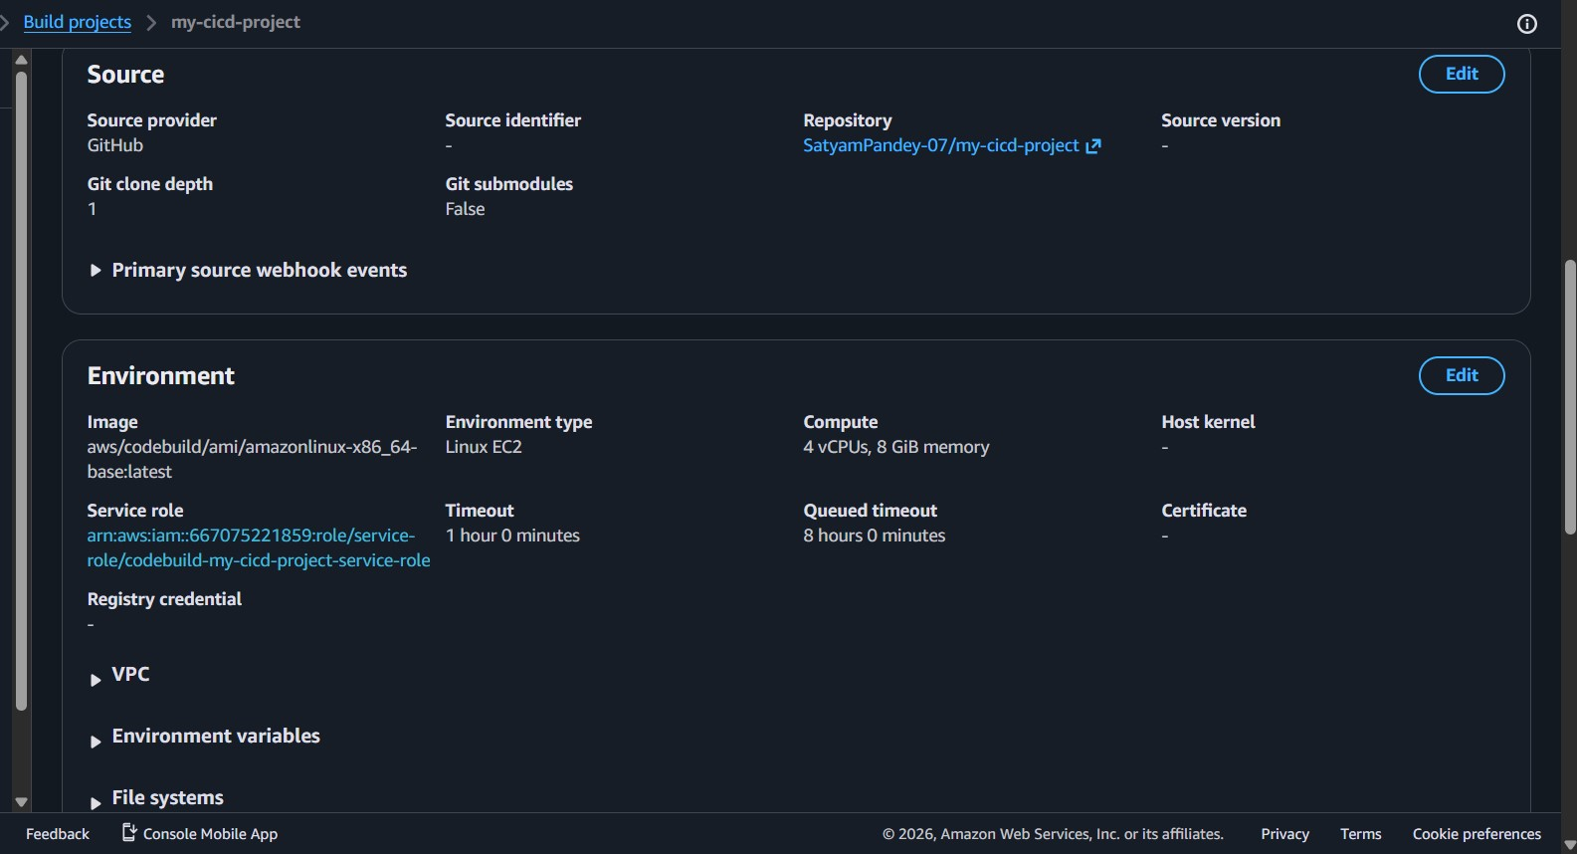
Buildspec: buildspec.yml

15
. Create AWS CodePipeline

Step 14: Open CodePipeline Search AWS for:
CodePipeline Open:
AWS CodePipeline → Pipelines Select:
Create pipeline
In the newer AWS interface, select:
Build custom pipeline
This allows the individual Source, Build and Deploy stages to be configured manually.
- Configure Pipeline Settings
Step 15: Configure Pipeline Enter a pipeline name.
Example:
my-cicd-pipeline Select:
New service role
AWS will create the required CodePipeline service role.
The pipeline stores and passes artifacts between its different stages.

- Configure Artifact Store
Step 16: Configure Artifact Store
Under advanced settings, configure the artifact store.
Use an Amazon S3 bucket for storing CodePipeline artifacts.
Example:
store-build-artifact-vb
Use the default AWS-managed encryption key unless a different key is required by the assignment.
Click:
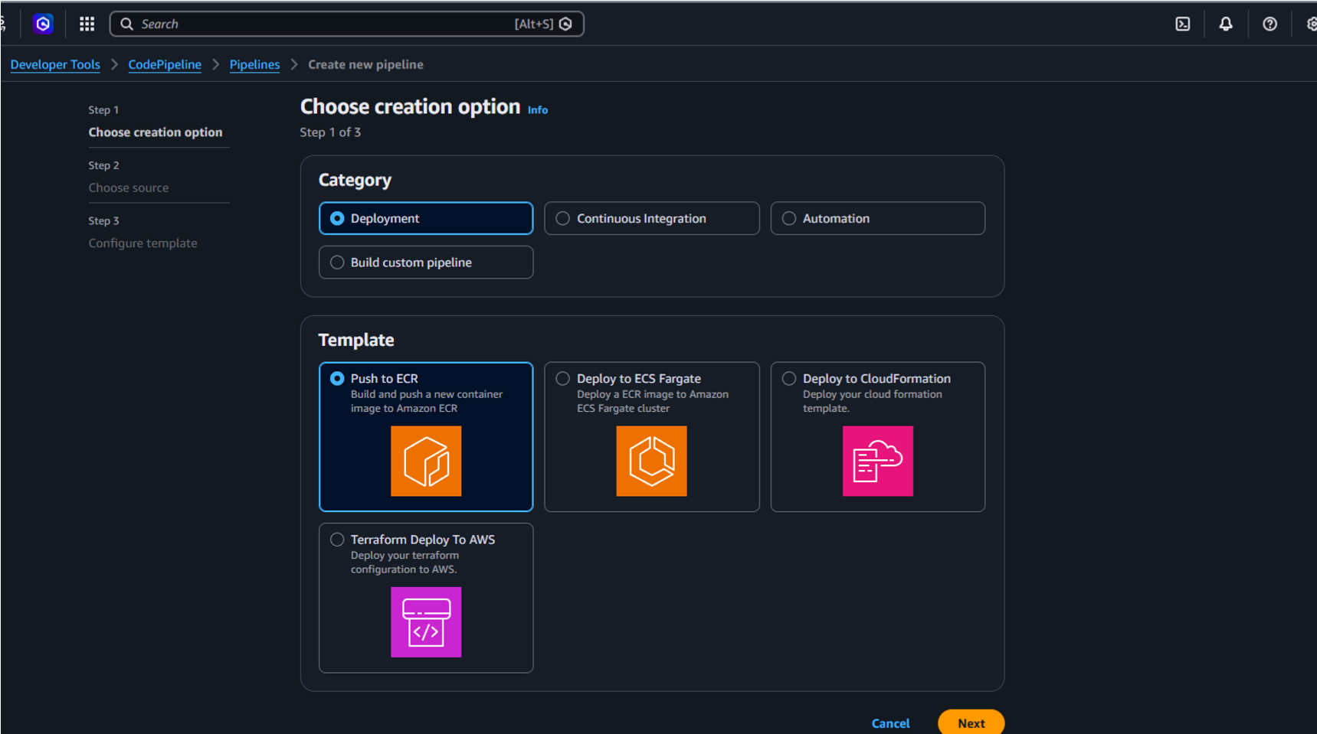
Nex
t

- Configure Source Stage Step 17: Add GitHub Source For the Source stage:
Select:
Source provider → GitHub Connect/authenticate your GitHub account.
Select: Repository: my-cicd-project Select the branch:
main
Enable automatic change detection if available.
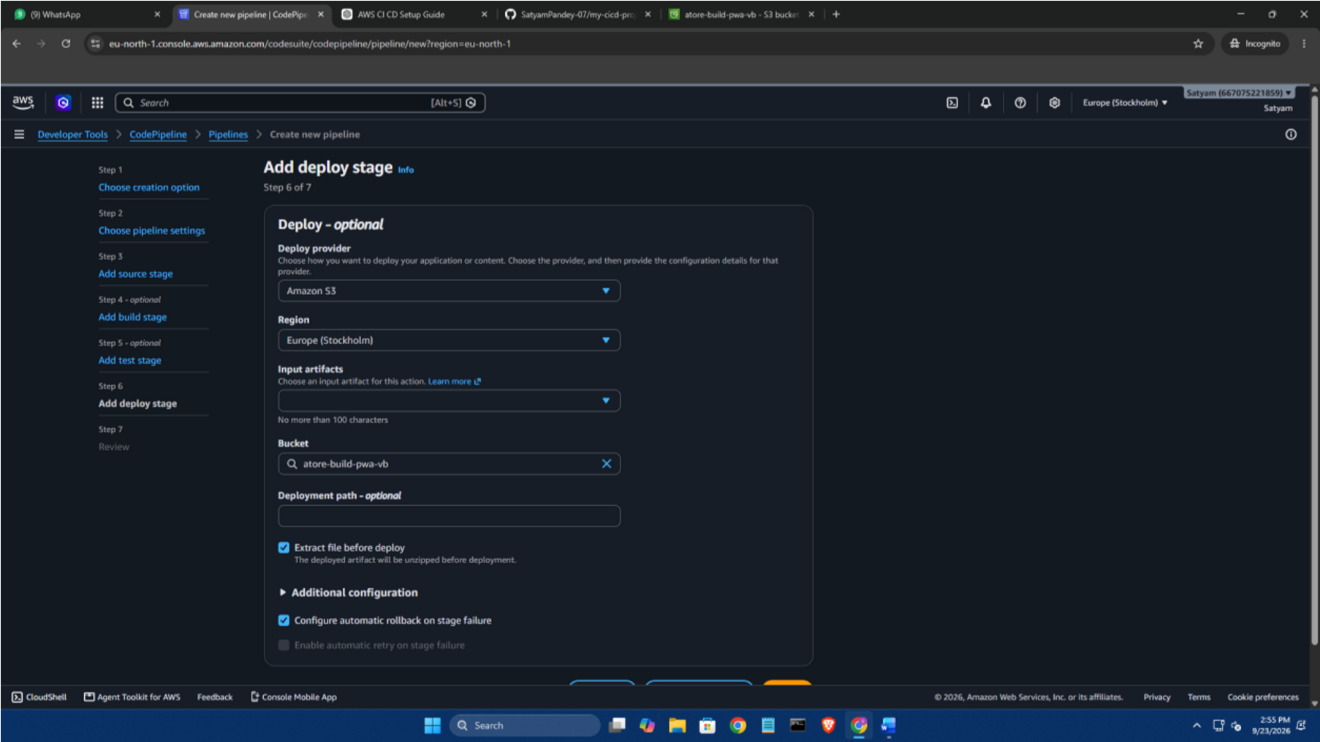
This allows CodePipeline to automatically detect new changes pushed to the repository.

19
. Configure Build Stage

Step 18: Add Build Stage Select:
Build provider
→ Other build providers
→ AWS CodeBuild
Select the CodeBuild project created earlier: my-cicd-project
The SourceArtifact generated from the GitHub source stage is provided as the input to CodeBuild.
Use:
Build type: Single build Click:
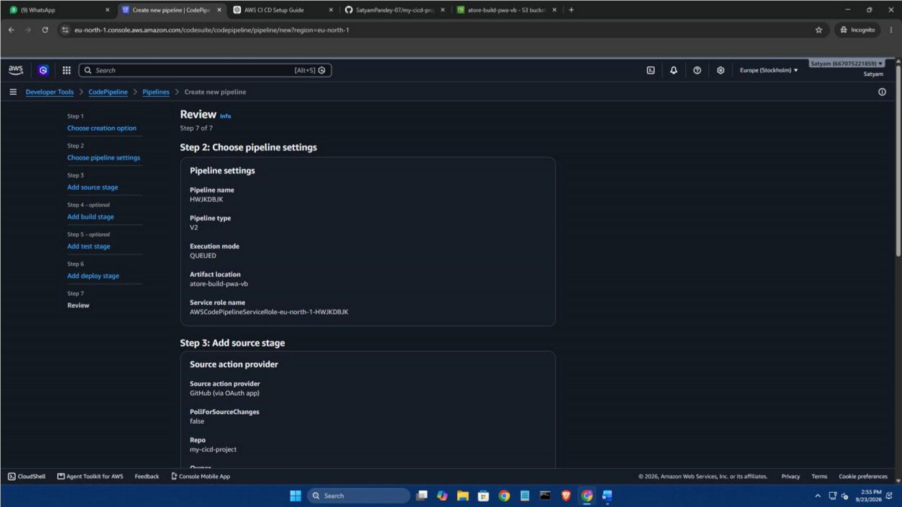
Next

20
. Configure Deploy Stage

Step 19: Add Deployment Stage
For the deployment stage, select:
Deploy provider → Amazon S3 Select the S3 deployment bucket.
Example: deployment-bucket-pwa-vb
Select the input artifact produced by the build stage.
Enable the option to extract the artifact before deployment if available.
Click:
Next
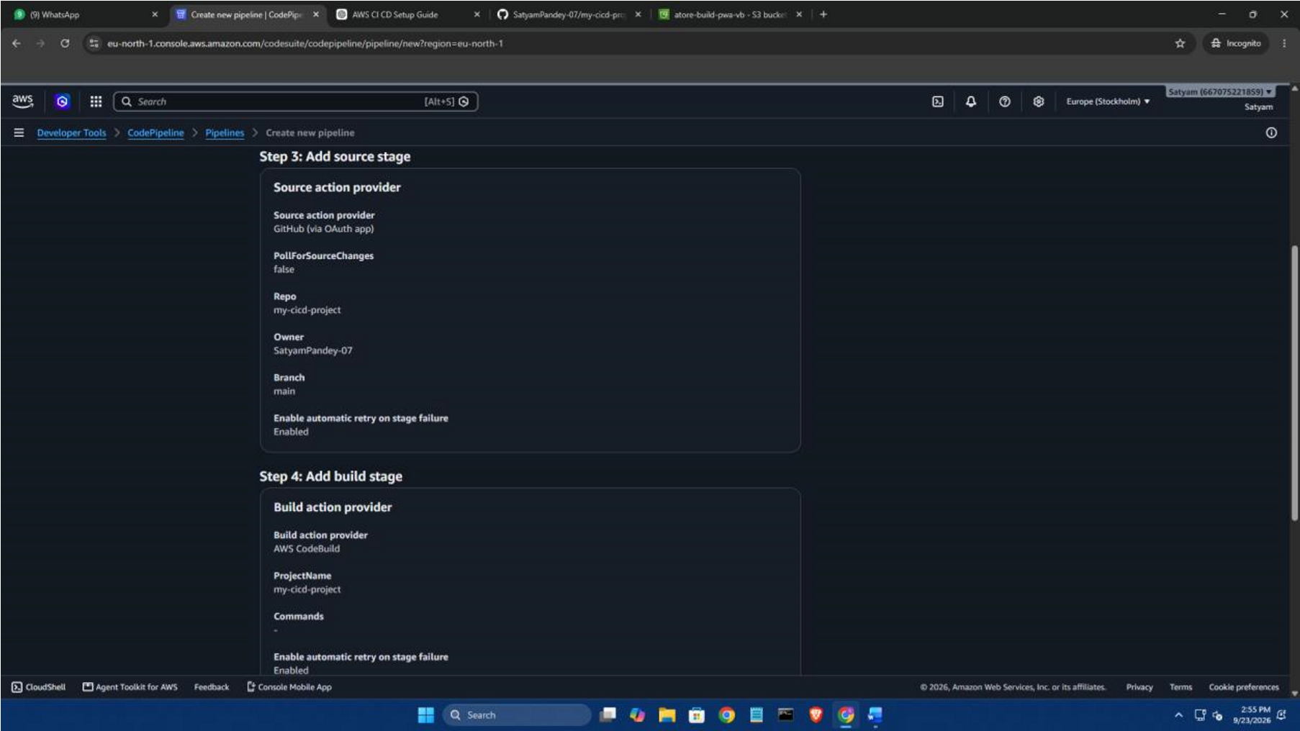

21
. Create Pipeline

Step 20: Review and Create Pipeline Review the complete pipeline configuration.
The pipeline should contain three major stages:
SOURCE
↓
BUILD
↓
DEPLOY Where: GitHub
↓
AWS CodePipeline
↓
AWS CodeBuild
↓
Amazon S3
Click:
Create pipeline
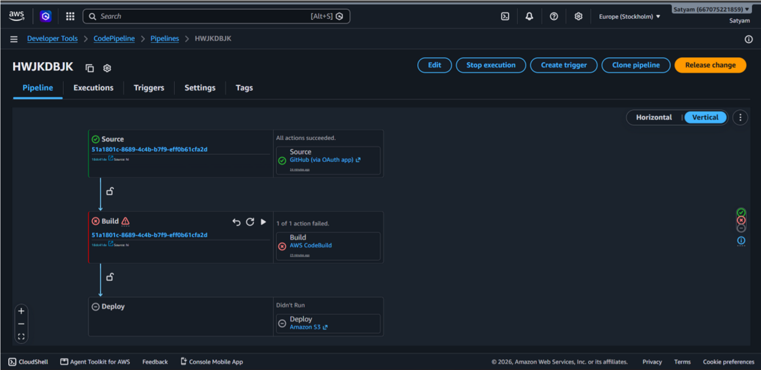
AWS will create and execute the pipeline.

22
. Handle Build Permission Issues

Step 21: Verify Build Execution
If the build fails because of insufficient permissions, open:
AWS CodeBuild
→ Build project
→ Build details
→ Service role
The service role opens in AWS IAM.
Open: Permissions and select: Add permissions
→ Attach policies
Search for the required S3 permission.
The reference procedure uses: AmazonS3FullAccess
and attaches it to the CodeBuild service role.
Note: For a production system, permissions should normally be restricted to only the required S3 actions/resources rather than granting full S3 access.
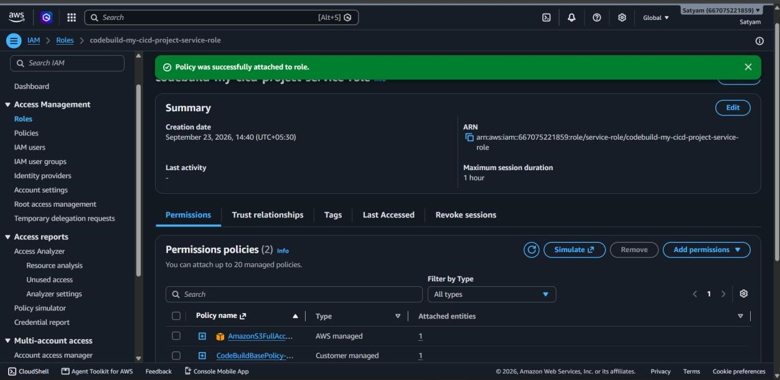

23
. Retry Pipeline

Step 22: Retry Pipeline Return to:
AWS CodePipeline
→ my-cicd-pipeline
Retry the failed execution.
Wait for the pipeline to complete.
The expected result is:
Source ✓ Build ✓
Deploy ✓
The pipeline should now execute successfully.

24. Configure Amazon S3 Static Website Hosting
Step 23: Open S3 Deployment Bucket Search AWS for:
S3
Open the deployment bucket.
Go to:
Properties
Scroll to:
Static website hosting Click:
Edit
Enable:
Static website hosting Select:
Host a static website Set the index document to: index.html Save the changes.
The reference document follows the same process of enabling static website hosting and
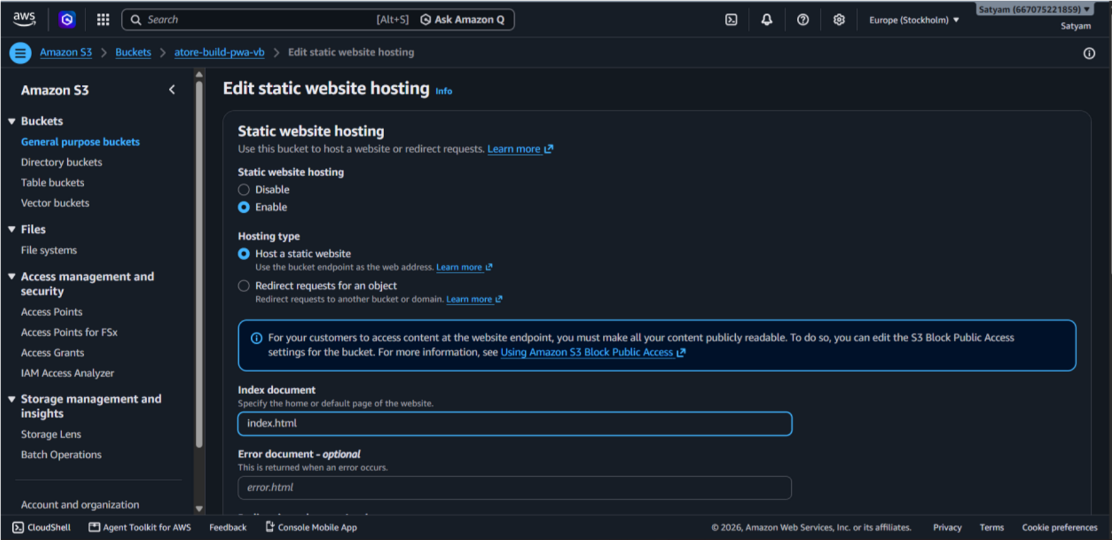
specifying index.html.

25
. Configure S3 Bucket Policy

Step 24: Edit Bucket Policy Go to:
S3
→ Deployment Bucket
→ Permissions
→ Bucket policy
Add a policy that permits public GetObject access if your assignment specifically requires a publicly accessible S3 website.
Use your actual bucket name in the resource ARN.
Example:
{
"Version": "2012-10-17",
"Statement": [
{
"Sid": "PublicReadGetObject",
"Effect": "Allow",
"Principal": "*",
"Action": "s3:GetObject",
"Resource": "arn:aws:s3:::YOUR-BUCKET-NAME/*"
}
]
}
Replace:
YOUR-BUCKET-NAME
with the actual S3 bucket name.
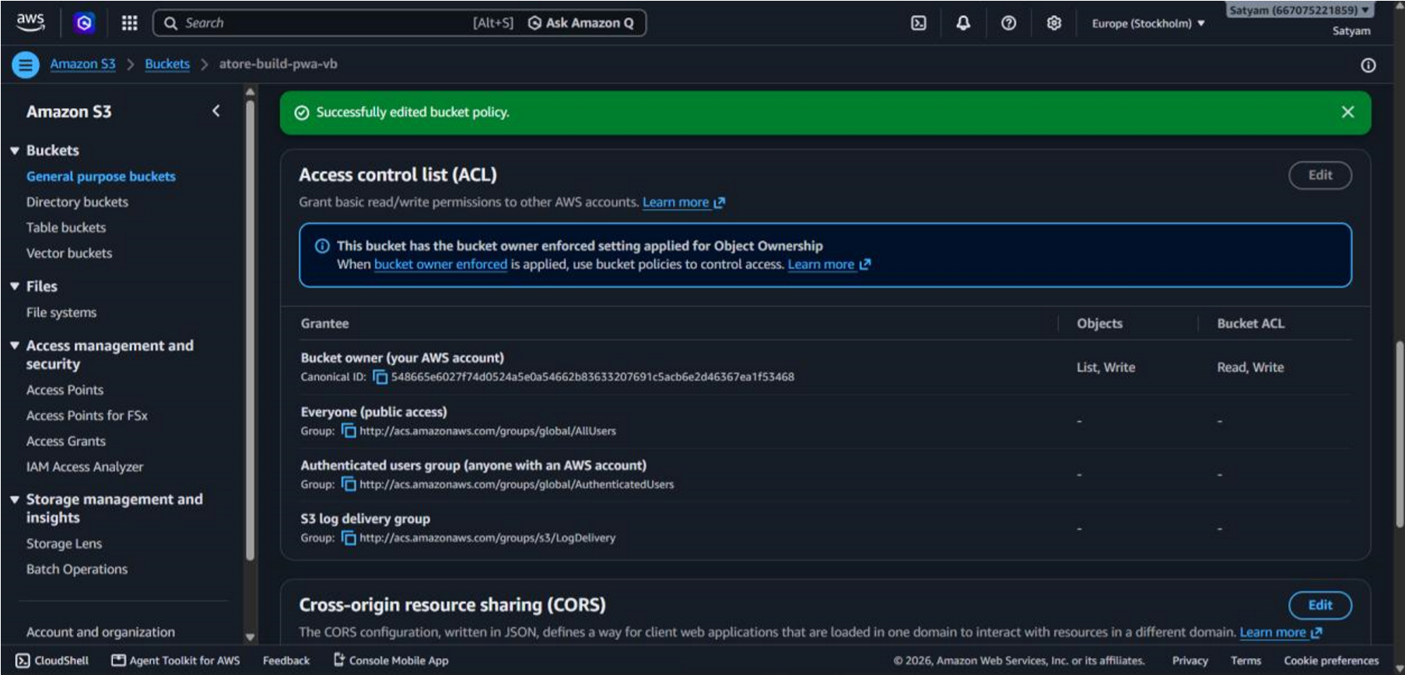
The reference document uses the same public s3:GetObject pattern.

26. Open the Deployed Website
Step 25: Access Website Return to:
S3
→ Deployment Bucket
→ Properties Scroll to:
Static website hosting
AWS displays the Bucket website endpoint.
Click the website endpoint.
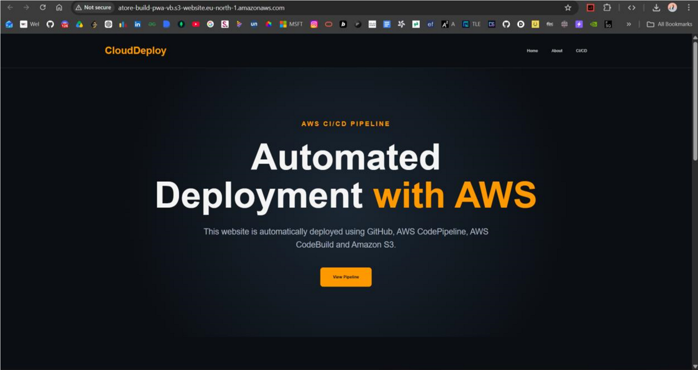
The deployed static website should open in the browser.

27
. Test Automatic Deployment

Step 26: Modify the Source Code
To verify that the CI/CD pipeline works automatically, make a small change to the website.
For example, modify the heading in index.html. Before:
<h1>Automated Deployment with AWS</h1>
After:
<h1>Automated Deployment with Saitama</h1>
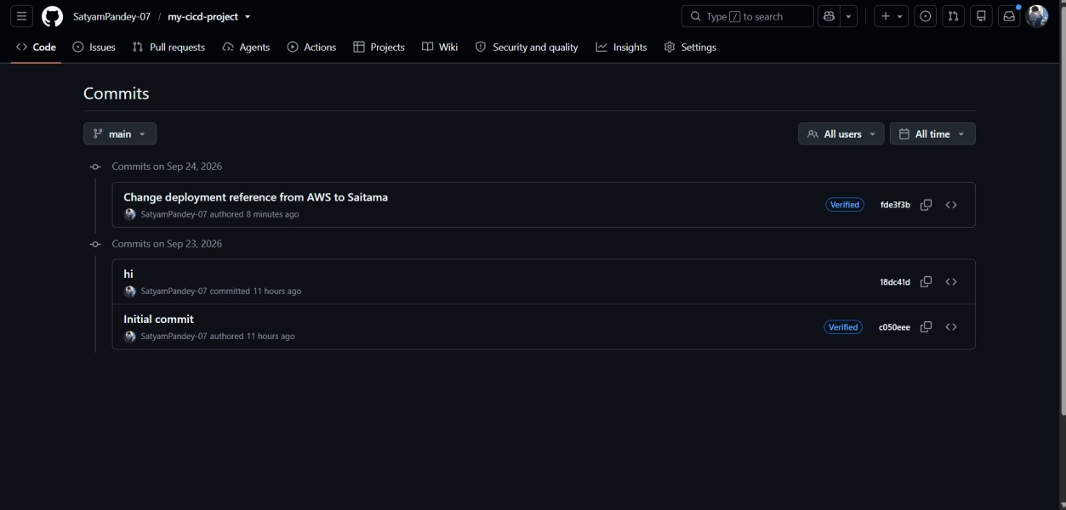
Commit and push the changes to GitHub.

28
. Verify Automatic Pipeline Trigger

Step 27: Check CodePipeline Open:
AWS CodePipeline
→ my-cicd-pipeline
A new pipeline execution should start after the GitHub change is detected.
The stages should execute in sequence:
GitHub
↓
Source
↓
Build
↓
Deploy
Wait until all stages become successful.
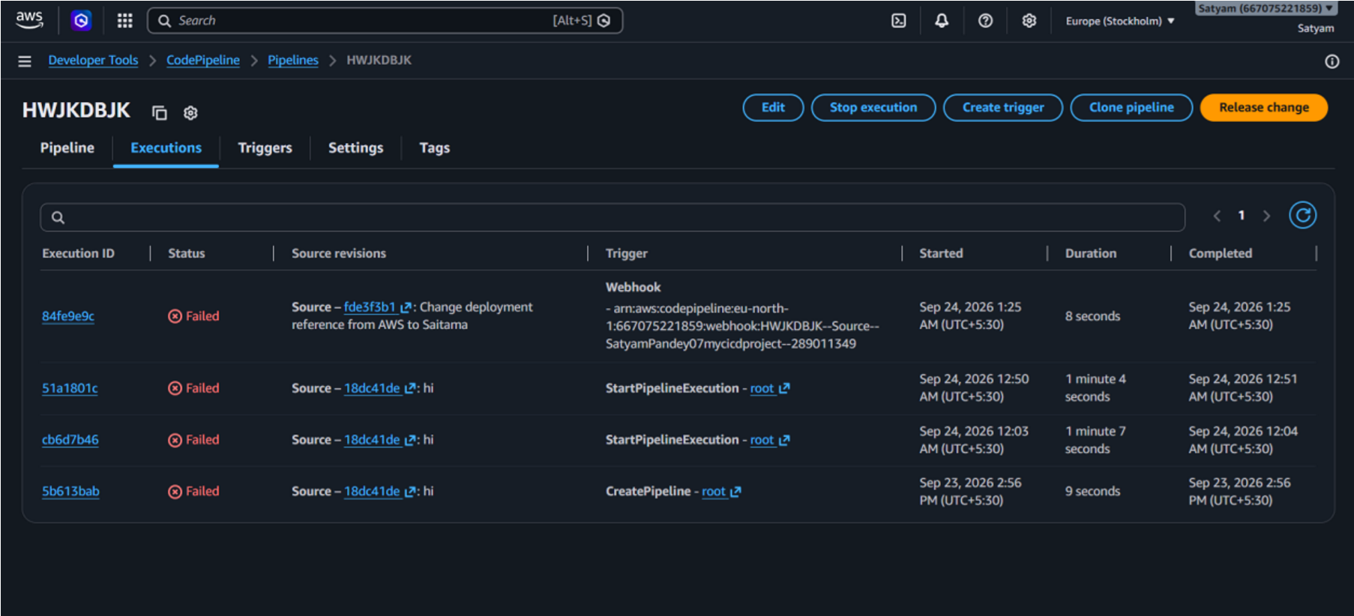

29
. Verify Updated Website

Step 28: Refresh the Website
Open the S3 static website endpoint again.
Refresh the page.
The changes made in GitHub should now be visible on the deployed website.
This verifies that the complete CI/CD workflow is functioning:
GitHub Change
↓
CodePipeline Trigger
↓
CodeBuild
↓
S3 Deployment
↓
Updated Website
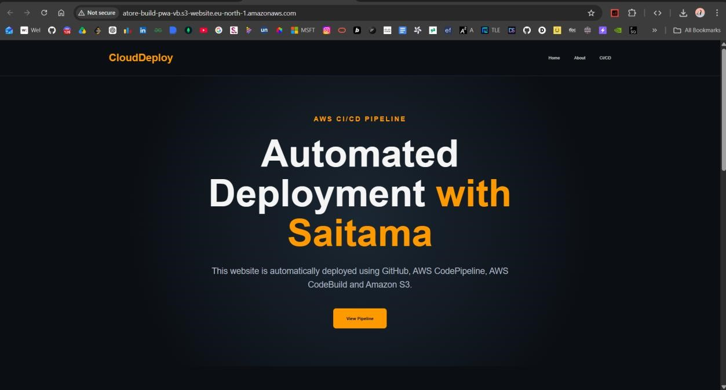

30
. Final CI/CD Workflow

The final implementation can be represented as:
┌─────────────────┐
│ GitHub │
│ Source Code │
└────────┬────────┘
│
│ Push
▼
┌─────────────────┐
│ AWS CodePipeline│
│ Source │
└────────┬────────┘
│
▼
┌─────────────────┐
│ AWS CodeBuild │
│ Build │
└────────┬────────┘
│
│ Artifact
▼
┌─────────────────┐
│ Amazon S3 │
│ Deploy │
└────────┬────────┘
│
▼
┌─────────────────┐
│ Static Website │
│ End Users │
└─────────────────┘

31. Result
The AWS CI/CD pipeline was successfully configured using GitHub, AWS CodePipeline, AWS CodeBuild and Amazon S3.
The source code was maintained in GitHub, automatically processed through AWS CodePipeline and CodeBuild, and deployed to an Amazon S3 static website hosting environment.
A subsequent change made to the GitHub repository triggered a new pipeline execution and updated the deployed website automatically.

32. Conclusion
Thus, the AWS CI/CD Pipeline for automated static website deployment was successfully implemented.
Amazon S3
↓
Static Website
The implementation demonstrates how source-code changes can be automatically built and deployed without manually uploading updated website files to the hosting environment.

