**Seprex Private Limited**

**Your partner in Technology Transfer**

**Page -1**

**About Us**

Seprex is started by a team of passionate engineers from renowned institutes in India. Seprex started with the objective of facilitating the chemical industry in technology transfer, troubleshooting and process improvement. Seprex is mainly engaged with manufacturing and supply of skid-mounted/modular, semi/fully automated Lab/Bench/Pilot/Demo Scale Plants on a turnkey basis at par with global standards. Seprex also assists in troubleshooting and improvement in production rates, yield, energy efficiency and quality by rigorous experimentation/process modeling and simulation/advanced process control. Seprex has an in-house pilot scale fixed bed/batch / Continuous reactor and distillation facility, where our client performs preliminary investigation to understand their systems.

## Core Competency

Technical knowhow

Experienced team

Team which can grasp R&D requirement

Linkage between R&D and commercial scale

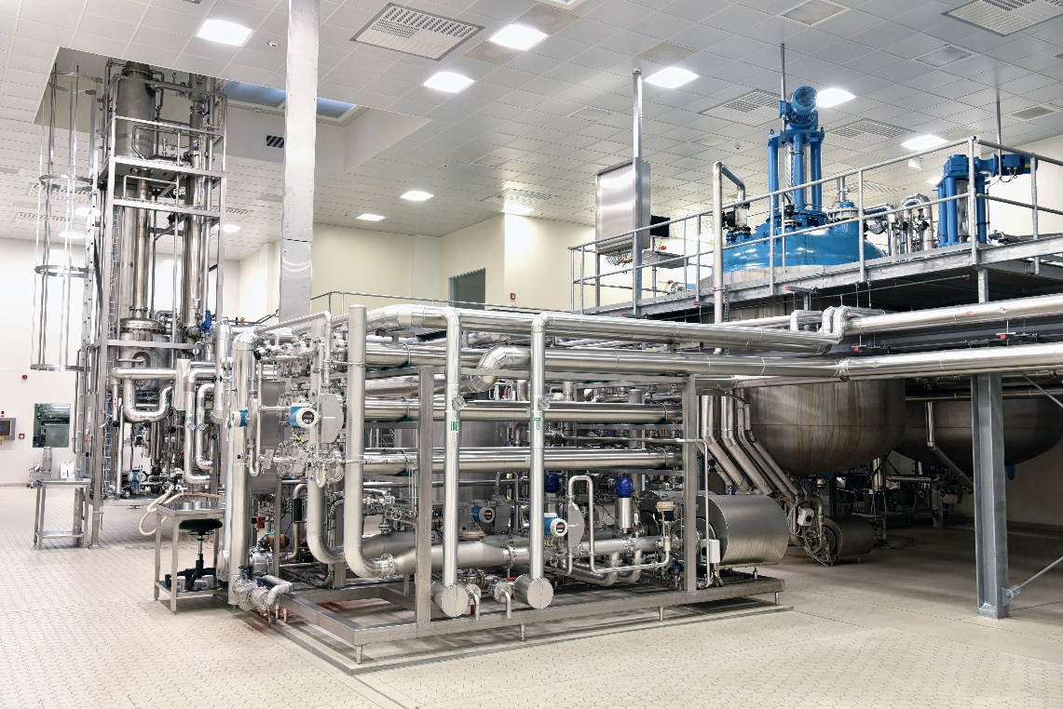

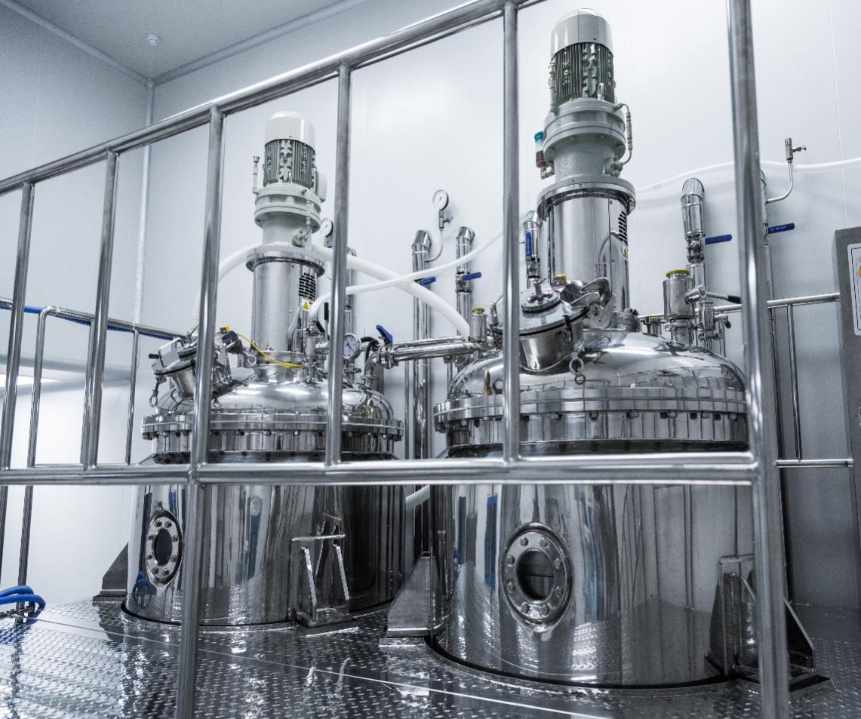

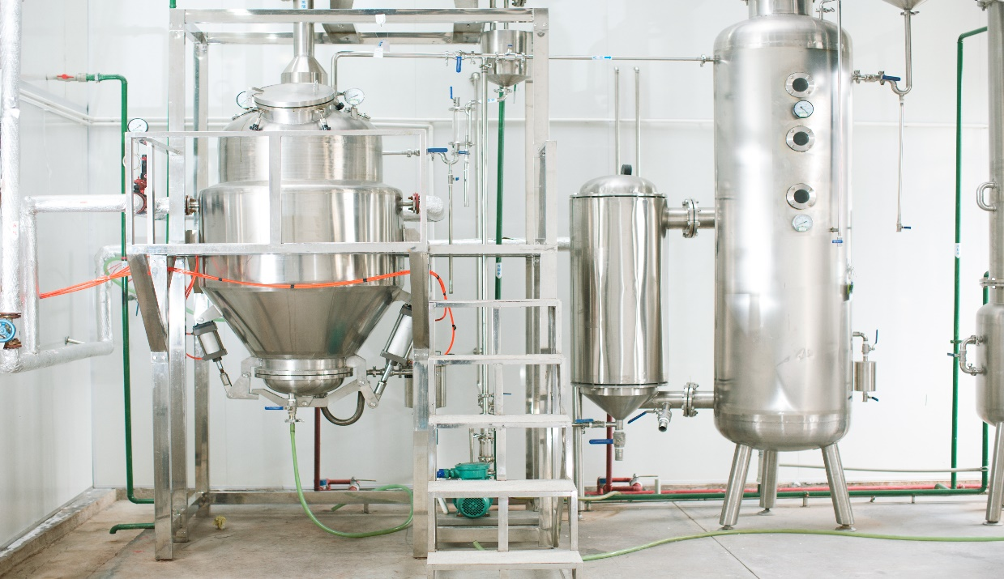

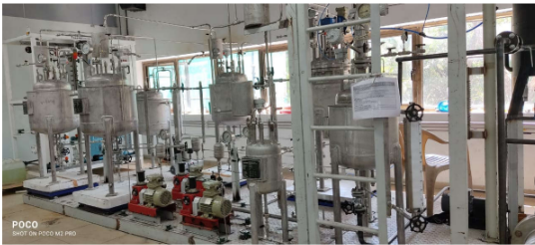

**Page -2 : Products**

1. **Lab/Bench/Pilot Plants**

The crucial elements of a good Lab/Bench/Pilot Plants trial is flexibility and safety. The ability to change or add auxiliary equipment/instruments, it is often required to quickly arrive at an optimum solution. Seprex engineers have the experience and expertise to build safe, flexible and adaptable modular/ skid mounted Lab/Bench/Pilot Plants. Experienced technician will perform tests over a range of actual process conditions to ensure that the unit is operating as per clients’ expectation, while optimizing the process.

Our team work with clients from start to understand their objectives, which are used to size, design, build, and operate a pilot plant with appropriate levels of automation and control. Common industries and process applications we work with include:

|  |  |  |
| --- | --- | --- |
| **Alternate Energy/Gasification** | **Catalytic Process** | **Unit Operation** |
| Upflow/Downflow Gasifier | Catalyst testing unit | Distillation |
| Fluidized Bed Reactor | Adiabatic Reactor System | Reactive Distillation |
| Moving Bed Reactor | Isothermal Reactor System | Super critical extraction |
| Biomass Gasification System | Liquid/Vapor /gas phase Fixed Bed Reactor | Pressure swing adsorption |
| Coal Gasification System | Fluidized Bed Reactor | Crystallization |
| Heavy Oil Gasification System | Trickle Bed Reactor | Evaporator |
| Pet coke Gasification System | Bubble Column | Extraction |
| Pyrolysis systems | Pulse Column |  |
| Coal Liquefaction System |  |  |
|  |  |  |
| **Oil & Gas** | **Pharmaceutical** | **Other** |
| Adsorption/Desorption Adsorbent Evaluation | CSTR | Hydrodynamics Study |
| Catalytic Cracking | Loop Reactor | Polymerization |
| Catalytic Dewaxing | Slurry CSTR | Flow reactors |
| Desulfurization |  |  |
| Hydrotreating |  |  |
| Alkylation |  |  |
|  |  |  |

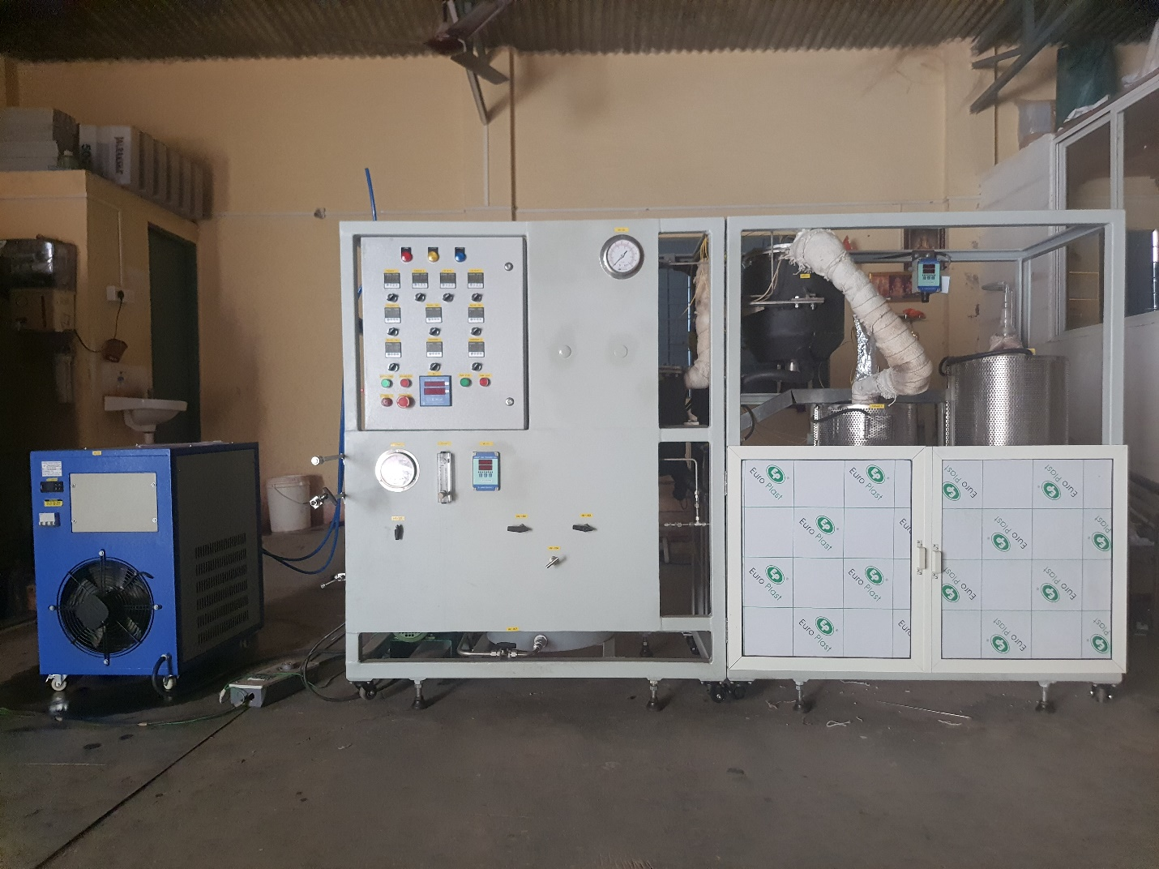

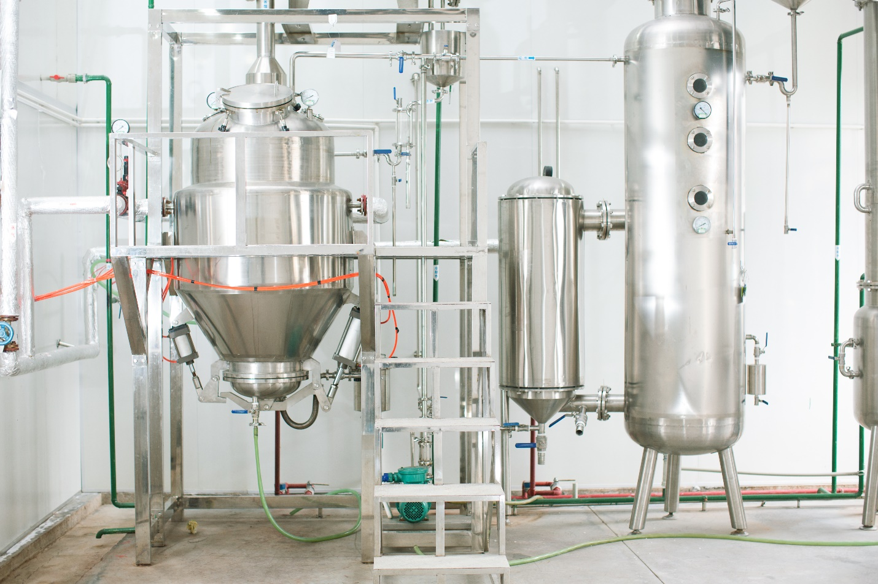

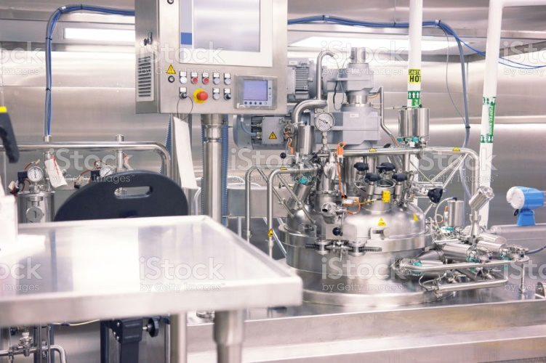

1. **Demo/Modular/Skid-Mounted Plants**

A client wish to start producing product at significant quantity to begin distribution and build a potential market. This demonstration plant was built to be easily expandable into a full production facility in the future, allowing organic growth for the client.

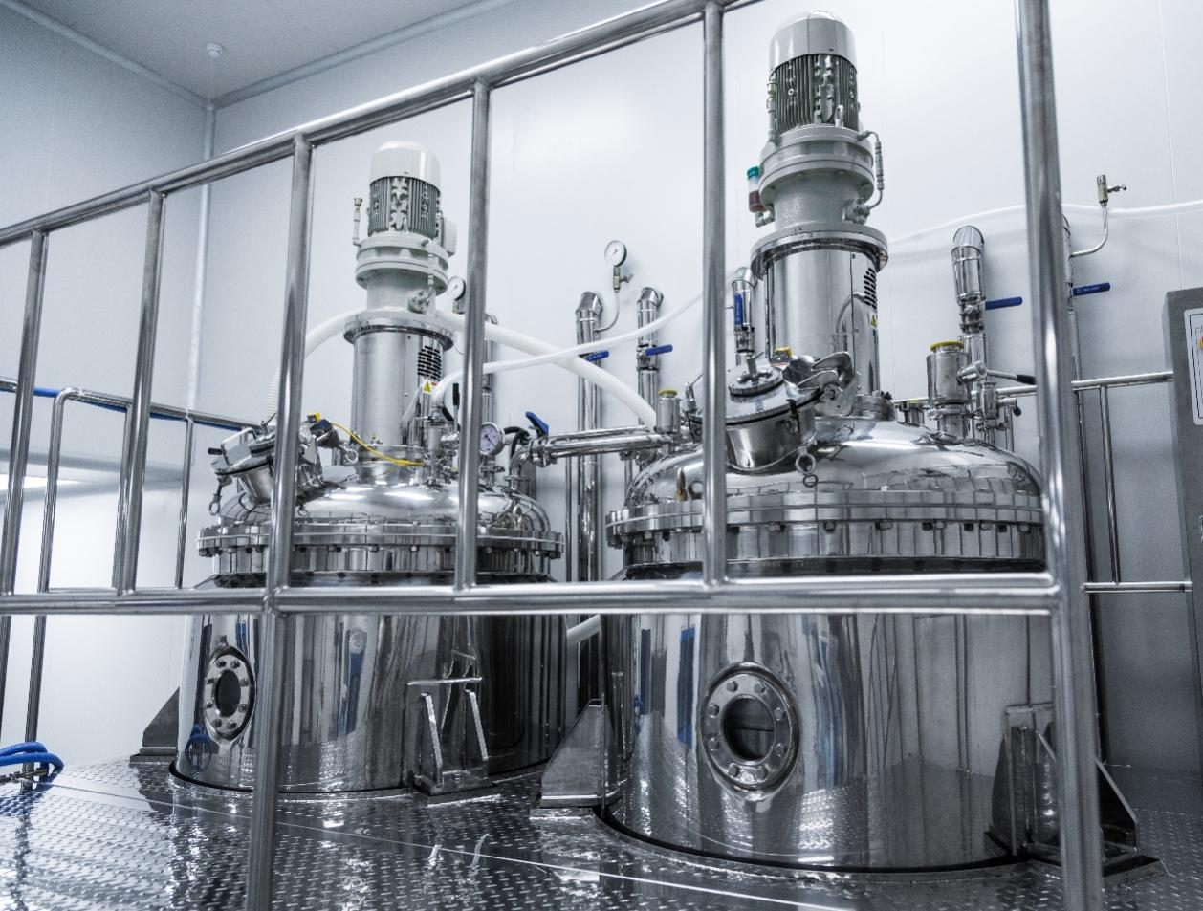

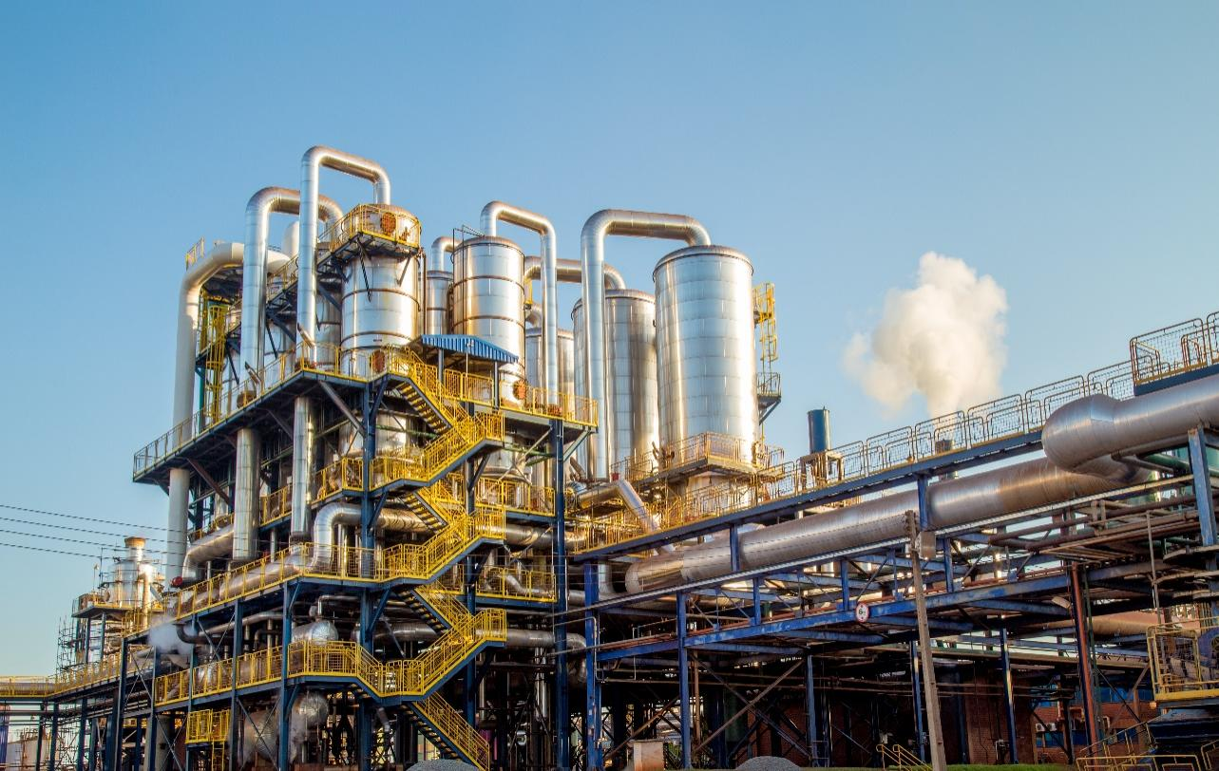

**Page-3 Services**

We offers process engineering services comprises conceptual design, Basic Engineering, Detailed engineering. The basic engineering design includes documents like Process flow diagrams, load list, P & ID, specification of equipments and bought out items. The detailed engineering documents comprise plant/equipment layout with load data (Plan and elevation), structural designs, fabrication drawing for equipment, piping GA and isometrics. Apart from it we offer process improvement and troubleshooting services.

1. **Process Engineering**
   1. PFD/P&IDs
   2. Basic Engineering Design Packages (BEP)
   3. Front End Engineering Design (FEED)
   4. Detailed Engineering Package

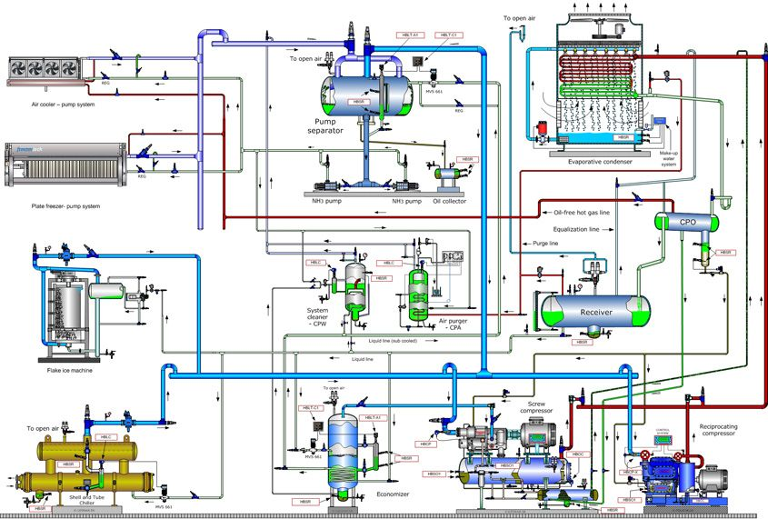

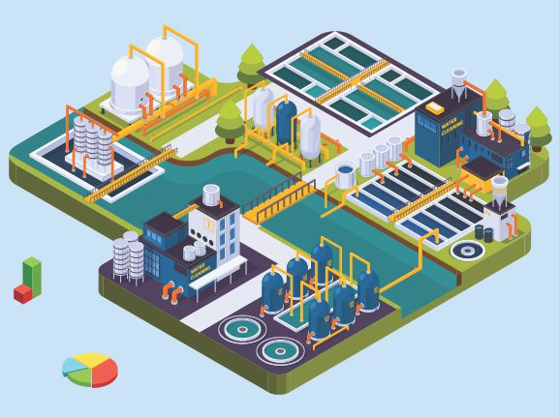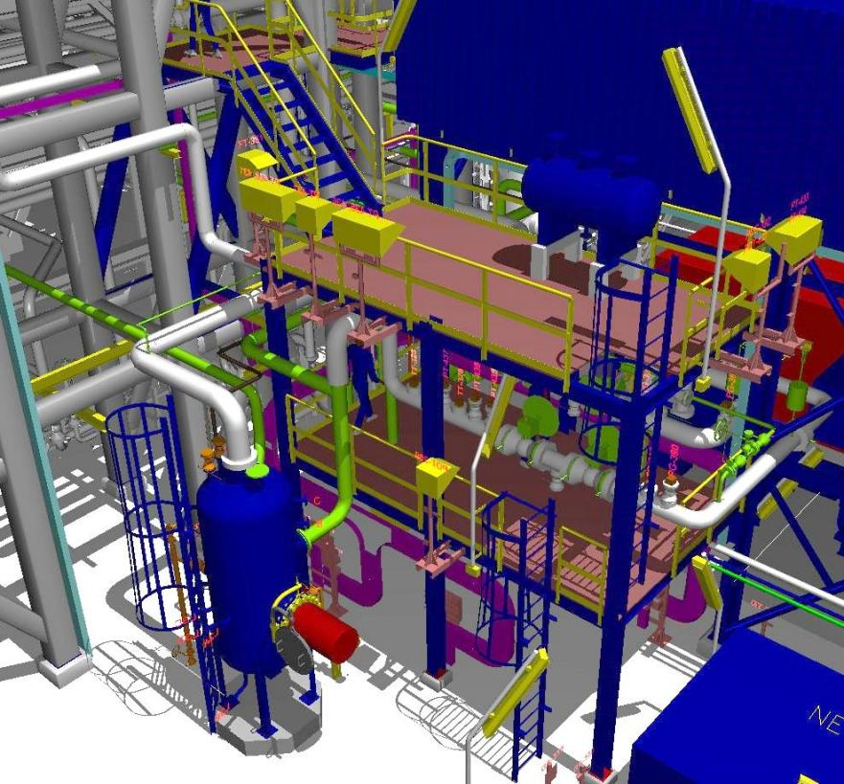

1. **Process Simulation**

Process Simulation can brings quickness to the entire engineering lifecycle: process design, simulation extreme conditions, training, and operations. Join forces of engineers and technocrats across all required disciplines on a single integrated platform to explore all dimensions of a potential design and quantify the impact on sustainability, feasibility, and profitability. Seprex provides a complete solution to design of plant or improve your processes.

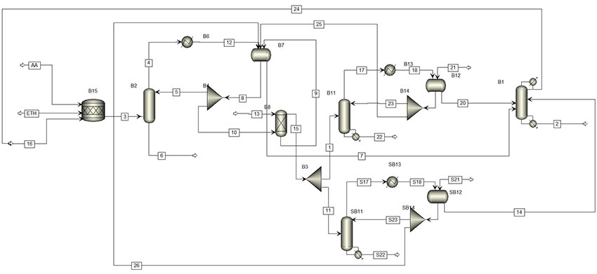

1. **CFD Simulation**

We offer our consulting services to identify and resolve complex physics involve systems such as multiphase flows, particulate flows, flows with chemical reactions, combustion etc, with help of commercial CFD software packages. These type solutions can be widely useful in the chemicals and its allied industry.

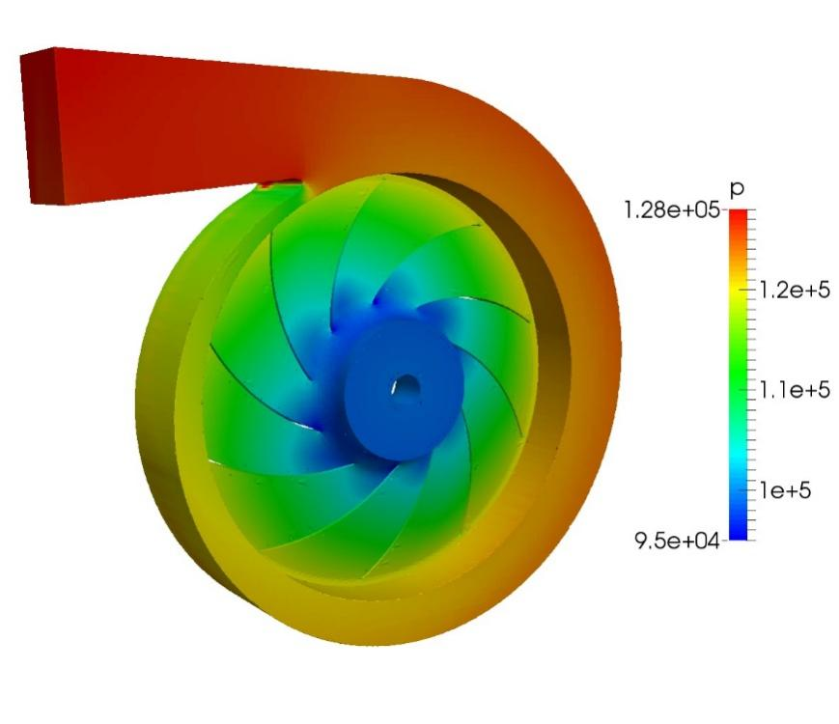

1. **Process Improvement and troubleshooting**

Process improvement or troubleshooting assignment involve following steps:

* Brainstorming and root causes
* Defining the hypotheses based on initial data
* Diagnostic different outcomes of proposed hypothesis.
* Rating the hypothesis based on hazards, cost and time

**Page -4 Trial facility**

**Pilot Scale Fixed Bed Reactor unit**

* Reactor Volume- 10 ml to 100 ml
* Reactor Temperature – Maximum 600 ◦C
* Reactor Pressure – 30 barg
* Preheated Temperature- 350 ◦C
* Automation- PID based control panel



**Pilot Scale Distillation unit**

* Mode: Batch as well as continuous
* Reboiler Volume- 20 Liter
* Reboiler Temperature – Maximum 300 ◦C
* Column Operating Pressure – Full Vacuum to 20 barg
* Column Height – 3 meters
* Automation- PID based control panel

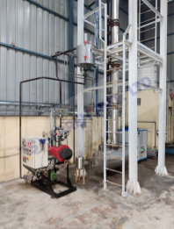

**Pilot Scale Batch Reactor unit**

* Reactor Volume- 85 Liters
* Reactor Temperature – Maximum 180 ◦C
* Reactor Pressure – 10 barg
* Automation- PID based control panel

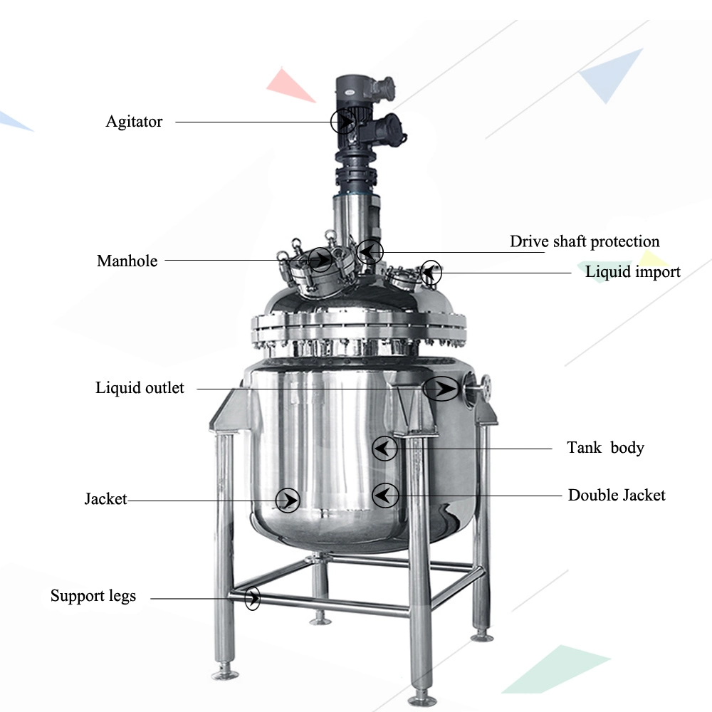

**Pilot Scale Continuous Flow Reactor unit**

* Reactor Volume- 5 Liters
* Reactor Temperature – Maximum 180 ◦C
* Reactor Pressure – 10 barg
* Automation- PID based control panel

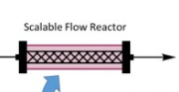

Analysis:

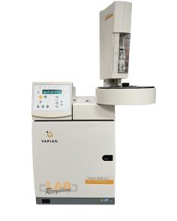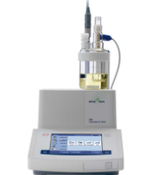

GC Analysis KF Analysis

