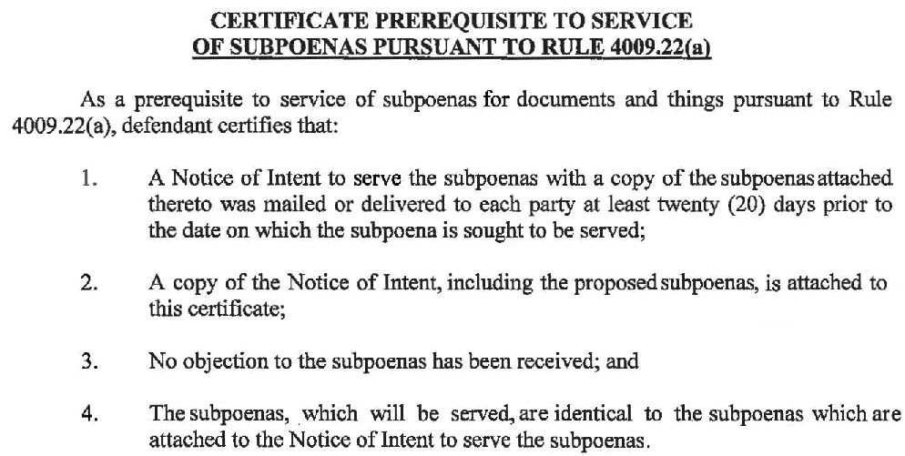
Maureen O’Connor, Esquire
208781
Lucas and Cavalier, LCC
Maureen O’Connor, Esquire
Identification No: , 208781
1500 Walnut Street Suite 1500
Philadelphia, PA 19102-0000
PH: (215) 751-9192
Fax:(215) 751-9277

Attorney(s) for Defendant(s)
Anthony Crocetto
KYLE WASHINGTON and JEAN-RENEL MARQUIS,
Plaintiff(s)
ANTHONY CROCETTO a/k/a ANTHONY CROCELTO,
Defendant(s)
v.
Maureen O’Connor
Maureen O’Connor, Esquire
COURT OF COMMON PLEAS
Philadelphia COUNTY

Term

No. April Term 2015 01810

CIVIL ACTION

Lucas and Cavalier, LCC

