
KYLE WASHINGTON and JEAN-RENEL MARQUIS,
ANTHONY CROCETTO a/k/a ANTHONY CROCELTO,
Anthony Crocetto
COURT OF COMMON PLEAS
Philadelphia
NO. April Term 2015 01810
Jeffrey Curry, Esquire
Rosenbaum & Associates, PC
1818 Market Street Ste 3200
Philadelphia, PA 19103-0000
Defendant Anthony Crocetto
See Following PAGe
Lucas and Cavalier, LCC
By: Maureen O’Connor, Esquire
Identification No: 208781
1500 Walnut Street Suite 1500
Philadelphia, PA 19102-0000
PH: (215) 751-9192
Fax:(215) 751-9277

Order No. 01-35503
_____________________________________________________________________________001 Safe Auto Insurance Company (Insurance Records) 4 Easton Oval, Columbus, OH 43219-0000 (614) 231-0200 Fax : (614) 670-7563_____________________________________________________________________________
Order No. 01-35503
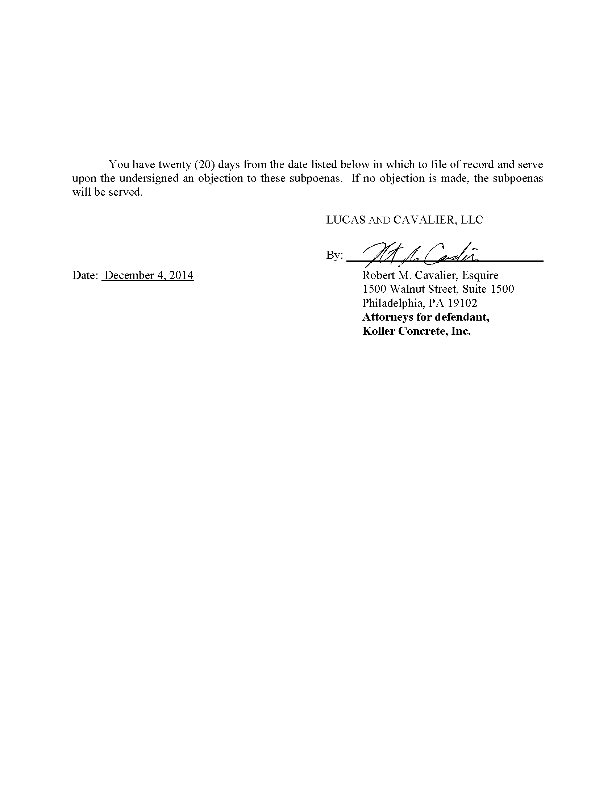
Maureen O’Connor
Lucas and Cavalier, LCC
1500 Walnut Street Suite 1500
Philadelphia, PA 19102-0000
Attorneys for defendant,
Anthony Crocetto

Order No. 01-35503
Maureen O’Connor
Lucas and Cavalier, LCC
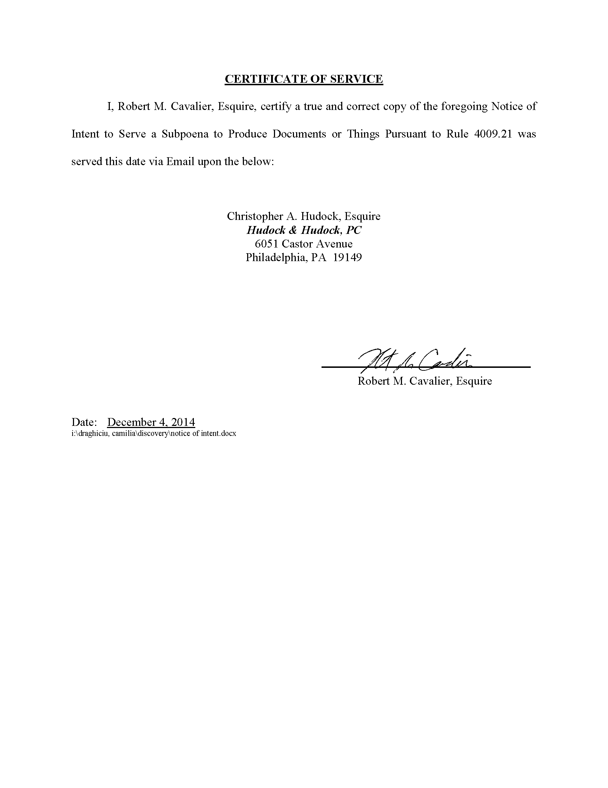

Jeffrey Curry, Esquire
Rosenbaum & Associates, PC
1818 Market Street Ste 3200
Philadelphia, PA 19103-0000
Maureen O’Connor
Maureen O’Connor
I, Maureen O’Connor
Order No. 01-35503
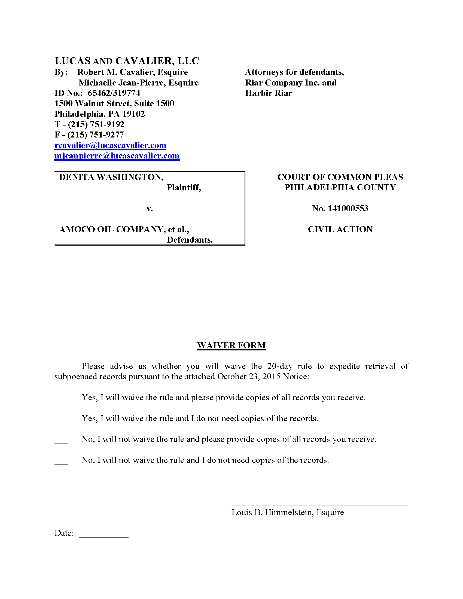
Order No. 01-35503
Anthony Crocetto
Philadelphia
April Term 2015 01810
Jeffrey Curry

Lucas and Cavalier, LCC
By: Maureen O’Connor, Esquire
Identification No: 208781
1500 Walnut Street Suite 1500
Philadelphia, PA 19102-0000
PH: (215) 751-9192
Fax:(215) 751-9277

KYLE WASHINGTON and JEAN-RENEL MARQUIS,
Plantiff(s)
v.
ANTHONY CROCETTO a/k/a ANTHONY CROCELTO,
Defendant(s)

