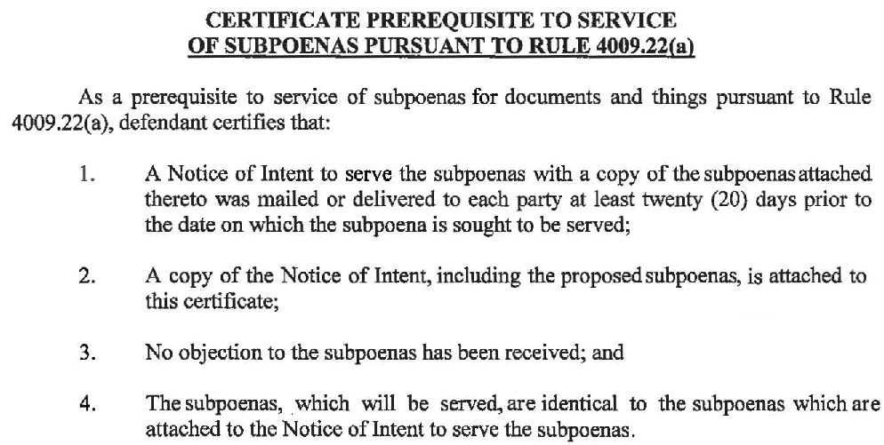
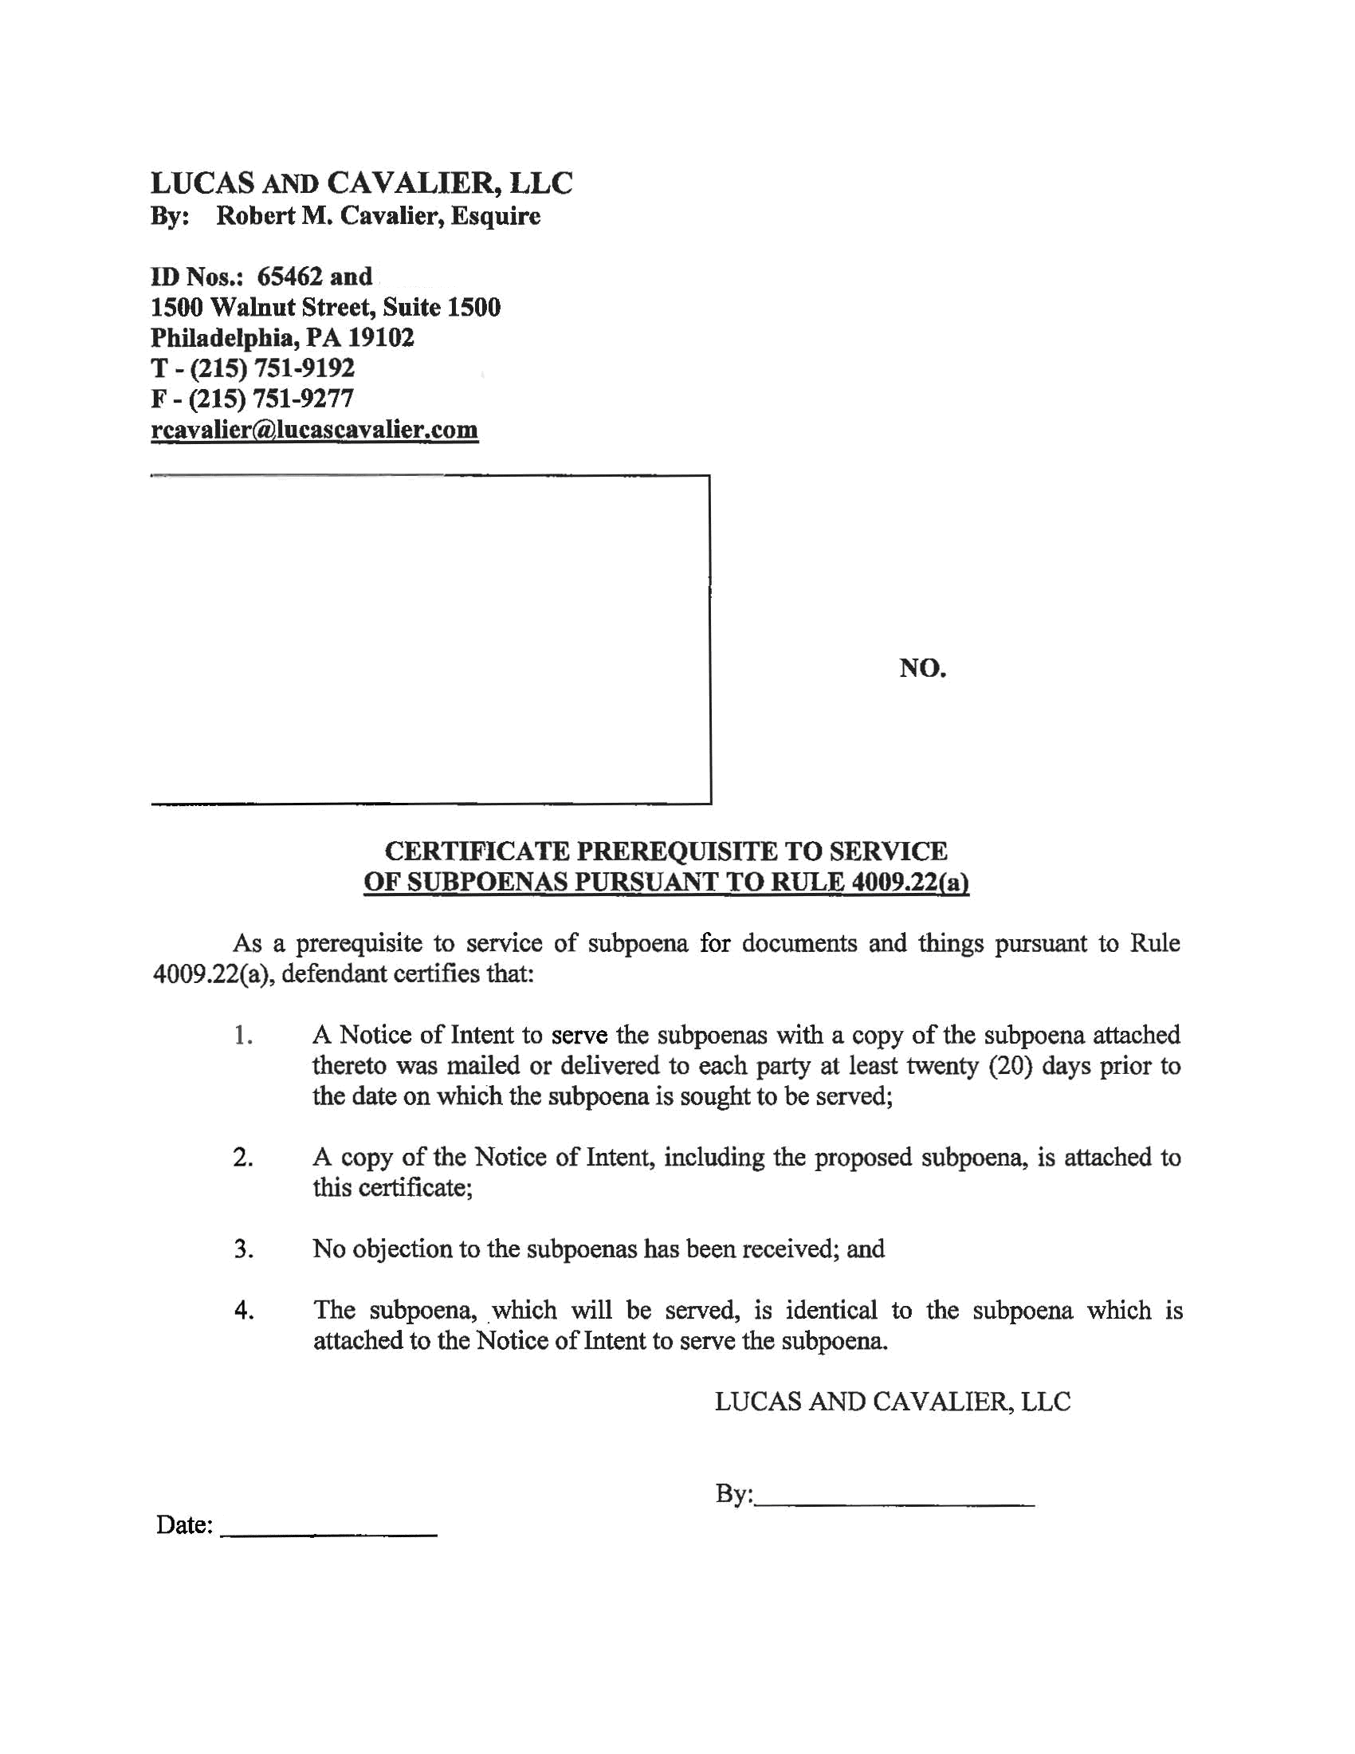
John Doe, Esquire

LUCAS AND CAVALIER LLC
By: Robert Cavalier, Esquire
John Doe, Esquire
Identification No: 65462,
123 East Main Street
Anywhere, MI 12345
PH: (123) 456-7890
Fax:(123) 456-7890
rcavalier@lucascavalier.com

Attorney(s) for Defendant(s)
Josh Sanford
Batman
Plaintiff(s)
Gotham City
Defendant(s)
v.
John Doe
John Doe, Esquire
COURT OF COMMON PLEAS
COUNTY

Term

No. 99-99999

CIVIL ACTION

