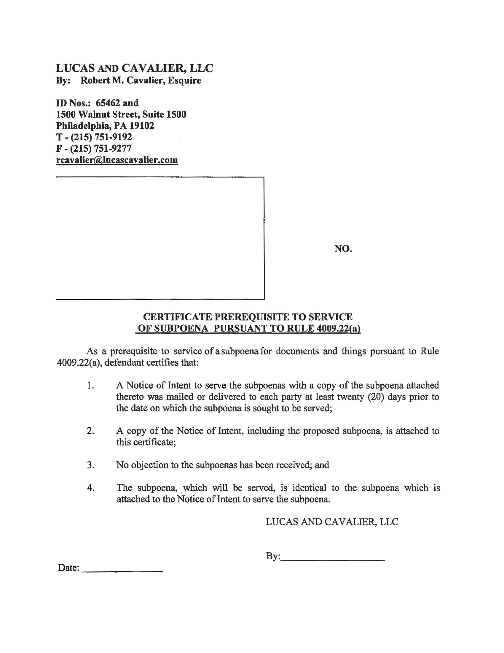
David Pizzica, Esquire
308937
LUCAS AND CAVALIER LLC
By: Robert Cavalier, Esquire
David Pizzica, Esquire
Identification No: 65462, 308937
1500 Walnut Street Suite 1500
Philadelphia, PA 19102-0000
PH: (215) 751-9192
Fax:(215) 751-9277
rcavalier@lucascavalier.com

Attorney(s) for Defendant(s)
John Dangelis
George Carey and Linda Carey
Plaintiff(s)
Giannone Services, Inc. and John Dangelis
Defendant(s)
v.
David Pizzica
David Pizzica, Esquire
COURT OF COMMON PLEAS
Montgomery COUNTY

Term

No. 2015-15055

CIVIL ACTION

