
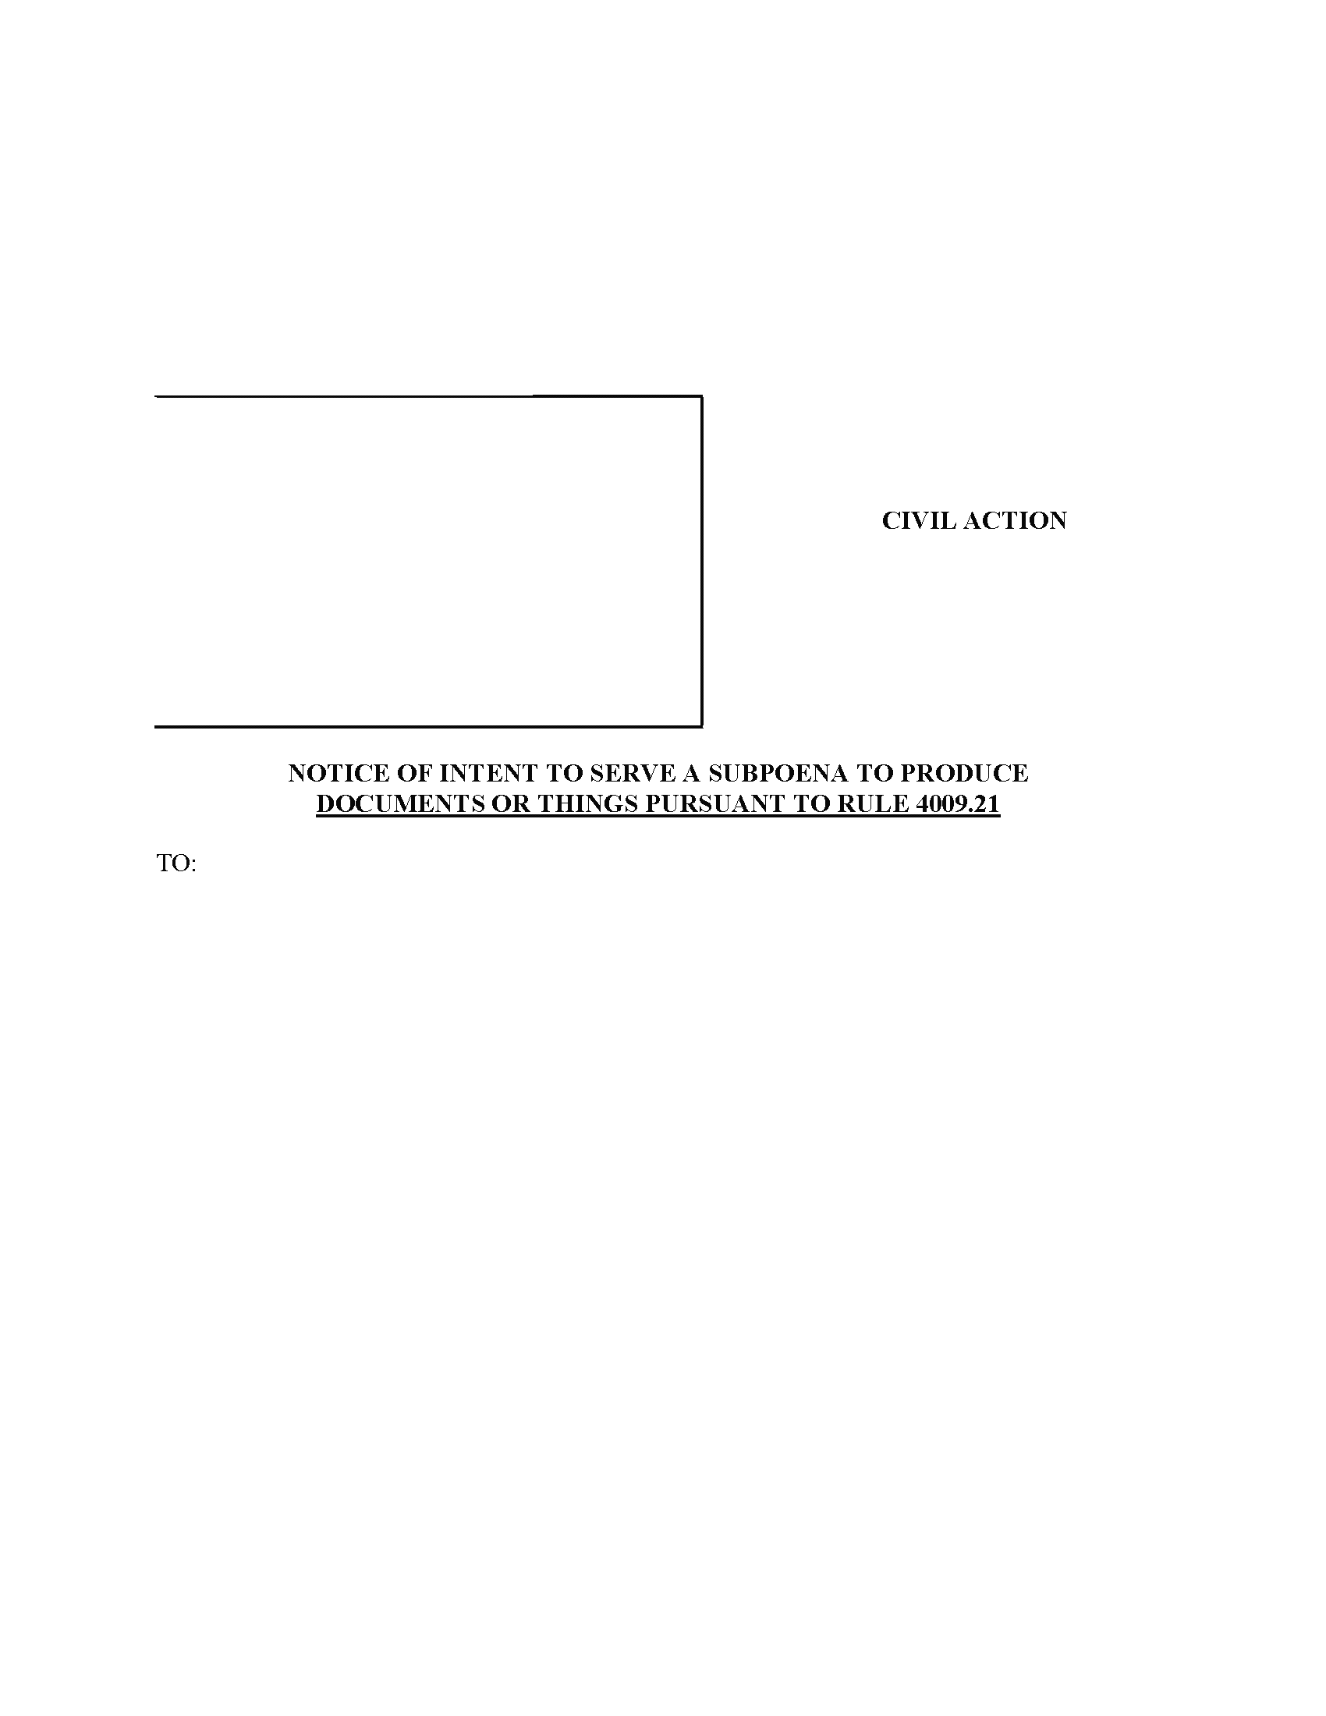
LUCAS AND CAVALIER LLC
By: Robert Cavalier, Esquire
Maureen O’Connor, Esquire
Identification No: 65462, 208781
1500 Walnut Street Suite 1500
Philadelphia, PA 19102-0000
PH: (215) 751-9192
Fax:(215) 751-9277
rcavalier@lucascavalier.com

Attorney(s) for Defendant(s)
Anthony Crocetto
Jeffrey Curry, Esquire
Rosenbaum & Associates, PC
1818 Market Street
Ste 3200
Philadelphia, PA 19103-0000
Defendant(s) Anthony Crocetto, intend(s) to serve record subpoena(s) identical to the Subpoena(s) attached to this notice on the following:
See Following PAGe
Order No. 01-35503
v.
COURT OF COMMON PLEAS
Philadelphia COUNTY

Term

No. April Term 2015 01810

CIVIL ACTION
KYLE WASHINGTON and JEAN-RENEL MARQUIS,
Plaintiff(s)

ANTHONY CROCETTO a/k/a ANTHONY CROCELTO,
Defendant(s)

_____________________________________________________________________________001 Safe Auto Insurance Company (Insurance Records) 4 Easton Oval, Columbus, OH 43219-0000 (614) 231-0200 Fax : (614) 670-7563_____________________________________________________________________________
You have twenty (20) days from the date listed below in which to file of record and serve upon the undersigned an objection to the/these subpoena(s). If no objection is made, the subpoena(s) will be served.
Maureen O’Connor, Esquire
Lucas and Cavalier, LCC
1500 Walnut Street
Suite 1500
Philadelphia, PA 19102-0000
Attorneys for defendant(s),
Anthony Crocetto

Order No. 01-35503
Maureen O’Connor
Maureen O’Connor
LUCAS AND CAVALIER. LLC
By:
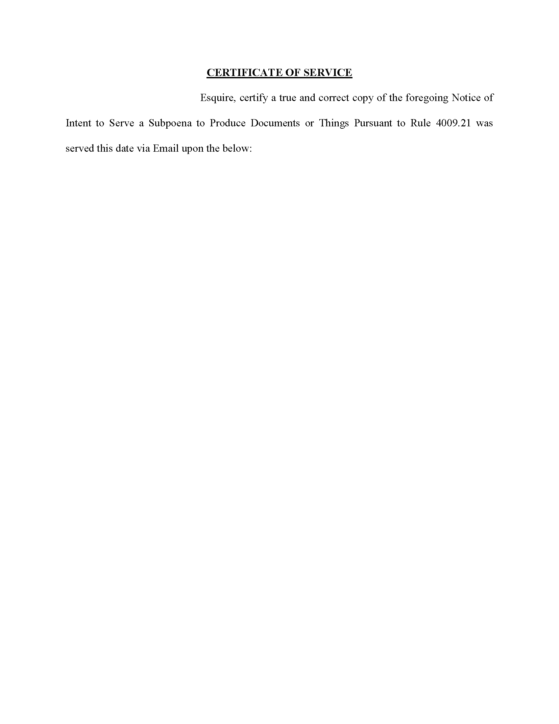
Order No. 01-35503
I, Maureen O’Connor,
Jeffrey Curry, Esquire
Rosenbaum & Associates, PC
1818 Market Street Ste 3200
Philadelphia, PA 19103-0000
Attorney for Plaintiff(s)

Maureen O’Connor
Maureen O’Connor, Esquire
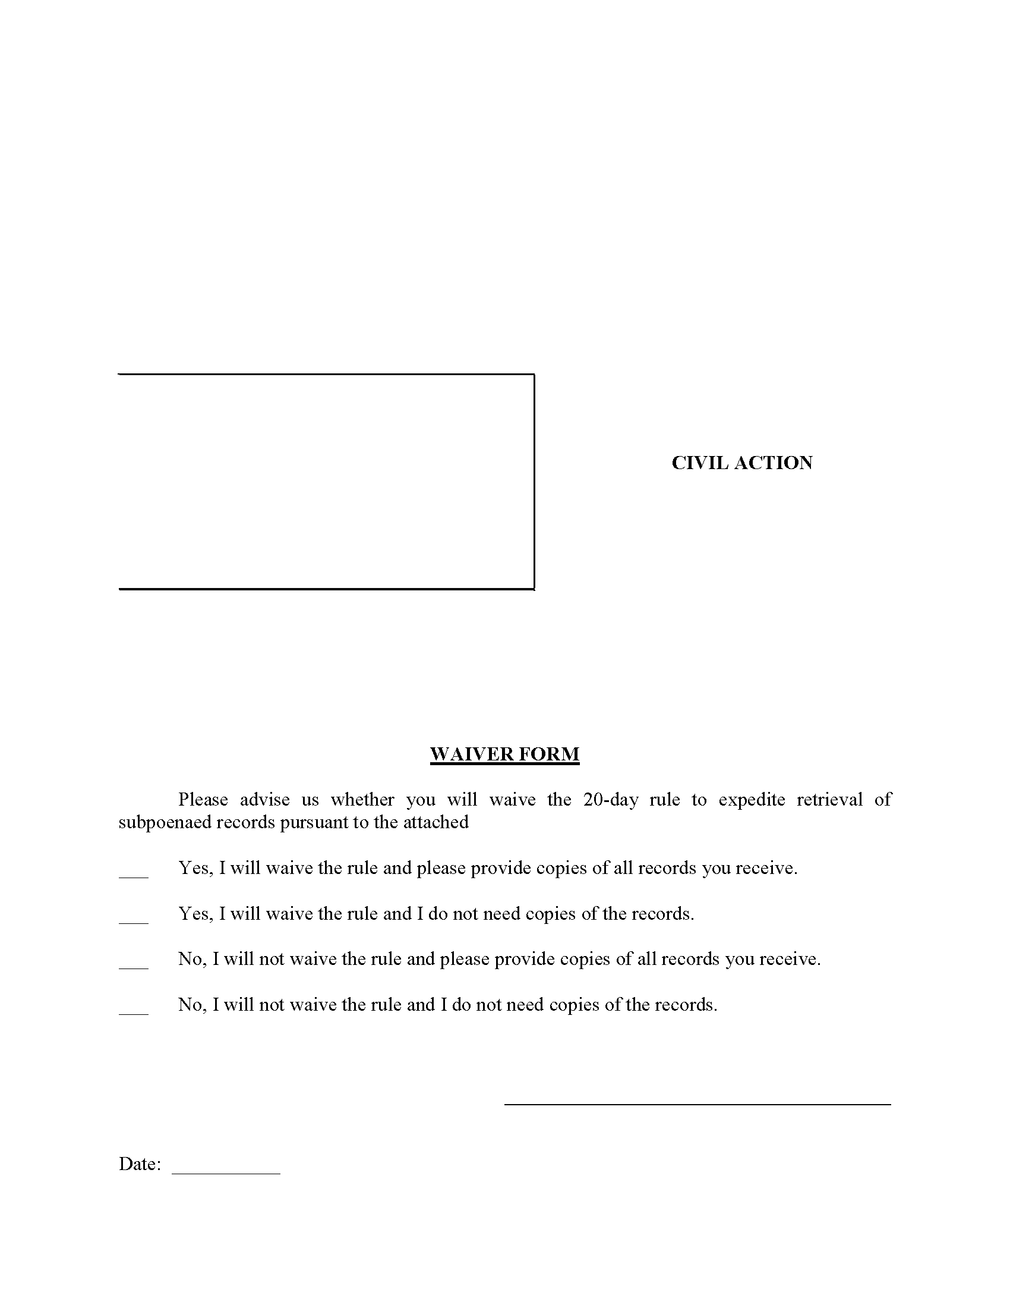
LUCAS AND CAVALIER LLC
By: Robert Cavalier, Esquire
Maureen O’Connor, Esquire
Identification No: 65462, 208781
1500 Walnut Street Suite 1500
Philadelphia, PA 19102-0000
PH: (215) 751-9192
Fax:(215) 751-9277
rcavalier@lucascavalier.com

Attorney(s) for Defendant(s)
Anthony Crocetto
Jeffrey Curry, Esquire

V.
COURT OF COMMON PLEAS
Philadelphia COUNTY

Term

No. April Term 2015 01810

CIVIL ACTION
KYLE WASHINGTON and JEAN-RENEL MARQUIS,
Plaintiff(s)

ANTHONY CROCETTO a/k/a ANTHONY CROCELTO,
Defendant(s)

Jeffrey Curry, Esquire
Rosenbaum & Associates, PC
1818 Market Street Ste 3200
Philadelphia, PA 19103-0000
Attorney for Plaintiff(s)
Kyle Washington a/k/a Tilet Washington
Maureen O’Connor, Esquire
Maureen O’Connor
I, Maureen O’Connor,
Maureen O’Connor, Esquire
Lucas and Cavalier, LCC
1500 Walnut Street Suite 1500
Philadelphia, PA 19102-0000
Attorneys for defendant,
Anthony Crocetto

Maureen O’Connor

