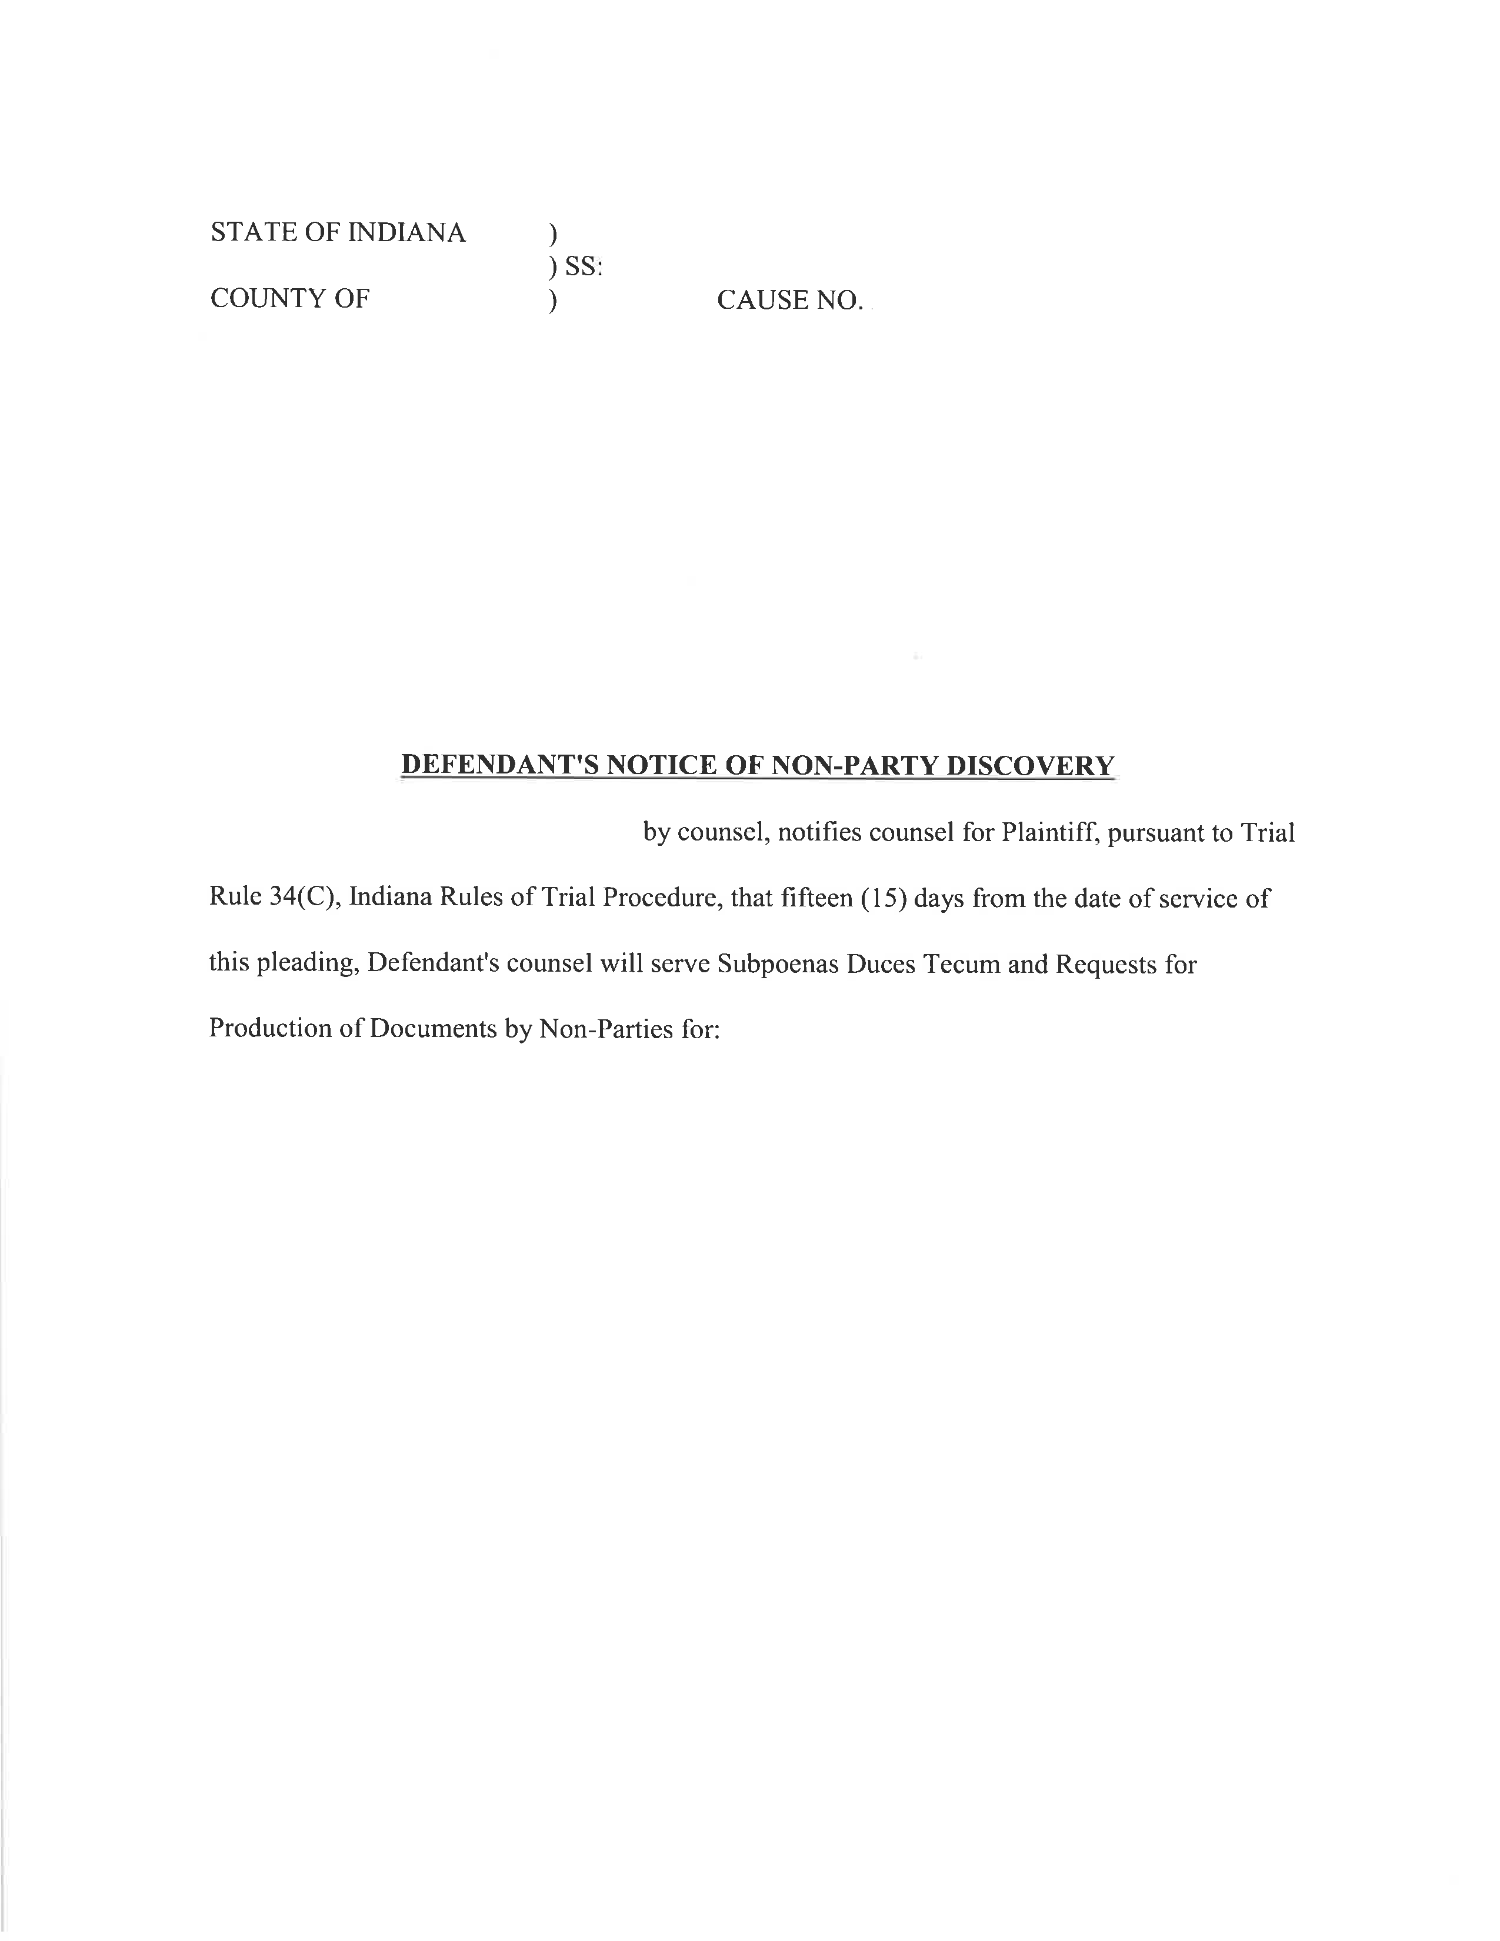
IN THE Philadelphia CIRCUIT COURT
April Term 2015 01810
Philadelphia
KYLE WASHINGTON and JEAN-RENEL MARQUIS,
Plaintiff,

vs.

ANTHONY CROCETTO a/k/a ANTHONY CROCELTO,
Defendant,

Defendant, Anthony Crocetto,
Lucas and Cavalier, LCC

By ____________
Maureen O’Connor 208781
1500 Walnut Street
Suite 1500
Philadelphia, PA 19102-0000
Telephone: (215) 751-9192

