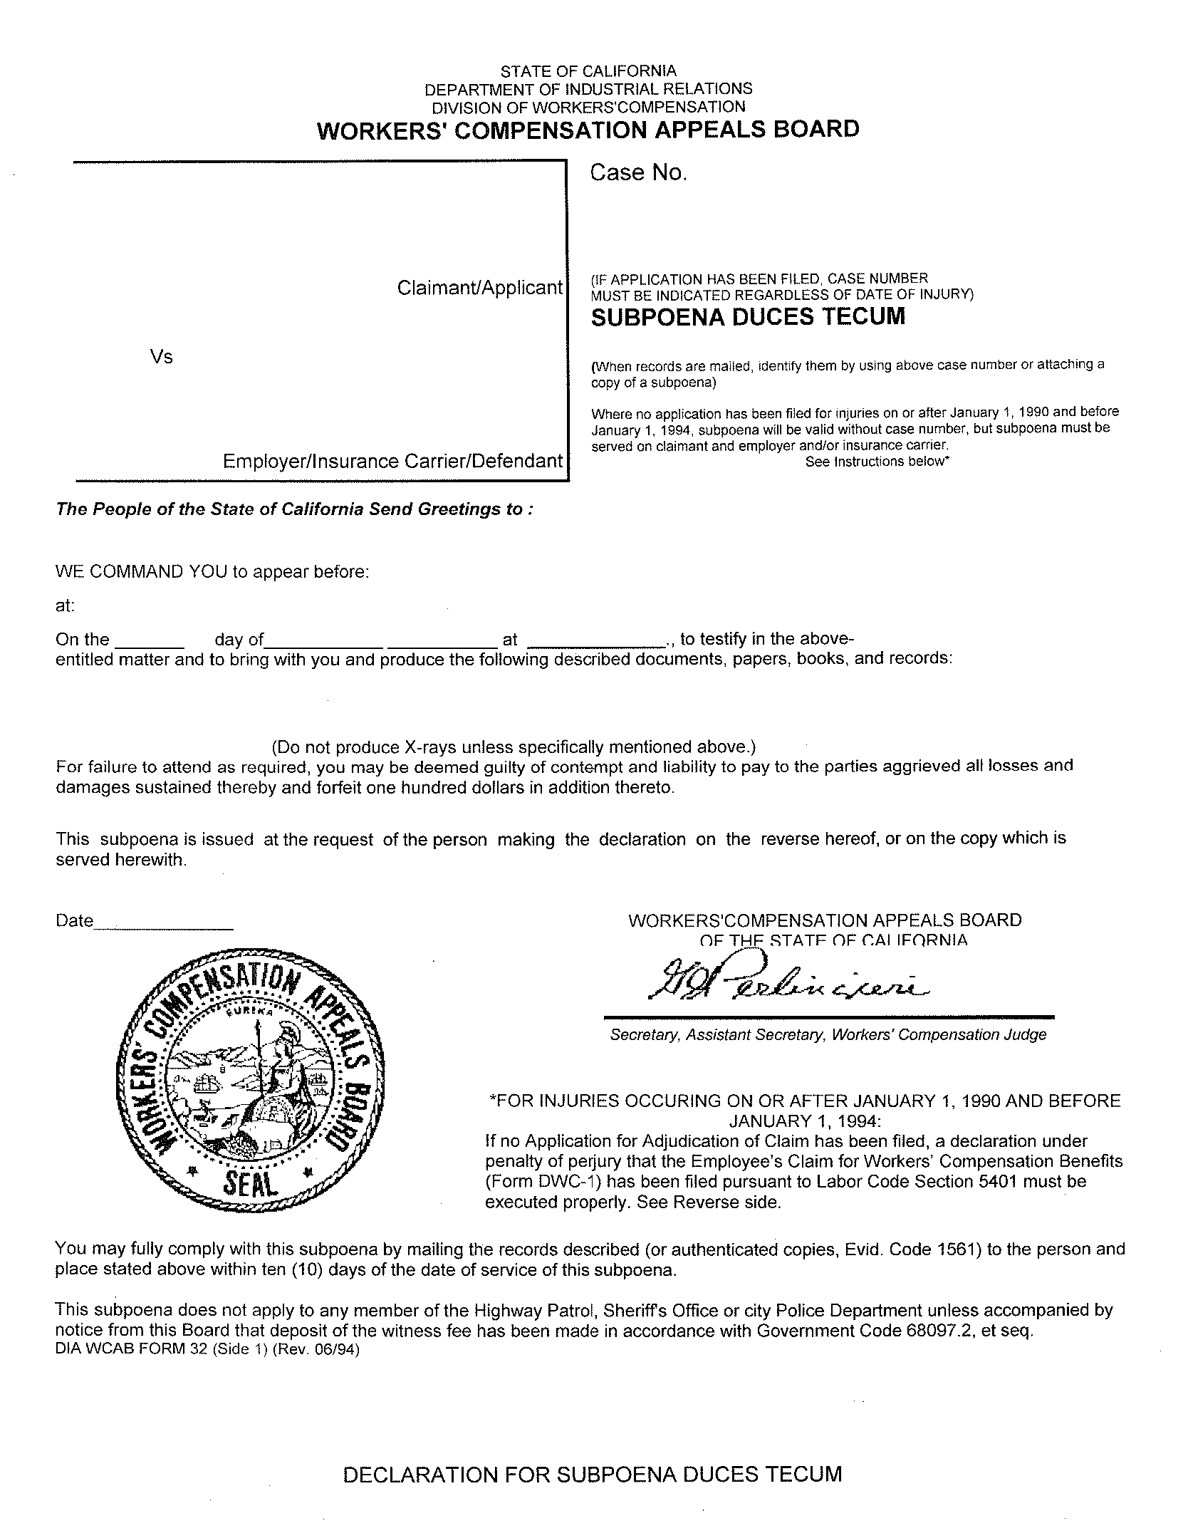
Batman
DOB: 01/01/1979
SSN: xxx-xx-5555
Gotham City
CUSTODIAN OF RECORDS
University of Michigan Hospital and Health Center

WE COMMAND YOU to provide document(s)/Material(s) to: Axiom Requisition Copy Service
March 15, 2016

FROM 01/01/1979 TO PRESENT: Any and all MEDICAL RECORDS, including but not limited to patient history form(s), reports, etc. pertaining to Batman SSN: xxx-xx-5555, DOB: 01/01/1979.
99-99999
2869 Jolly Road Okemos, MI 48864
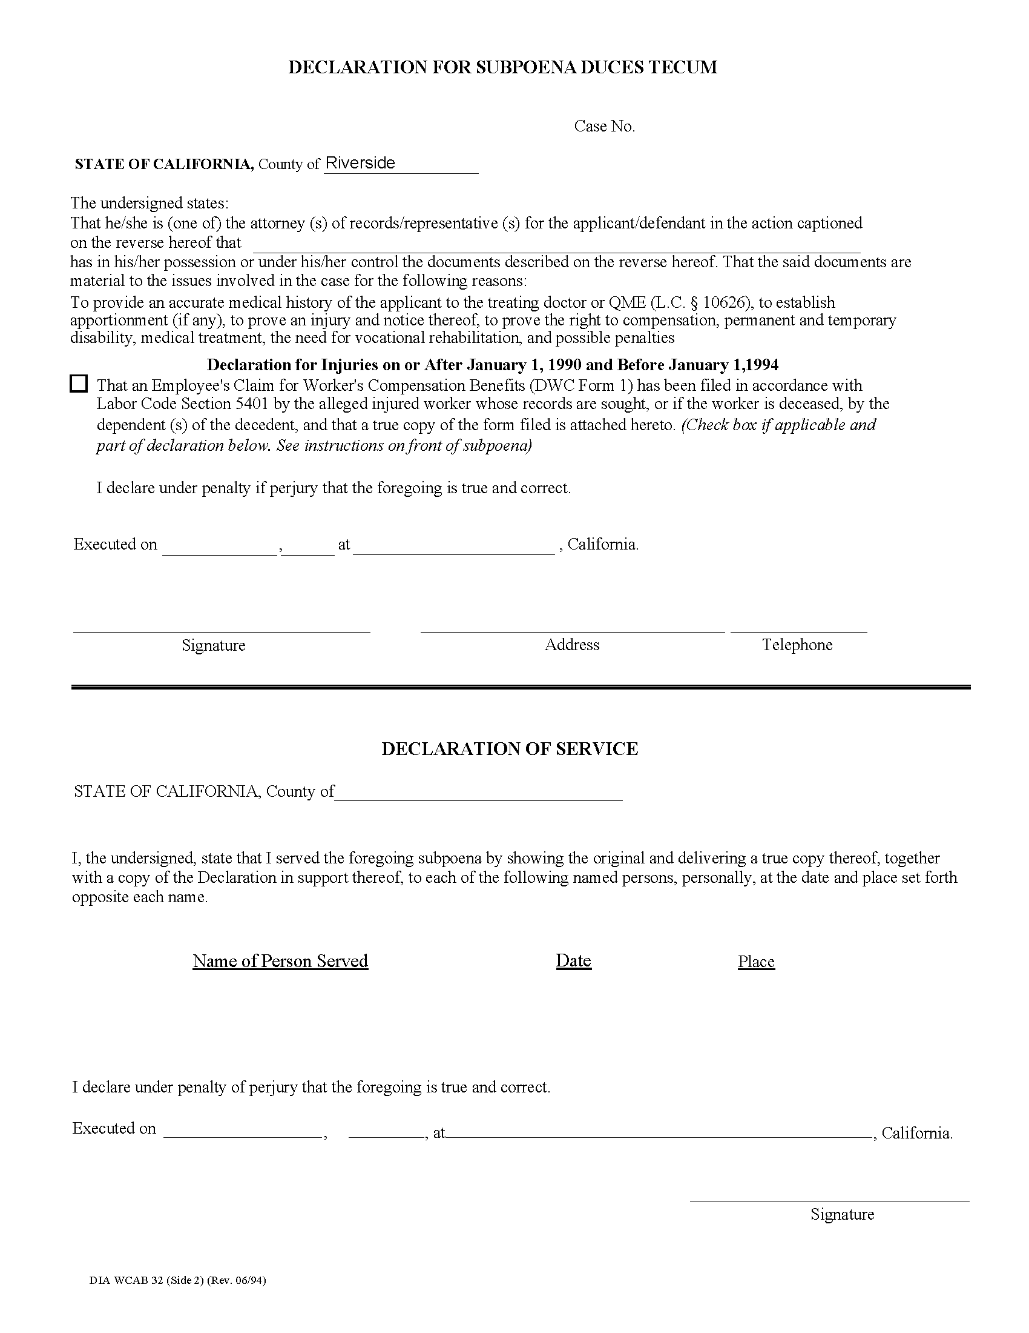
99-99999

University of Michigan Hospital and Health Center
John Doe
123 East Main Street Anywhere, MI 12345 (123) 456-7890

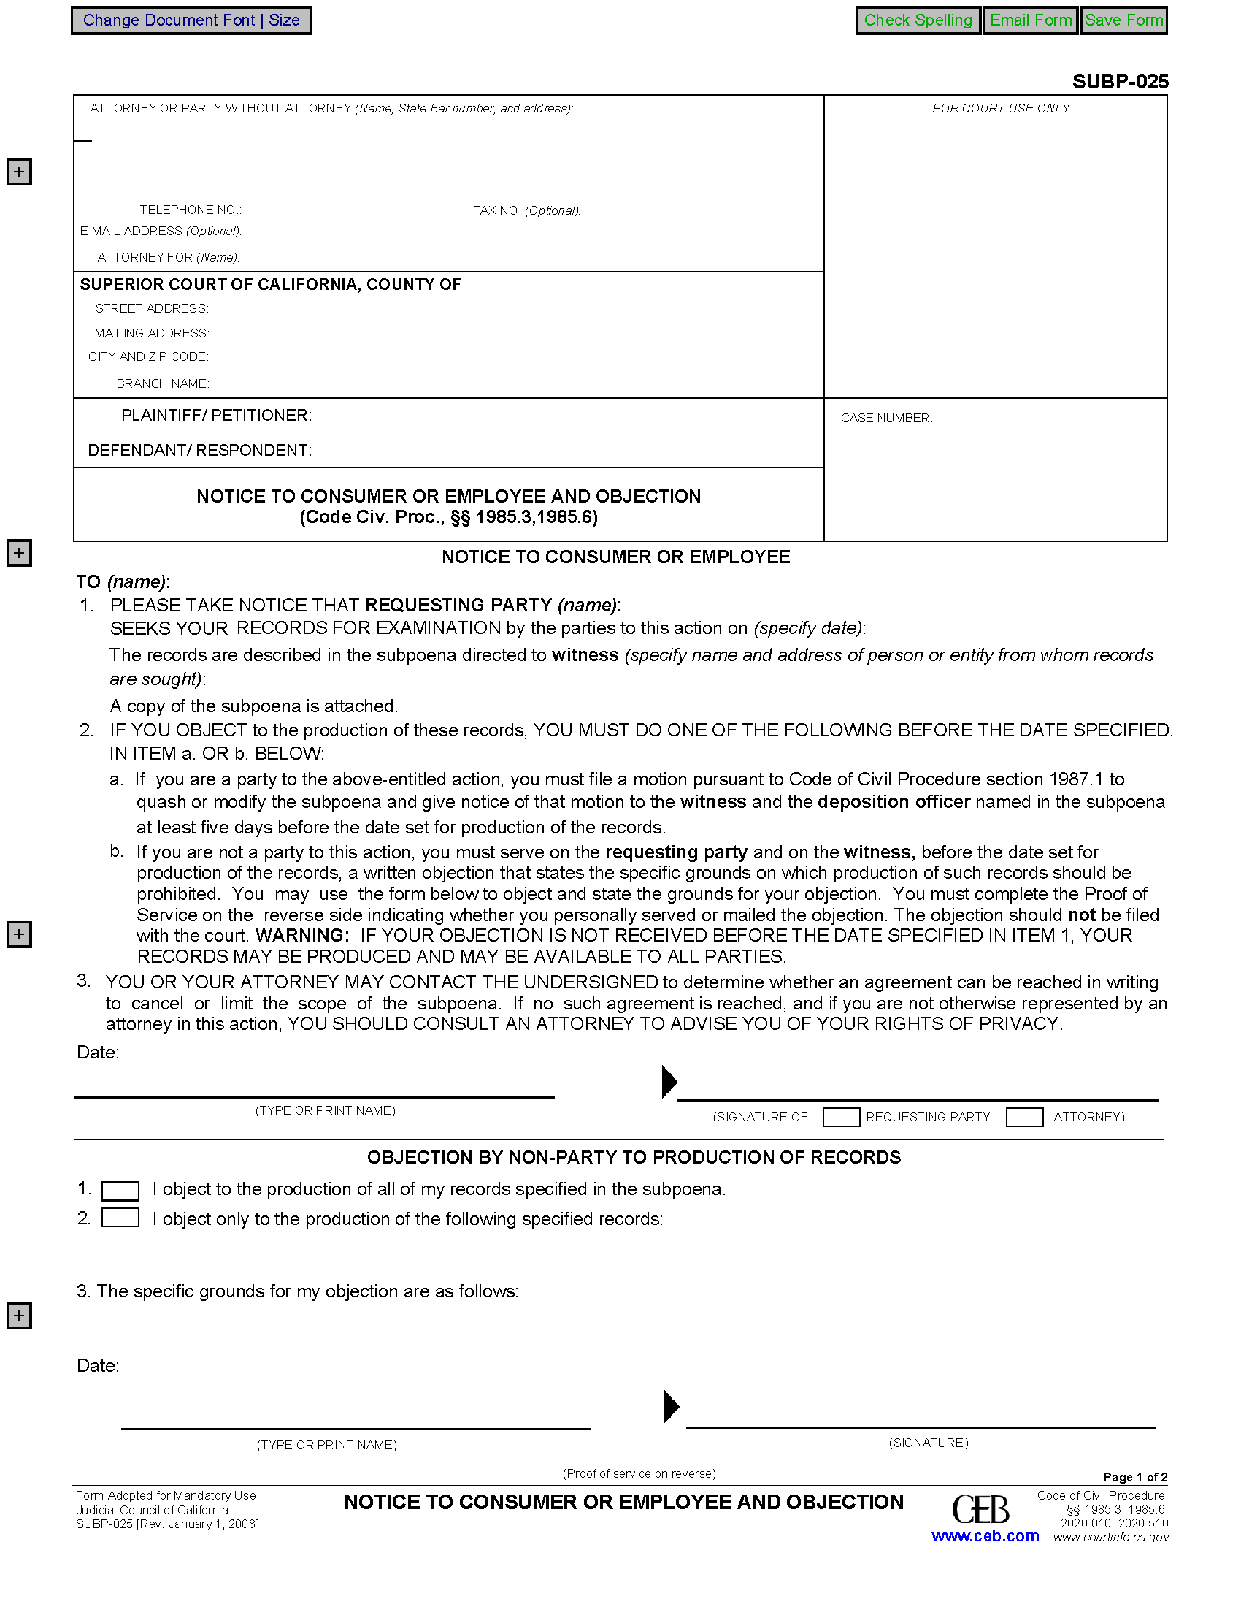

John Doe
Smith and Jones PC
123 East Main Street
Anywhere, MI 12345
(123) 456-7890
(123) 456-7890
WORKERS COMPENSATION APPEALS BOARD
1515 Clay Street, 6th Floor

Oakland, California 94612
Batman
Gotham City
99-99999
Batman
Smith and Jones PC
University of Michigan Hospital and Health Center
2901 Hubbard Street Room 2722 Ann Arbor, MI 48109-0000
John Doe
John Doe
March 15, 2016
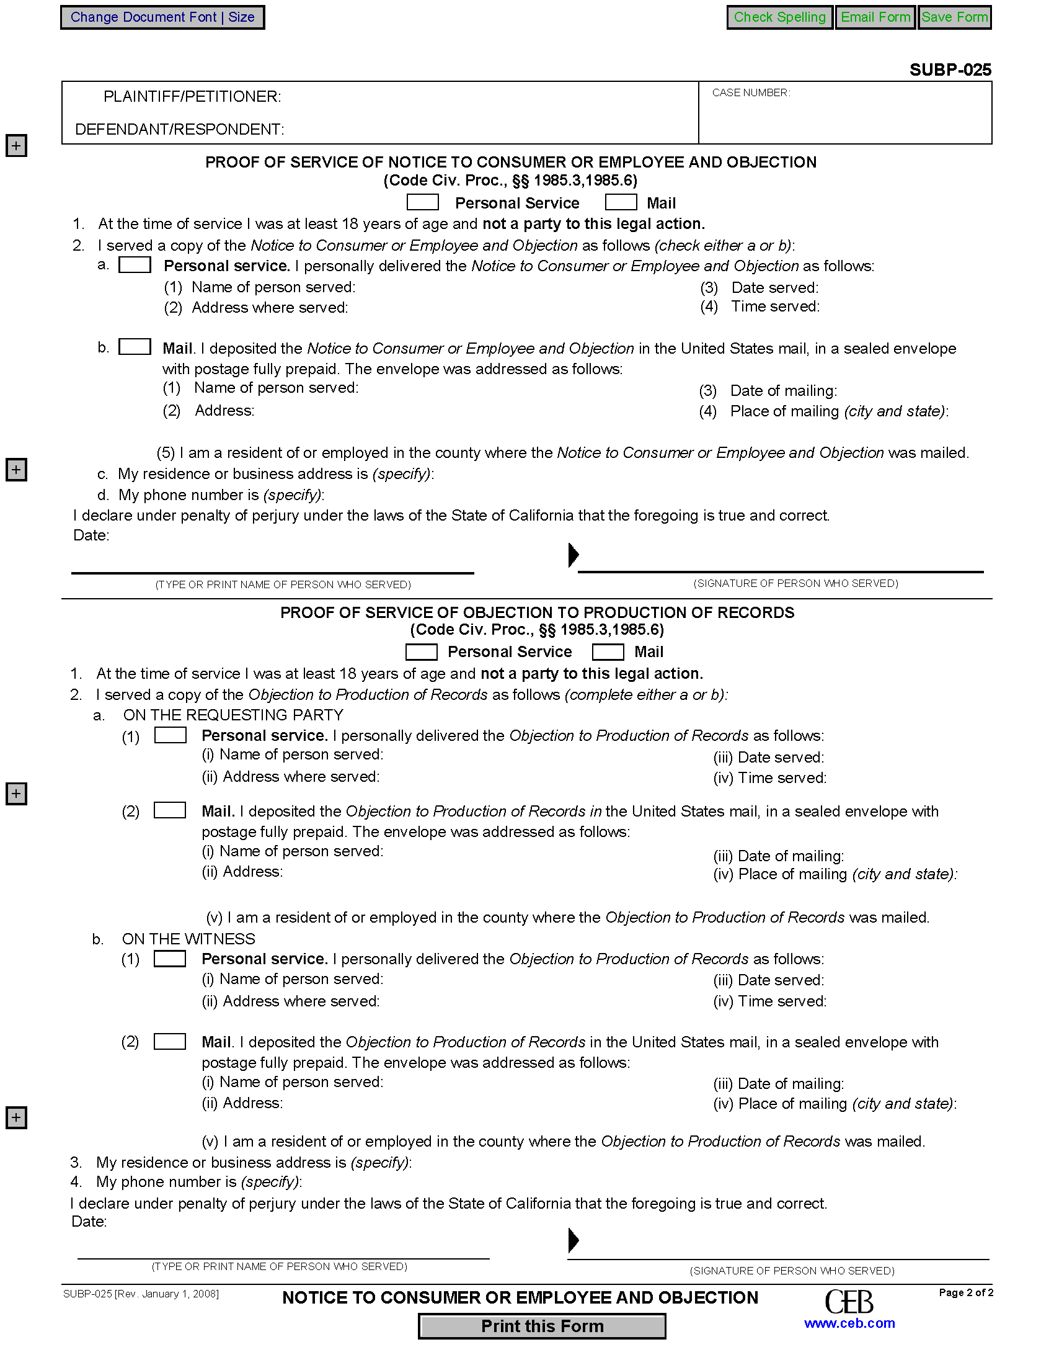

Batman
Gotham City
99-99999
X
X
Jack Zuk
Okemos, MI
2869 Jolly Rd
Okemos, MI 48864-____
Axiom Requisition Copy Service2869 Jolly Road Okemos, MI 48864
(877) 886-5090

