University of Michigan Hospital and Health Center Release of Information Unit
Dept. Release of Information Unit - NCAC
2901 Hubbard Street Room 2722
Ann Arbor, MI 48109-0000

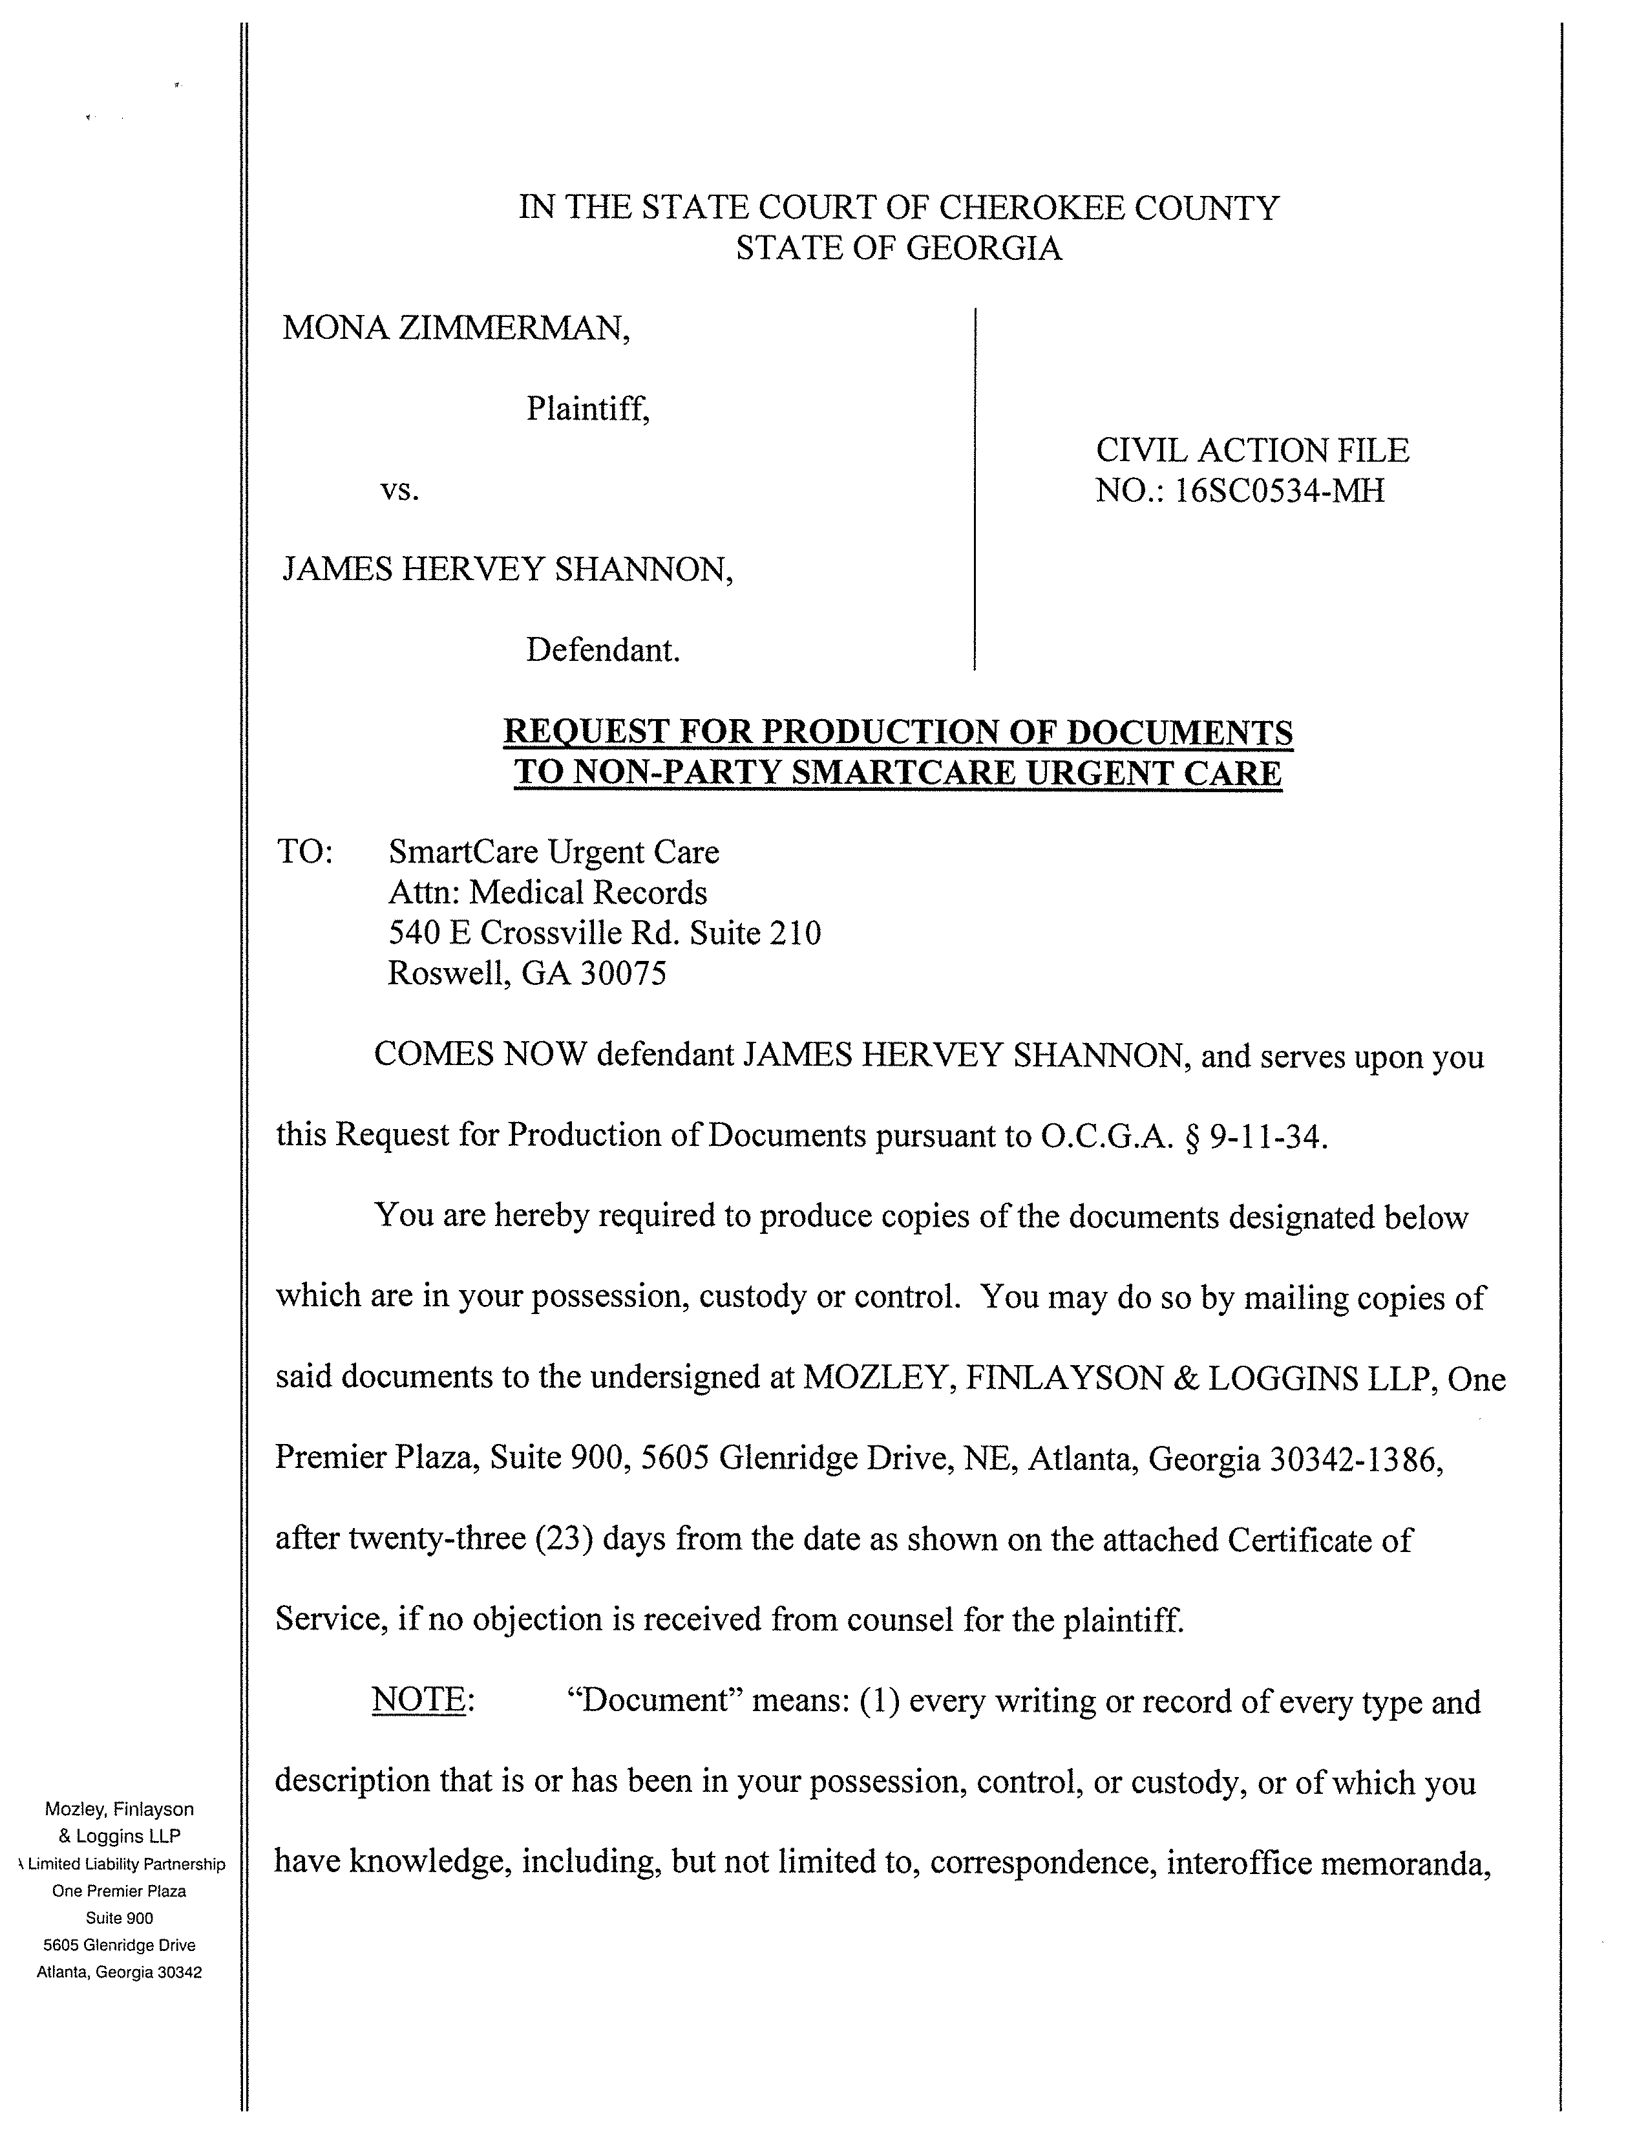
IN THE COURT OF COUNTY
STATE OF GEORGIA
Batman,
Gotham City,
99-99999
University of Michigan Hospital and Health Center Release of Information Unit
2901 Hubbard Street Room 2722
Ann Arbor, MI 48109-0000
COMES NOW Defendant Josh Sanford, and serves upon you this Request for Production of Documents pursuant to O.C.G.A. § 9-11-34.
You are hereby required to produce copies of the documents designated below
which are in your possession, custody or control. You may do so by mailing copies of
said documents to the undersigned at Axiom Requisition, 2869 Jolly RD, Okemos, MI
48864, after twenty-three (23) days from the date as shown on the attached Certificate of
Service, if no objection is received from counsel for the plaintiff.

DEFENDANT’S REQUEST FOR PRODUCTION OF DOCUMENTS TO NON-PARTY
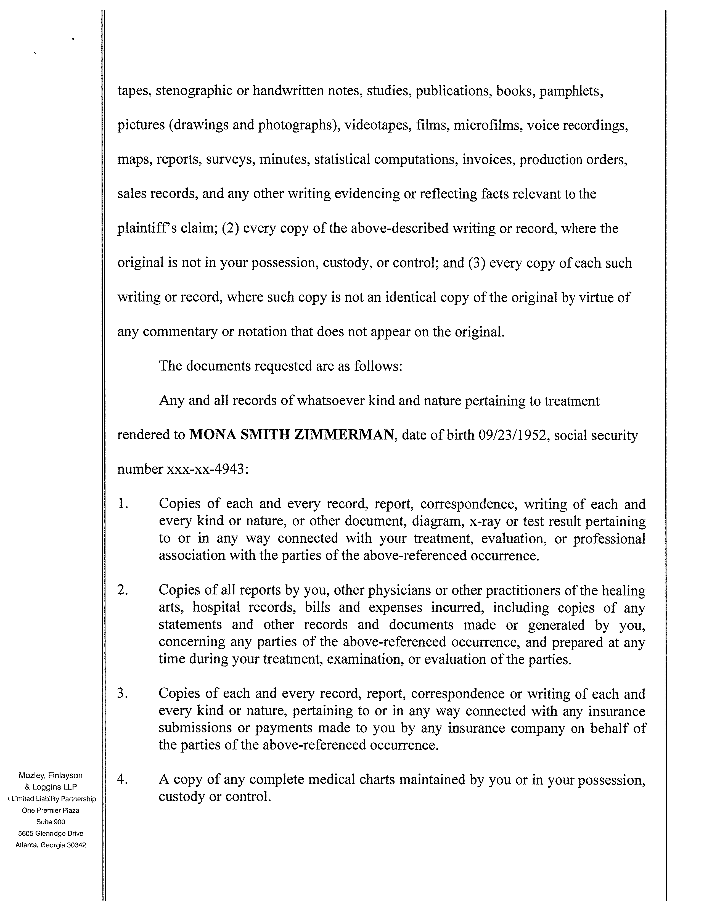
FROM 01/01/1979 TO PRESENT: Any and all MEDICAL RECORDS, including but not limited to patient history form(s), reports, etc. pertaining to Batman SSN: xxx-xx-5555, DOB: 01/01/1979.

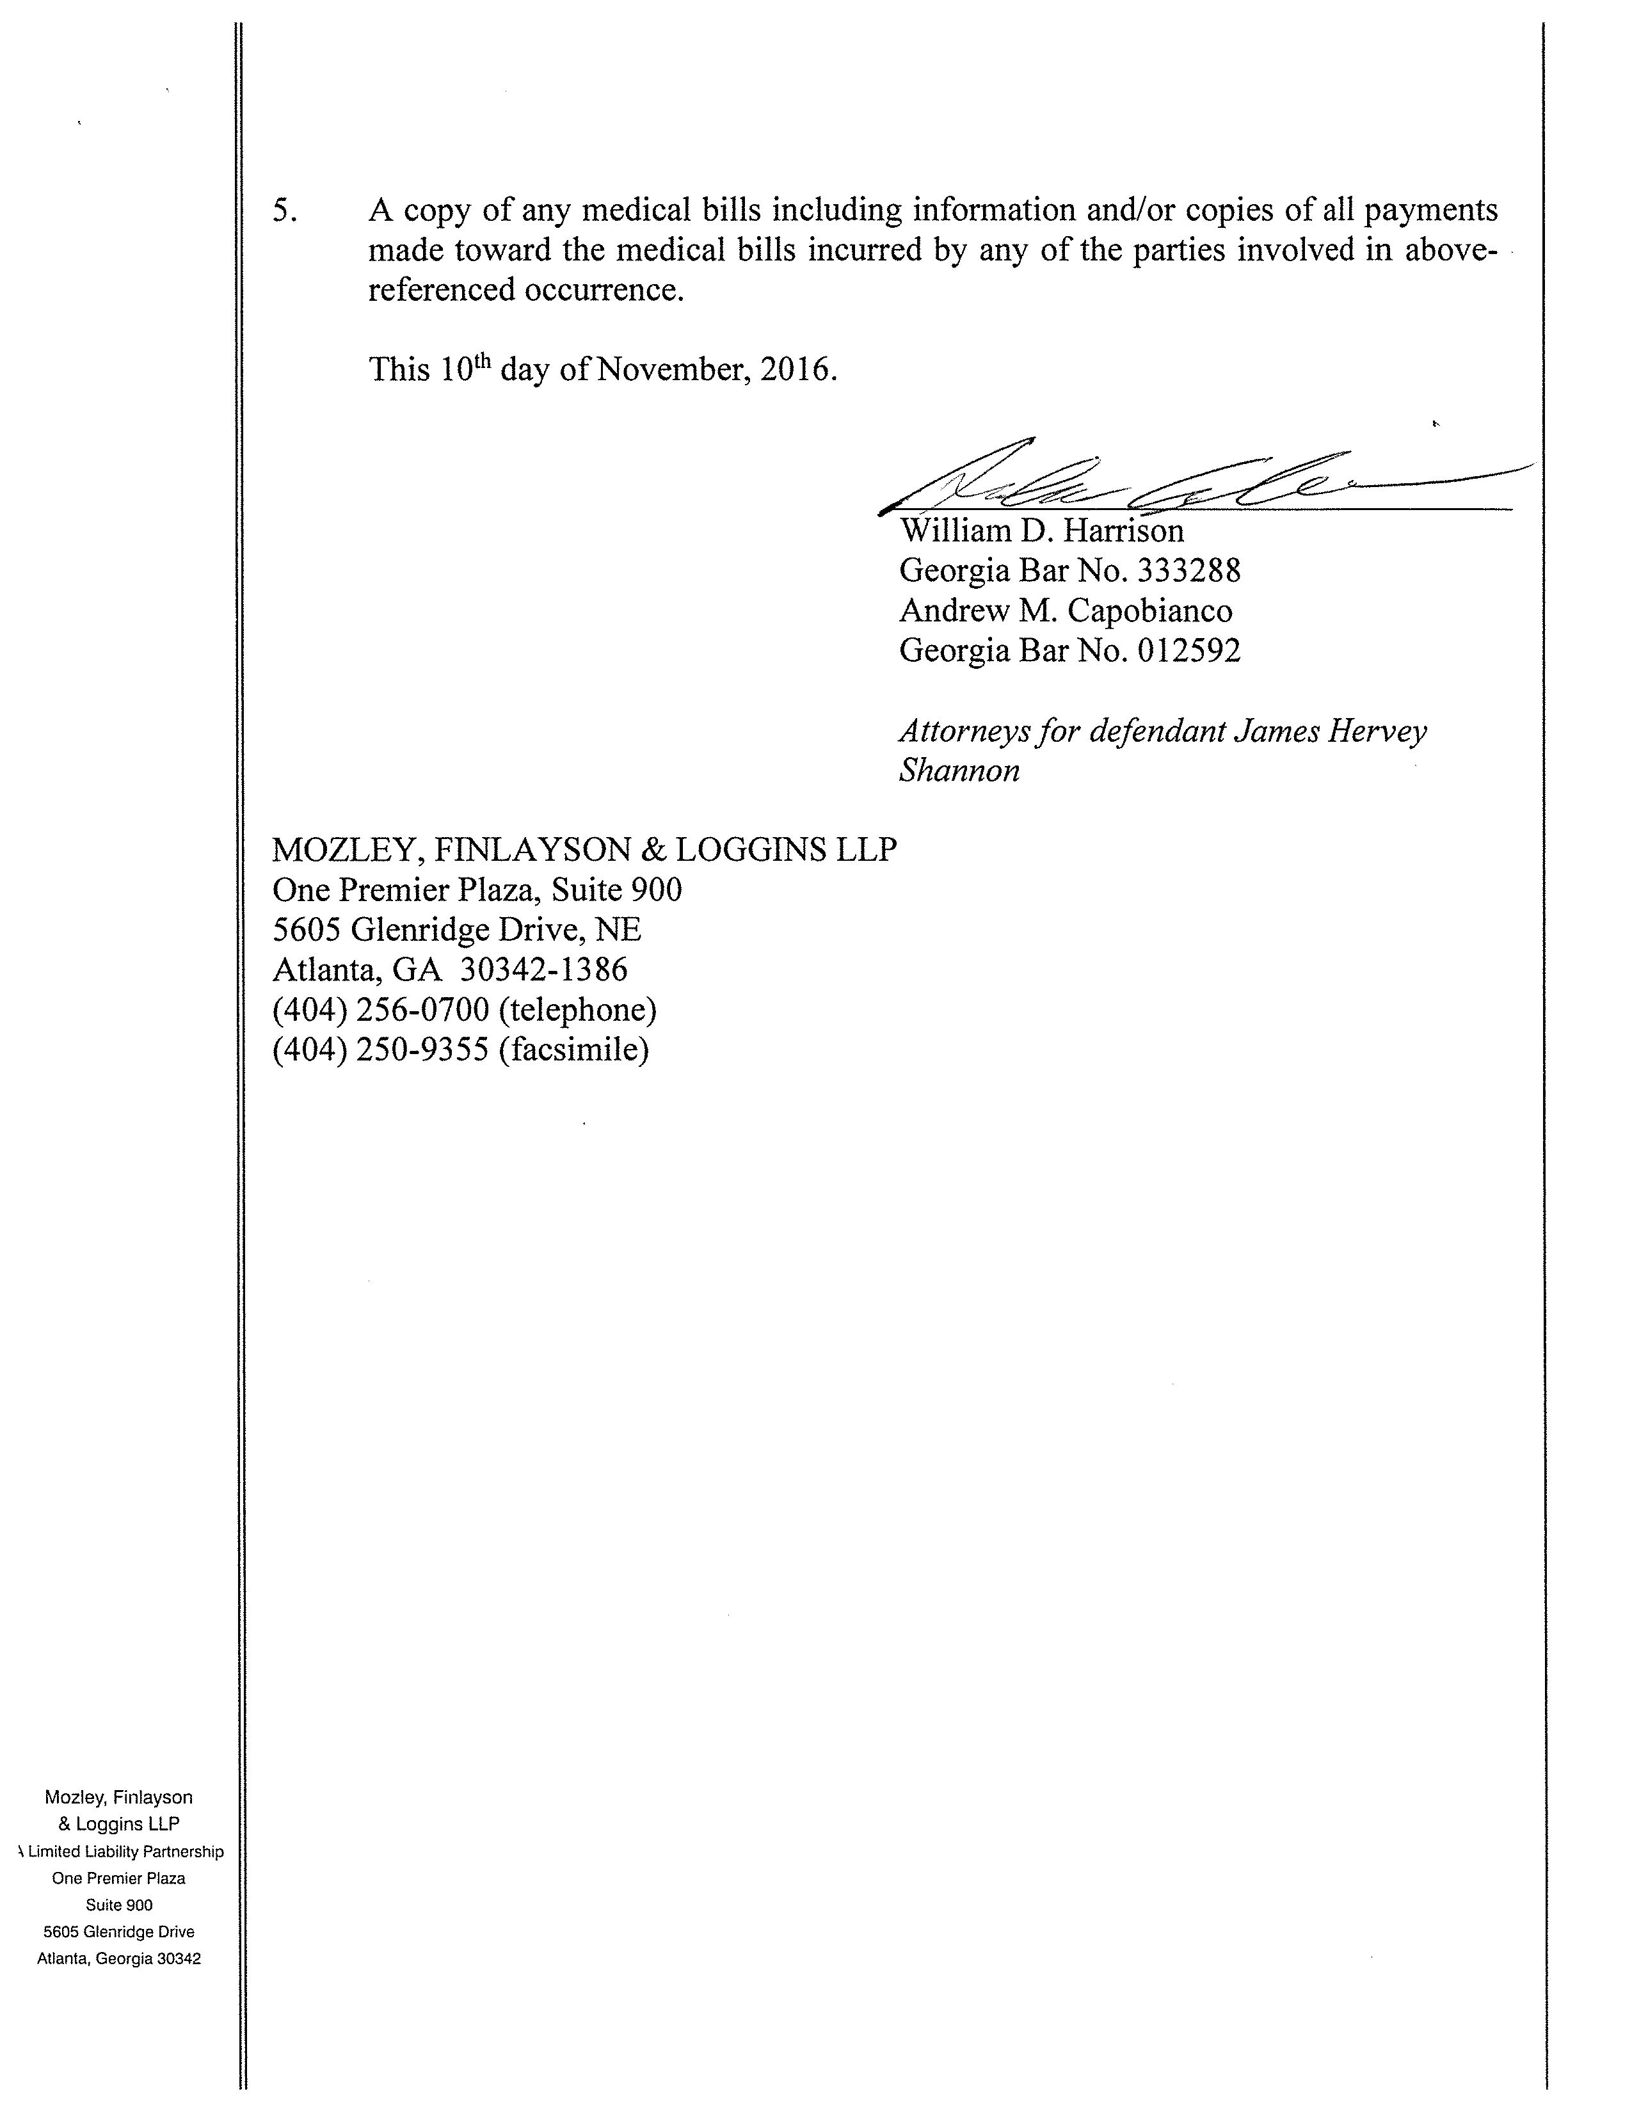

This ___ day of November, 2026
________________
John Doe
Georgia Bar No.

Attorney for defendant Josh Sanford
Smith and Jones PC
123 East Main Street
Anywhere, MI 12345
(123) 456-7890 (telephone)
(123) 456-7890 (facsimile)
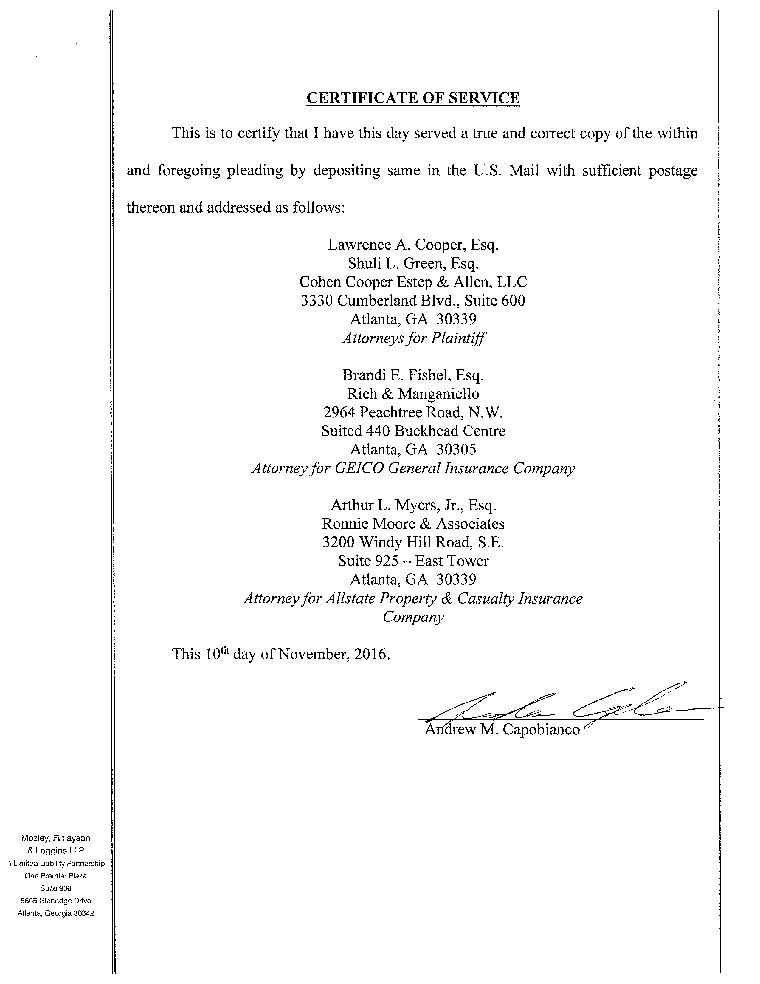
John Doe, Esquire
Georgia Bar No.
Attorney for defendant Josh Sanford
Smith and Jones PC
123 East Main Street
Anywhere, MI 12345
(123) 456-7890 (telephone)
(123) 456-7890 (facsimile)
Jack Zuk, Esq.
Axiom Requisition Copy Service
2869 Jolly Rd
Okemos, MI 48864-____
Attorney for Plaintiff(s)
This ___ day of November, 2026
______________

IN THE STATE COURT OF COUNTY
STATE OF GEORGIA
cIVil ACTION FILE
Batman,
no.: 99-99999

Plantiff,

vs.
Gotham City,

DEFENDANT.

AFFIDAVIT OF CUSTODIAN OF RECORDS AND CERTIFICATE OF AUTHENTICATION OF RECORD

THE UNDERSIGNED, _________________________, certifies that he/she is a custodian of records and is a person responsible for the keeping of the records of University of Michigan Hospital and Health Center, and the within and attached records are true and accurate copies of the records of Batman, which were maintained in the offices of the aforesaid University of Michigan Hospital and Health Center and the records were made at or near the time of the described acts, events, conditions, opinions, or diagnoses; were made by, or from information transmitted by, a person with personal knowledge and a business duty to report; were kept in the course of a regularly conducted business activity; and it was the regular practice of that business activity to make the memorandum, report, record, or data compilation. The within and attached records consisting of _____ pages and/or films, constitute the entire file of the materials requested.

The undersigned further states that the records accompanying this Affidavit are offered in connection with a request for said records from Smith and Jones PC, pursuant to O.C.G.A. § 9-11-34(c), and are certified pursuant to O.C.G.A. §§ 24-8-803(6) and 24-9-902(11)(12) in lieu of the personal appearance of the undersigned, and in connection with a case or proceedings entitled in the above listed case style or matter.

________________________________
Records Custodian
University of Michigan Hospital and Health Center

Sworn to and subscribed to before me
this _______ day of ______, 2018.

______________________________
Notary Public
My Commission Expires____________

