University of Michigan Hospital and Health Center Release of Information Unit
Dept. Release of Information Unit - NCAC
2901 Hubbard Street Room 2722
Ann Arbor, MI 48109-0000

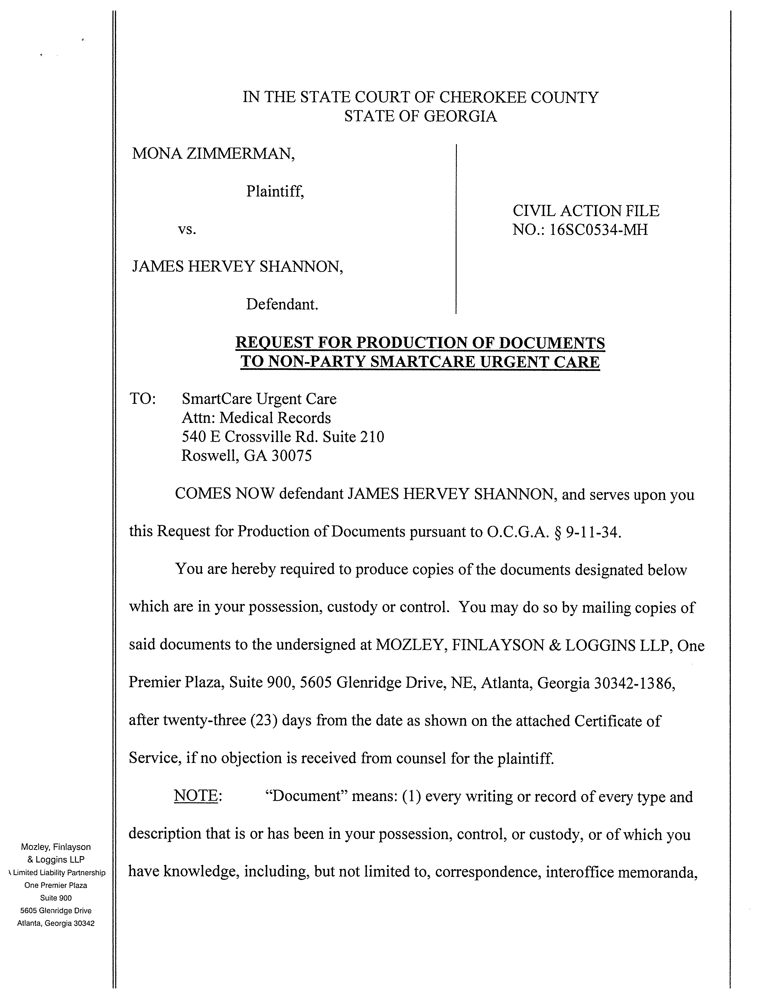
IN THE COURT OF COUNTY
STATE OF GEORGIA
Batman,
Gotham City,
99-99999
University of Michigan Hospital and Health Center Release of Information Unit
2901 Hubbard Street Room 2722
Ann Arbor, MI 48109-0000
COMES NOW defendant Josh Sanford, and serves upon you
this Request for Production of Documents pursuant to O.C.G.A. § 9-11-34.
You are hereby required to produce copies of the documents designated below
which are in your possession, custody or control. You may do so by mailing copies of
said documents to the undersigned at Axiom Requisition, 2869 Jolly RD, Okemos, MI
48864, after twenty-three (23) days from the date as shown on the attached Certificate of
Service, if no objection is received from counsel for the plaintiff.

REQUEST FOR PRODUCTION OF DOCUMENTS TO NON-PARTY
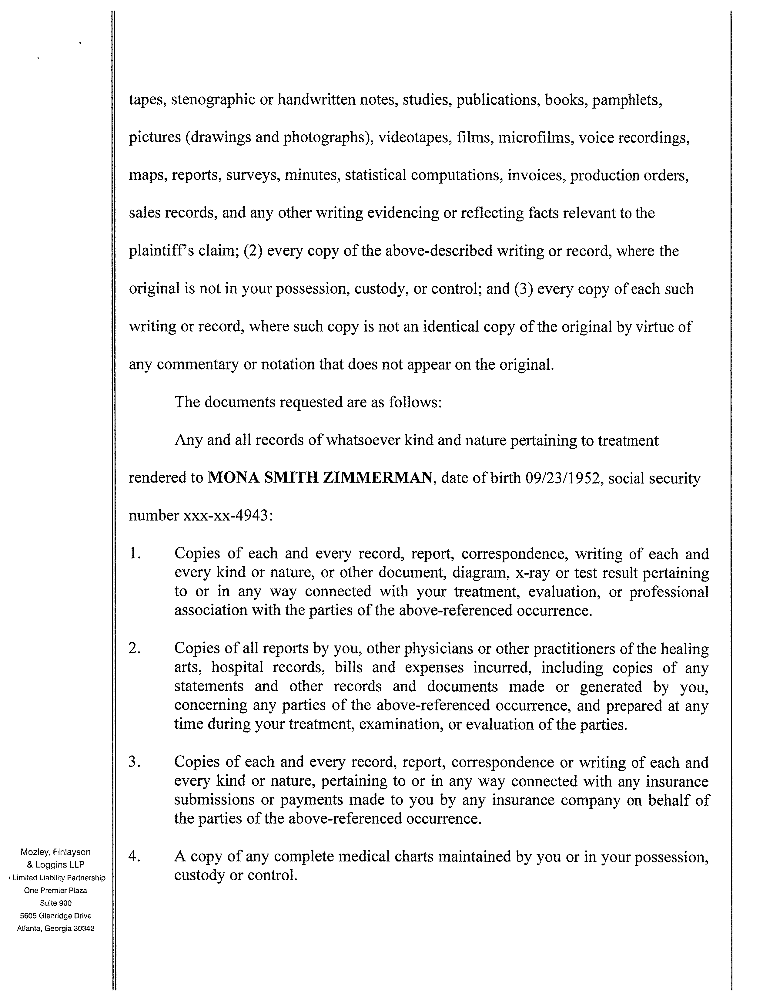
FROM 01/01/1979 TO PRESENT: Any and all MEDICAL RECORDS, including but not limited to patient history form(s), reports, etc. pertaining to Batman SSN: xxx-xx-5555, DOB: 01/01/1979.

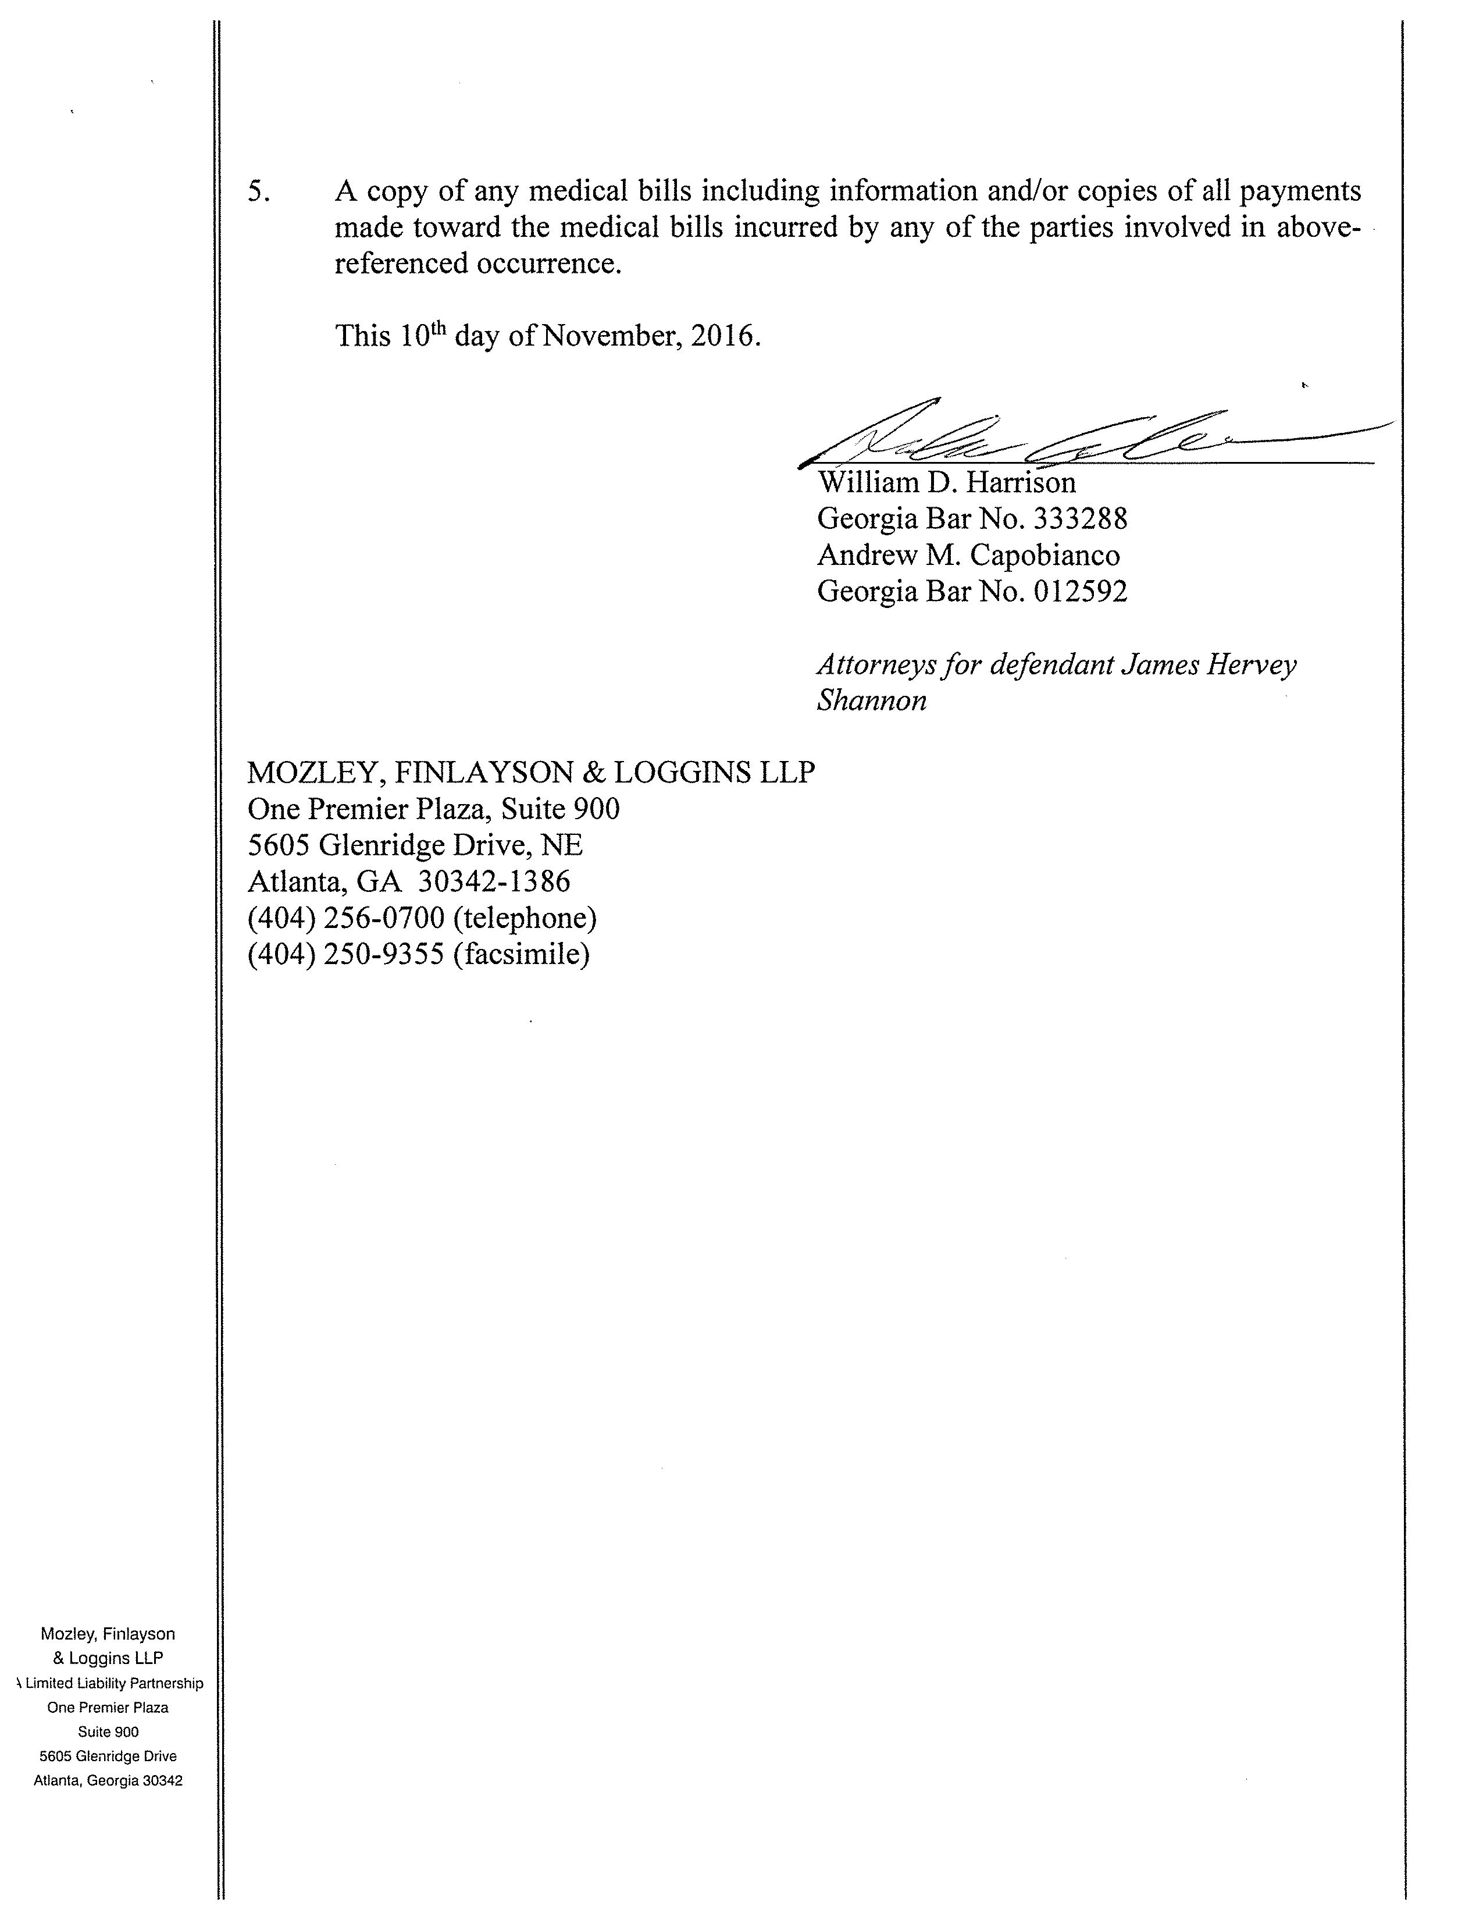

John Doe
John Doe
Georgia Bar No.

Attorney(s) for defendant Josh Sanford
Smith and Jones PC
123 East Main Street
Anywhere, MI 12345
(123) 456-7890 (telephone)
(123) 456-7890 (facsimile)
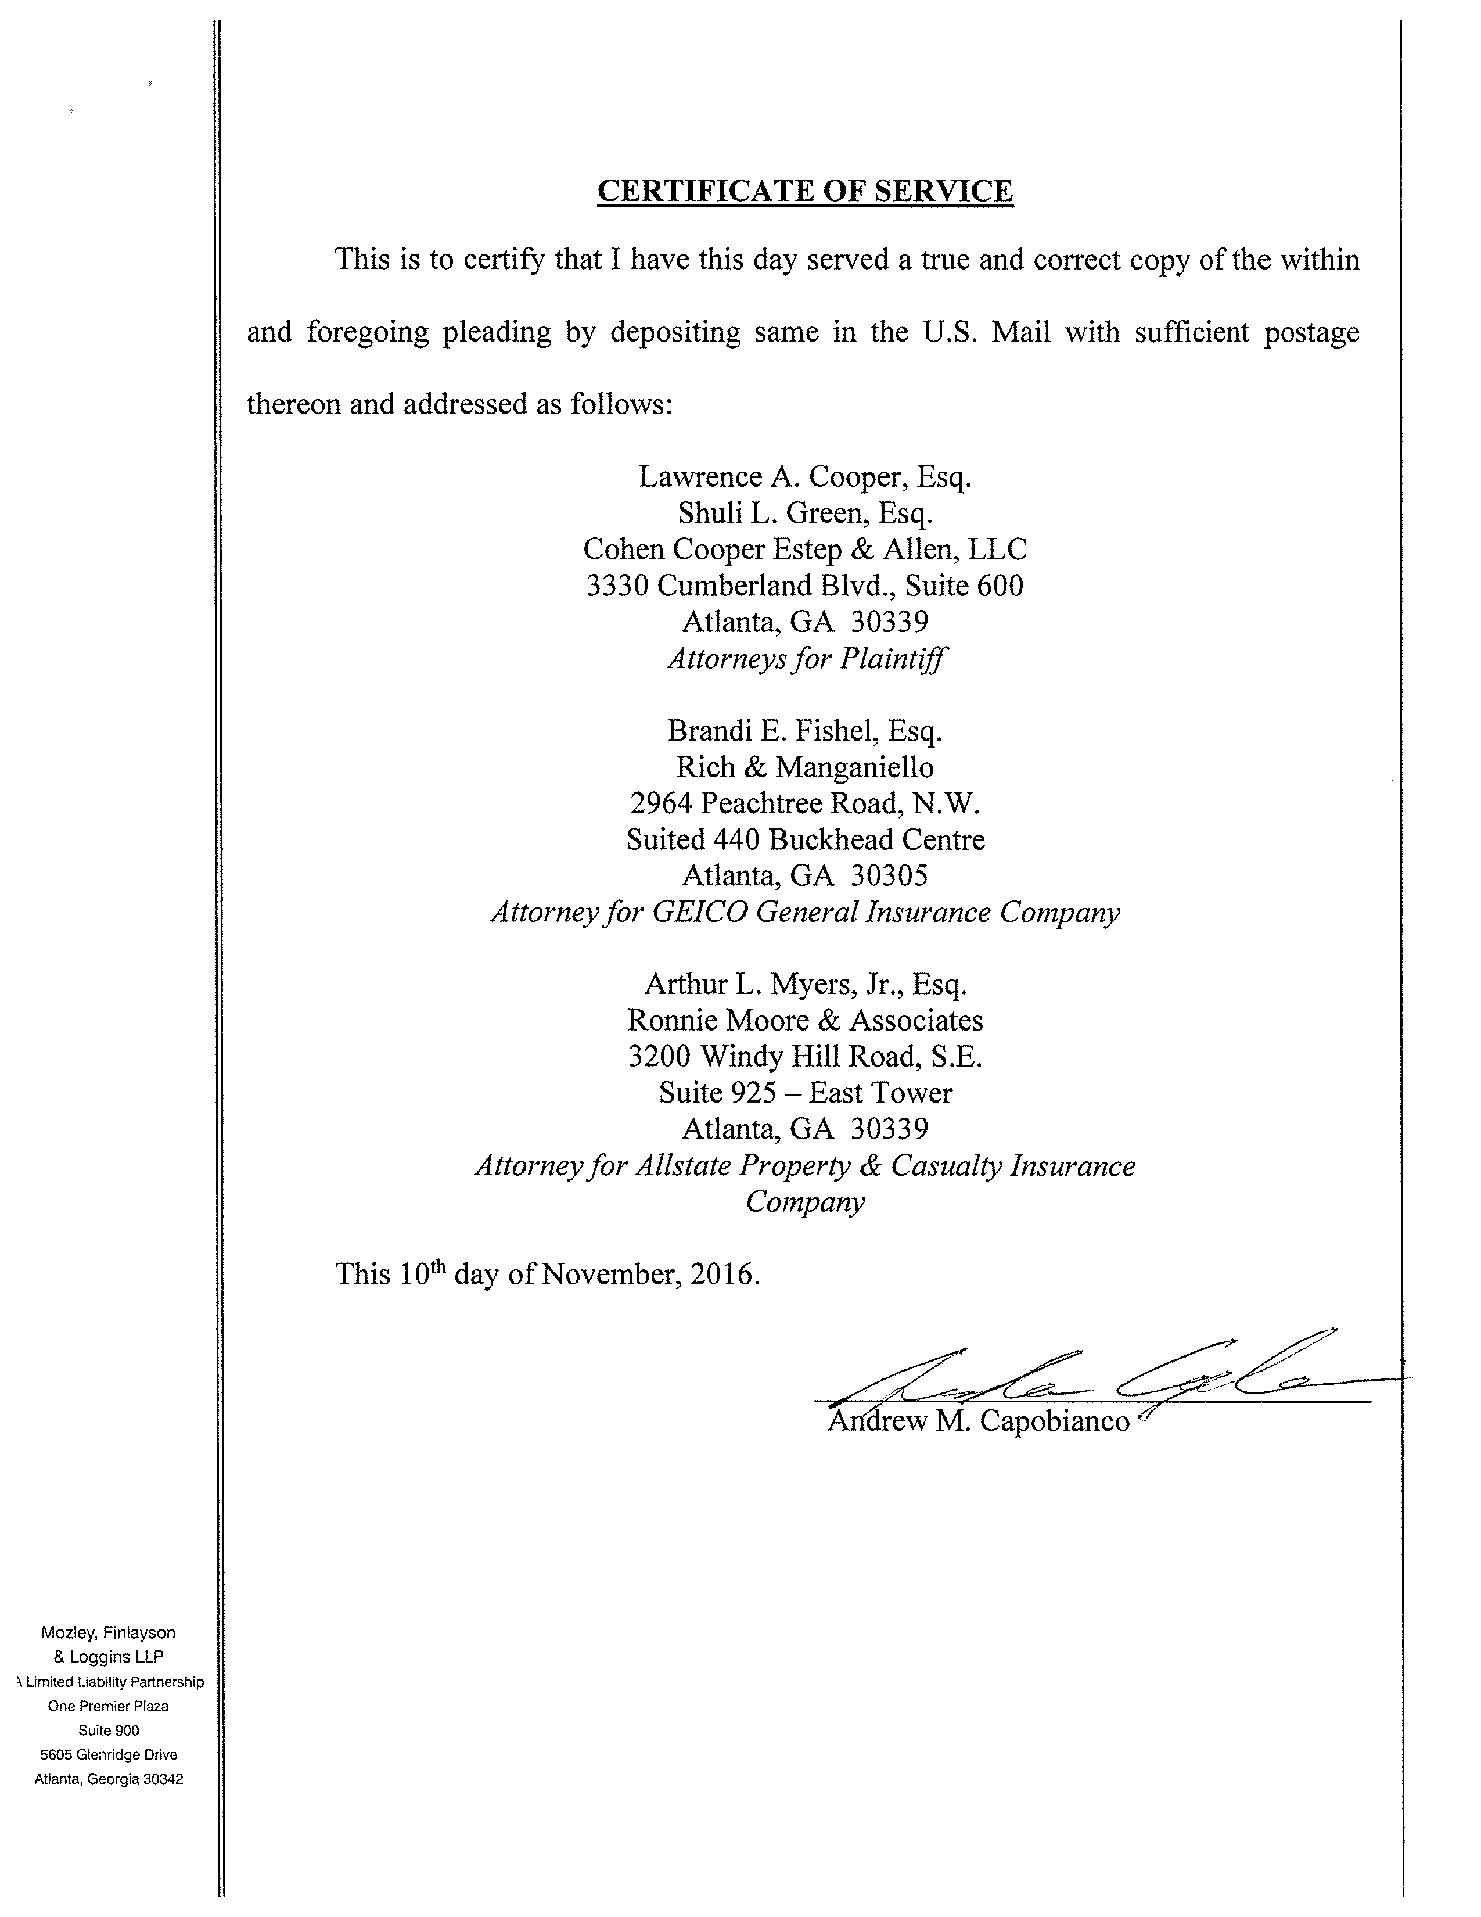
Jack Zuk, Esq.
Axiom Requisition Copy Service
2869 Jolly Rd
Okemos, MI 48864-____
Attorney for Plaintiff(s)
John Doe
John Doe, Esquire

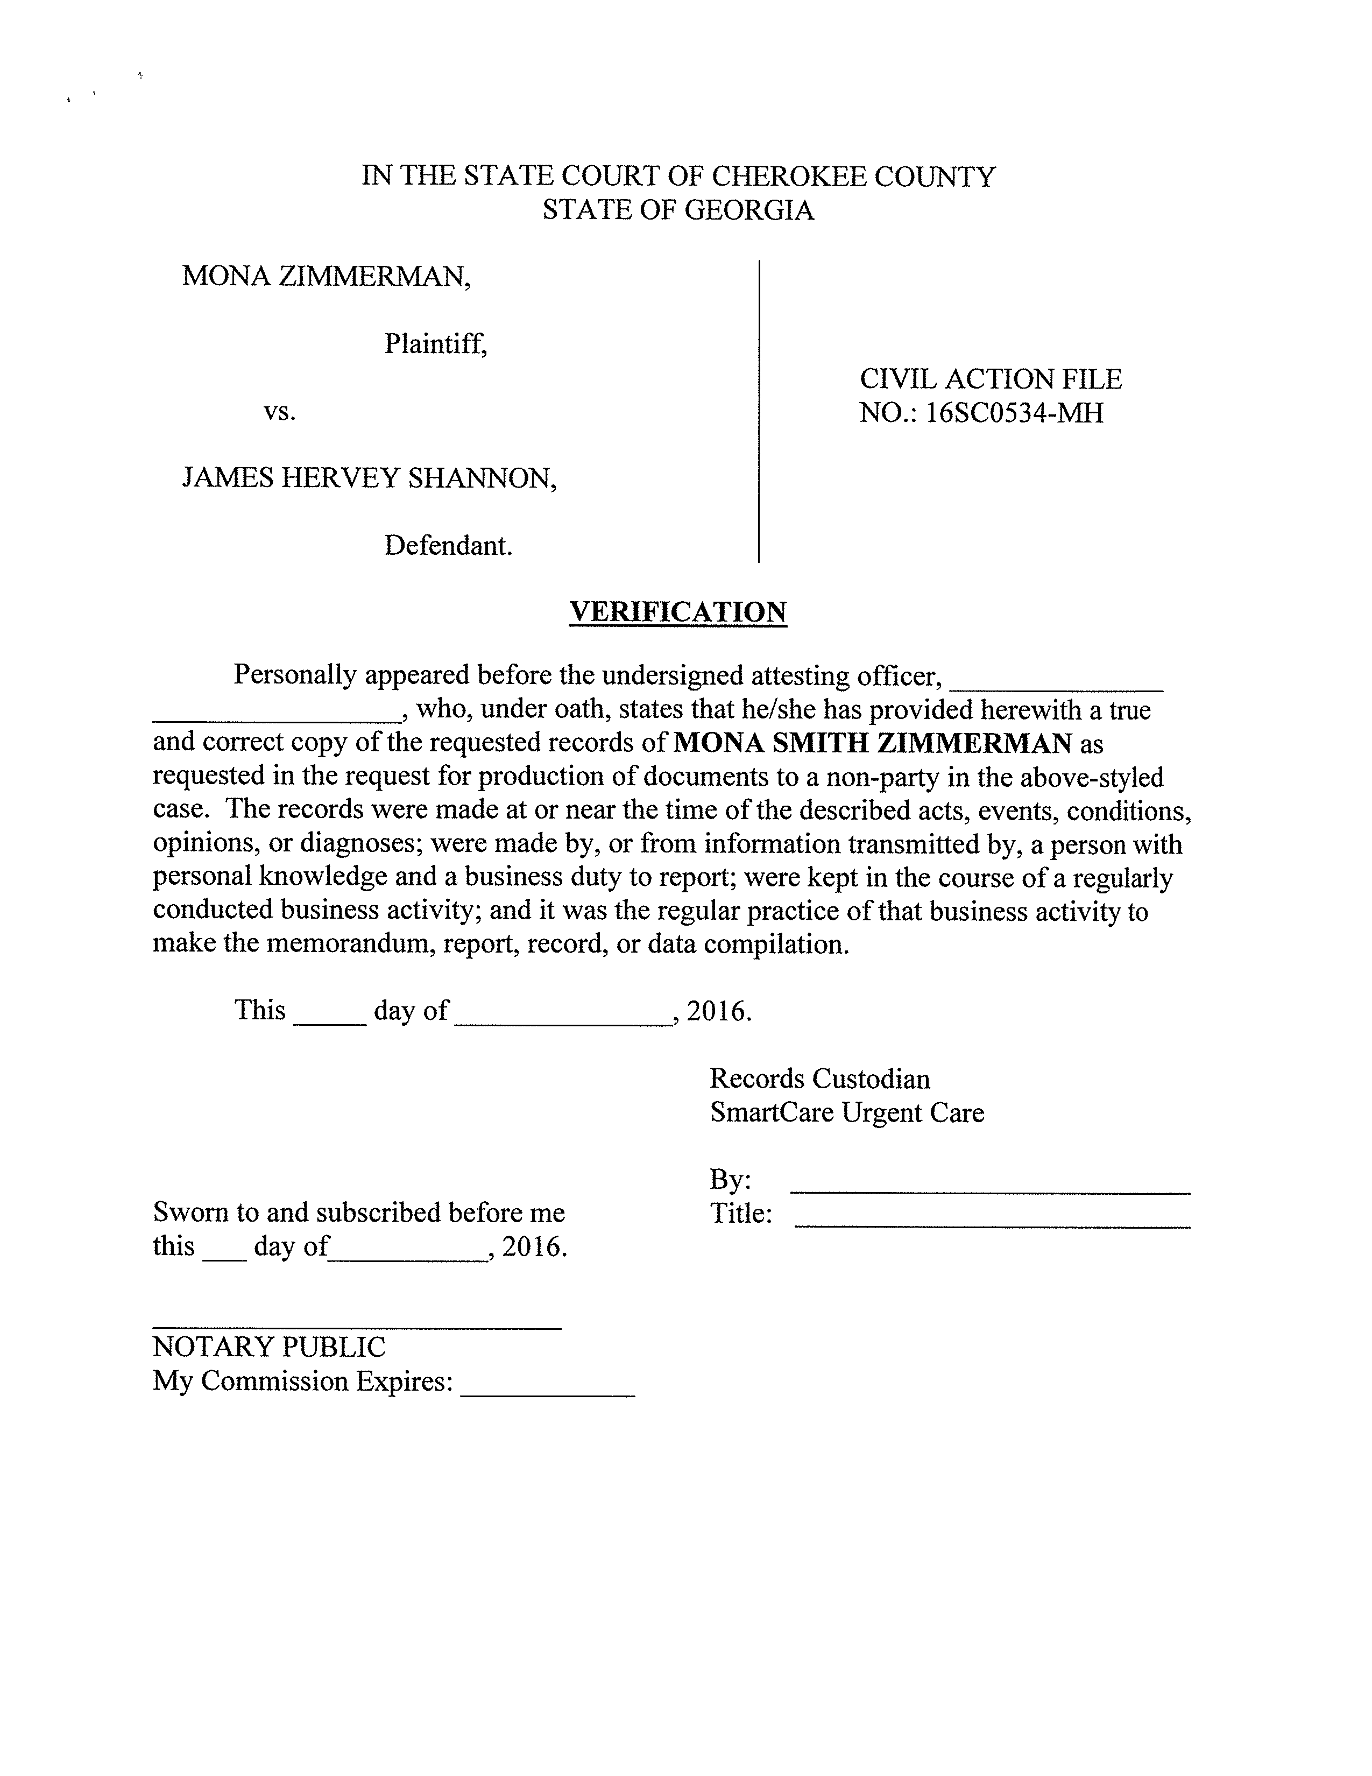
IN THE STATE COURT OF COUNTY
STATE OF GEORGIA
Batman,
Gotham City,
99-99999
Personally appeared before the undersigned attesting officer,_______________
__________________, who, under oath, states that he/she has provided herewith a true
and correct copy of the requested records of Batman as requested in the request for production of documents to a non-party in the above-styled case. The records were made at or near the time of the described acts, events, conditions, opinions, or diagnoses; were made by, or from information transmitted by, a person with personal knowledge and a business duty to report; were kept in the course of a regularly conducted business activity; and it was the regular practice of that business activity to make the memorandum, report, record, or data compilation.
2026.
2026.
University of Michigan Hospital and Health Center

