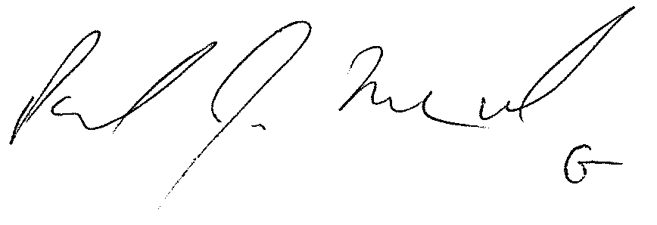
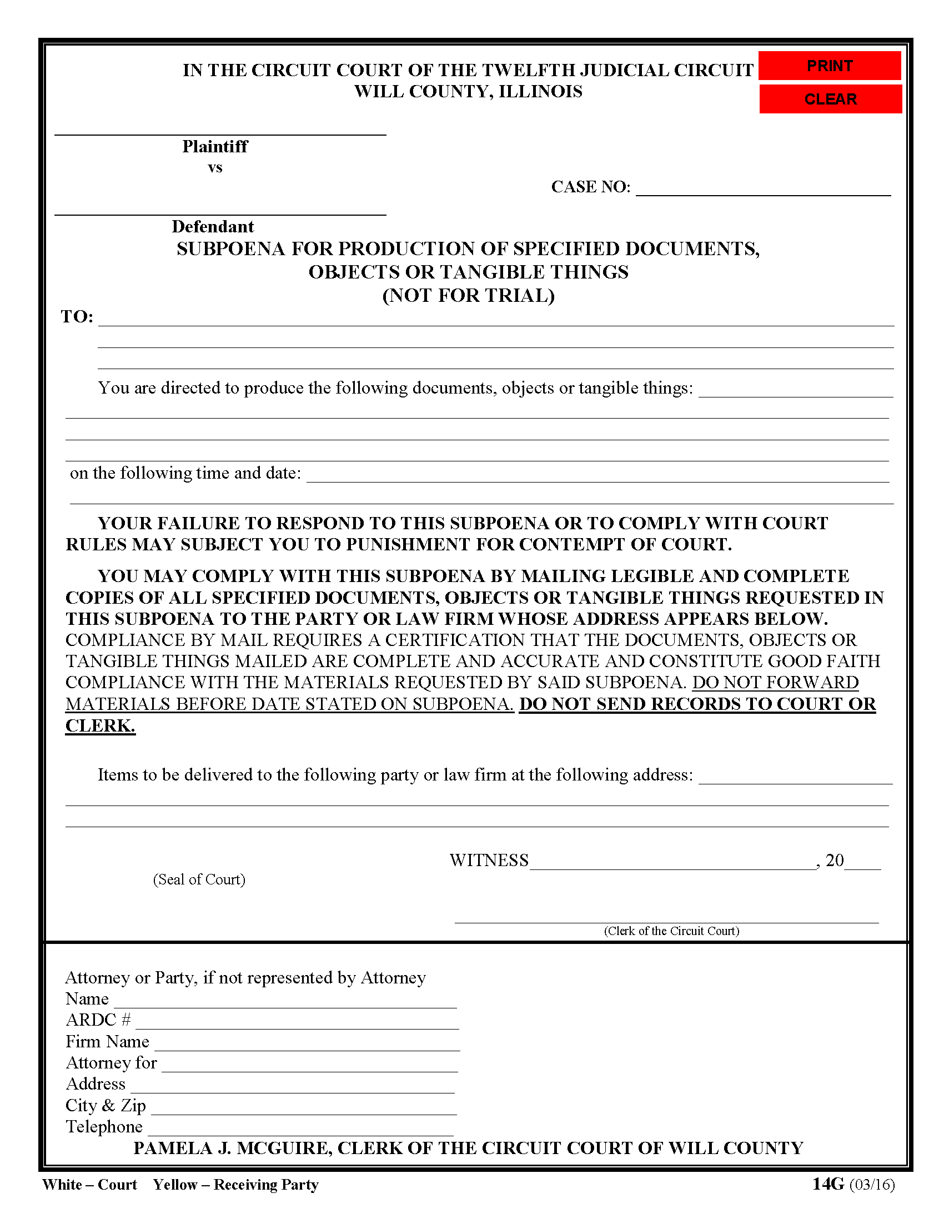
Batman
Gotham City
99-99999
University of Michigan Hospital and Health Center Release of Information Unit
2901 Hubbard Street Room 2722
Ann Arbor, MI 48109-0000
Axiom Requisition Copy Service

2869 Jolly Road Okemos, MI 48864

Smith and Jones PC
123 East Main Street
Josh Sanford
Anywhere, MI 12345
(123) 456-7890
FROM 01/01/1979 TO PRESENT: Any and all MEDICAL RECORDS, including but not limited to patient history form(s), reports, etc. pertaining to Batman SSN: xxx-xx-5555, DOB: 01/01/1979.

John Doe

