University of Michigan Hospital and Health Center Release of Information Unit
2901 Hubbard Street Room 2722
Ann Arbor, MI 48109-0000
Order No: 01-29018-002
IN THE COUNTY COURT
CAUSE NO. 99-99999
Batman

Plaintiff(s),

vs.

Gotham City

Defendant(s).

FROM 01/01/1979 TO PRESENT: Any and all MEDICAL RECORDS, including but not limited to patient history form(s), reports, etc. pertaining to Batman SSN: xxx-xx-5555, DOB: 01/01/1979.
The manner and means of making the request for production and inspection shall be by sending Defendant(s) counsel, John Doe, c/o Axiom Requisition, 2869 Jolly Rd., Okemos, MI 48864 a true copy of the items requested. In addition, if deemed necessary by Defendant(s)’ counsel, said counsel may thereafter inspect the original copy of each of said documents at you place of business.
STATE OF INDIANA

COUNTY OF
)
) SS:
)
REQUEST FOR PRODUCTION
OF DOCUMENTS BY NON-PARTIES
YOU ARE HEREBY REQUESTED to produce and permit Defendant(s) through

their attorney, to inspect and copy the following documents:
TO:
)
)
)
)
)
)
)
)
)
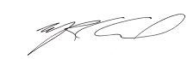
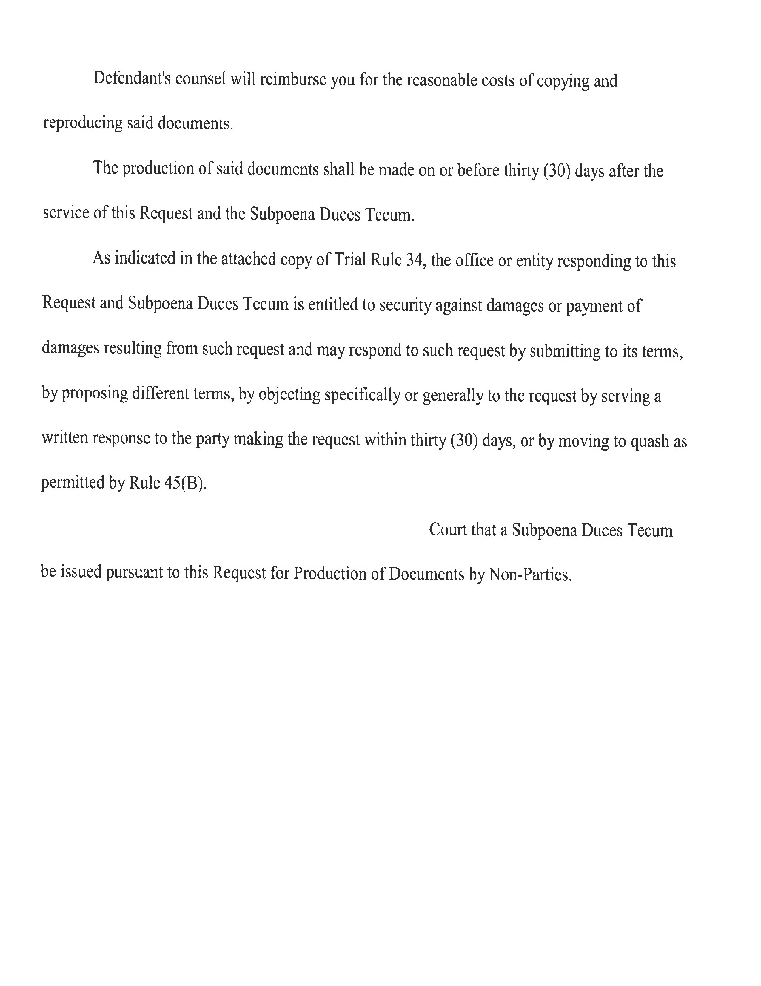
Defendant’s counsel will reimburse you for the reasonable costs of copying and reproducing said documents.
The production of said documents shall be made on or before thirty (30) days after the service of this Request and the Subpoena Duces Tecum.
As indicated in the attached copy of Trial Rule 34, the office or entity responding to this Request and Subpoena Duces Tecum is entitled to security against damages or payment of damages resulting from such request and may respond to such request by submitting to its terms, by proposing different terms, by objecting specifically or generally to the request by serving a written response to the party making the request within thirty (30) days, or by moving to quash as permitted by Rule 45(B).
Demand is made upon the clerk of County Court that a subpoena Duces Tecum be issued pursuant to this Request for Production of Documents by Non-Parties.
Smith and Jones PC

By __________________
Mark Correll
123 East Main Street,
Anywhere, MI 12345
Telephone: (123) 456-7890
Order No: 01-29018-002
Smith and Jones PC

By _______________________
Mark Correll
123 East Main Street,
Anywhere, MI 12345
Telephone: (123) 456-7890
IN THE COUNTY COURT
Batman

Plaintiff(s),

vs.

Gotham City

Defendant(s).

University of Michigan Hospital and Health Center Release of Information Unit
2901 Hubbard Street Room 2722
Ann Arbor, MI 48109-0000
FROM 01/01/1979 TO PRESENT: Any and all MEDICAL RECORDS, including but not limited to patient history form(s), reports, etc. pertaining to Batman SSN: xxx-xx-5555, DOB: 01/01/1979.
CAUSE NO. 99-99999
SUBPOENA DUCES TECUM
Order No: 01-29018-002
)
) SS:
)
TO:
YOU ARE HEREBY COMMANDED to produce:
dated:
Respectively submitted,
STATE OF INDIANA

COUNTY OF
)
)
)
)
)
)
)
)
)
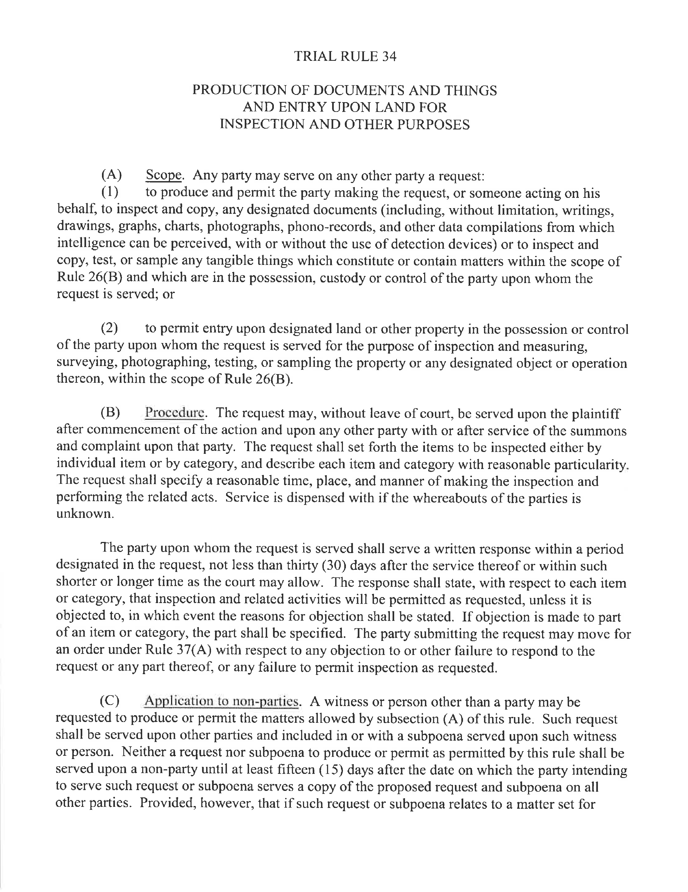

IN THE CIRCUIT COURT
99-99999
Batman
Plaintiff,

vs.

Gotham City
Defendant,

University of Michigan Hospital and Health Center Release of Information Unit
2901 Hubbard Street Room 2722
Ann Arbor, MI 48109-0000
FROM 01/01/1979 TO PRESENT: Any and all MEDICAL RECORDS, including but not limited to patient history form(s), reports, etc. pertaining to Batman SSN: xxx-xx-5555, DOB: 01/01/1979.
May 13, 2016
Order No: 01-29018-002
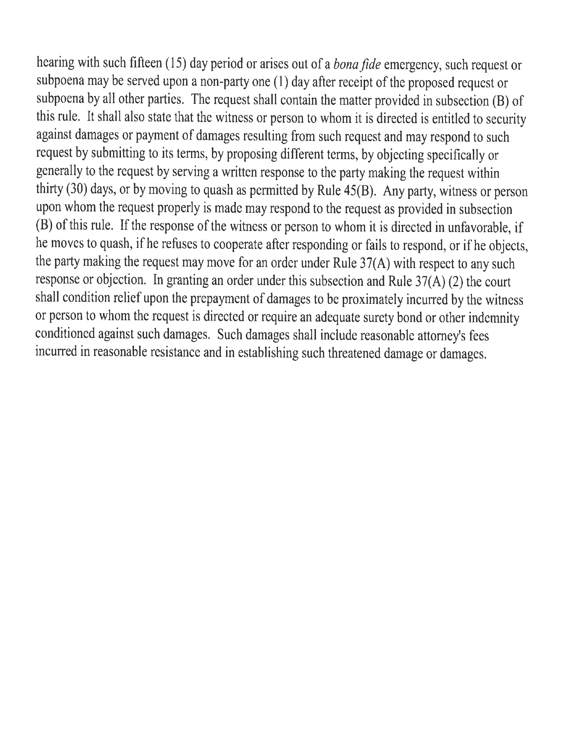
Order No: 01-29018-002

