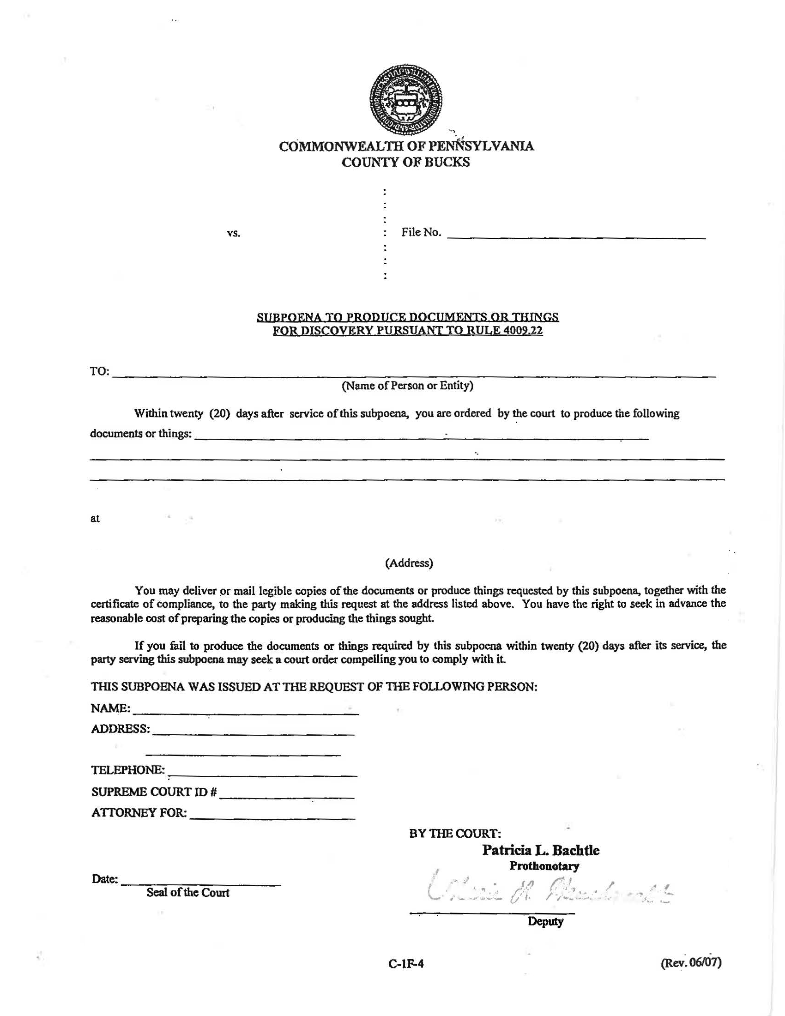
99-99999
Batman
Gotham City
University of Michigan Hospital and Health Center

FROM 01/01/1979 TO PRESENT: Any and all MEDICAL RECORDS, including but not limited to patient history form(s), reports, etc. pertaining to Batman SSN: xxx-xx-5555, DOB: 01/01/1979.
Axiom Requisition Copy Service 2869 Jolly Road, Okemos, MI 48864
On behalf of John Doe, Esquire
John Doe
123 East Main Street
Anywhere, MI 12345
Order Number: 01-29018-002
(123) 456-7890

Gotham City
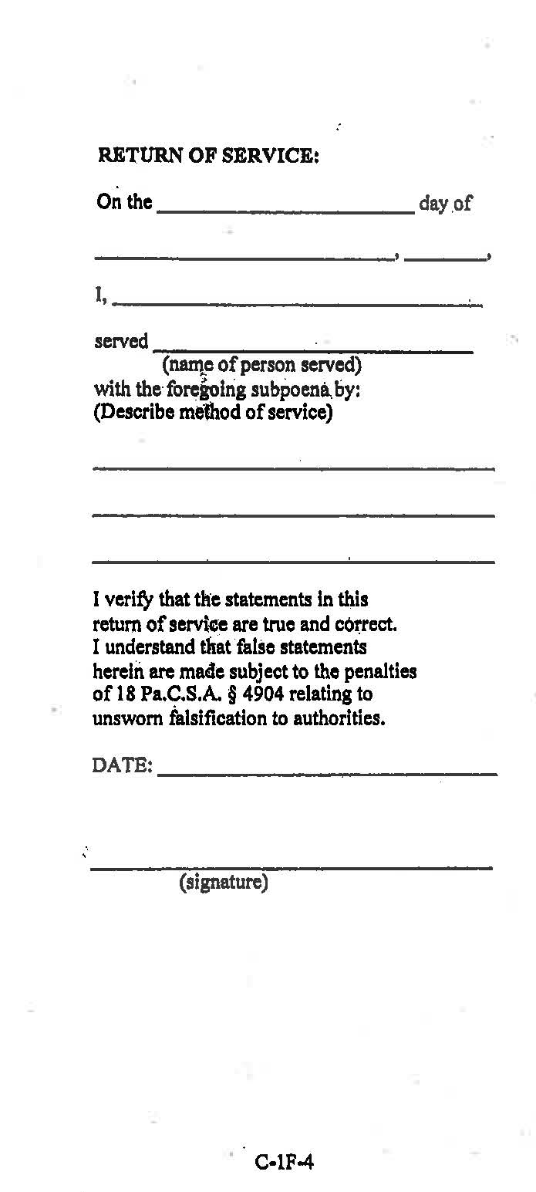

Order Number: 01-29018-002

