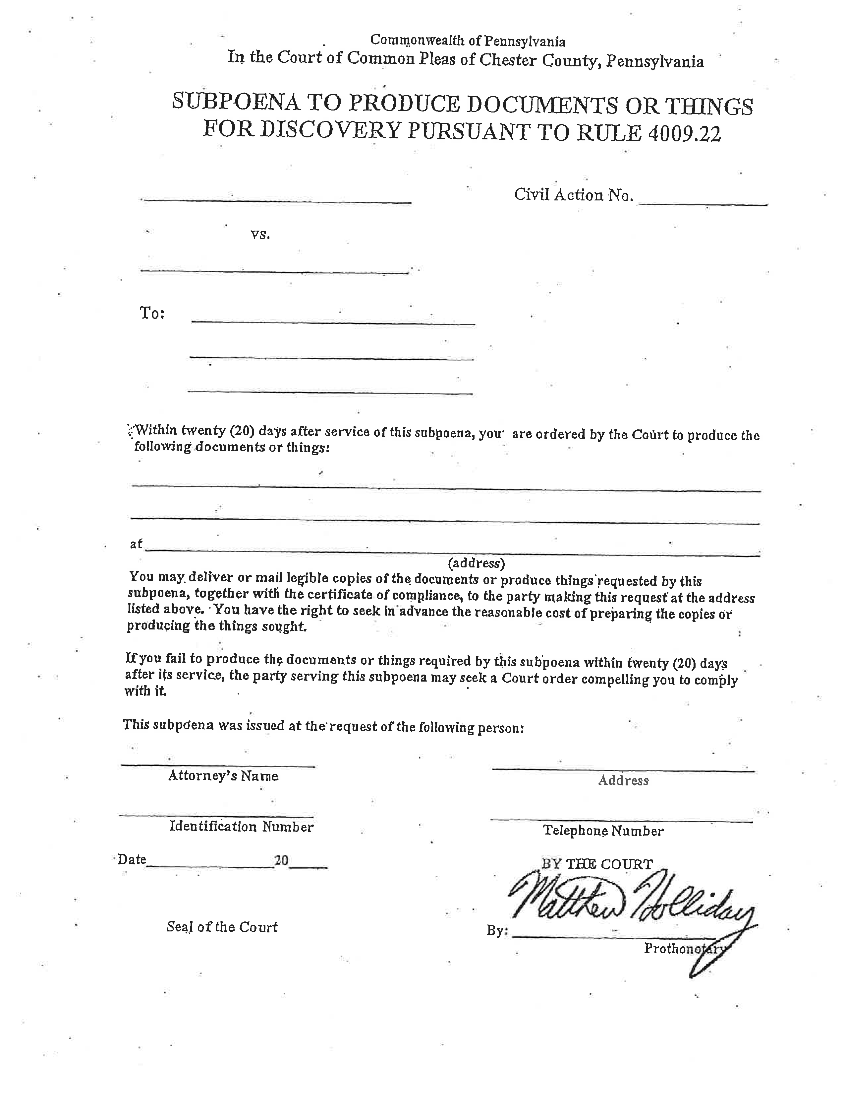
Batman
Plaintiff(s)

Gotham City
Defendant(s)

99-99999
University of Michigan Hospital and Health Center

2901 Hubbard Street Room 2722

Ann Arbor, MI 48109-0000
See Attached Addendum
Axiom Requisition Copy Service - 2869 Jolly Road Okemos, MI 48864 (877) 886-5090
John Doe, Esquire
123 East Main Street Anywhere, MI 12345

(123) 456-7890

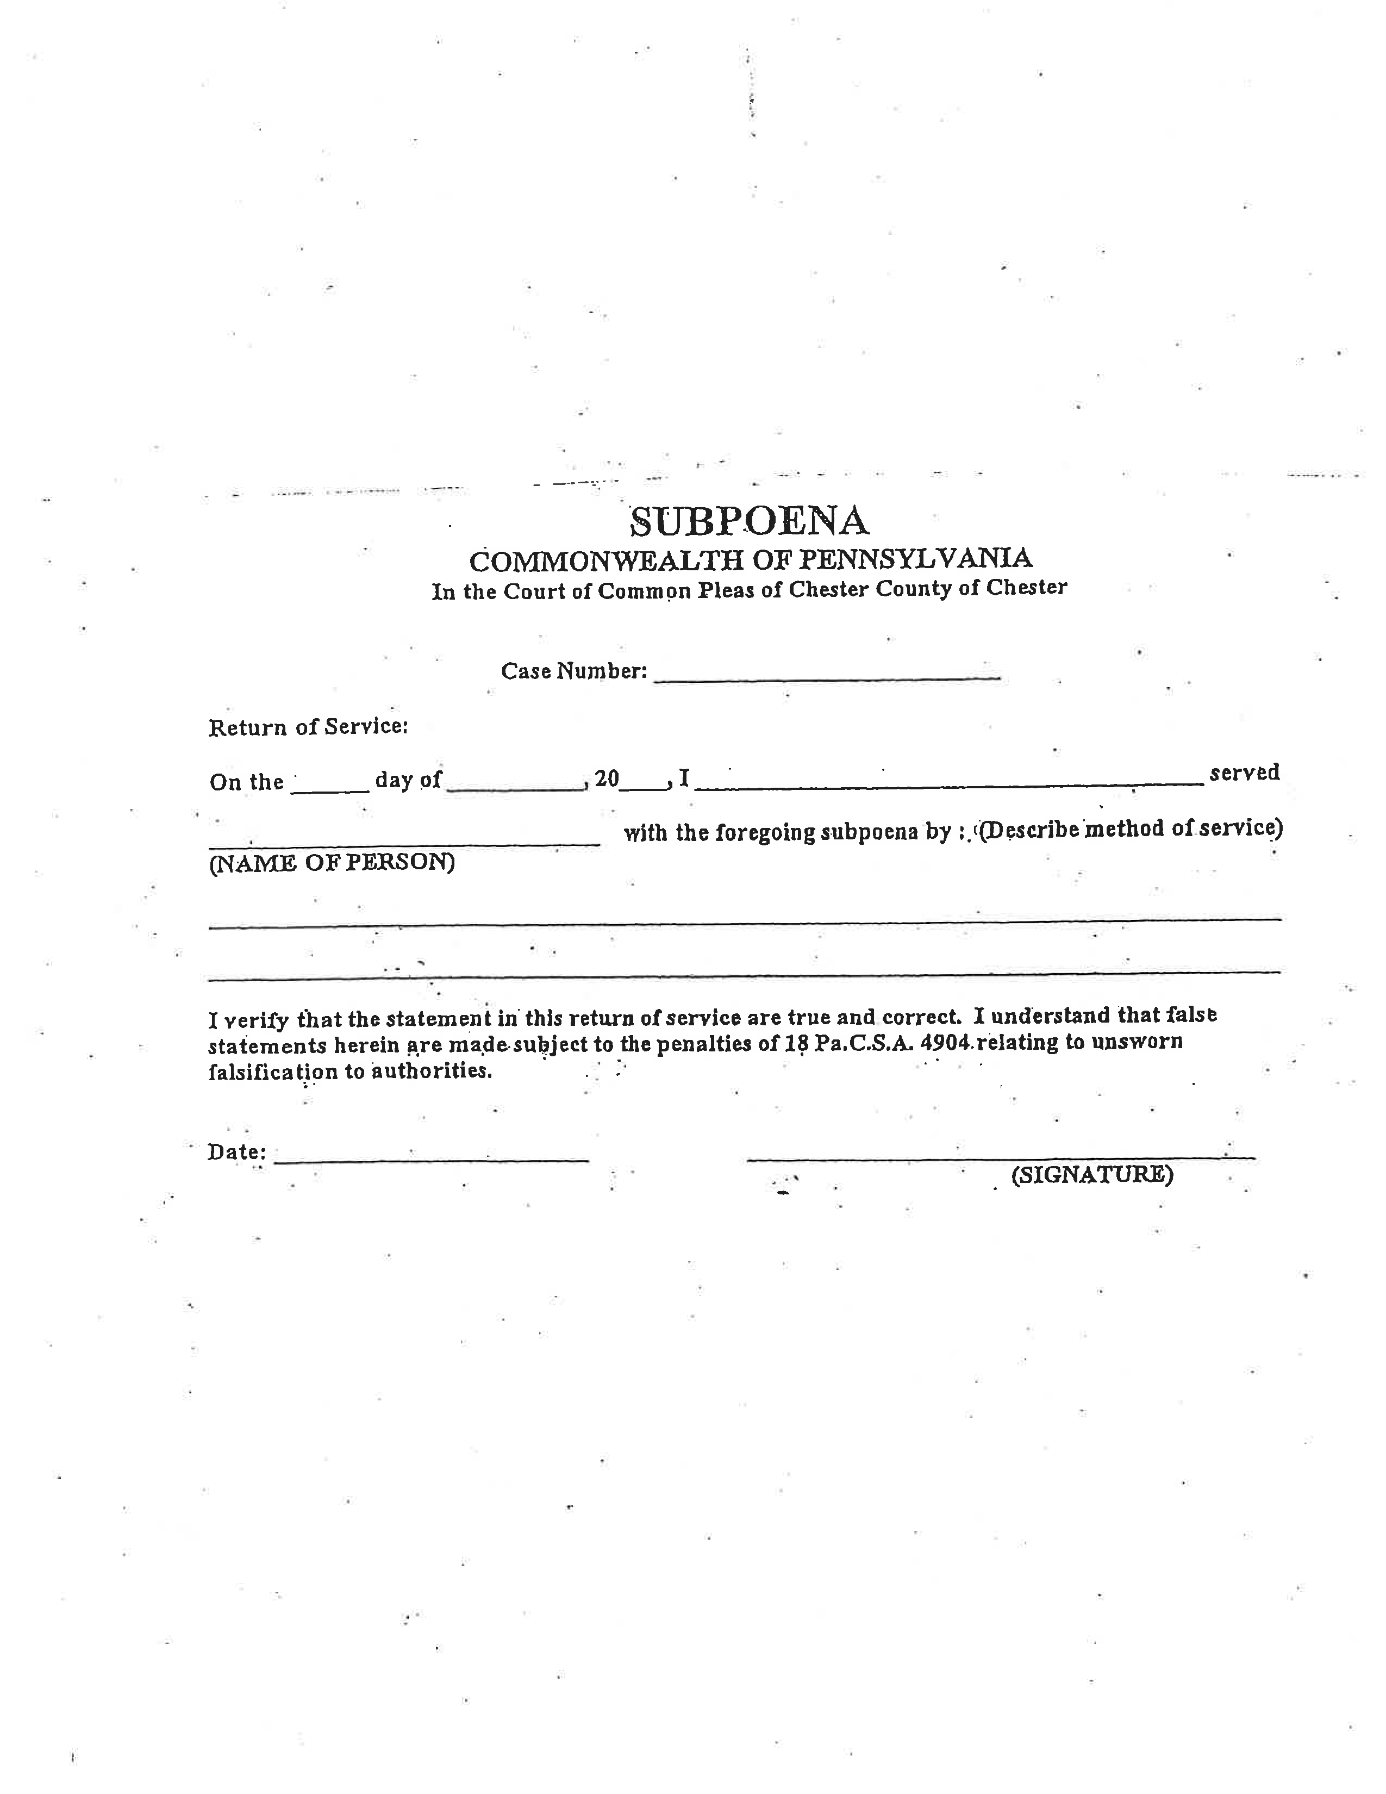
99-99999

Addendum to Subpoena

FROM 01/01/1979 TO PRESENT: Any and all MEDICAL RECORDS, including but not limited to patient history form(s), reports, etc. pertaining to Batman SSN: xxx-xx-5555, DOB: 01/01/1979.

