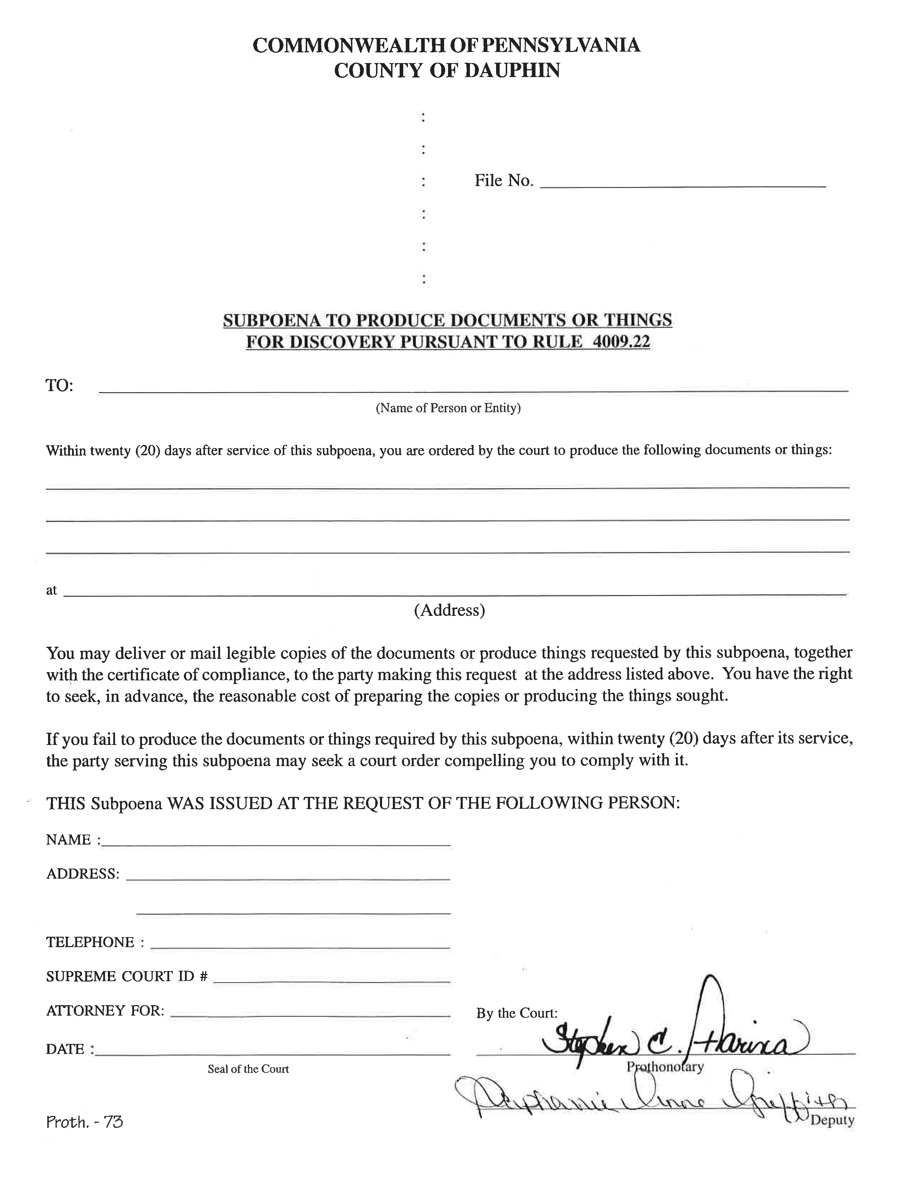

99-99999
University of Michigan Hospital and Health Center
Axiom Requisition Copy Service 2869 Jolly Road Okemos, MI 48864 PH: (877) 886-5090 Fax: (517) 886-4116
John Doe
123 East Main Street
Anywhere, MI 12345

Batman
Plaintiff(s)

vs.

Gotham City
Defendant(s)
(123) 456-7890
See Attached Addendum
Josh Sanford

ADDENDUM TO SUBPOENA

FROM 01/01/1979 TO PRESENT: Any and all MEDICAL RECORDS, including but not limited to patient history form(s), reports, etc. pertaining to Batman SSN: xxx-xx-5555, DOB: 01/01/1979.

