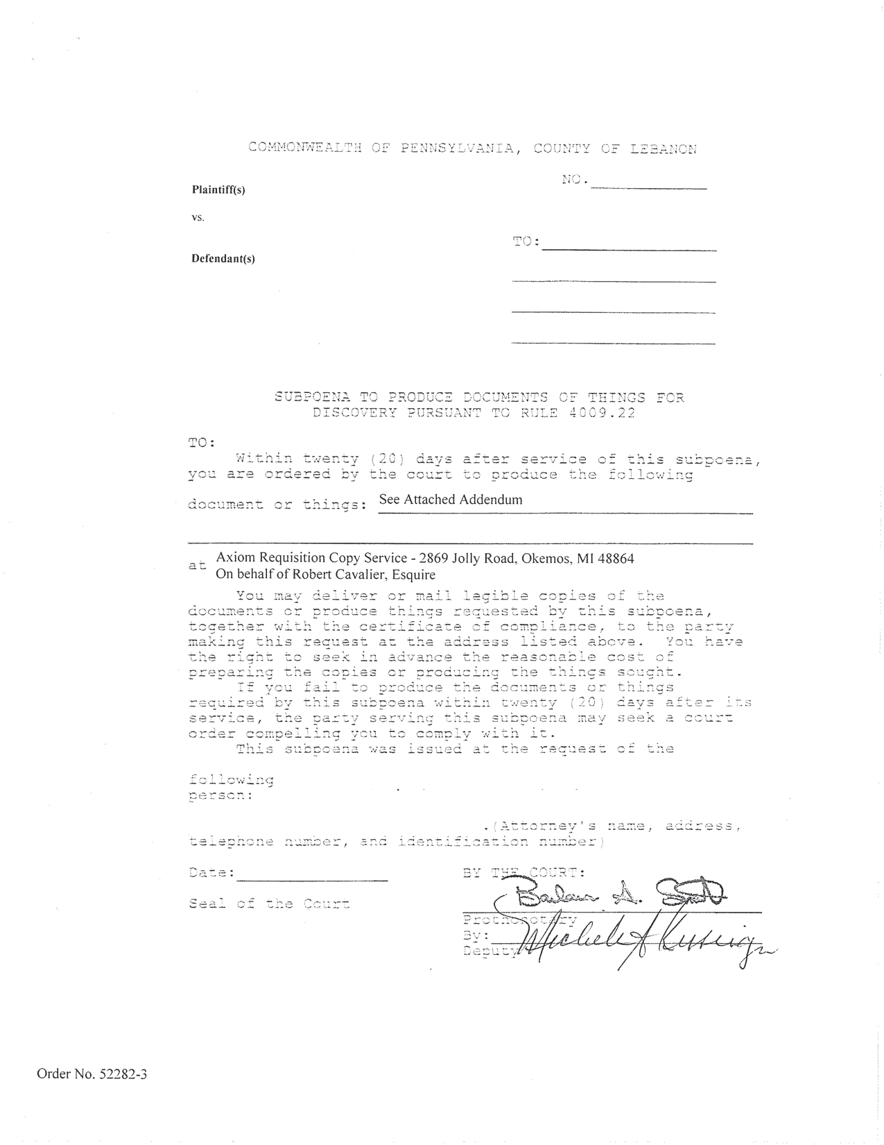
University of Michigan Hospital and Health Center
Axiom Requisition Copy Service - 2869 Jolly Road, Okemos, MI 48864
On behalf of John Doe, Esquire
John Doe, Esquire, Smith and Jones PC,
123 East Main Street , Anywhere, MI 12345
Order No. 01-29018-002
Batman
Plaintiff(s)

vs.

Gotham City
Defendant(s)
University of Michigan Hospital and Health Center
99-99999
2901 Hubbard Street Room 2722
Ann Arbor, MI 48109-0000
See Attached Addendum
(123) 456-7890,

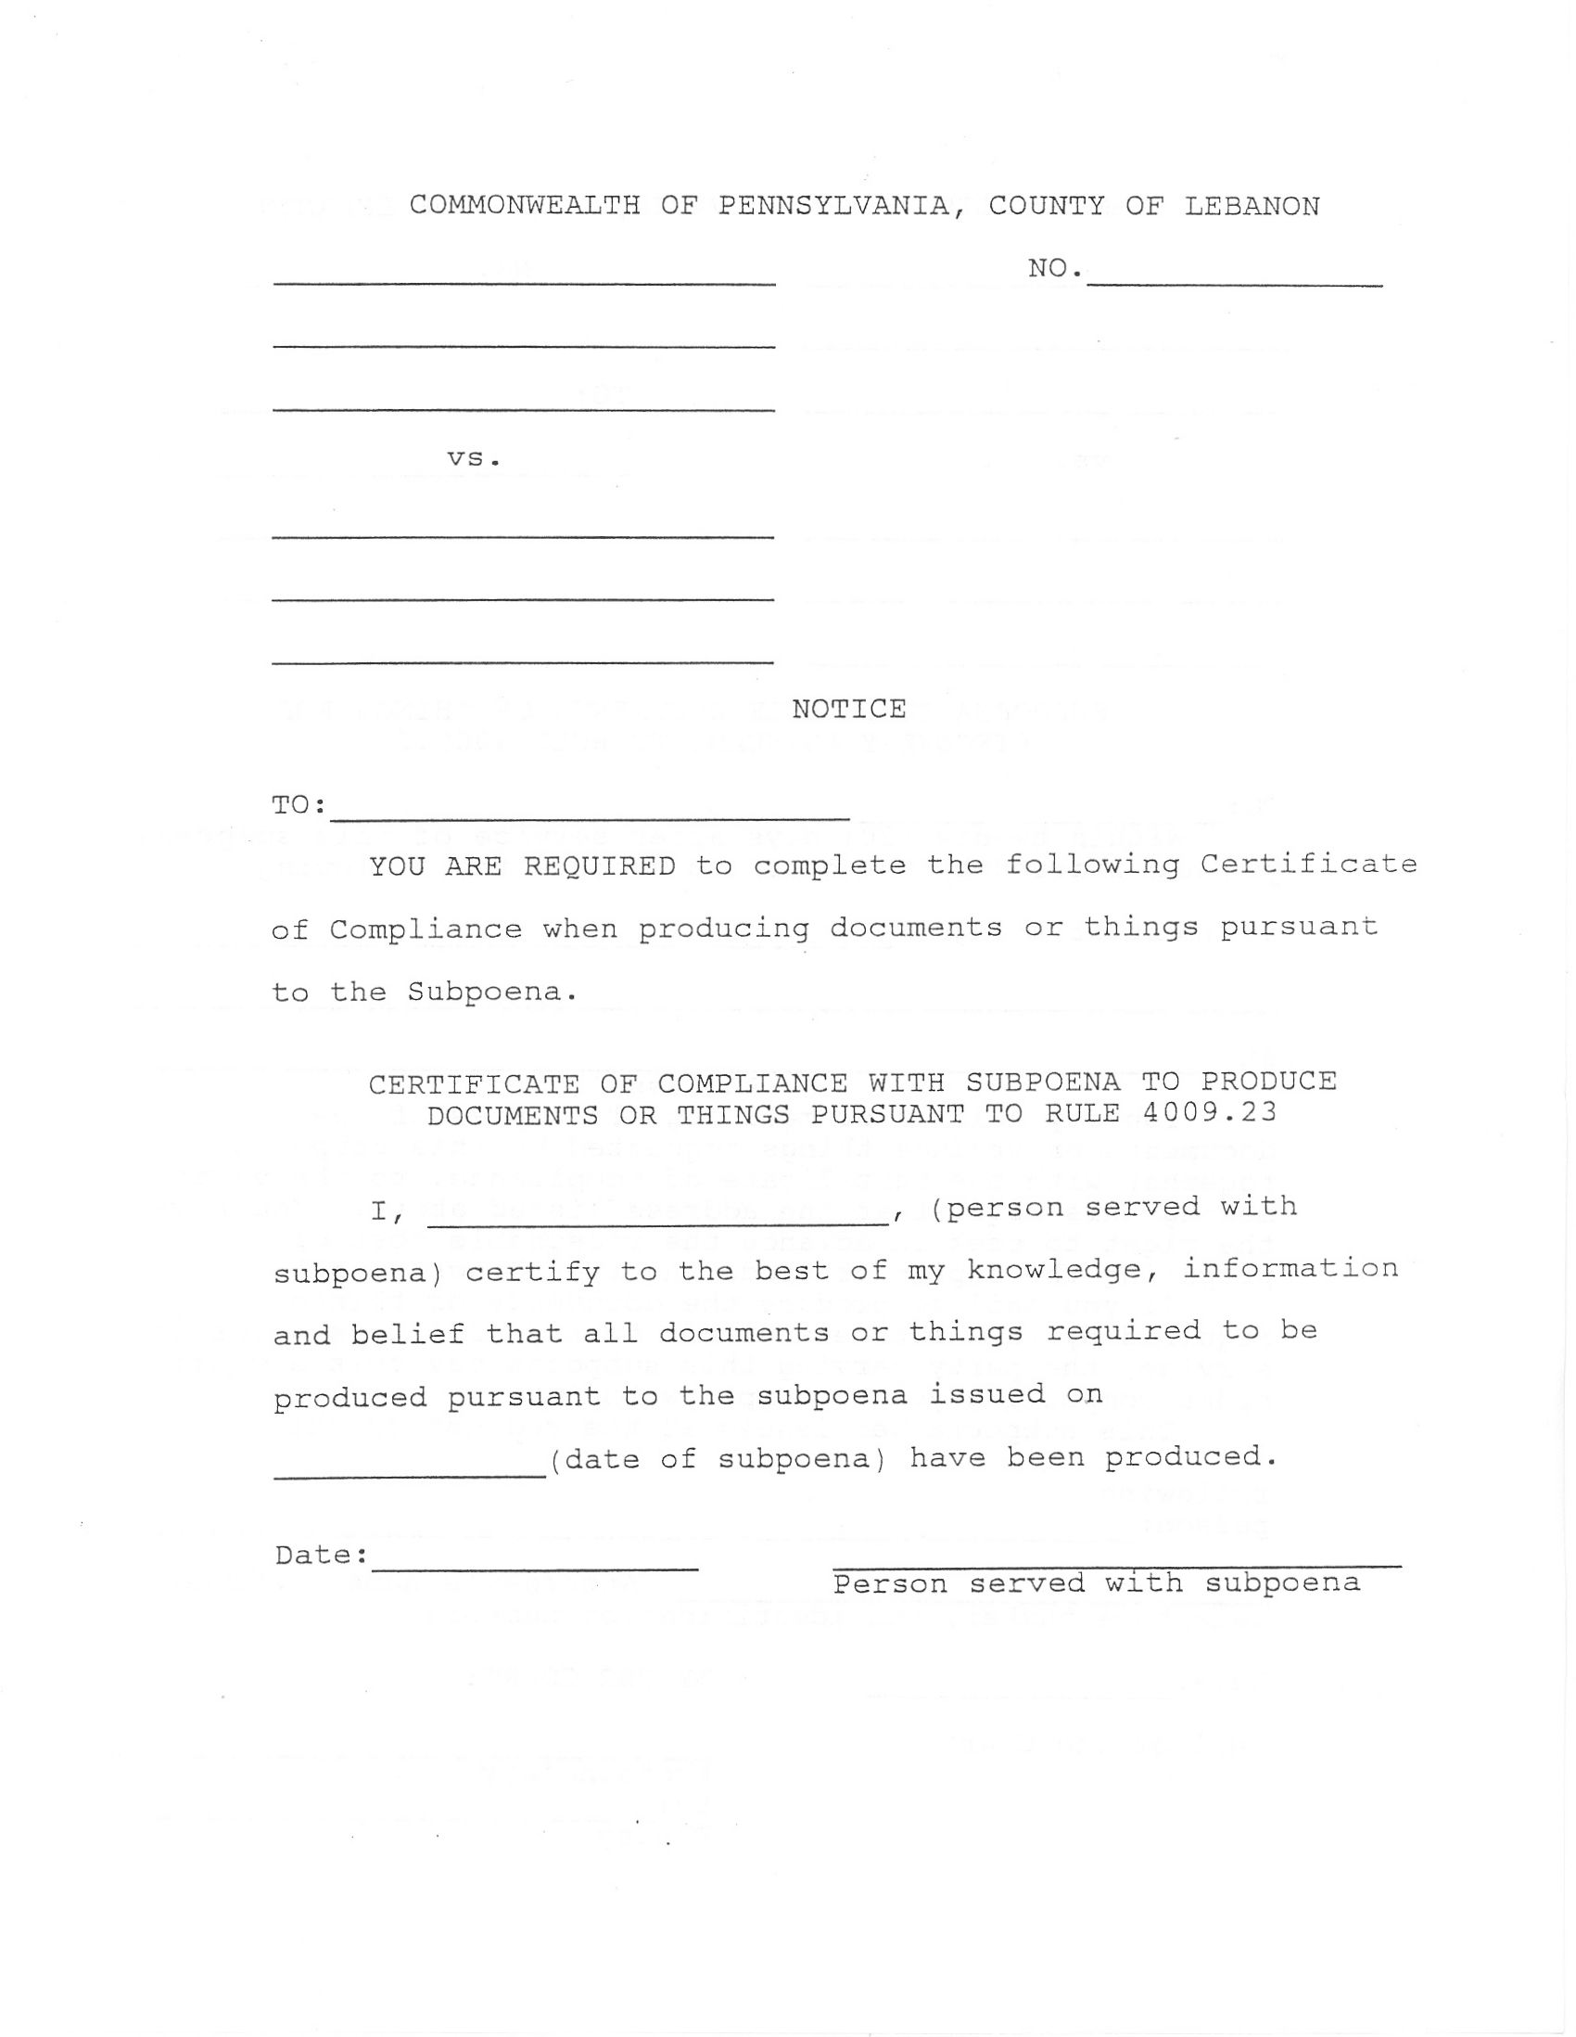
University of Michigan Hospital and Health Center
Order No. 01-29018-002
Batman
Plaintiff(s)

vs.

Gotham City
Defendant(s)
99-99999

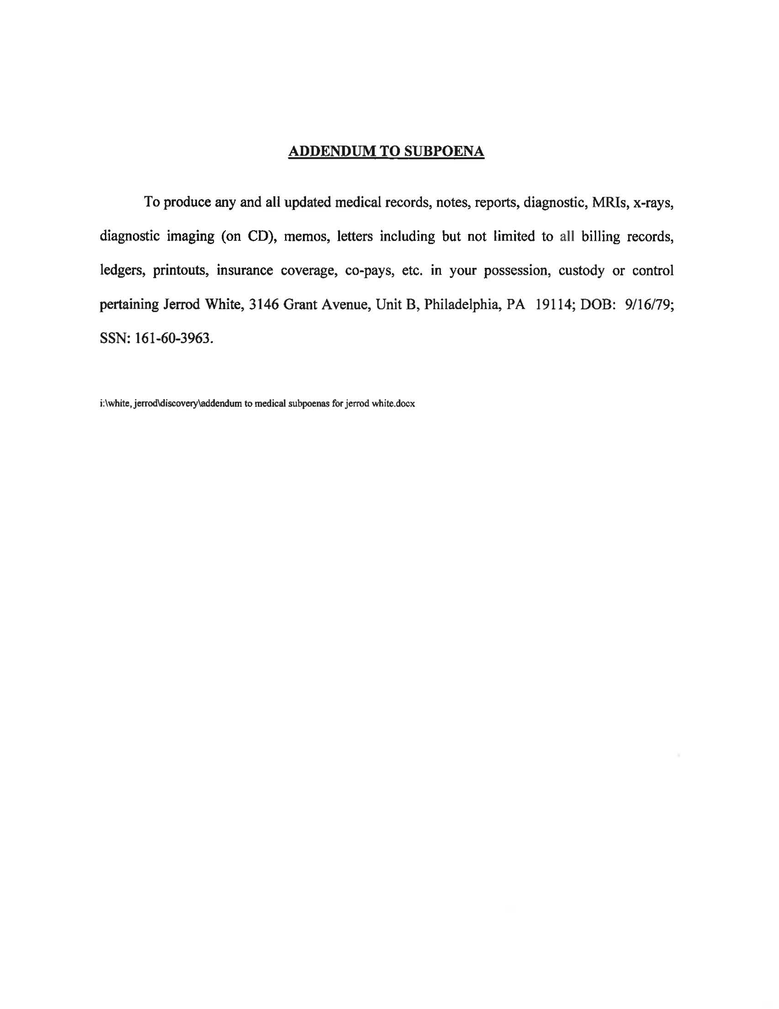
FROM 01/01/1979 TO PRESENT: Any and all MEDICAL RECORDS, including but not limited to patient history form(s), reports, etc. pertaining to Batman SSN: xxx-xx-5555, DOB: 01/01/1979.
Order No. 01-29018-002

