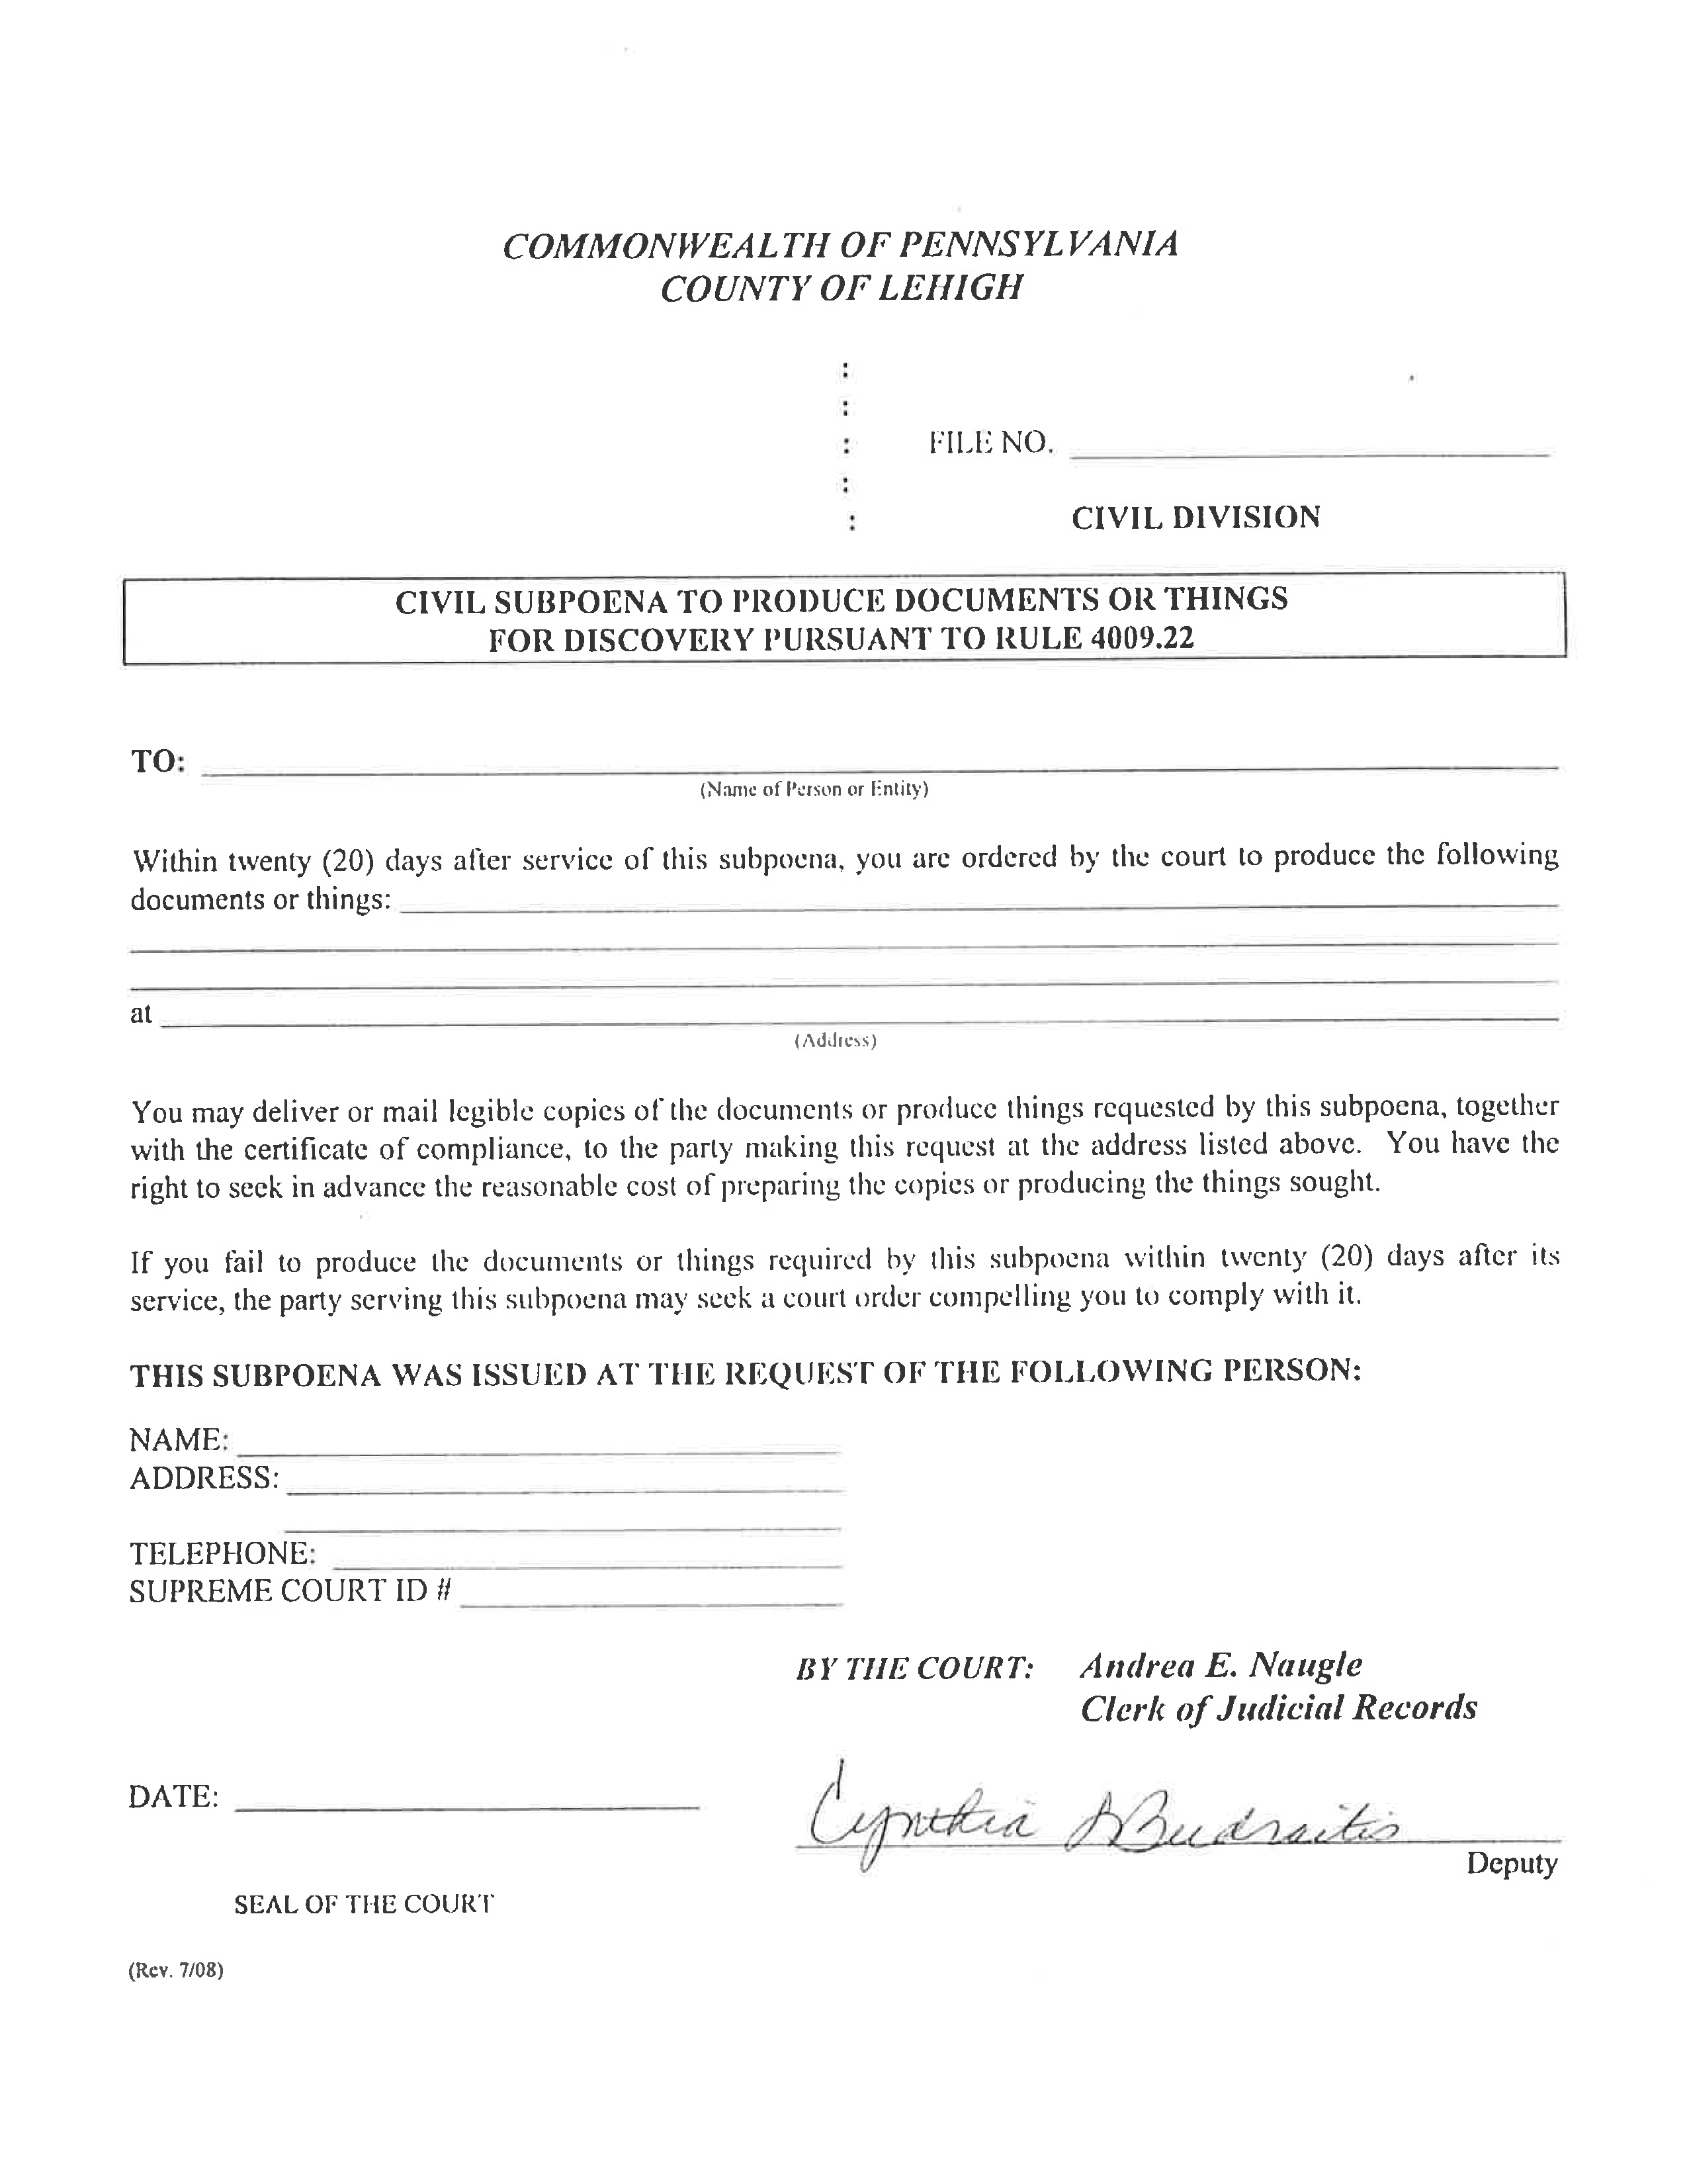

99-99999
University of Michigan Hospital and Health Center
Axiom Requisition Copy Service 2869 Jolly Road Okemos, MI 48864
John Doe
123 East Main Street
Anywhere, MI 12345

Batman
Plaintiff(s)

vs.

Gotham City
Defendant(s)
(123) 456-7890
See Attached Addendum
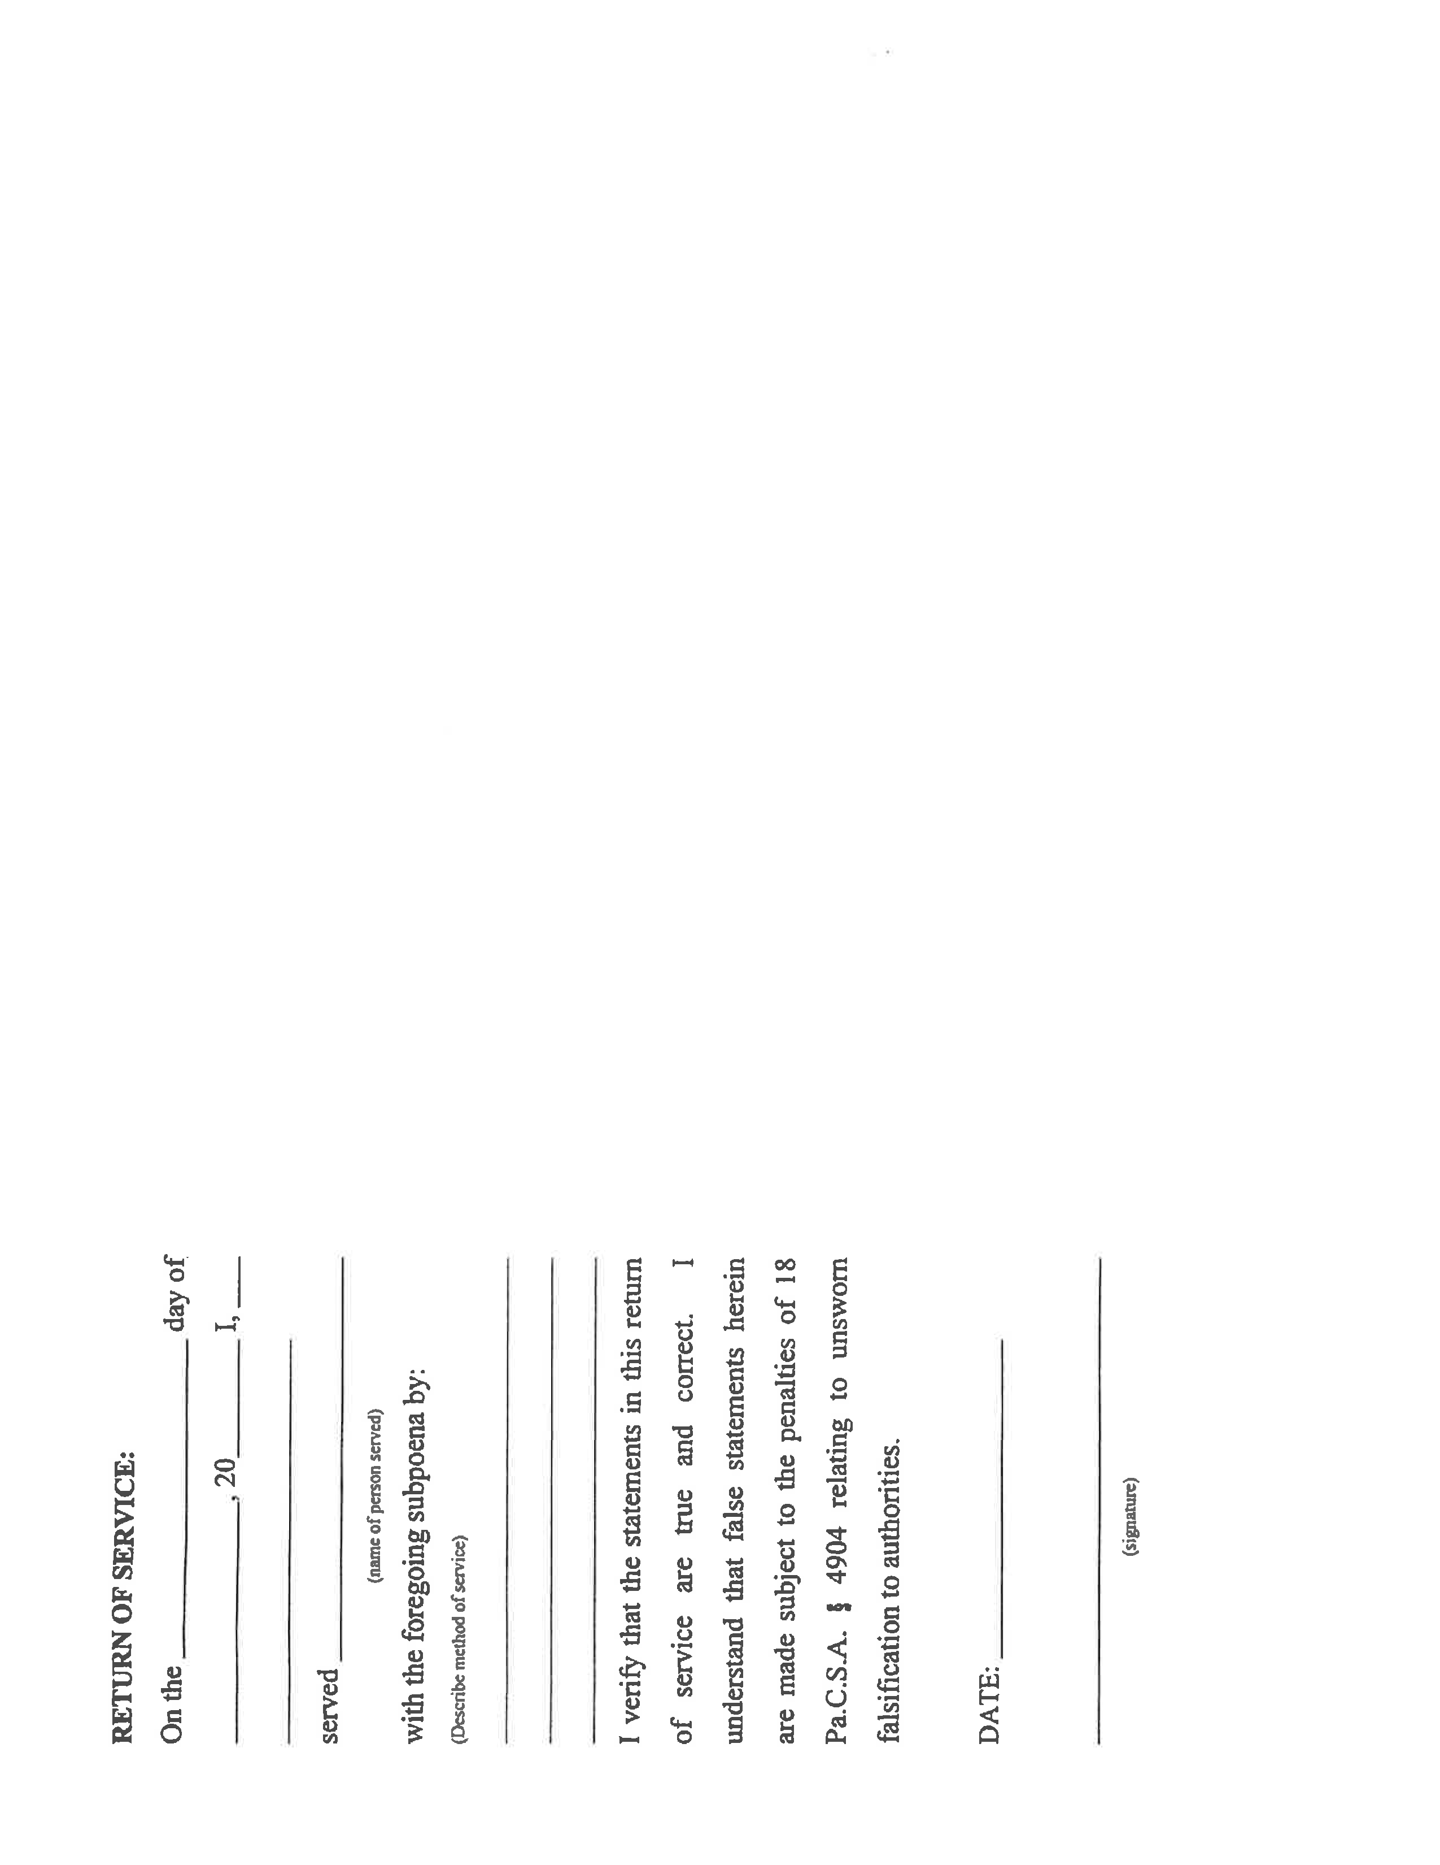

ADDENDUM TO SUBPOENA

FROM 01/01/1979 TO PRESENT: Any and all MEDICAL RECORDS, including but not limited to patient history form(s), reports, etc. pertaining to Batman SSN: xxx-xx-5555, DOB: 01/01/1979.

