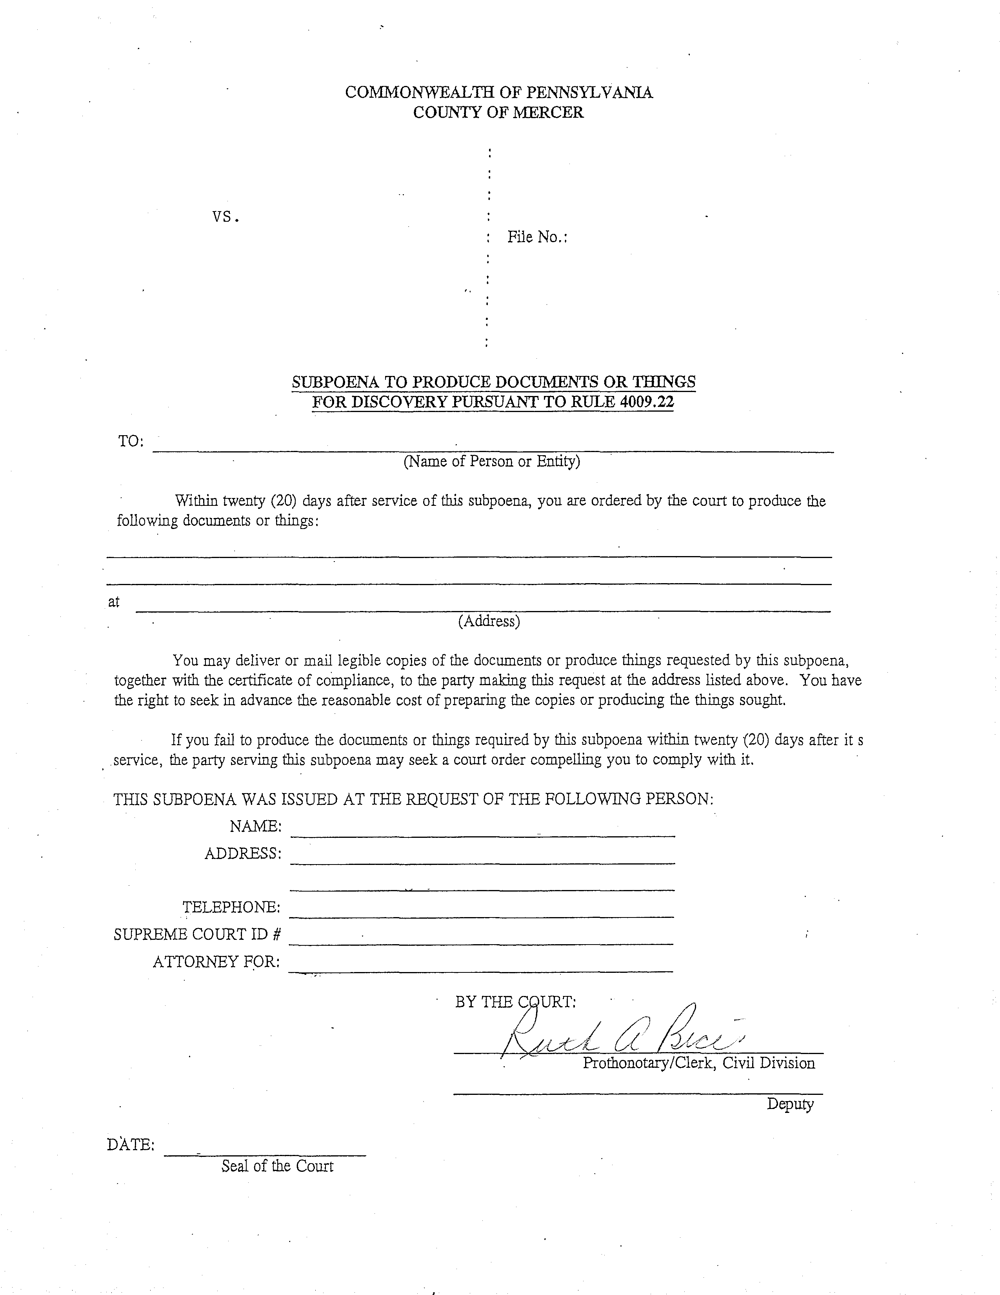
99-99999
Batman
Gotham City
University of Michigan Hospital and Health Center
See Attached Addendum
Axiom Requisition Copy Service 2869 Jolly Road, Okemos, MI 48864
On behalf of John Doe, Esquire
John Doe
123 East Main Street
Anywhere, MI 12345
Order Number: 01-29018-002
(123) 456-7890

Gotham City
vs

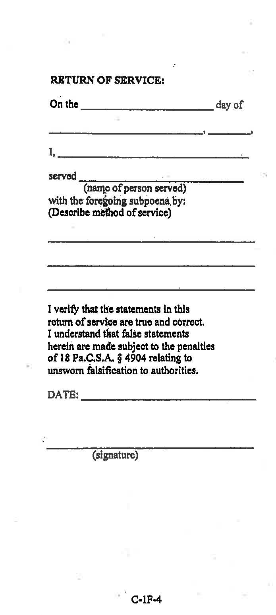
Order Number: 01-29018-002

ADDENDUM TO SUBPOENA

FROM 01/01/1979 TO PRESENT: Any and all MEDICAL RECORDS, including but not limited to patient history form(s), reports, etc. pertaining to Batman SSN: xxx-xx-5555, DOB: 01/01/1979.

Order Number: 01-29018-002

