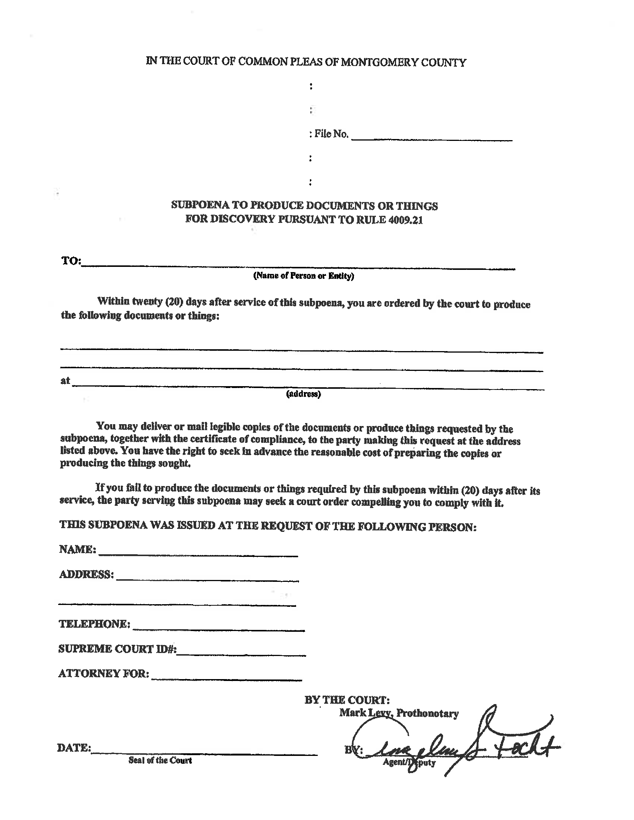
CI-02014-04607
Barbara Manuli
The ohio Bell Telephone Co, dba
Comprehensive Center for Pain Management

FROM 09/02/2003 TO PRESENT: Any and all MEDICAL RECORDS, BILLING RECORDS and FILMS (ON CD IF AVAILABLE), including (generated by Dr. Jeremy Shirey) but not limited to telephone notes, patient history form(s), and billing payments, etc. pertaining to Barbara Manuli SSN: , DOB: 06/28/1964.
Axiom Requisition Copy Service 2869 Jolly Road, Okemos, MI 48864
On behalf of Robert J. Huebner, Esquire
Robert J. Huebner, Esquire
House Counsel Grange Insurance Company
3245 Levis Commons Blvd. Perrysburg, OH 43551
Order Number: 01-35680-001
(419) 873-2324

Palmer Enterprises
v.
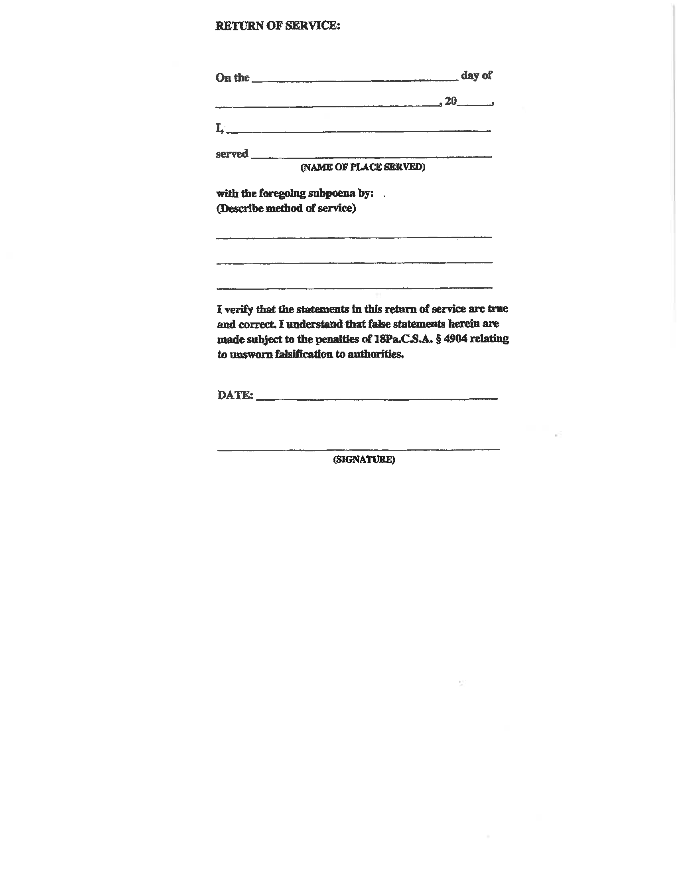
Order Number: 01-35680-001
Order Number: 01-35680-001

