
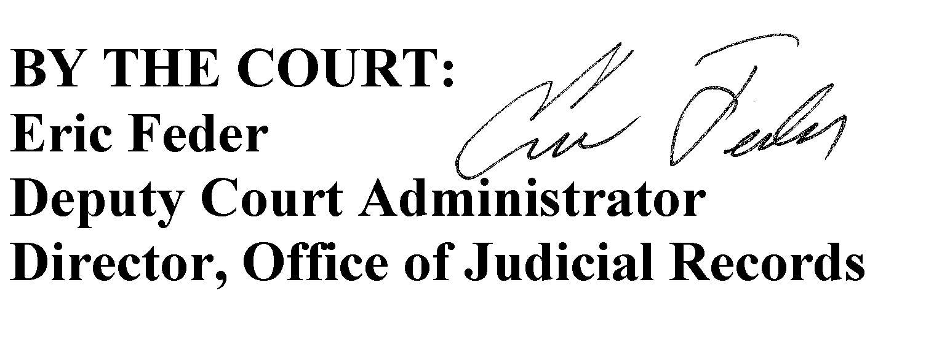
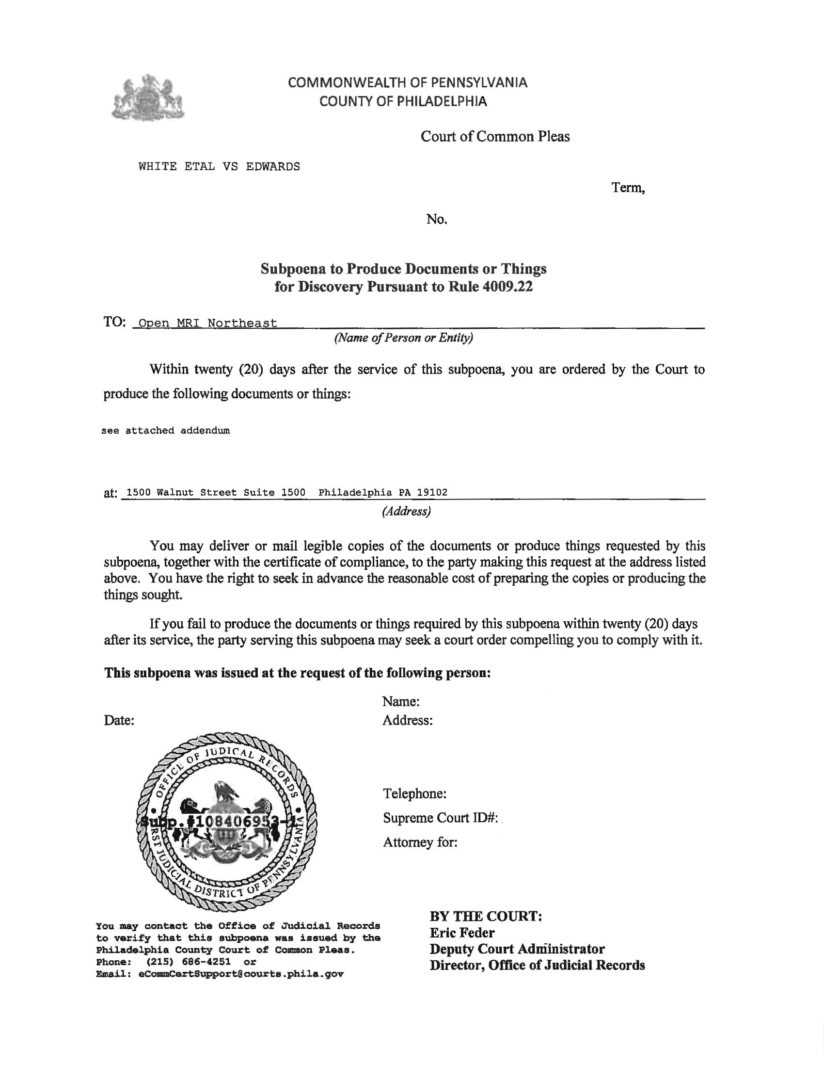

University of Michigan Hospital and Health Center
Axiom Requisition Copy Service - 2869 Jolly Road, Okemos, MI 48864
On behalf of John Doe, Esquire
John Doe, Esquire

Smith and Jones PC
123 East Main Street
Anywhere, MI 12345
(123) 456-7890
Defendant(s)

Order No. 01-29018-002

Batman
Plaintiff(s)

vs.

Gotham City
Defendant(s)
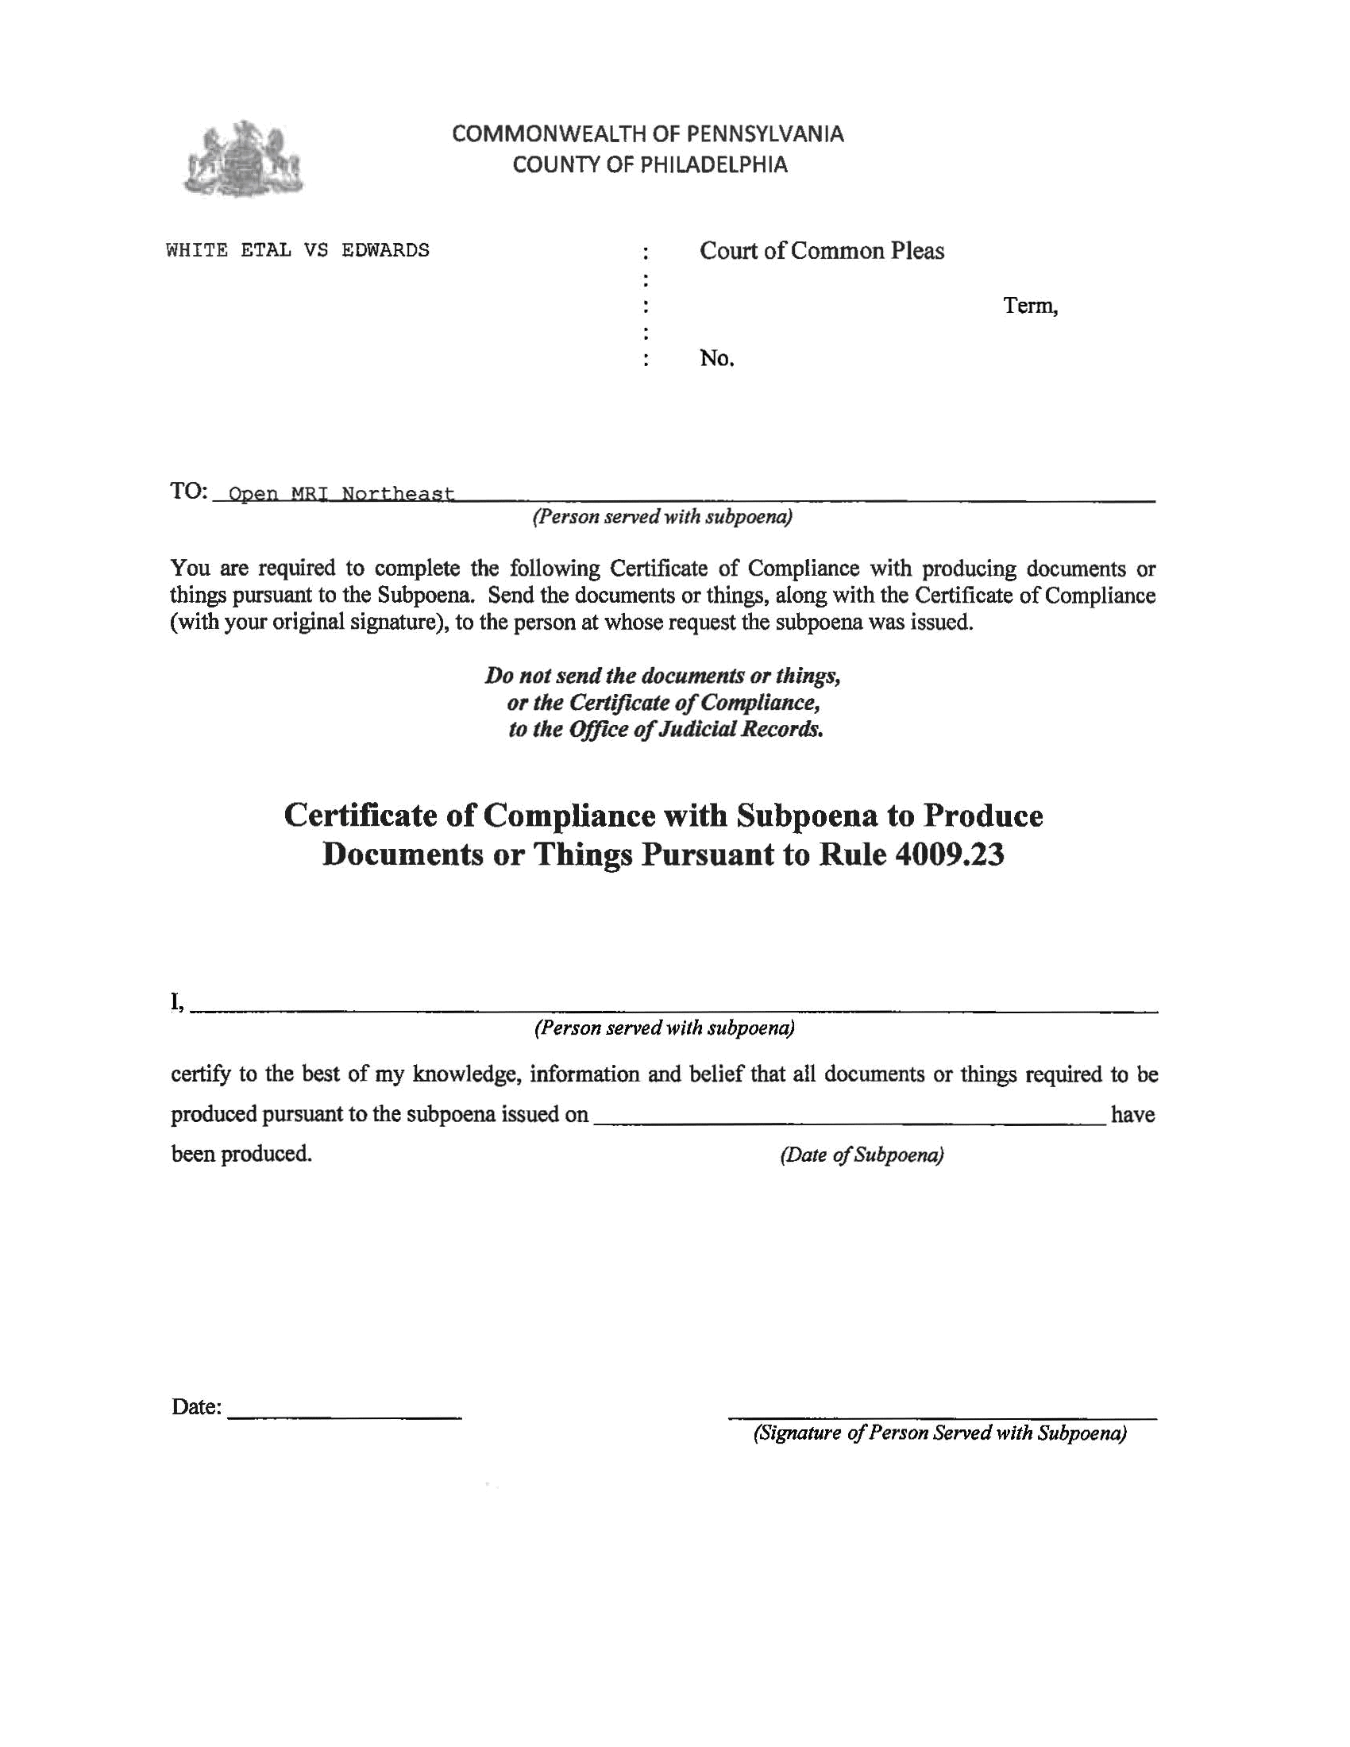
Order No. 01-29018-002

University of Michigan Hospital and Health Center
Batman
Plaintiff(s)

vs.

Gotham City
Defendant(s)
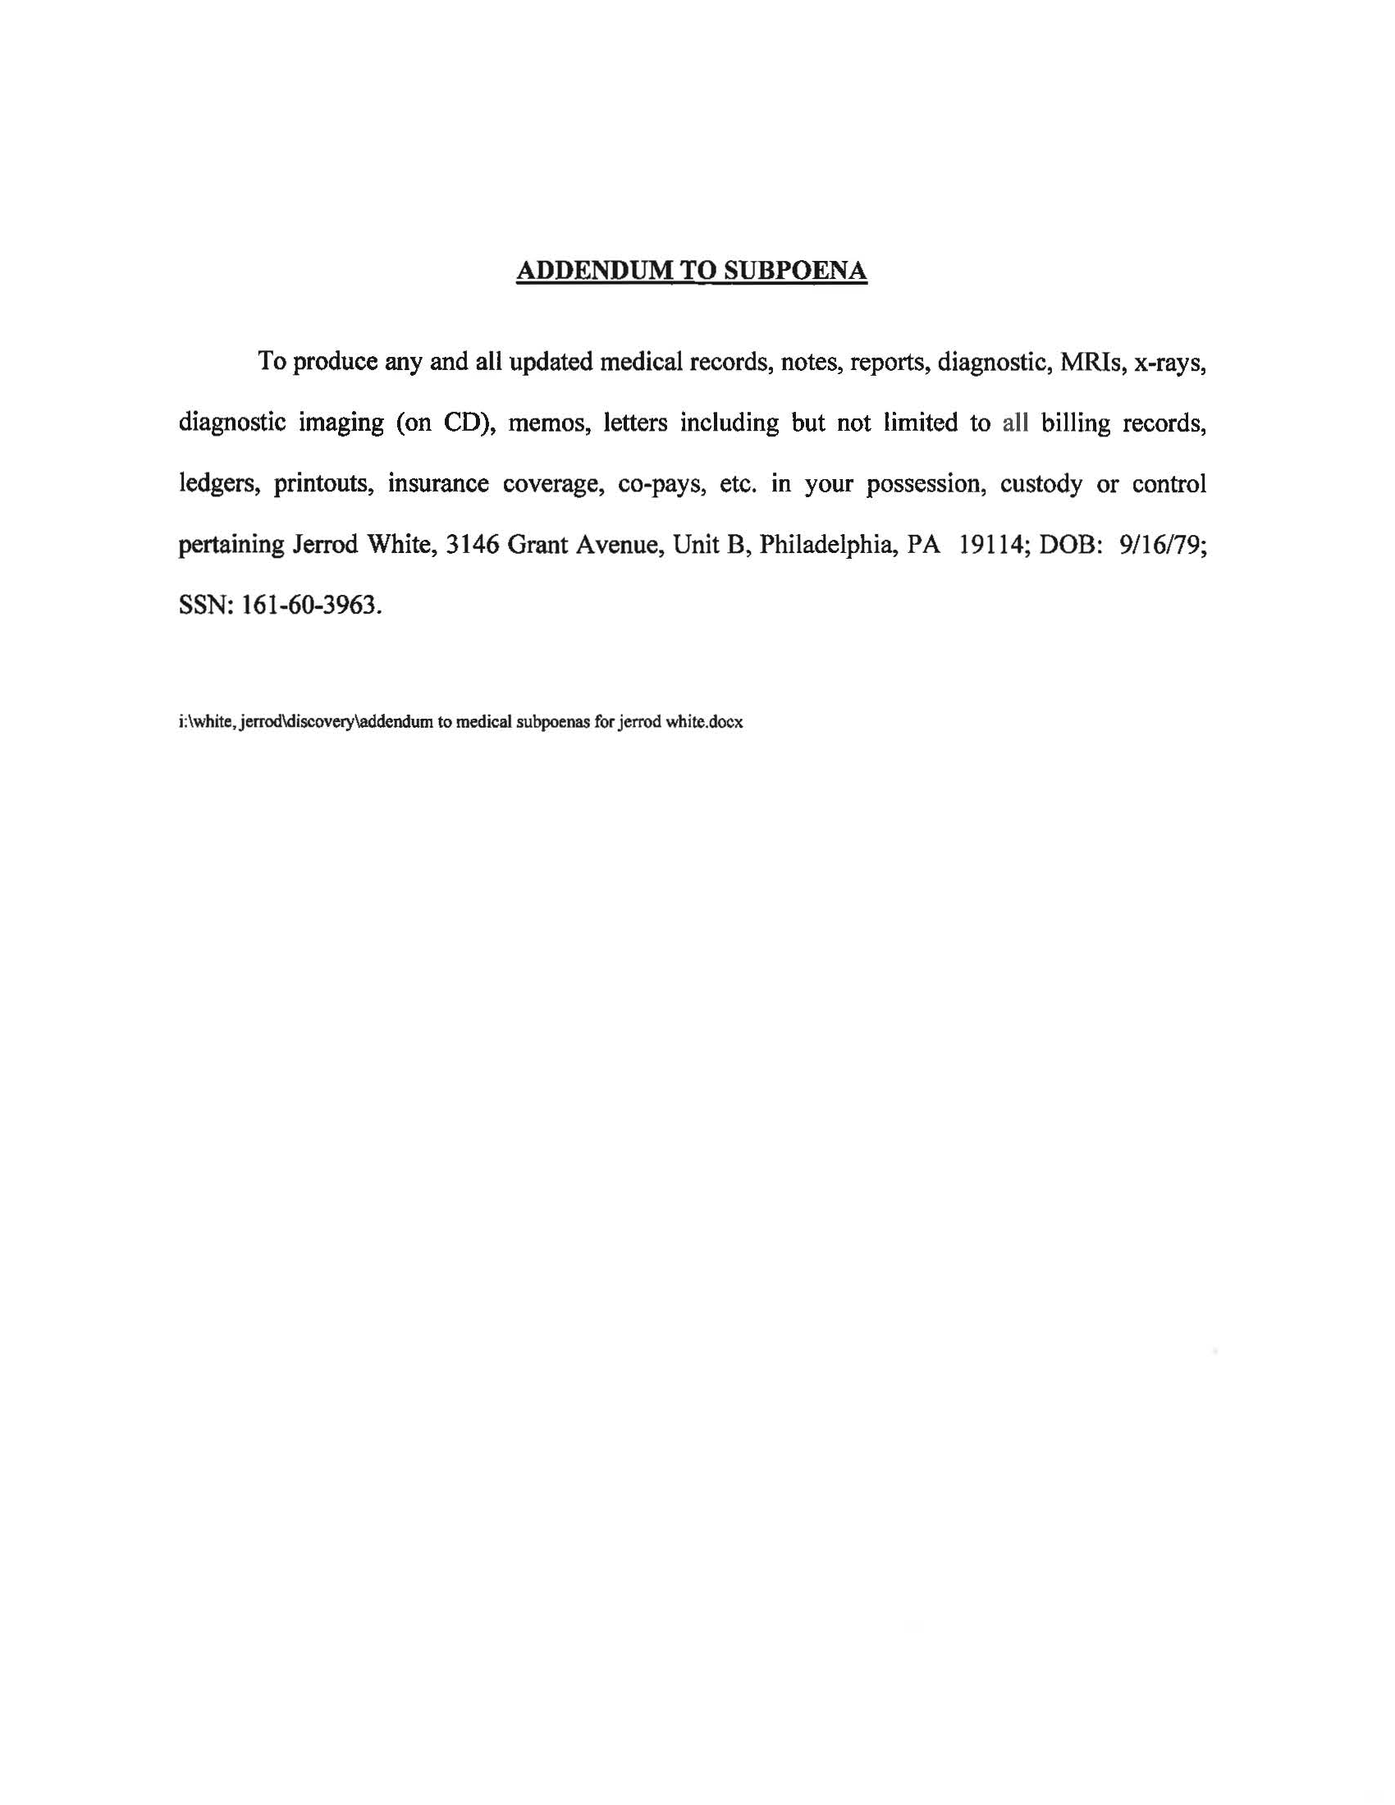
FROM 01/01/1979 TO PRESENT: Any and all MEDICAL RECORDS, including but not limited to patient history form(s), reports, etc. pertaining to Batman SSN: xxx-xx-5555, DOB: 01/01/1979.
Order No. 01-29018-002

