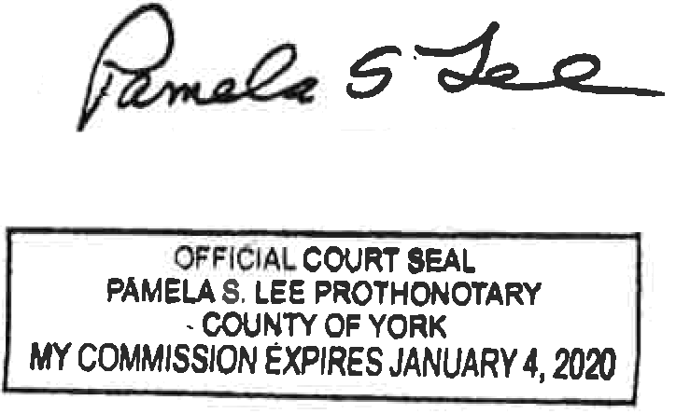
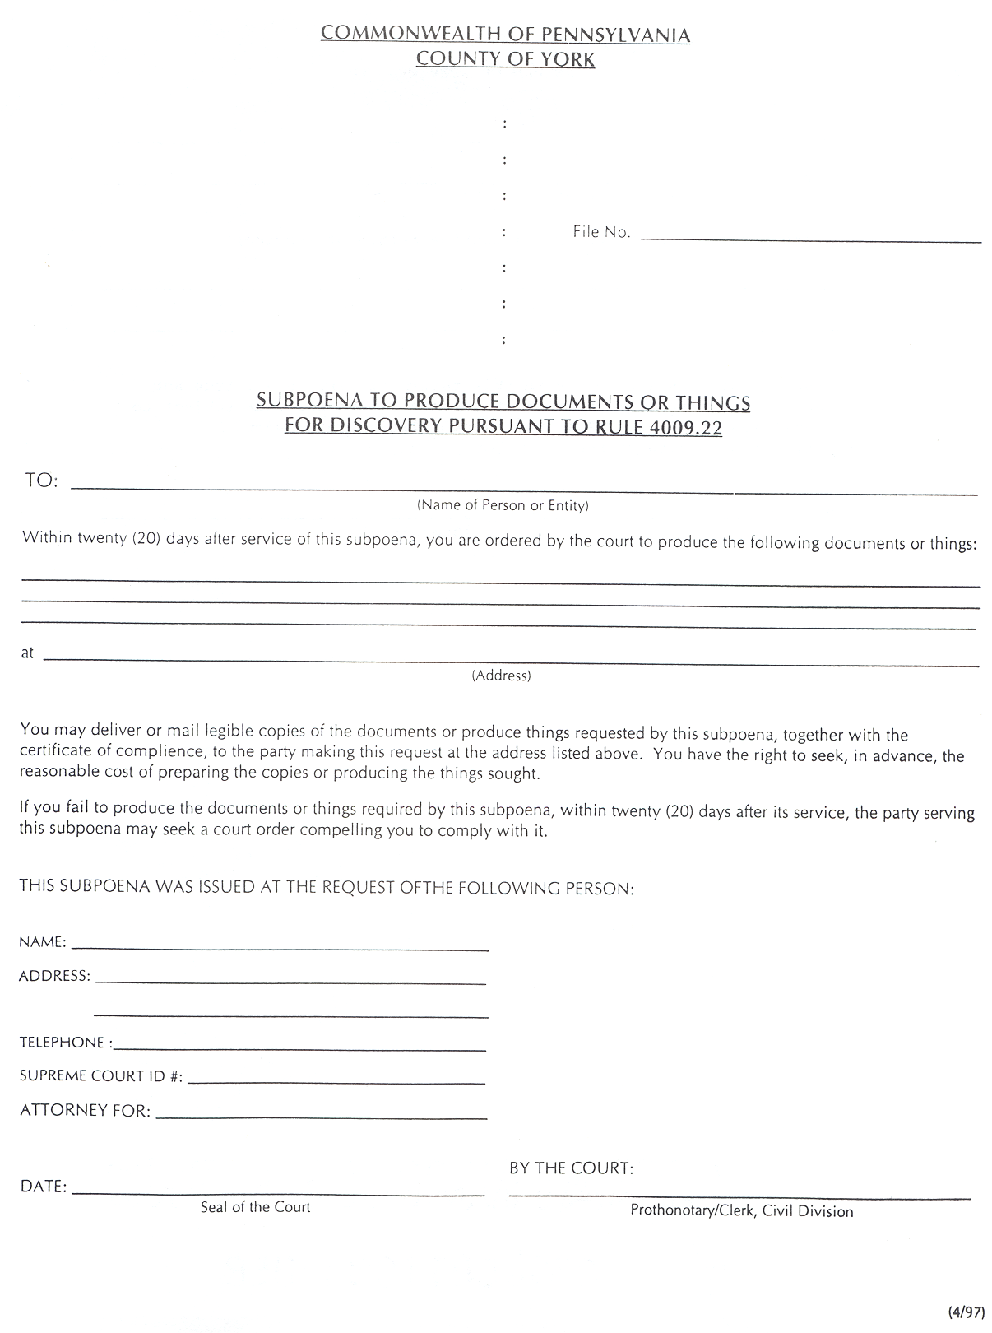
Batman
Plaintiff(s)

vs.

Gotham City
Defendant(s)

99-99999
University of Michigan Hospital and Health Center - 2901 Hubbard Street Room 2722 Ann Arbor, MI 48109-0000
FROM 01/01/1979 TO PRESENT: Any and all MEDICAL RECORDS, including but not limited to patient history form(s), reports, etc. pertaining to Batman SSN: xxx-xx-5555, DOB: 01/01/1979.
Axiom Requisition Copy Service - 2869 Jolly Road Okemos, MI 48864 (877) 886-5090 On behalf of John Doe
John Doe, Esquire
123 East Main Street
Anywhere, MI 12345
(123) 456-7890

Gotham City
