The Hanover Law Office  7130 Glen Forest Drive - Suite 200A  Henrico, Virginia 23226  Telephone: (804) 673-7845  Not a legal partnership. Licensed attorneys employed by The Hanover Insurance Group,  or affiliated companies, for the purpose of representing its policyholders and insureds | Benjamin T. Owings  Attorney at Law  bowings@hanover.com  Direct (804) 673-7802  Facsimile (508) 926-2603  Jennifer G. Capocelli  Attorney at Law  jcapocelli@hanover.com  Direct (804) 673-5573  Facsimile (508) 926-1258  Legal Assistant:  Sharon Carter-Sims  scartersims@hanover.com  Direct (804) 673-5587

University of Michigan Hospital and Health Center
Release of Information Unit
2901 Hubbard Street Room 2722
Ann Arbor, MI 48109-0000

Re: Batman vs. Gotham City
Case No. 99-99999
Claim No.

Dear Sir/Madam:

Please accept this letter as written certification that the time for filing a Motion to Quash the subpoena which I had issued upon you in this matter has elapsed and either no Motion to Quash was filed or any Motion to Quash which was filed has been resolved. Accordingly, pursuant to Virginia Code §32.1-127.1:03, you are under a duty to comply with the subpoena by furnishing me with the records which are the subject of the subpoena within five (5) days of the date of receipt of this letter or by the return date on the subpoena, whichever is later.

Thank you for your attention to this matter.

Sincerely,
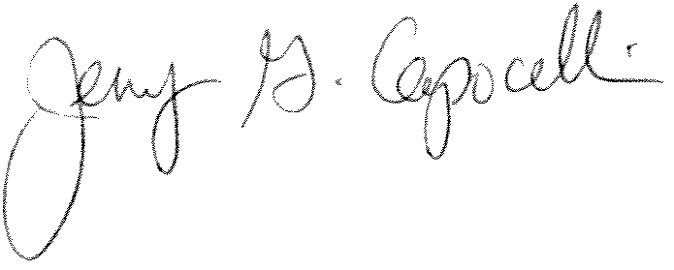

Jennifer G. Capocelli

JGC/secs

