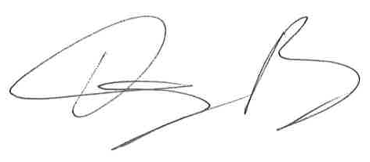
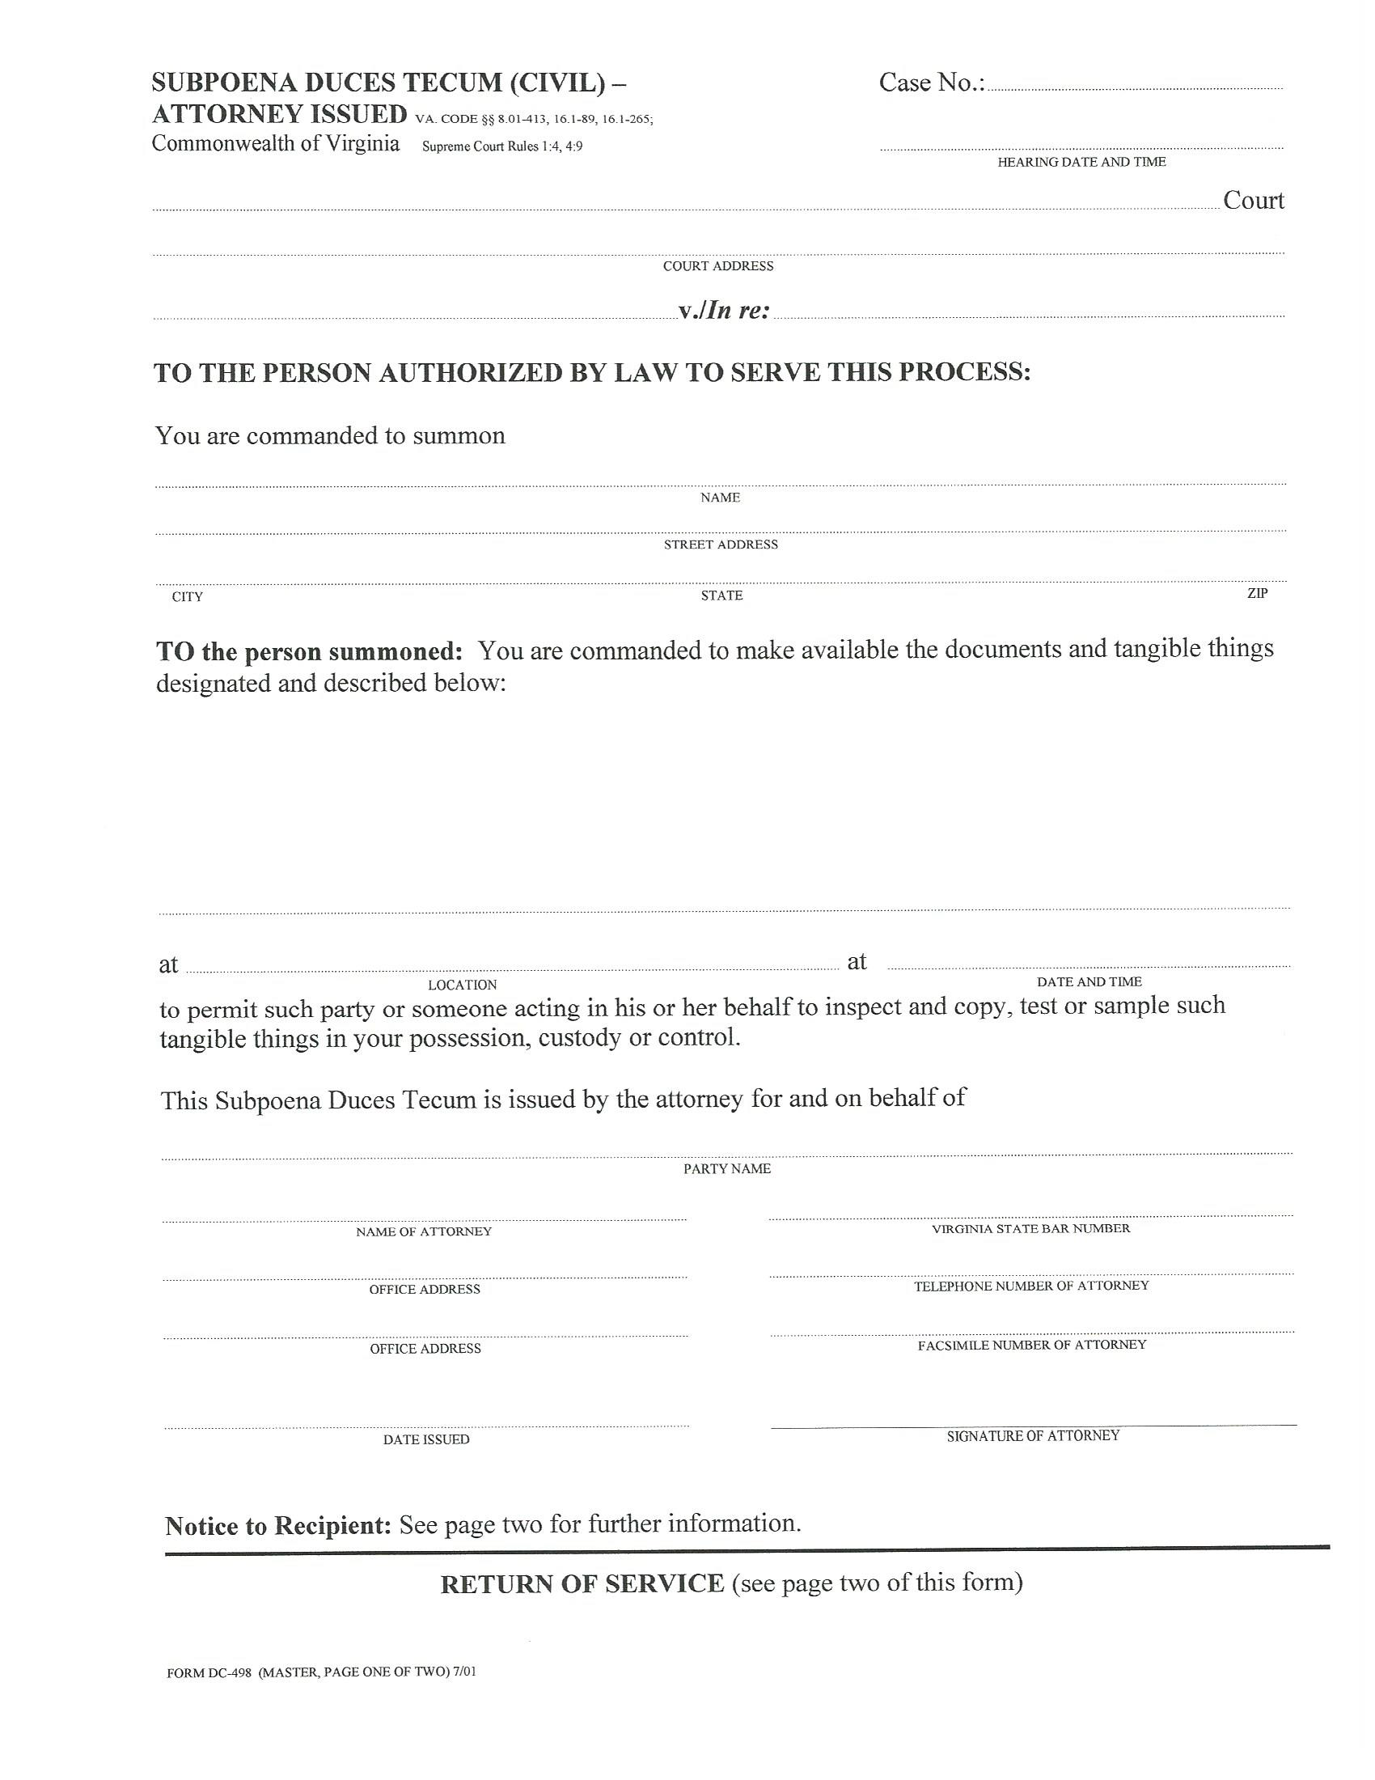
COUNTY OF

Batman, Plaintiff
V.
Gotham City, Defendant
University of Michigan Hospital and Health Center Release of Information Unit
2901 Hubbard Street Room 2722
Ann Arbor, MI 48109-0000
FROM 01/01/1979 TO PRESENT: Any and all MEDICAL RECORDS, including but not limited to patient history form(s), reports, etc. pertaining to Batman SSN: xxx-xx-5555, DOB: 01/01/1979.
At the offices of: Kalbaugh, Pfund & Messersmith, P.C.- John Doe C/O Axiom Requisition Copy Service
2869 Jolly Road Okemos, MI 48864 (877) 886-5090
John Doe
Smith and Jones PC
123 East Main Street
Gotham City

(804) 320-6300
(804) 320-6312
99-99999

At 10:00 AM
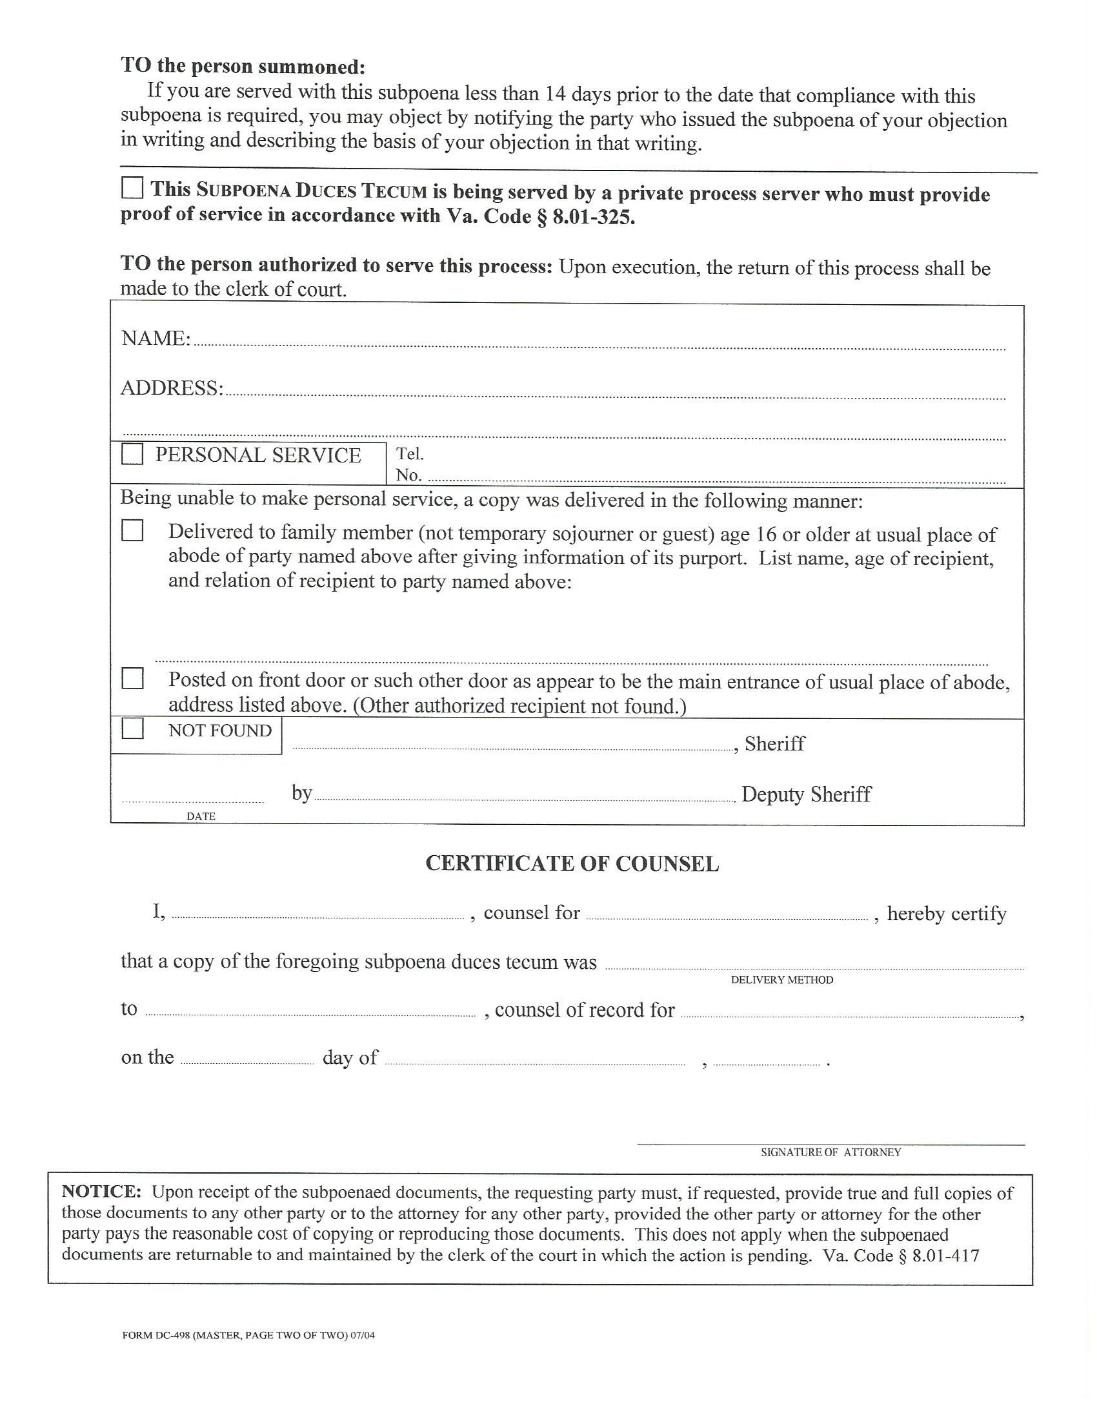
University of Michigan Hospital and Health Center Release of Information Unit
2901 Hubbard Street Room 2722
Ann Arbor, MI 48109-0000

X
John Doe
Gotham City
Mail
Jack Zuk
Batman
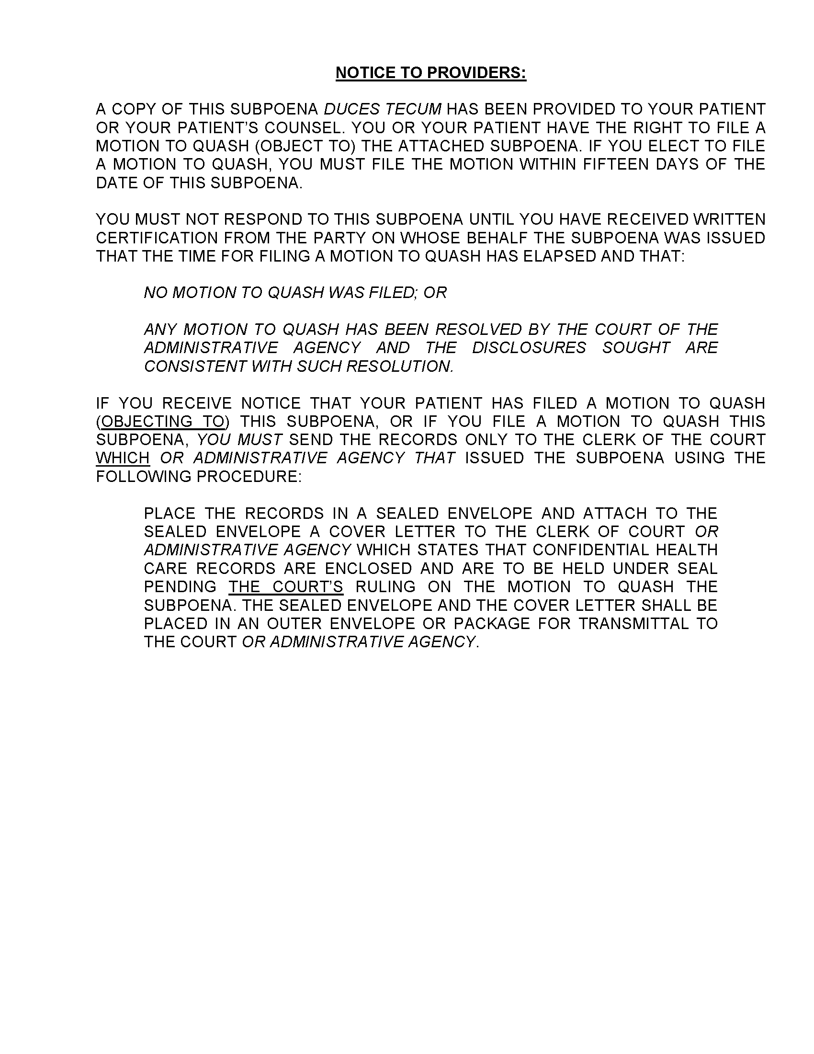
STATEMENT OF BUSINESS RECORDS CERTIFICATION
Va. Code Section 8.01-390.3 (Circuit Court)
Va. Code Section 16.1-88.2 (General District Court)

I, _______________________________, as an authorized representative employed by University of Michigan Hospital and Health Center, do hereby certify and declare to the following:
1. That I am the custodian of records for University of Michigan Hospital and Health Center;
2. That the attached records are true and exact copies of all the medical records, documents, writings, photographs, and other papers concerning Batman; SSN: xxx-xx-5555; DOB: 01/01/1979, described by the duly served subpoena duces tecum, which are in the possession, custody and/or control of University of Michigan Hospital and Health Center; its agents, and/or employees;

3. That the attached records were made at or near the time of the occurrence of the matters described therein;

4. That the entries in the attached records were made by an authorized person with knowledge of those matters, or from information transmitted by a person with knowledge of those matters;

5. That the attached records were made and kept in the ordinary course of regularly conducted business activity; and

6. The attached records are the type of records which are relied upon by those who prepare them or for whom they are prepared.

7. [ ] Please check box if applicable:

There are no records, documents, writings, photographs pertaining to Batman; SSN: xxx-xx-5555; DOB: 01/01/1979, described by the duly served subpoena duces tecum, which are in the possession, custody and/or control for University of Michigan Hospital and Health Center;, its agents, and/or employees.

__________________________________ ________________________
Signature Date

****************************************************************************************************
State of __________________:

City/County of _____________________, to wit:

Subscribed and sworn to before me on this ______ day of _____________, 2015.

_______________________________ [SEAL]
Notary Public My commission expires: / /

