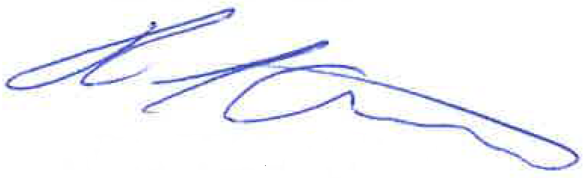
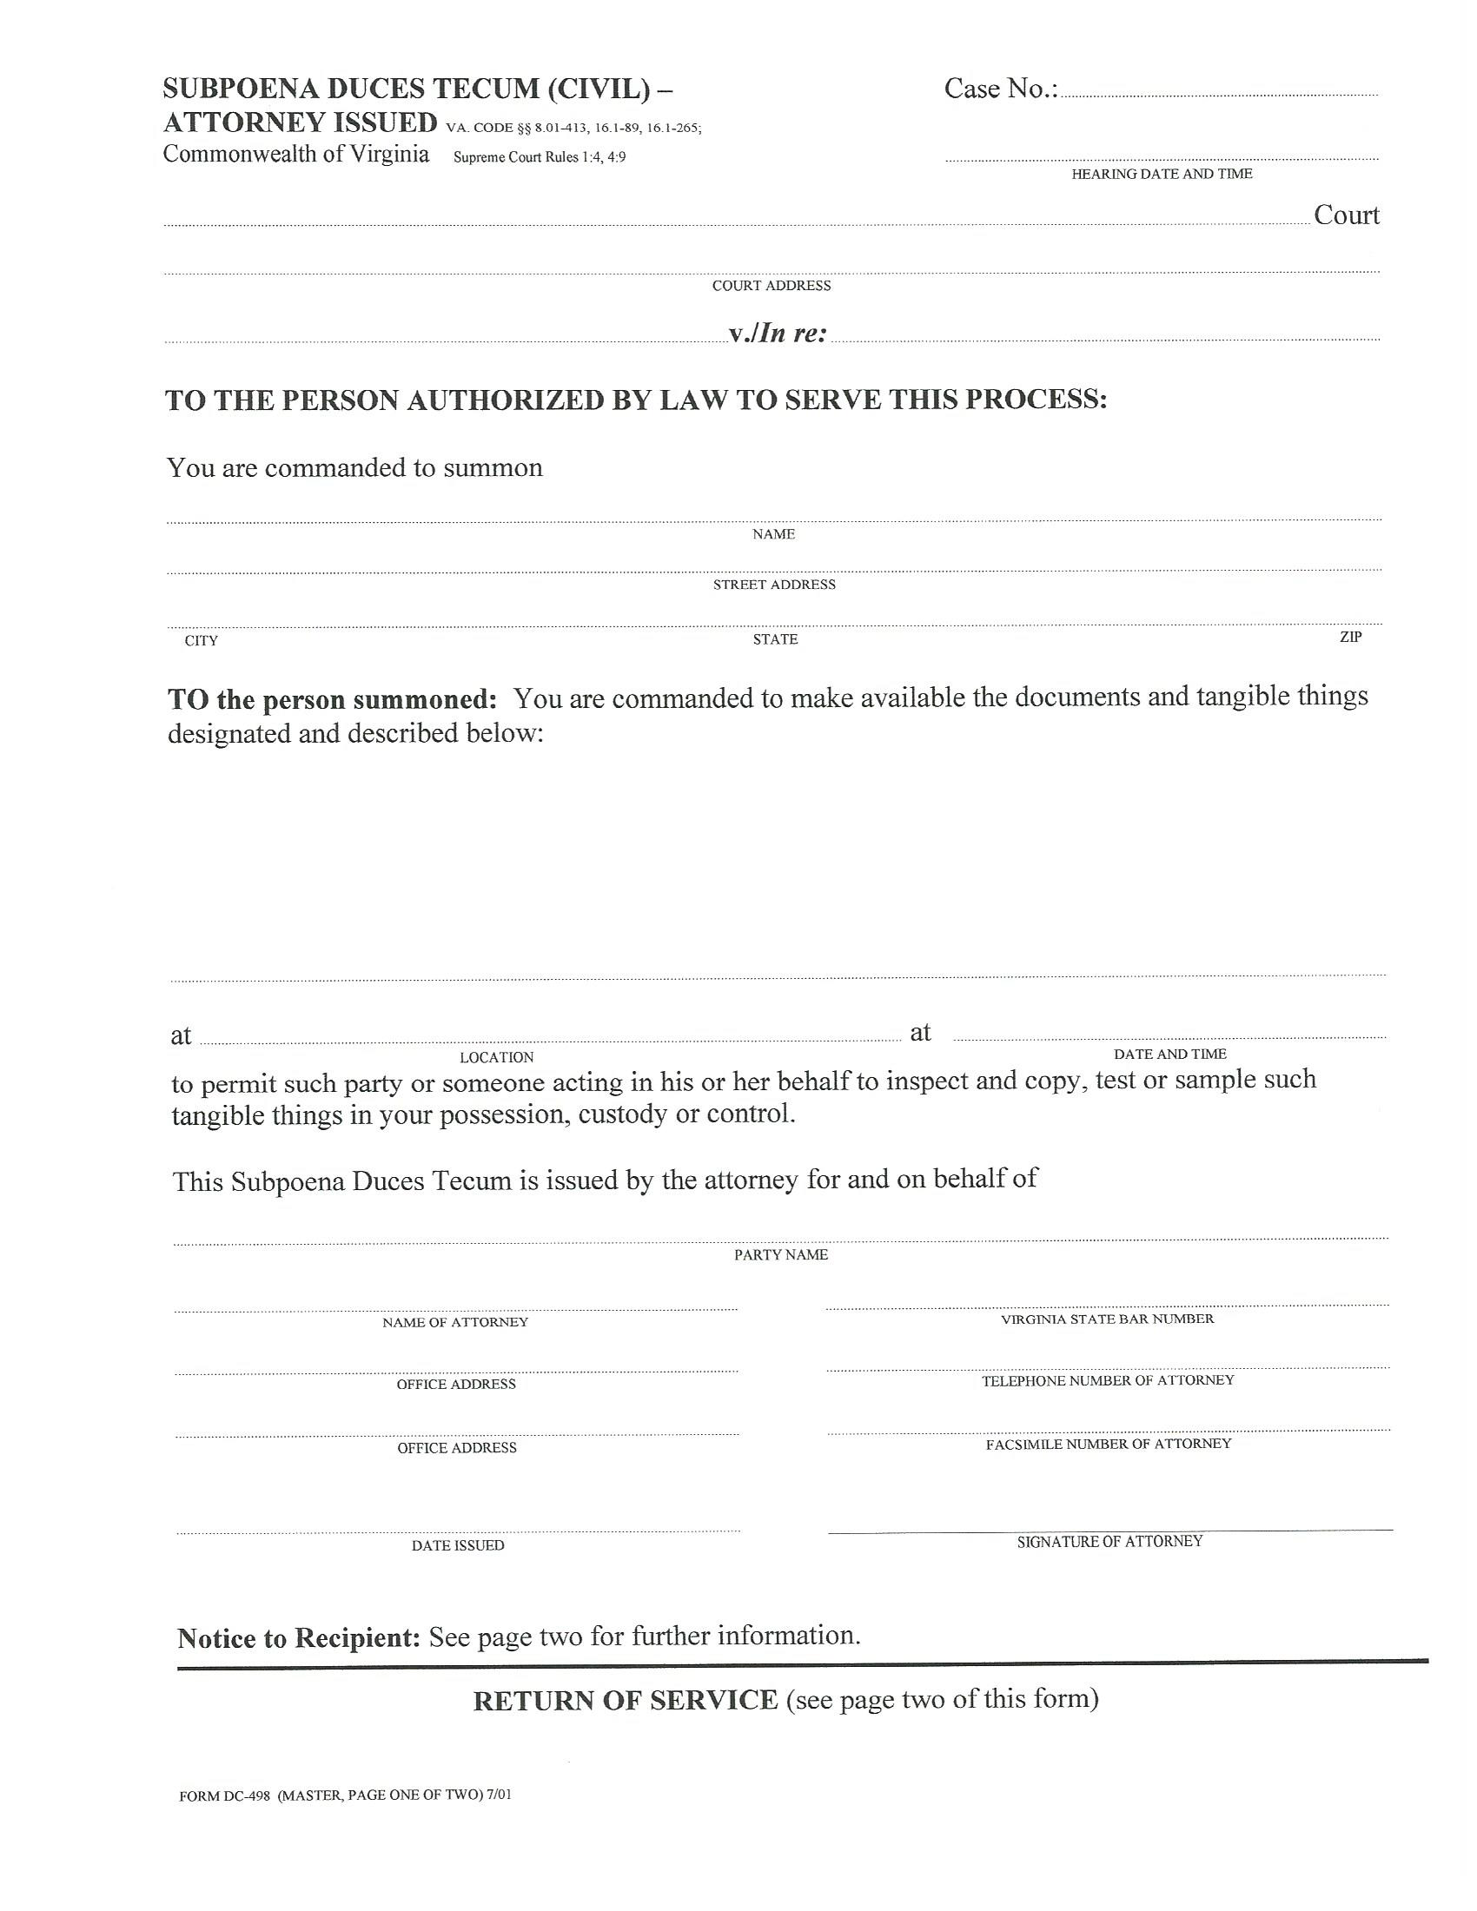
COUNTY OF

Batman, Plaintiff
V.
Gotham City, Defendant
University of Michigan Hospital and Health Center Release of Information Unit
2901 Hubbard Street Room 2722
Ann Arbor, MI 48109-0000
FROM 01/01/1979 TO PRESENT: Any and all MEDICAL RECORDS, including but not limited to patient history form(s), reports, etc. pertaining to Batman SSN: xxx-xx-5555, DOB: 01/01/1979.
At the offices of: Kalbaugh, Pfund & Messersmith, P.C.- John Doe C/O Axiom Requisition Copy Service
2869 Jolly Road Okemos, MI 48864 (877) 886-5090
John Doe
Smith and Jones PC
123 East Main Street
Gotham City

(804) 320-6300
(804) 320-6312
99-99999
At 10:00 AM

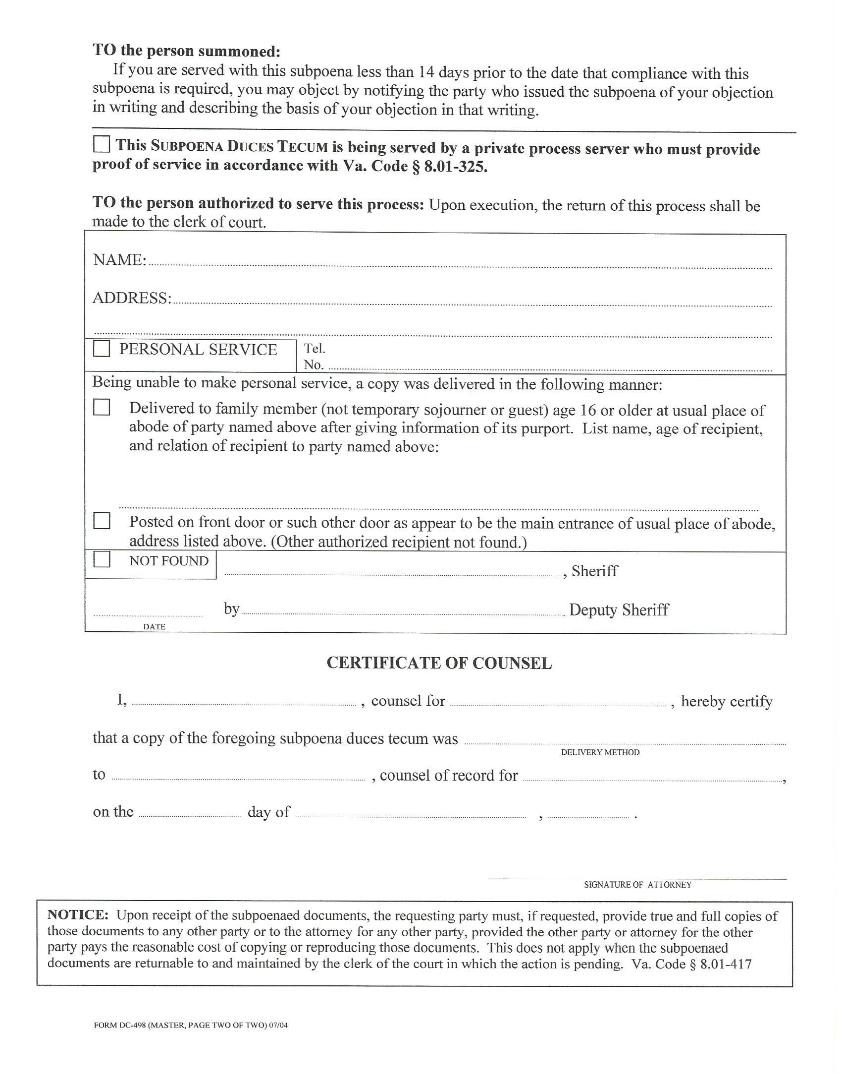
University of Michigan Hospital and Health Center Release of Information Unit
2901 Hubbard Street Room 2722
Ann Arbor, MI 48109-0000

X
John Doe
Gotham City
Mail
Jack Zuk
Batman
