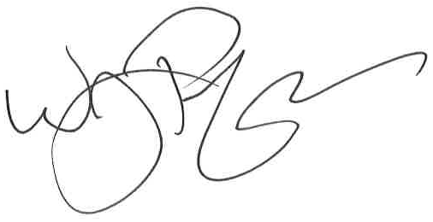
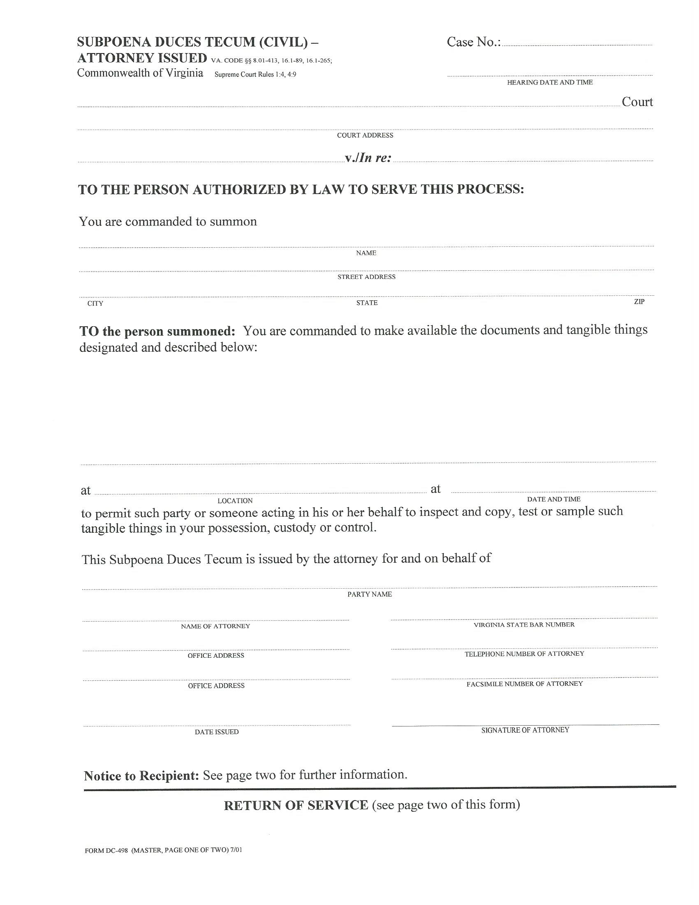
Common Pleas COUNTY OF Lucas

Barbara Manuli, Plaintiff
V.
The ohio Bell Telephone Co, dba, Defendant
Comprehensive Center for Pain Management a/k/a Toledo Pain Services
7053 W. Central Avenue
Toledo, OH 43617-____
FROM 09/02/2003 TO PRESENT: Any and all MEDICAL RECORDS, BILLING RECORDS and FILMS (ON CD IF AVAILABLE), including (generated by Dr. Jeremy Shirey) but not limited to telephone notes, patient history form(s), and billing payments, etc. pertaining to Barbara Manuli SSN: , DOB: 06/28/1964.
At the offices of: Kalbaugh, Pfund & Messersmith, P.C.- Robert J. Huebner C/O Axiom Requisition Copy Service
2869 Jolly Road Okemos, MI 48864 (877) 886-5090
Robert J. Huebner
The Law Office of Raymond H. Pittman, III
House Counsel Grange Insurance Company
The ohio Bell Telephone Co, dba

(804) 320-6300
(804) 320-6312
CI-02014-04607
At 10:00 AM

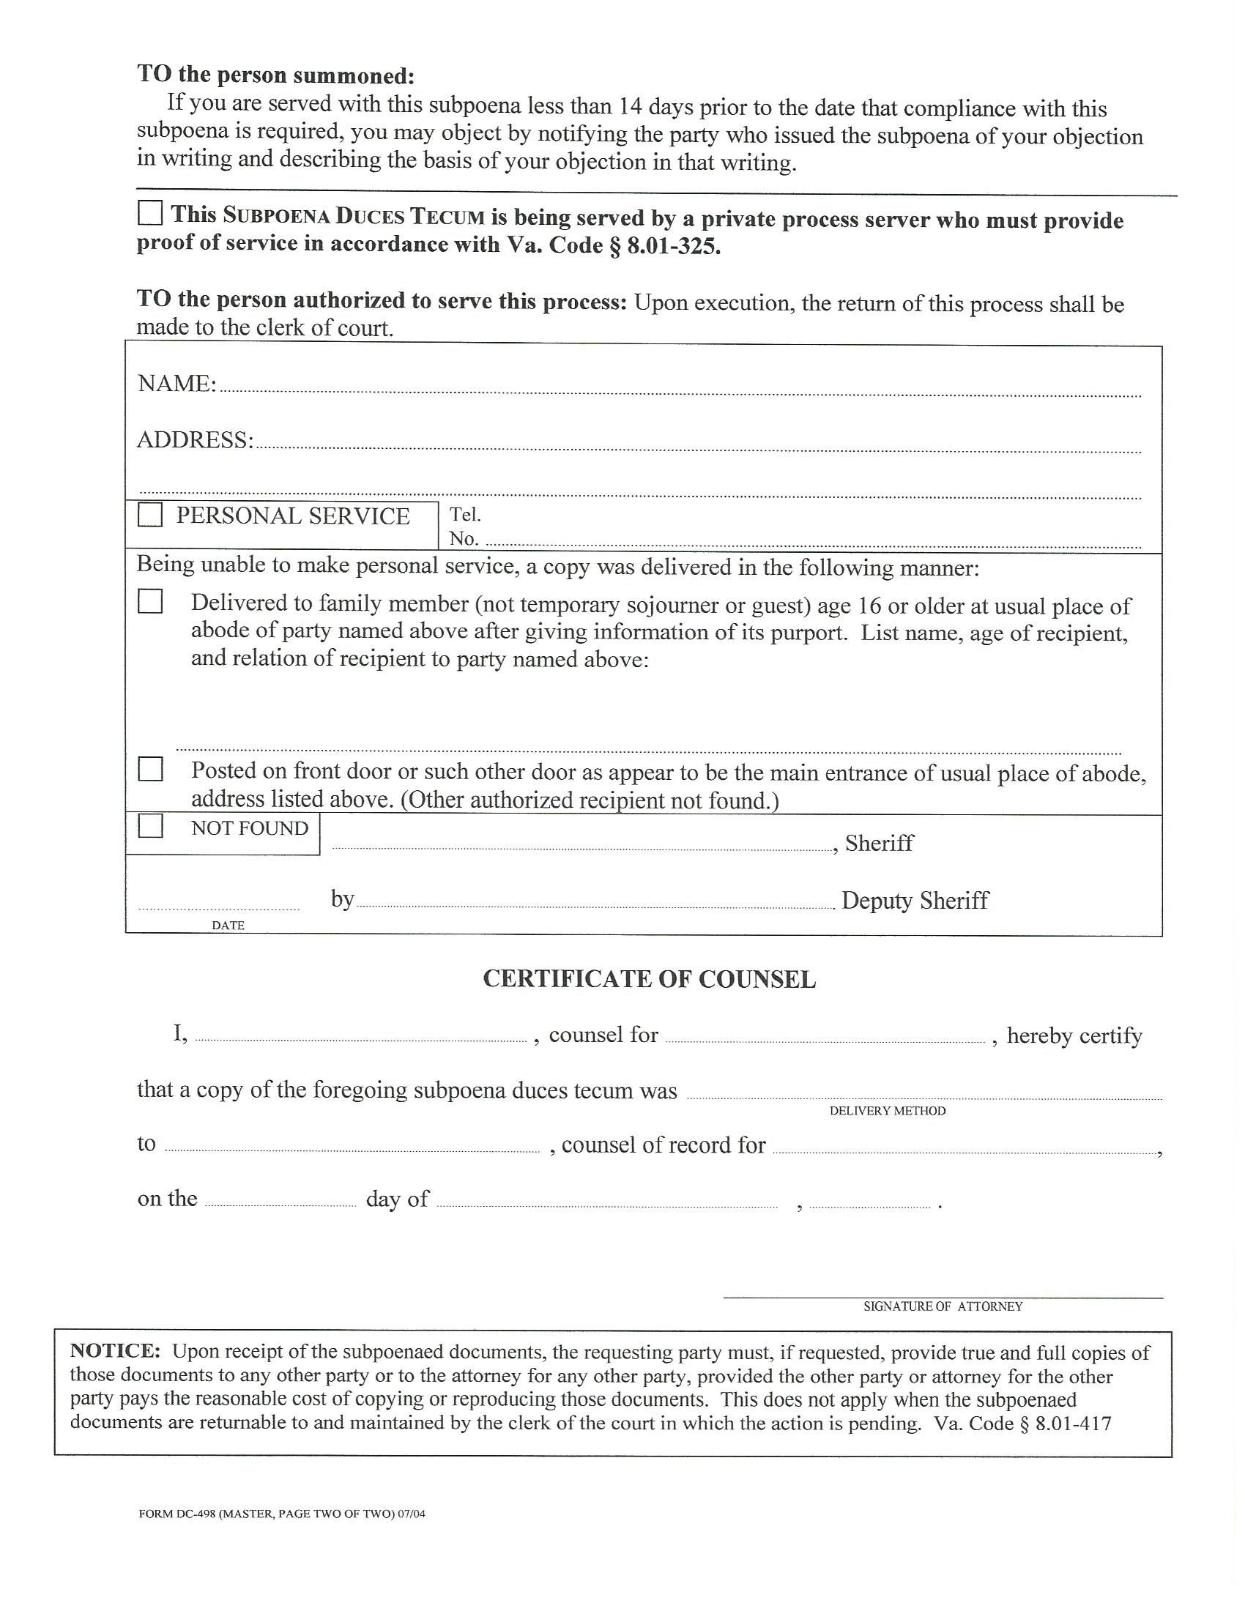
Comprehensive Center for Pain Management a/k/a Toledo Pain Services
7053 W. Central Avenue
Toledo, OH 43617-____

X
Robert J. Huebner
The ohio Bell Telephone Co, dba
Mail
Joseph Hartle
Barbara Manuli
