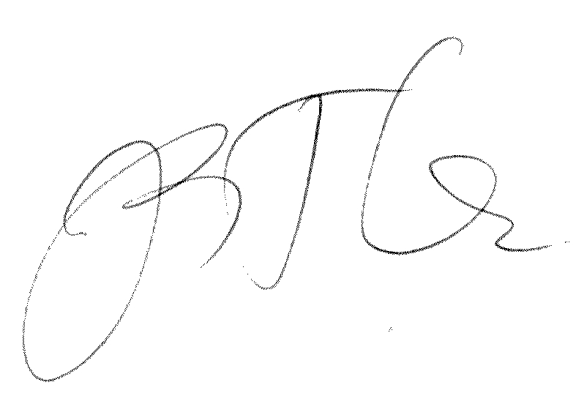
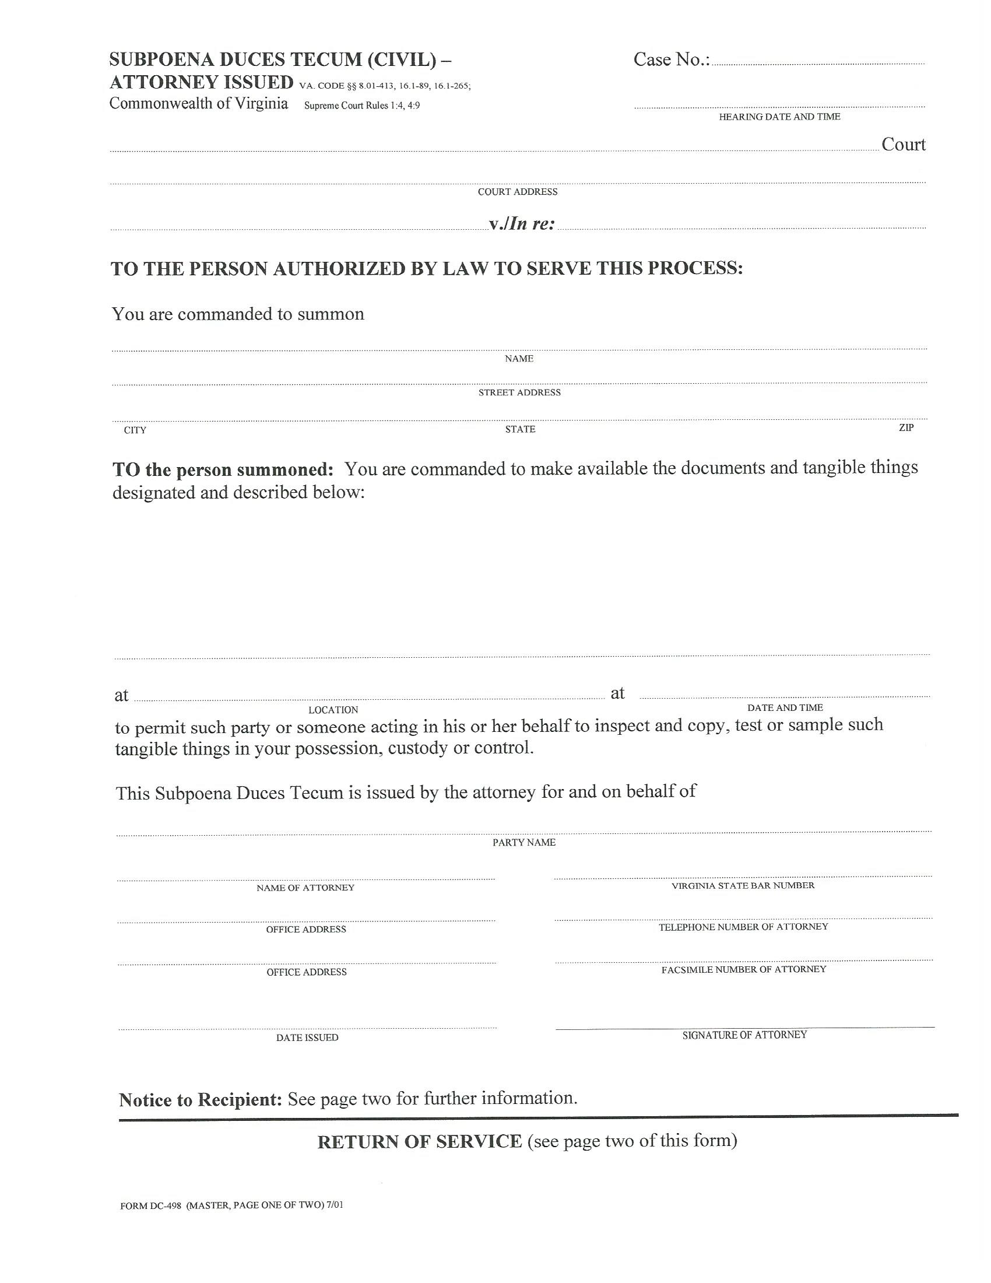
COUNTY COURT

Batman, Plaintiff
V.

Gotham City, Defendant
University of Michigan Hospital and Health Center Release of Information Unit
2901 Hubbard Street Room 2722
Ann Arbor, MI 48109-0000
FROM 01/01/1979 TO PRESENT: Any and all MEDICAL RECORDS, including but not limited to patient history form(s), reports, etc. pertaining to Batman SSN: xxx-xx-5555, DOB: 01/01/1979.
At the offices of: Hanover Law Group - John Doe C/O Axiom Requisition Copy Service
2869 Jolly Road Okemos, MI 48864 (877) 886-5090
John Doe
Smith and Jones PC
123 East Main Street Anywhere, MI 12345
Gotham City

(804) 673-5587
(508) 926-2603

99-99999
At 10:00 AM

(Signature) John Doe
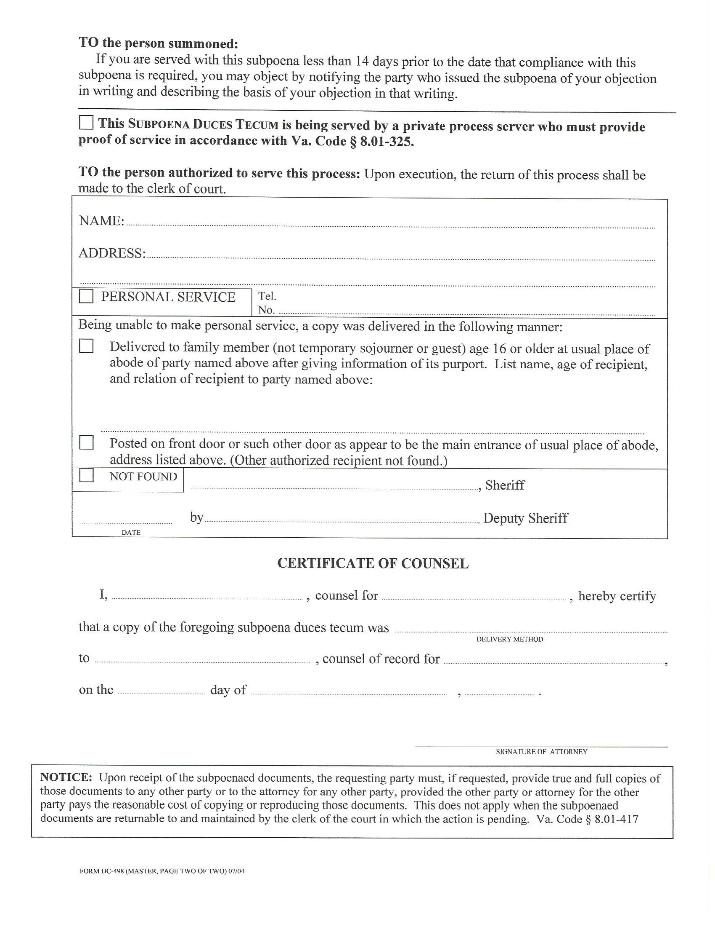
University of Michigan Hospital and Health Center Release of Information Unit
2901 Hubbard Street Room 2722
Ann Arbor, MI 48109-0000

X
John Doe
Gotham City
Mail
Jack Zuk
Batman
