**Task Manager Application**

**Database Design:**

Database used: H2 Spring Database

1. Created database tables. Find the schema below.

* UserType

Columns: UserTypeID, Code, Name

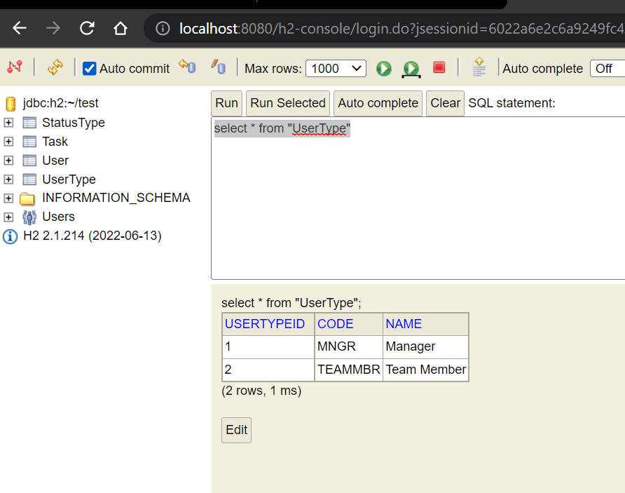

* StatusType

Columns: StatusTypeID, Code, Name

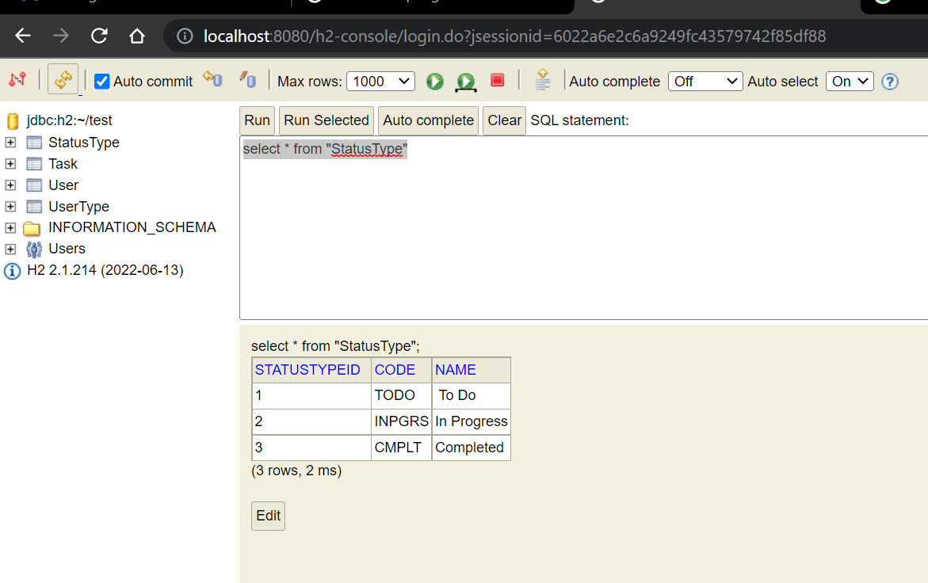

* User

Columns: UserID, UserName, UserTypeID -> UserType. UserTypeID

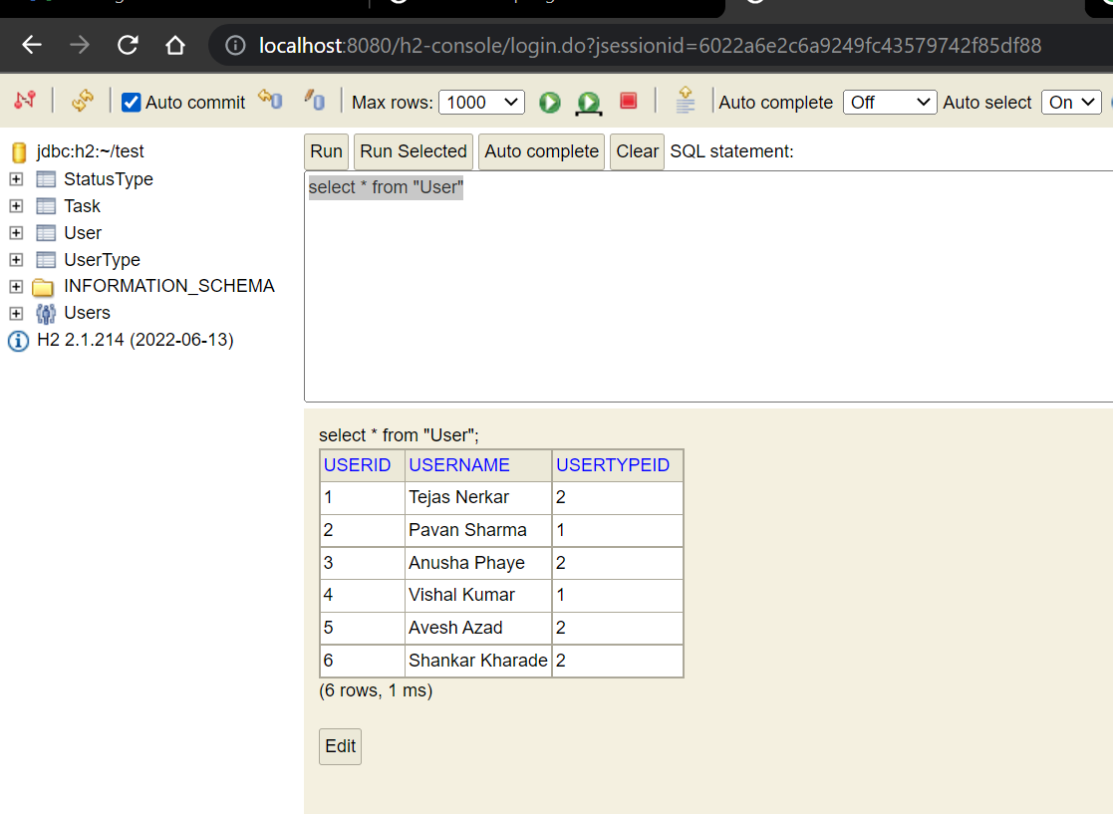

* Task

Columns : TaskID

CreatedBy - > UserType.UserTypeID

AssignedTo-> UserType.UserTypeID

StatusTypeID -> StatusType.StatusTypeID

Details, Comments

1. Rest Endpoints:

* <http://localhost:8080/api/createTask>

Creates task and assign to Team Member:

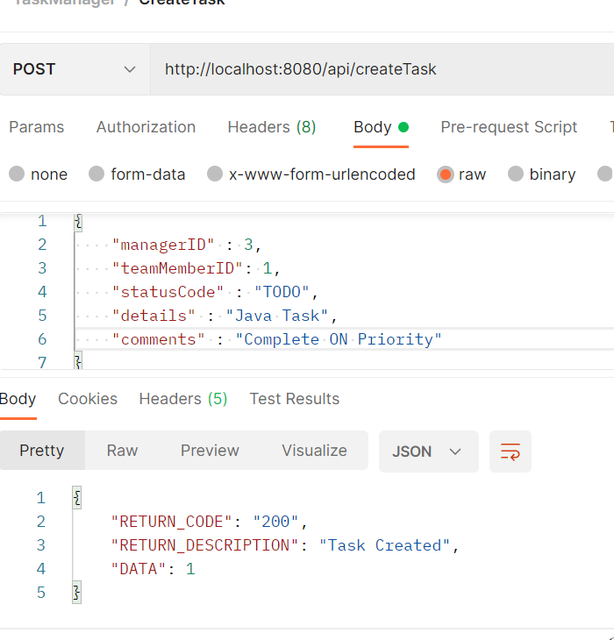

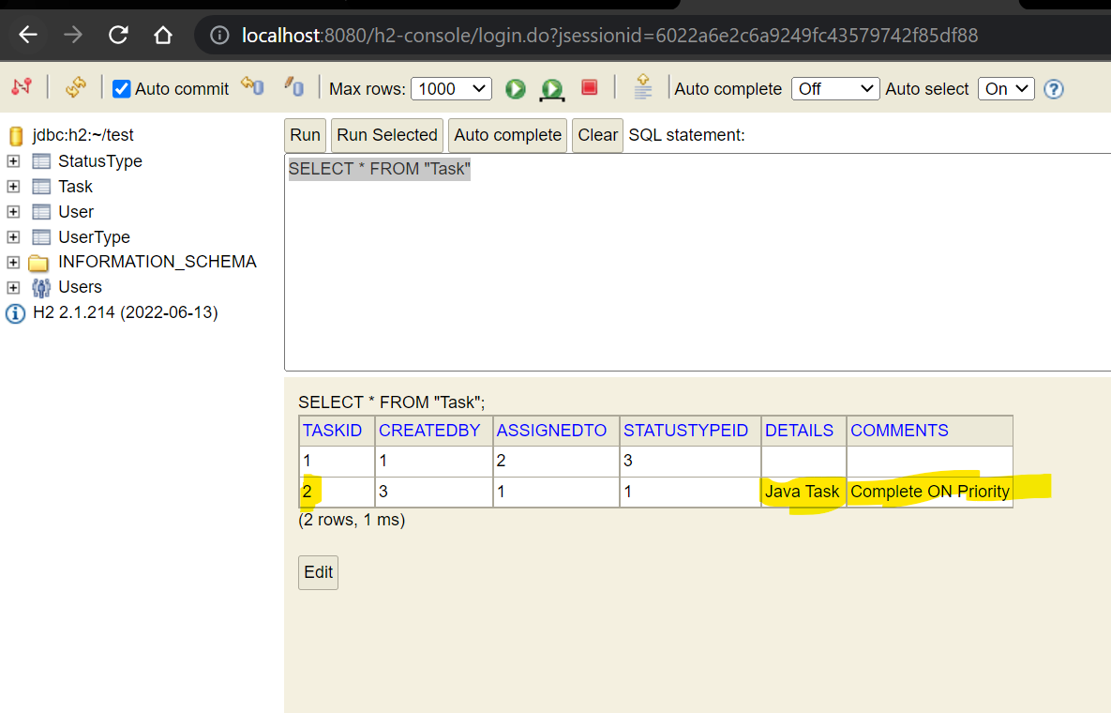

* <http://localhost:8080/api/deleteTask/1>

Manager can delete the task

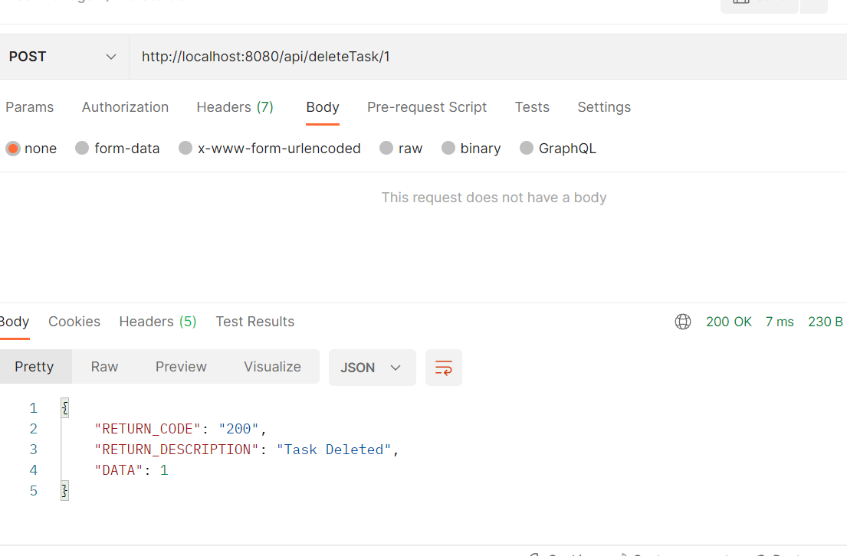

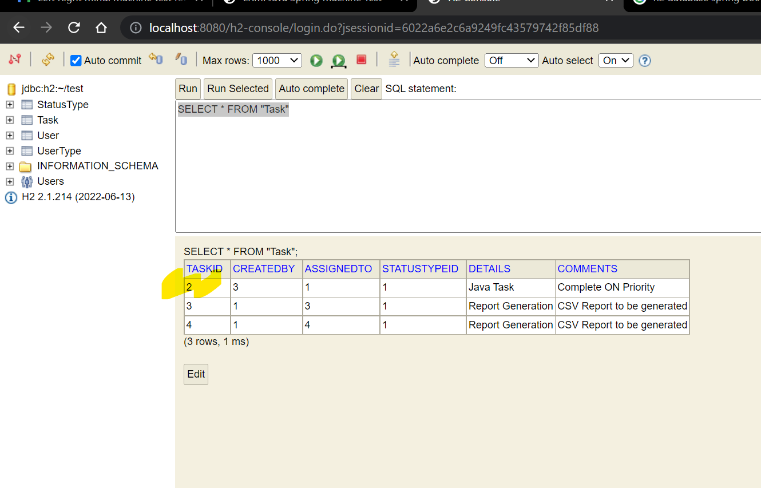

* <http://localhost:8080/api/updateDetails/3>

Manager can update details in task

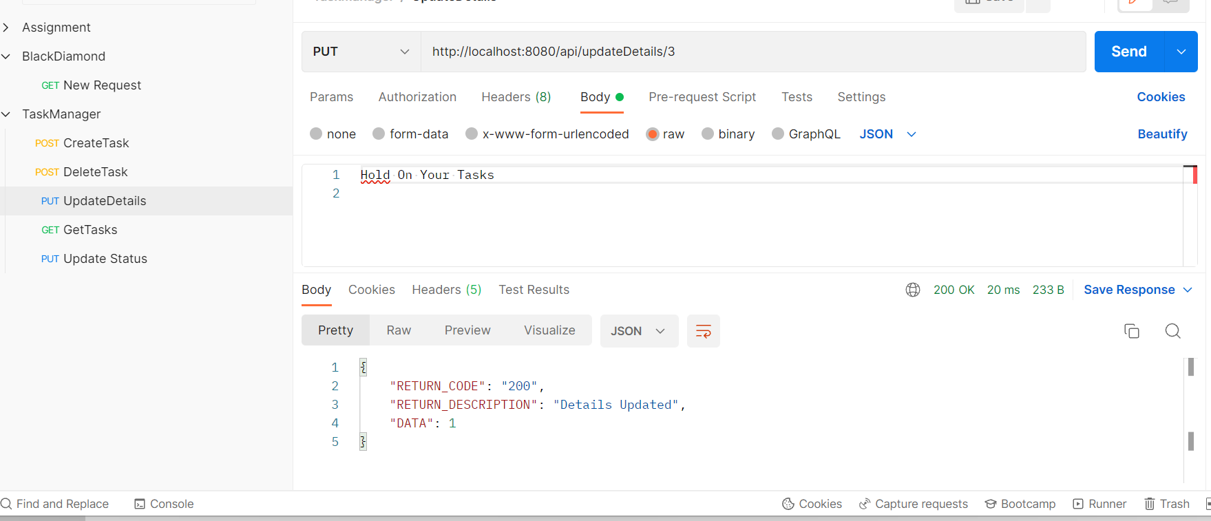

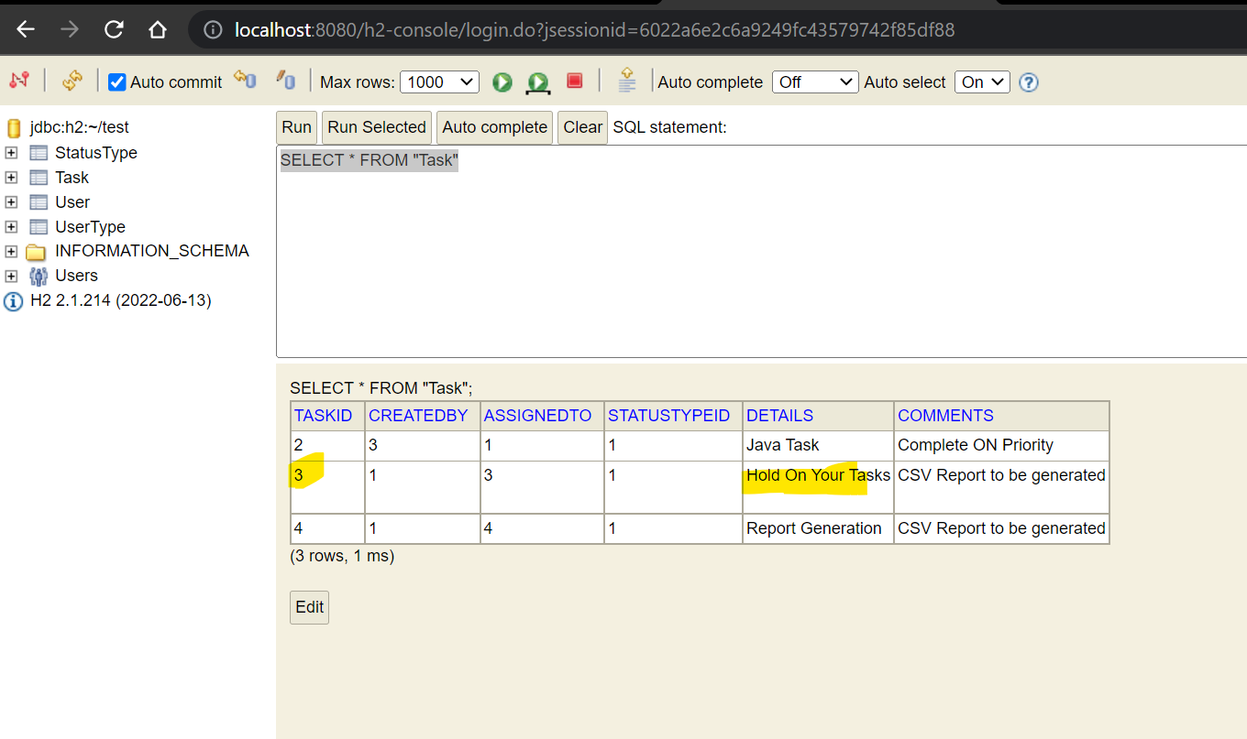

* <http://localhost:8080/api/getAssignedTasks/3>

Team Member can check assigned tasks.

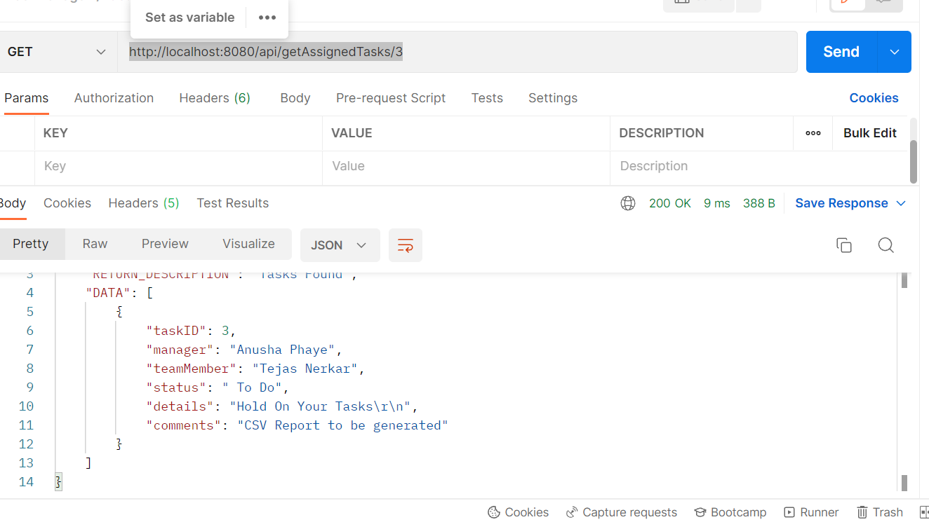

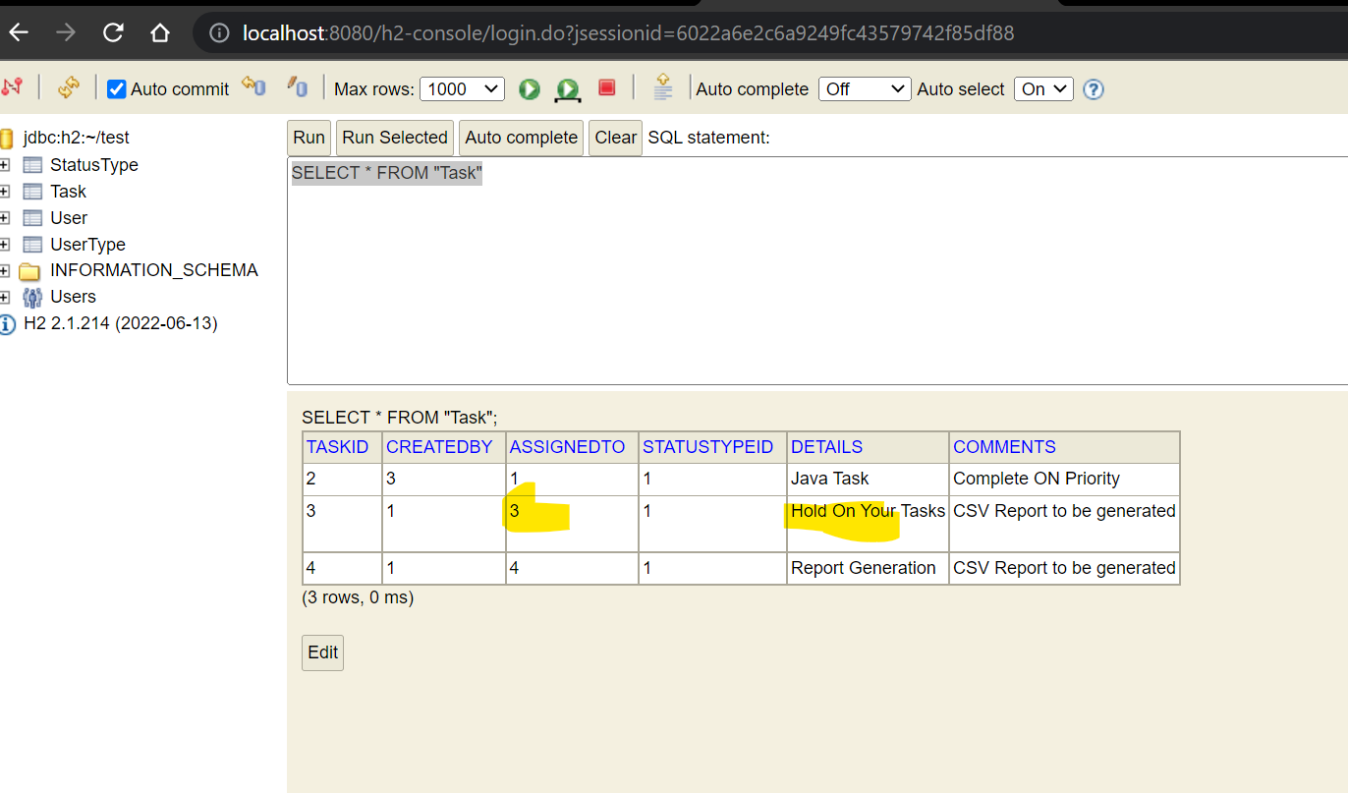

* <http://localhost:8080/api/getAssignedTasks/3?status=CMPLT>

Checks assigned tasks with filter on status

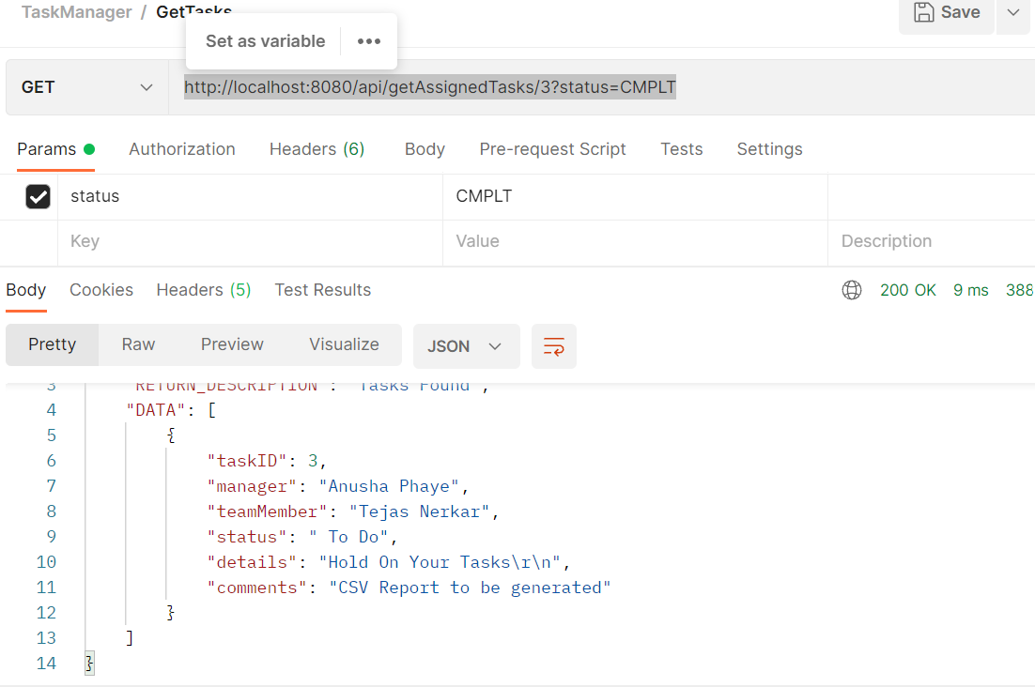

If no assigned tasks, API will return 400 Not found:

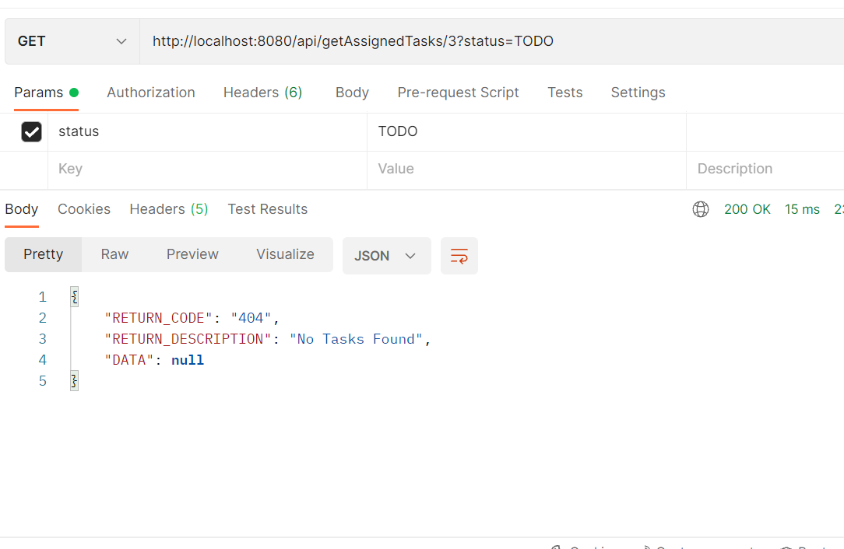

* <http://localhost:8080/api/updateStatus/2/CMPLT>

Updates comments for specific task:

