RESEARCH TREATISE
A Dissertation Submitted to
SVKM’s NMIMS (Deemed To Be University)
In Partial Fulfilment for the Degree of
M.Sc. Statistics and Data Science

Deep Learning for Portfolio Optimization
By: Group 8
Roll No. | Name | Sap ID
A033 | Rajeshwari Majumdar | 86062500055
A034 | Shivam Majumder | 86062500013
A044 | Sarrah Pittalwala | 86062500015
A046 | Jigar Rambhiya | 86062500036
A059 | Tejas Sonwane | 86062500026

Project Supervisor
Dr. Rajesh K. Maurya

Programme chairperson M.Sc. Statistics and Data Science
Nilkamal School of Mathematics, Applied Statistics and Analytics,
SVKM’s Narsee Monjee Institute of Management Studies (Deemed-To-Be-University)
Vile Parle (West), Mumbai – 400056
ACKNOWLEDGEMENT
Words on paper are only ink marks until they carry a purpose. We thank everyone whose guidance and support helped bring this project to completion.
We would like to express our sincere appreciation to our project guide, Dr. Rajesh K. Maurya, for her guidance, patience and constant encouragement. Her feedback shaped both the questions we asked and the care with which we tested them.
We are thankful to the Nilkamal School of Mathematics, Applied Statistics and Analytics (NSoMASA), NMIMS, SVKM, for giving us the opportunity and the resources to carry out this work.
We also acknowledge all professors and staff members of NSoMASA for their suggestions and support, and our families and classmates for their encouragement throughout the project.
ABSTRACT
This project studies whether deep learning can allocate capital across asset classes by directly maximising the Sharpe ratio. We start from the framework of Zhang, Zohren and Roberts (2020), in which an LSTM reads 50 days of prices and returns for four ETFs (stock, bond, commodity, volatility) and outputs long-only portfolio weights through a softmax. We first replicate that strategy and test it against seven benchmarks. We then extend it in two parts.
In Part 1, four models are compared under identical data, loss, optimiser, retraining dates and seeds: (A) the plain LSTM, (B) Attention, (C) LSTM with EIIE and (D) Attention with EIIE. The winner is chosen on validation Sharpe only. The plain LSTM wins (validation Sharpe 2.56) and has the highest test Sharpe in all three experiments. Attention and EIIE are both worse than the LSTM in all three. In Part 2, the same four models are retrained on Indian ETFs (NIFTYBEES, LTGILTBEES, GOLDBEES and India VIX) with the same protocol, using a compact attention encoder close to the LSTM in size. In each experiment, the model with the highest test Sharpe is reported as the experiment winner. Attention wins Experiment 1 (Sharpe 1.49) and Experiment 2 (1.39), and the LSTM wins Experiment 3 (0.59). The validation-selected model is the LSTM, and the margins between the leading models are small compared with the seed-to-seed spread.
The results hold for the designs tested and are not a general verdict on attention or EIIE. In Part 1 the attention models have about 21 times the LSTM’s parameters and memorise the training data. The volatility-scaled results of the paper are only partly reproduced, and only the literal per-asset scaling reading (S0) is reported.
TABLE OF CONTENTS
1. Introduction
2. Rationale
3. Glossary and terminologies
4. Motivation
5. Aim and Objectives
6. Literature Review
7. Data Description
8. Methodology
8.1 Problem Setting and Portfolio Network
8.2 The Four Model Combinations
8.3 Training Protocol
8.4 Backtest: Retraining, Costs and Volatility Scaling
8.5 Performance Measures
8.6 Benchmarks and Fair-Comparison Design
8.7 Adapting the Protocol to Indian ETFs
8.8 Summary of Methodological Framework
9. Analysis and Results
9.1 Replication of the Reference Paper
9.2 Part 1: Model Selection on Validation Data
9.3 Part 1: Test-Period Results
9.4 The 2 x 2 Decomposition
9.5 Holdings, Turnover and Costs
9.6 Reproduction Check of Model A
9.7 Part 2: Four Models on Indian ETFs
10. Discussion and Model Improvement
11. Conclusion and Future Work
12. References
INTRODUCTION
Portfolio construction is usually split into two steps: forecast returns and risks, then optimise weights using those forecasts. Forecasting errors pass straight into the weights. Zhang, Zohren and Roberts (2020) propose a different route. A neural network reads recent market history and outputs portfolio weights directly, and it is trained to maximise the Sharpe ratio of the resulting portfolio. No separate forecasting step is needed.
This project, “Deep Learning for Portfolio Optimization: LSTM, Attention and EIIE Models, with an Application to Indian ETFs”, does three things. First, it replicates the reference paper’s LSTM strategy and compares it with seven benchmark strategies. Second, in Part 1, it asks whether two popular architectural ideas improve the LSTM: a self-attention encoder, and the EIIE topology of Jiang et al. (2017) in which each asset is evaluated by the same small network. The four combinations form a 2 x 2 design. Third, in Part 2, it retrains all four models on four Indian ETFs, names the winner of each experiment, and checks whether the approach carries over to a different market.
Every model is trained and evaluated under one protocol: same data, split, features, loss, optimiser, retraining dates and seeds. The best model is chosen on validation data only, and test-period numbers are reported only after that choice. In Part 2 we also name the winner of each experiment by test Sharpe, and we say clearly where that differs from the validation choice. Where the paper is silent, our implementation choice is recorded as a deviation rather than tuned toward the paper’s numbers.
RATIONALE
Deep learning papers in finance are often hard to trust for three reasons: results are not reproduced independently, additions to a baseline are not tested one at a time, and results from one market are assumed to hold in another. This study addresses each point.
Replication. The reference paper claims that its LSTM strategy ranks first among eight methods in all three experiments. We test this claim by computing all benchmarks ourselves on the same data, and we report which numbers do and do not reproduce.
Controlled comparison. Attention and EIIE are both attractive additions to an LSTM. A 2 x 2 design (LSTM or attention, with or without EIIE) isolates the effect of each one and shows whether the two interact.
A second market. India has a growing ETF market and a large investor base, but its ETF histories are short and some funds trade thinly. Applying the same protocol to Indian ETFs shows what changes when the data are shorter, the assets differ and the liquidity is lower.
TERMINOLOGY OVERVIEW
A
- Adam: Gradient-based optimiser used to train every network (learning rate 1e-3, mini-batch 64, 100 epochs).
- Attention (self-attention): Mechanism that weights every day of the 50-day input against every other day before the output layer.
C
- Cost rate (C): Proportional transaction cost per unit of position change: 0.01% in the base case and 0.1% in the stress case.
D
- Downside deviation (DD): Annualised root-mean-square of negative returns only; denominator of the Sortino ratio.
- DLS: Deep Learning Strategy: the LSTM portfolio model of the reference paper.
E
- E(R): Annualised mean return (252 times the mean daily return).
- EIIE: Ensemble of Identical Independent Evaluators: one shared-weight mini-network per asset, joined only at the softmax (Jiang et al., 2017).
- Expanding window: Each retraining uses all data observed so far.
- Experiment winner: In Part 2, the model with the highest mean test Sharpe in an experiment. It can differ from the validation-selected model.
L
- LSTM: Long Short-Term Memory network, a recurrent network for sequences.
M
- MDD (Maximum Drawdown): Largest peak-to-trough fall of cumulative wealth.
P
- Parameter count: Number of trainable weights in a network; used to judge whether models are compared fairly.
S
- S0: Literal per-asset reading of volatility scaling (scale factor s = 10% / EWM volatility of each asset). It is the only reading reported.
- Seed: Random-number start value for network initialisation and shuffling; results are averaged over seeds 0, 1 and 2.
- Sharpe ratio: Annualised mean return divided by annualised standard deviation (no risk-free rate, as in the paper).
- Softmax: Output layer that makes weights positive and sum to one (long-only, fully invested).
- Sortino ratio: E(R) divided by downside deviation.
T
- Turnover: Mean daily sum of absolute weight changes; a measure of trading intensity.
V
- Validation set: Last 10% of each training window, used for model selection and never for reporting.
- VIX / India VIX: Implied-volatility indices of the S&P 500 and of the Nifty 50. They are indices, not tradable assets.
- Volatility scaling: Resizing positions so that each asset targets 10% annual volatility.
MOTIVATION
Risk-adjusted performance matters more to a portfolio manager than raw return, and the Sharpe ratio is the standard measure. A model trained on the Sharpe ratio itself aligns what the network optimises with what the manager is judged on.
Two questions motivated the extensions. Attention models have transformed sequence modelling, so it is natural to ask whether they find structure in 50 days of prices that an LSTM misses. EIIE promises parameter sharing across assets and a cleaner structure, so it is natural to ask whether it helps when the assets are as different as stocks, bonds, commodities and a volatility index.
For the Indian application, the motivation is practical. If a model trained on four liquid US ETFs also works on Indian ETFs, it becomes a candidate tool for Indian asset allocation. If it does not, the reasons (short history, gold in place of a commodity basket, thin bond ETF trading) tell us what to fix first.
AIM AND OBJECTIVES
Aim
The aim of this project is to evaluate, under a single controlled protocol, whether attention and EIIE improve a Sharpe-trained LSTM portfolio model, and which of the four models works best on Indian ETFs. The reference is “Deep Learning for Portfolio Optimization” by Zhang, Zohren and Roberts (2020).
Objectives
To achieve this aim, the study has the following objectives:
- Replication: To re-implement the reference LSTM strategy and test whether it ranks first against seven independently computed benchmarks.
- Model comparison (Part 1): To compare LSTM, Attention, LSTM + EIIE and Attention + EIIE under identical conditions, and to select the winner on validation Sharpe only.
- Effect isolation: To separate the effect of EIIE and the effect of attention using the 2 x 2 design, over three experiments and three seeds.
- Indian application (Part 2): To retrain all four models on Indian ETFs under the same protocol, to name the winner of each experiment, and to compare the models with fixed-allocation strategies on the same data.
- Transparency: To record every deviation from the paper and every caveat, so that no number is quoted without its limits.
LITERATURE REVIEW
Classical portfolio theory chooses weights from estimated means and covariances, so estimation error feeds directly into the allocation. Learning-based approaches try to avoid this by mapping market history to weights through a network.
Zhang, Zohren and Roberts (2020) train an LSTM on the past 50 days of prices and returns of four ETFs (VTI, AGG, DBC, VIX). The output layer is a softmax, so the weights are long-only and sum to one, and the loss is the negative Sharpe ratio. The model is retrained every two years on an expanding window and tested from 2011 to April 2020, against seven benchmarks, in three experiments with volatility scaling and transaction costs. This is the main paper and the reproduction target.
Jiang, Xu and Liang (2017) introduce the Ensemble of Identical Independent Evaluators (EIIE) for portfolio management. Each asset passes through the same mini-network with shared parameters, and the networks interact only at the softmax. This reduces parameters and imposes a common treatment of assets. Their portfolio-vector memory is not used here because transaction costs are already handled in Zhang’s return equation.
Vaswani et al. (2017) introduce scaled dot-product and multi-head self-attention with positional encoding, which lets a model relate every time step to every other. Esslinger, Platt and Amato (2022) apply self-attention over a fixed 50-step history with learned positional encodings in Deep Transformer Q-Networks. We borrow only the encoder design, not the Q-learning loss, and keep the Sharpe loss for all models.
Building on these, the present study asks two questions the papers do not answer together: does attention or EIIE improve the Sharpe-trained LSTM when everything else is held fixed, and does the result transfer to a market with different assets and a shorter history?
DATA DESCRIPTION
Part 1: US ETFs (replication and model comparison)
The data are daily observations for four assets, one for each asset class: VTI (US stocks), AGG (US bonds), DBC (commodities) and ^VIX (volatility index). The sample runs from 7 February 2006 to 29 April 2020 and contains 3,581 trading days. Dividend-adjusted closing prices (Adj Close) are used for both features and returns. All validation checks passed: dates strictly increasing, no missing or non-positive prices, and no calendar gap longer than 5 days.
Each input window is the past 50 days of the closing price and daily return of each asset, which gives 50 x 8 = 400 features. Features are z-scored with means and standard deviations computed only from rows before each retraining date, so no future information is used.
Table 1. Annualised mean and standard deviation of daily returns, US sample (2006–2020)
Asset | Class | Annualised mean | Annualised std
VTI | Stock | 0.101 | 0.203
AGG | Bond | 0.045 | 0.051
DBC | Commodity | -0.030 | 0.194
^VIX | Volatility | 0.825 | 1.287

Part 2: Indian ETFs
The Indian counterparts were downloaded from Yahoo Finance (yfinance). The youngest series, LTGILTBEES, sets the start of the common sample (11 May 2018). Its early history is sparse (about weekly, followed by a 167-day hole ending 20 June 2019), so the study uses 21 June 2019 to 30 October 2026, which is 1,777 trading days.
Table 2. Asset mapping from US to India
Asset class | US (Part 1) | India (Part 2) | Note
Stock | VTI | NIFTYBEES.NS | Nifty 50 ETF
Bond | AGG | LTGILTBEES.NS | Long-term gilt ETF, thinly traded
Commodity | DBC | GOLDBEES.NS | Gold only, not a broad basket
Volatility | ^VIX | ^INDIAVIX | Index, not tradable

Data cleaning. Yahoo’s adjusted price is not always split-adjusted for Indian ETFs. Daily moves above 30% in absolute value (NIFTYBEES on 19 and 23 December 2019, GOLDBEES on the same dates, with price ratios of 0.10, 9.97, 0.01 and 100) are un-adjusted splits, not returns. Those four returns were set to zero and the price series were rebuilt from the cleaned returns. ^INDIAVIX is exempt, because it has genuine daily moves of up to 66%.
Table 3. Liquidity and data-quality diagnostics, Indian sample (full sample)
Series | Zero-return days (%) | Zero-volume days (%) | Max |daily return| | Ann. mean | Ann. std
NIFTYBEES.NS | 0.451 | 0.169 | 0.102 | 0.119 | 0.159
LTGILTBEES.NS | 9.408 | 0.000 | 0.194 | 0.067 | 0.125
GOLDBEES.NS | 1.352 | 0.113 | 0.105 | 0.209 | 0.181
^INDIAVIX | 0.676 | 100.000 | 0.656 | 0.395 | 0.906

LTGILTBEES has zero return on 9.4% of days, a sign of stale prices, so its measured volatility is probably too low. ^INDIAVIX has zero volume by construction because it is an index.
METHODOLOGY
The study uses one pipeline for all models. Only the network that maps the input window to the portfolio weights changes. This section sets out the model, the training rules, the backtest and the performance measures.
8.1 Problem Setting and Portfolio Network
At the close of day t, the network sees the last 50 days of price and return for each of the four assets and outputs a vector of four weights. The return of the portfolio on day t+1 is the weighted sum of the four asset returns. The network is trained to maximise the Sharpe ratio of these portfolio returns, so the loss is the negative Sharpe ratio of a mini-batch:
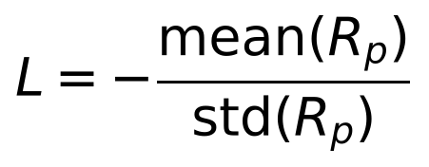
The raw network outputs z are turned into weights by a softmax, so the weights are positive and sum to one (long-only, fully invested):
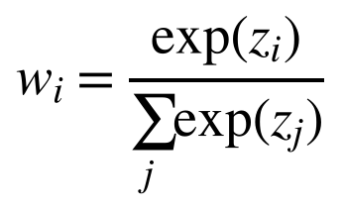
8.2 The Four Model Combinations
The four models differ only in what they read and how they encode it. EIIE is a network topology, not an evaluation method: each stream sees only its own asset, and the streams interact only at the softmax. The attention starting point (2 layers, 8 heads, model width 128) was adapted from the DTQN encoder and tuned on validation data of the first window only (before 2011), so no test-period information was used. In Part 2 a compact attention encoder (1 layer, 4 heads, model width 32, about 14,800 parameters) is used instead, so that its size is close to the LSTM’s (Section 8.7).
Table 4. The four model combinations
Model | Input to the network | Encoder | Output
A. LSTM (baseline) | All 4 assets together (50 x 8) | Single-layer LSTM, 64 units | 4 raw weights
B. Attention | Same as A | Embedding + positional encoding, multi-head self-attention over 50 days | 4 raw weights
C. LSTM + EIIE | Each asset alone (50 x 2), one stream per asset | The same LSTM shared across the 4 streams | 1 score per asset
D. Attention + EIIE | Each asset alone (50 x 2), one stream per asset | The same attention encoder shared across streams | 1 score per asset
8.3 Training Protocol
The protocol below is fixed for all models. Hyperparameters were chosen on validation data only.
Table 5. Training and evaluation protocol
Item | Setting
Objective | Maximise Sharpe ratio directly by gradient ascent; no return-forecasting step
Output layer | Softmax: long-only weights summing to 1
Optimiser | Adam, learning rate 1e-3, mini-batch 64, 100 epochs
Validation | Last 10% of each training window (chronological, not random)
Input scaling | z-score using statistics from rows before each retraining date only
Seeds | 0, 1, 2; reported numbers are means over the three seeds
Retraining | Every 2 years on an expanding window
8.4 Backtest: Retraining, Costs and Volatility Scaling
Retraining timeline. In Part 1 the model is retrained on 1 January of 2011, 2013, 2015, 2017 and 2019, and each model is used until the next retraining date. The test period runs from 2011 to 29 April 2020 and includes the COVID-19 crash. A leakage check confirms that every input row used at a retraining date is dated before it.
Costs and volatility scaling. Three experiments are run. Experiment 1 has no volatility scaling and a cost rate C = 0.01%. Experiment 2 scales to a 10% volatility target with C = 0.01%. Experiment 3 scales to the same target with a stress cost rate C = 0.1%. The scaled return follows the paper’s Eq. (7): positions are the weights times a scale factor, and a cost is charged on every change of position.
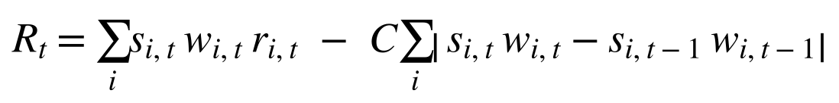
The paper does not say exactly how the scale factor s is formed. We use the literal reading, S0: per-asset scaling, with s = 10% / EWM volatility of the asset. Volatility is an exponentially weighted standard deviation with a 50-day span. This gives three experiments in all: Exp 1, Exp 2 and Exp 3. To keep the experiments simple, only S0 is reported. Other readings of the scale factor (for example, scaling the whole portfolio to 10%) are possible and could change the volatility-scaled results, so Exp 2 and Exp 3 should be read as S0 results only.
8.5 Performance Measures
All measures are annualised with 252 trading days, as in the paper. E(R) is 252 times the mean daily return. Std is the daily standard deviation times the square root of 252. The Sharpe ratio is E(R)/Std with no risk-free rate. The Sortino ratio is E(R) divided by the downside deviation:
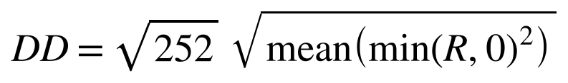
We also report maximum drawdown (MDD), the share of positive days, and average profit divided by average loss. The paper gives no explicit formulas for these, so the standard definitions are used.
8.6 Benchmarks and Fair-Comparison Design
Benchmarks (replication). Four fixed allocations (stock/bond/commodity/volatility: 25/25/25/25, 50/10/20/20, 10/50/20/20 and 40/40/10/10, rebalanced on the first trading day of each year), plus Mean-Variance, Maximum Diversification and Deep-Weighted-Portfolio strategies. All are computed by us on the same data.
Fair comparison. All four models share data, split, features, loss, optimiser and seeds. A vs C and B vs D isolate the effect of EIIE. A vs B and C vs D isolate the effect of attention. The winner is chosen by validation Sharpe, and the test period is used once, for final reporting. The reproduction target is Table 1 of the paper (LSTM model):
Table 6. Reproduction target: the paper’s LSTM strategy
Setting | Sharpe | Sortino | E(R) | MDD
No scaling, C = 0.01% | 1.858 | 3.135 | 0.313 | 0.102
Vol scaling 10%, C = 0.01% | 1.962 | 3.322 | 0.206 | 0.123
Vol scaling 10%, C = 0.1% | 1.403 | 2.327 | 0.148 | 0.125
8.7 Adapting the Protocol to Indian ETFs
In Part 2 all four models (A to D) are trained under the same protocol on the four Indian series. The 50-day window (now 50 x 8 features), the loss, the optimiser, the validation rule, the seeds, the three experiments and the S0 scaling are unchanged. The validation-selected model is chosen on the first retraining window (before 2022). In each experiment we also report the model with the highest mean test Sharpe as the experiment winner. The validation choice is the pre-declared selection rule, and the experiment winner is a descriptive test result. Four things change, each flagged as a deviation:
- Retraining dates are computed from the data. The US dates are impossible with a history that starts in 2019. The first retraining date is the first 1 January with at least 500 training samples, then every 2 years. This gives 2022, 2024 and 2026.
- Benchmarks. The four fixed allocations are kept as reference strategies. They do not depend on training, and their results come from the earlier run of the benchmark code, not from the four-model run. Mean-Variance, Maximum Diversification and DWP are not repeated.
- Data cleaning. Un-adjusted split days are neutralised, dates where any series is missing are dropped, and the sparse early rows of LTGILTBEES are removed.
- Compact attention encoder. The Part 1 attention encoder (404,868 parameters) is replaced by a compact one (1 layer, 4 heads, model width 32, no dropout). Model B has 14,788 parameters and Model D has 14,497, about 0.77 and 0.83 times the size of their LSTM counterparts (A and C), so the comparison is closer to a matched-capacity test than in Part 1.
Table 7. Retraining timeline, Indian ETFs
Retrain date | Train samples | Validation samples | Test samples | Test period
1 Jan 2022 | 506 | 56 | 475 | 3 Jan 2022 – 29 Dec 2023
1 Jan 2024 | 933 | 104 | 486 | 2 Jan 2024 – 31 Dec 2025
1 Jan 2026 | 1,371 | 152 | 203 | 2 Jan 2026 – 30 Oct 2026
8.8 Summary of Methodological Framework
The framework has four stages, applied identically to every model: (1) prepare the data and build 50-day windows; (2) train and select, training models A to D for every seed and retraining date and picking the winner on validation Sharpe before any test number is shown; (3) evaluate in three experiments against benchmarks, with the 2 x 2 decomposition and a look at holdings, turnover and costs; (4) check and transfer, confirming that Model A reproduces the paper and then retraining all four models on Indian ETFs, naming the winner of each experiment, with every deviation reported.
ANALYSIS AND RESULTS
9.1 Replication of the Reference Paper
The paper’s LSTM strategy (50-day window, 64 LSTM units, softmax weights, Sharpe loss) was re-implemented and compared with seven benchmarks that were all computed independently. Retraining is on an expanding window at 2011, 2013, 2015, 2017 and 2019, and the test period runs from 2011 to 29 April 2020.
Table 8. Replication: paper against our DLS (V1, seed 0)
Experiment | Paper Sharpe | Replicated DLS | DLS rank (of 8)
Exp 1: no vol scaling | 1.858 | 1.997 | 1
Exp 2: vol target 10% | 1.962 | 0.972 | 8
Exp 3: vol target, C = 0.1% | 1.403 | 0.713 | 7

DLS ranks first in Exp 1 only, so the paper’s claim that it ranks first throughout is not reproduced. Under S0 the realised volatility of every method is 0.04 to 0.08, against 0.10 to 0.11 in the paper, which is why S0 does not match. The fixed-allocation benchmarks also differ in Exp 1 (for example Allocation 1 Sharpe 0.35 against 0.93). A diagnostic shows that daily rebalancing on adjusted close gets closer (0.81), so the paper probably rebalanced more often than once a year.
9.2 Part 1: Model Selection on Validation Data
Model A has the highest validation Sharpe (2.56). The attention models have about 21 times the LSTM’s parameters and memorise the training period: for Model B the train Sharpe is 19.7 and the validation Sharpe is 1.8.
Table 9. Model selection (validation only)
Model | Parameters | Train Sharpe | Validation Sharpe | Seed sd | Params vs A
A. LSTM | 19,204 | 11.23 | 2.562 | 0.348 | 1.0x
B. Attention | 404,868 | 19.69 | 1.775 | 0.463 | 21.1x
C. LSTM + EIIE | 17,473 | 3.99 | 2.051 | 0.090 | 0.9x
D. Attention + EIIE | 403,713 | 6.64 | 0.913 | 0.259 | 21.0x

Table 10. Validation Sharpe by retraining date (mean over seeds)
Year | A | B | C | D
2011 | 3.09 | 3.03 | 1.83 | 1.78
2013 | 1.66 | 0.57 | 2.42 | 1.09
2015 | 2.98 | 1.02 | 1.17 | -1.30
2017 | 3.07 | 2.56 | 2.57 | 1.46
2019 | 2.00 | 1.69 | 2.26 | 1.55

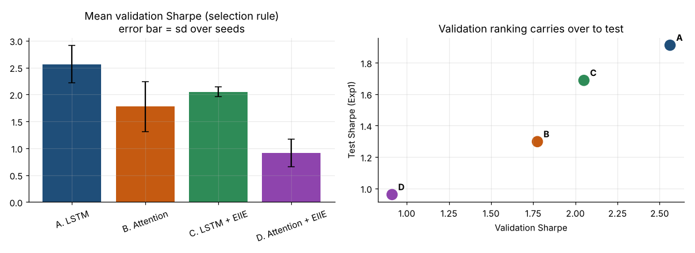
Figure 1. Validation Sharpe (the selection rule) and its relation to test Sharpe.
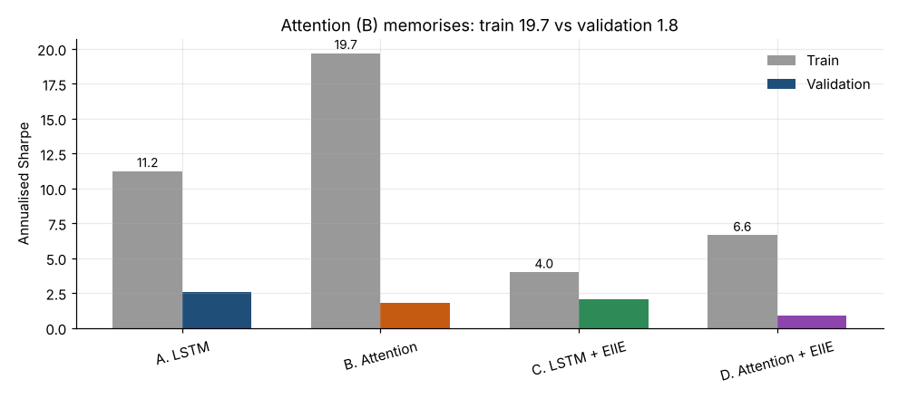
Figure 2. Train against validation Sharpe: attention memorises the training period.
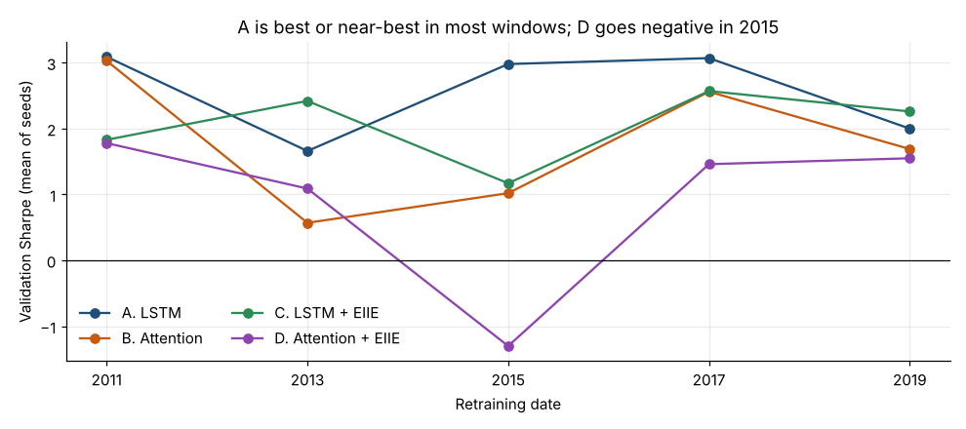
Figure 3. Validation Sharpe by retraining date.
Because parameter counts differ so much, a validation win for Model A may partly reflect capacity rather than architecture. This is one of the caveats in Section 10. Part 2 uses a compact attention encoder of about the LSTM’s size for this reason.
9.3 Part 1: Test-Period Results
The tables show means over three seeds for the test period 2011 to April 2020. Columns are annualised return E(R), standard deviation, Sharpe, downside deviation (DD), Sortino, maximum drawdown (MDD), share of positive days, average profit over average loss (P/L), and the seed-to-seed standard deviation of Sharpe.
Table 11. Exp 1: no volatility scaling, C = 0.01%
Model | E(R) | Std | Sharpe | DD | Sortino | MDD | % Pos | P/L | Sharpe sd
A. LSTM | 0.239 | 0.125 | 1.912 | 0.071 | 3.351 | 0.168 | 0.532 | 1.304 | 0.060
B. Attention | 0.157 | 0.122 | 1.298 | 0.076 | 2.130 | 0.251 | 0.535 | 1.118 | 0.479
C. LSTM + EIIE | 0.935 | 0.553 | 1.688 | 0.259 | 3.611 | 0.352 | 0.499 | 1.504 | 0.043
D. Attention + EIIE | 0.551 | 0.573 | 0.961 | 0.320 | 1.752 | 0.512 | 0.504 | 1.248 | 0.305
Table 12. Exp 2: vol target 10%, C = 0.01%, S0 (literal Eq. 7, headline)
Model | E(R) | Std | Sharpe | DD | Sortino | MDD | % Pos | P/L | Sharpe sd
A. LSTM | 0.078 | 0.078 | 1.004 | 0.056 | 1.394 | 0.246 | 0.550 | 0.981 | 0.036
B. Attention | 0.052 | 0.079 | 0.659 | 0.058 | 0.903 | 0.258 | 0.542 | 0.949 | 0.362
C. LSTM + EIIE | 0.060 | 0.089 | 0.675 | 0.060 | 0.996 | 0.217 | 0.510 | 1.083 | 0.056
D. Attention + EIIE | 0.026 | 0.096 | 0.274 | 0.068 | 0.390 | 0.220 | 0.506 | 1.026 | 0.140
Table 13. Exp 3: vol target 10%, C = 0.1%, S0
Model | E(R) | Std | Sharpe | DD | Sortino | MDD | % Pos | P/L | Sharpe sd
A. LSTM | 0.010 | 0.078 | 0.133 | 0.058 | 0.178 | 0.360 | 0.518 | 0.952 | 0.077
B. Attention | -0.149 | 0.080 | -1.861 | 0.065 | -2.290 | 0.763 | 0.459 | 0.852 | 0.388
C. LSTM + EIIE | -0.032 | 0.089 | -0.366 | 0.063 | -0.507 | 0.360 | 0.474 | 1.039 | 0.298
D. Attention + EIIE | -0.239 | 0.098 | -2.443 | 0.078 | -3.044 | 0.897 | 0.417 | 0.911 | 0.528
Table 14. Test Sharpe of all four models in the three experiments
Setting | A | B | C | D | Best
Exp1 none | 1.912 | 1.298 | 1.688 | 0.961 | A
Exp2 S0 | 1.004 | 0.659 | 0.675 | 0.274 | A
Exp3 S0 | 0.133 | -1.861 | -0.366 | -2.443 | A

Model A has the highest test Sharpe in all three experiments. Raising the cost rate from 0.01% to 0.1% hurts B and D the most.
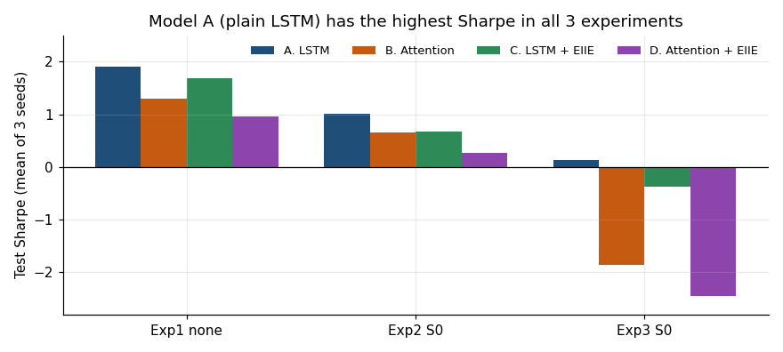
Figure 4. Test Sharpe of all four models in every experiment.
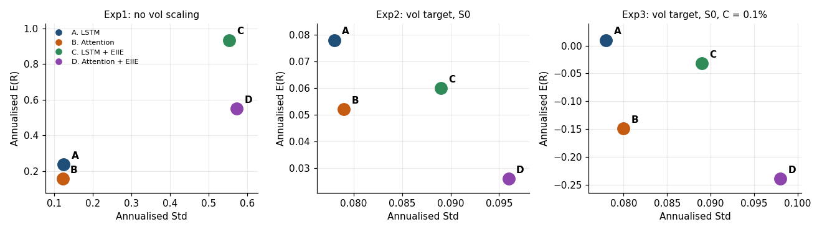
Figure 5. Return against risk. EIIE models take far more risk without more return.
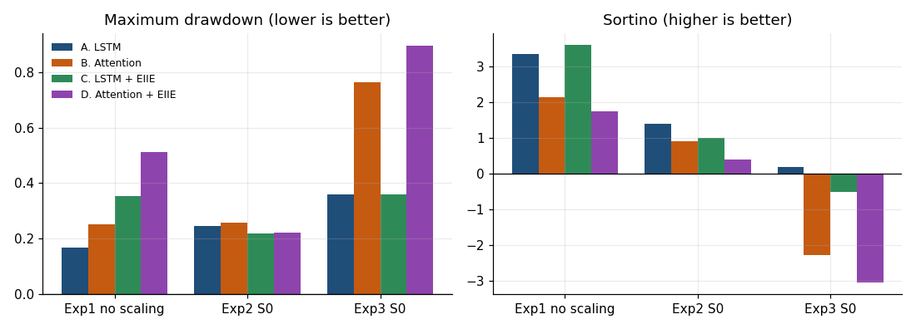
Figure 6. Maximum drawdown and Sortino across the three experiments.
9.4 The 2 x 2 Decomposition
The table shows the Sharpe difference (mean over seeds). The k/n in brackets is the number of seeds in which the difference is positive.
Table 15. Effect of EIIE and of attention on test Sharpe
Setting | EIIE: C−A | EIIE: D−B | Attention: B−A | Attention: D−C
Exp1 none | -0.223 (0/3) | -0.338 (1/3) | -0.613 (0/3) | -0.728 (0/3)
Exp2 S0 | -0.329 (0/3) | -0.385 (1/3) | -0.346 (1/3) | -0.401 (0/3)
Exp3 S0 | -0.499 (0/3) | -0.581 (1/3) | -1.994 (0/3) | -2.077 (0/3)

On validation data, the LSTM has Sharpe 2.562 without EIIE and 2.051 with it (−0.511), and attention has 1.775 without EIIE and 0.913 with it (−0.862). The attention effect is −0.788 without EIIE and −1.138 with it. Attention hurts in all three experiments, and so does EIIE.
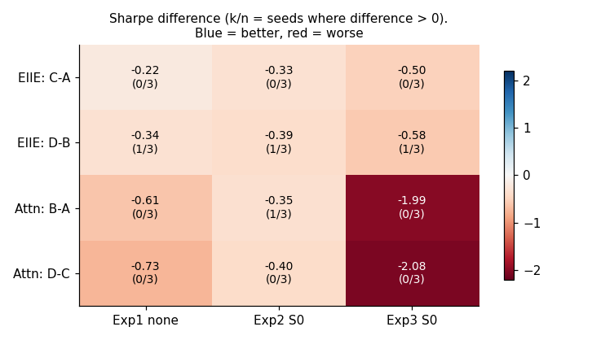
Figure 7. 2 x 2 effects of EIIE and attention by experiment.
9.5 Holdings, Turnover and Costs
Table 16. Average allocation and turnover over the test period
Model | Stock | Bond | Commodity | Volatility | Turnover
A. LSTM | 0.511 | 0.222 | 0.178 | 0.090 | 0.188
B. Attention | 0.514 | 0.297 | 0.119 | 0.069 | 0.577
C. LSTM + EIIE | 0.039 | 0.042 | 0.522 | 0.398 | 0.497
D. Attention + EIIE | 0.198 | 0.253 | 0.285 | 0.263 | 0.971

- EIIE: Model C holds almost no stock or bond. With one shared encoder and no asset identity, the network can tell assets apart only through their input values. This is a plausible reason for its Std of 0.55 in Exp 1, but it is a hypothesis, not a tested result.
- Attention: turnover is 0.58 for B and 0.97 for D against 0.19 for A, so raising costs from 0.01% to 0.1% hurts them most (Exp 3 S0 Sharpe −1.86 and −2.44).
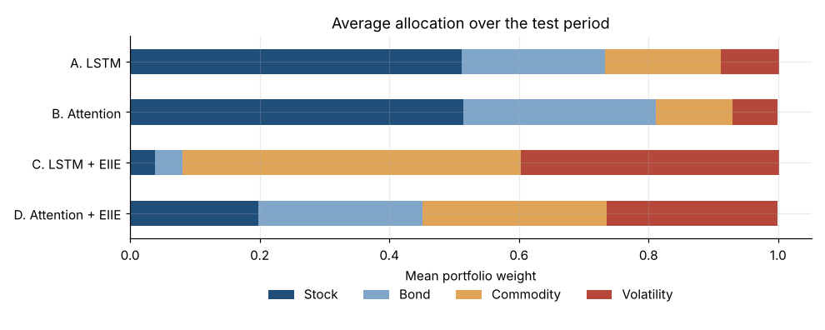
Figure 8. Average allocation over the test period (seed 0).
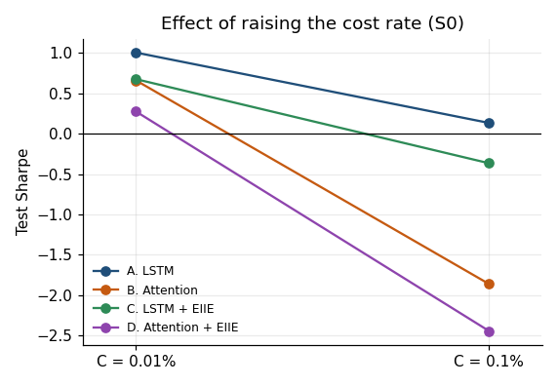
Figure 9. Effect of raising the cost rate.
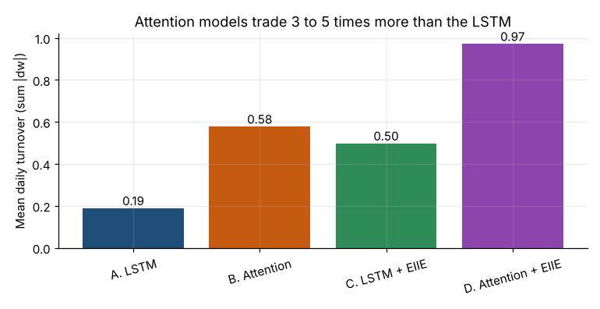
Figure 10. Mean daily turnover.
9.6 Reproduction Check of Model A
Table 17. Model A against the paper
Setting | Metric | Ours (mean) | Paper | Difference
Exp1 none | Sharpe | 1.912 | 1.858 | +0.054
Exp1 none | Sortino | 3.351 | 3.135 | +0.216
Exp1 none | E(R) | 0.239 | 0.313 | -0.074
Exp1 none | MDD | 0.168 | 0.102 | +0.066
Exp2 S0 | Sharpe | 1.004 | 1.962 | -0.958
Exp3 S0 | Sharpe | 0.133 | 1.403 | -1.270

Model A matches the paper without volatility scaling (Sharpe 1.91 against 1.86) but not with it. Under S0, our scaled Sharpe ratios are about half of the paper’s in Exp 2 and far below it in Exp 3.
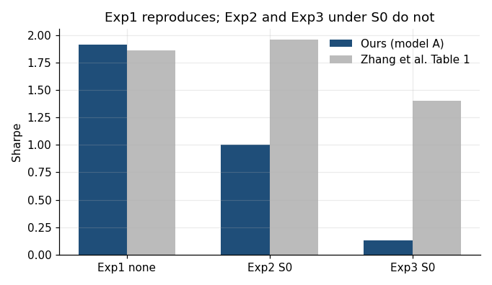
Figure 11. Model A against the paper’s Table 1.
9.7 Part 2: Four Models on Indian ETFs
All four models were retrained on the four Indian series for each seed and each retraining date (2022, 2024, 2026). The test period is 3 January 2022 to 30 October 2026 (1,164 days). The 36 model fits (4 models x 3 seeds x 3 windows) took about 30 minutes on a CPU.
Model selection on validation data
Table 18. Model selection on the first validation window (retraining date 1 January 2022)
Model | Parameters | Params vs A | Val Sharpe (mean) | Seed sd | Seed values
A. LSTM | 19,204 | 1.0x | 1.564 | 1.854 | 3.704, 0.450, 0.538
B. Attention | 14,788 | 0.77x | -0.049 | 0.141 | 0.046, -0.211, 0.018
C. LSTM + EIIE | 17,473 | 0.91x | 0.307 | 1.273 | -1.162, 1.004, 1.079
D. Attention + EIIE | 14,497 | 0.75x | 0.498 | 1.409 | 1.657, 0.908, -1.071

Model A (LSTM) has the highest validation Sharpe (1.56) and is the validation-selected model. The first validation set has only 56 samples, and the seed spread of Model A (1.85) is larger than its mean, so this selection is provisional.
Test-period performance
The tables show the four models (mean over three seeds) in the three experiments. The row in bold is the experiment winner, the model with the highest test Sharpe in that experiment.
Table 19. Exp 1: no volatility scaling, C = 0.01%
Model | E(R) | Std | Sharpe | DD | Sortino | MDD | % Pos | P/L | Sharpe sd
A. LSTM | 0.152 | 0.113 | 1.334 | 0.068 | 2.258 | 0.122 | 0.535 | 1.121 | 0.293
B. Attention | 0.140 | 0.094 | 1.494 | 0.061 | 2.318 | 0.113 | 0.538 | 1.119 | 0.195
C. LSTM + EIIE | 0.377 | 0.589 | 0.644 | 0.336 | 1.125 | 0.516 | 0.482 | 1.239 | 0.117
D. Attention + EIIE | 0.448 | 0.608 | 0.738 | 0.334 | 1.362 | 0.504 | 0.491 | 1.234 | 0.235
Table 20. Exp 2: vol target 10%, C = 0.01%, S0
Model | E(R) | Std | Sharpe | DD | Sortino | MDD | % Pos | P/L | Sharpe sd
A. LSTM | 0.099 | 0.087 | 1.150 | 0.059 | 1.696 | 0.105 | 0.540 | 1.035 | 0.207
B. Attention | 0.128 | 0.093 | 1.389 | 0.062 | 2.077 | 0.105 | 0.546 | 1.047 | 0.250
C. LSTM + EIIE | 0.093 | 0.090 | 1.037 | 0.052 | 1.798 | 0.090 | 0.498 | 1.229 | 0.182
D. Attention + EIIE | 0.103 | 0.101 | 1.020 | 0.057 | 1.823 | 0.092 | 0.504 | 1.207 | 0.226
Table 21. Exp 3: vol target 10%, C = 0.1%, S0
Model | E(R) | Std | Sharpe | DD | Sortino | MDD | % Pos | P/L | Sharpe sd
A. LSTM | 0.052 | 0.087 | 0.587 | 0.061 | 0.844 | 0.135 | 0.521 | 1.018 | 0.219
B. Attention | 0.018 | 0.094 | 0.186 | 0.066 | 0.265 | 0.189 | 0.507 | 1.004 | 0.358
C. LSTM + EIIE | 0.051 | 0.090 | 0.570 | 0.053 | 0.955 | 0.109 | 0.481 | 1.205 | 0.198
D. Attention + EIIE | -0.015 | 0.102 | -0.142 | 0.061 | -0.235 | 0.205 | 0.457 | 1.157 | 0.068
Table 22. Test Sharpe of all four models on Indian ETFs, with the experiment winner
Setting | A | B | C | D | Winner
Exp1 none | 1.334 | 1.494 | 0.644 | 0.738 | B
Exp2 S0 | 1.150 | 1.389 | 1.037 | 1.020 | B
Exp3 S0 | 0.587 | 0.186 | 0.570 | -0.142 | A

Attention (B) is the experiment winner in Exp 1 (Sharpe 1.49 against 1.33 for the LSTM) and in Exp 2 (1.39 against 1.15). The LSTM (A) wins Exp 3, where the cost rate is ten times higher (0.59, with Model C close behind at 0.57), and it is also the model chosen on validation data. The EIIE models (C and D) take much more risk in Exp 1 (Std 0.59 and 0.61 against 0.09 for B and 0.11 for A) and win no experiment. The margins between the leading models are small compared with the seed spread (Sharpe sd 0.2 to 0.25 for the winners), so with three seeds the Exp 1 and Exp 2 results should not be read as a firm ranking. B trades more than A (mean daily weight turnover 0.30 against 0.13), which is why its Sharpe falls from 1.39 to 0.19 when the cost rate is raised.
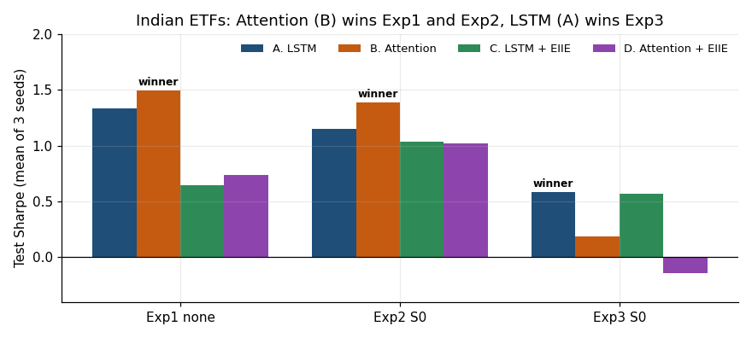
Figure 12. Test Sharpe of the four models on Indian ETFs in each experiment.
Table 23. Paired-seed Sharpe difference against the LSTM (k/n = seeds in which the model beats the LSTM)
Setting | Attention: B−A | EIIE: C−A | Both: D−A | Test leader
Exp1 none | +0.159 (2/3) | -0.690 (0/3) | -0.597 (0/3) | B
Exp2 S0 | +0.238 (2/3) | -0.113 (1/3) | -0.130 (1/3) | B
Exp3 S0 | -0.400 (0/3) | -0.017 (2/3) | -0.728 (0/3) | A

Attention beats the LSTM in two of three seeds in Exp 1 and Exp 2, and in none in Exp 3. The EIIE models beat the LSTM in at most one seed in Exp 1 and Exp 2. In Exp 3, C beats the LSTM in two seeds, but its mean difference is slightly negative (−0.017).
For context, Table 24 sets each experiment winner against the best of the four fixed-allocation reference strategies. These were computed earlier on the same ETFs and were not re-run in the four-model notebook.
Table 24. Experiment winner against the best fixed-allocation reference strategy, Sharpe
Setting | Model winner | Winner Sharpe | Best fixed allocation | Allocation Sharpe
Exp1 none | B. Attention | 1.494 | Allocation 4 | 0.919
Exp2 S0 | B. Attention | 1.389 | Allocation 1 | 2.623
Exp3 S0 | A. LSTM | 0.587 | Allocation 1 | 2.485

With no volatility scaling, the winner beats the best fixed allocation (1.49 against 0.92). Under per-asset scaling (S0) the fixed allocations do much better (2.62 and 2.49) and are above every model in Exp 2 and Exp 3. Mean S0 scale factors in the test period were 3.05 for LTGILTBEES and 0.13 for ^INDIAVIX, so scaling lifts a low-measured-volatility bond ETF whose prices are partly stale. We read this as a likely reason for the fixed allocations’ strong S0 results, but we did not test it separately.
Holdings and turnover
Table 25. Average weights and mean daily turnover of the four models, Indian test period (mean over seeds)
Model | NIFTYBEES | LTGILTBEES | GOLDBEES | ^INDIAVIX | Turnover
A. LSTM | 0.708 | 0.222 | 0.028 | 0.042 | 0.129
B. Attention | 0.676 | 0.292 | 0.015 | 0.017 | 0.301
C. LSTM + EIIE | 0.233 | 0.092 | 0.091 | 0.583 | 0.237
D. Attention + EIIE | 0.130 | 0.210 | 0.081 | 0.579 | 0.534

The LSTM and attention models hold mostly equity (71% and 68%) and gilts (22% and 29%), with very little in gold or volatility. The two EIIE models put about 58% in India VIX, which is an index and not tradable, so their results should be read with care. The shared-encoder explanation given in Part 1 may apply here too, but it remains a hypothesis. Mean daily turnover is 0.13 for the LSTM, 0.24 for C, 0.30 for B and 0.53 for D.
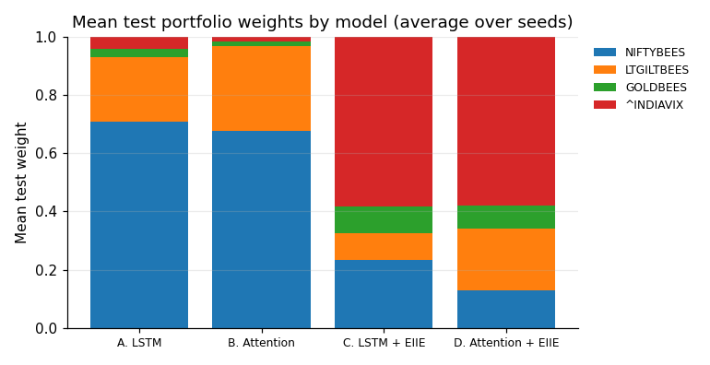
Figure 13. Mean test portfolio weights by model on Indian ETFs (average over seeds).
India against the US
Table 26. Experiment winner: US (Part 1) against India (Part 2)
Setting | US winner (Sharpe) | India winner (Sharpe) | Model A Sharpe: US / India
Exp1 none | A (1.912) | B (1.494) | 1.912 / 1.334
Exp2 S0 | A (1.004) | B (1.389) | 1.004 / 1.150
Exp3 S0 | A (0.133) | A (0.587) | 0.133 / 0.587

The two markets cover different assets and test periods, so this is context, not a controlled comparison. The attention encoder is also much smaller in Part 2 (about 14,800 parameters against about 405,000 in Part 1), so the change in attention’s result cannot be put down to the market alone. The Indian Sharpe ratios are also flattered because no risk-free rate is subtracted and Indian interest rates are higher than US rates.
DISCUSSION AND MODEL IMPROVEMENT
Replication. The replicated LSTM matches the paper when no volatility scaling is used (Sharpe 1.91 against 1.86). It does not match once scaling is added, and it ranks first among the eight methods in only one of three experiments. The paper’s description of scaling leaves room for several readings, and we report only the literal one (S0), so volatility scaling is the least reliable part of the replication.
Part 1. The plain LSTM is the best of four models in this design. Attention and EIIE are each worse in all three experiments. The attention models memorise the training window (train Sharpe 19.7 against validation 1.8 for Model B), turn over their portfolios three to five times as fast as the LSTM, and are hit hardest by higher costs. The EIIE models concentrate in commodity and volatility. These findings say that these designs did not help, not that attention or EIIE cannot help.
Part 2. On Indian ETFs the LSTM and attention models are close in Exp 1 and Exp 2. Attention (B) has the highest test Sharpe in Exp 1 (1.49) and Exp 2 (1.39), and the LSTM (A) in Exp 3 (0.59), where the higher cost rate hurts the more active attention model. The validation choice was the LSTM, so the experiment winner differs from the validation choice in two of three experiments. The margins are within the seed spread, and the first validation window has only 56 samples. The EIIE models take large positions in India VIX and win no experiment. Fixed allocations computed earlier do better than every model under per-asset scaling. The Indian setting also adds problems of its own: a short history (three retraining windows and a 56-sample first validation window), gold in place of a commodity basket, a thinly traded gilt ETF, and an untradable volatility index.
Limitations
- Parameter mismatch. In Part 1 the attention encoder has about 21 times the LSTM’s parameters, although the methodology asks for similar counts, so a validation win for Model A may partly reflect capacity. Part 2 uses a compact encoder (about 0.77 times the LSTM’s size), but the two parts then use different attention designs and cannot be compared directly.
- Noisy tuning and few seeds. Attention tuning used two seeds on one window, and the seed spread (0.3 to 0.5) is as large as some gaps between configurations. Three seeds is a small sample. In Part 2 the experiment winners lead the next-best model by 0.02 to 0.24 in Sharpe, which is no larger than the seed spread (about 0.2 to 0.25 for the winners).
- EIIE design. The weak results of C and D may be caused by the shared encoder with no asset identity, not by EIIE itself.
- Indian data. Different assets and a different test period mean India and the US cannot be compared directly. Costs of 0.01% and 0.1% are probably optimistic for LTGILTBEES, and taxes, brokerage and impact cost are not modelled. The validation selection on Indian data rests on only 56 samples, and the experiment winners are named on test Sharpe, so they are descriptive and were not chosen in advance.
- Volatility scaling. Only the literal per-asset reading (S0) is reported. Other readings of the paper’s scale factor could change the Exp 2 and Exp 3 results.
Model improvement
- Repeat the US comparison with a parameter-matched attention model (about 19,000 parameters, as used in Part 2), optionally with dropout or weight decay, to separate capacity from architecture.
- Test EIIE with a per-asset embedding, so that the shared encoder can tell assets apart.
- Increase the seeds to 5 to 10, re-run the 2 x 2 table, and test other readings of volatility scaling beside S0.
- For India, test a broader commodity exposure, model realistic costs for LTGILTBEES, and use a longer history as it becomes available.
CONCLUSION AND FUTURE WORK
We replicated the Sharpe-trained LSTM portfolio strategy of Zhang, Zohren and Roberts (2020) and found that it reproduces without volatility scaling (Sharpe 1.91 against 1.86) but not with it, so the paper’s claim of ranking first in every experiment is not supported by our runs.
In a controlled 2 x 2 comparison, the plain LSTM beat attention in all three experiments and EIIE in all three, and it was chosen on validation Sharpe before the test period was examined. The attention models are much larger, memorise the training data and trade more, so the finding applies to the designs tested here.
Retrained on Indian ETFs with the same protocol, the four models are close. Attention is the winner of Experiment 1 (Sharpe 1.49) and Experiment 2 (1.39), and the LSTM wins Experiment 3 (0.59). The LSTM was the model chosen on validation data, and the margins between the leading models are within the seed spread. Fixed allocations computed earlier on the same data do better than every model under volatility scaling. The Indian result is promising but rests on three short retraining windows, three seeds and a thinly traded gilt ETF.
Future work includes parameter-matched attention on the US data, per-asset embeddings for EIIE, more seeds, a clearer treatment of volatility scaling, a broader commodity exposure for India, and realistic Indian trading costs and taxes. A natural next step is to repeat the Indian comparison with more seeds and a longer history, so that the experiment winners can be separated from noise.
REFERENCES
- Zhang, Z., Zohren, S. and Roberts, S. (2020). Deep Learning for Portfolio Optimization. arXiv:2005.13665. https://arxiv.org/abs/2005.13665
- Jiang, Z., Xu, D. and Liang, J. (2017). A Deep Reinforcement Learning Framework for the Financial Portfolio Management Problem (Deep Portfolio Management). arXiv:1706.10059. https://arxiv.org/abs/1706.10059
- Vaswani, A. et al. (2017). Attention Is All You Need. arXiv:1706.03762. https://arxiv.org/abs/1706.03762
- Esslinger, K., Platt, R. and Amato, C. (2022). Deep Transformer Q-Networks for Partially Observable Reinforcement Learning. arXiv:2206.01078. https://arxiv.org/abs/2206.01078
- Yahoo Finance price data for NIFTYBEES.NS, LTGILTBEES.NS, GOLDBEES.NS and ^INDIAVIX, downloaded with the yfinance Python library.

