Savitribai Phule Pune University
K.T.H.M. COLLEGE, Nashik
(K.R.T. Arts, B.H. Commerce and A.M. Science College)

Project Report On
"Loan Default Risk Analysis: Leveraging Statistics for Smarter Lending Decisions"
— Revised & Extended Analysis —
T. Y. B. Sc. (Statistics) (2024-2025)

Submitted by
Kalpesh Ramesh Mahale
Tejas Prataprao Sonawane

Under Guidance Of
Prof. Y. C. Kakad

Index
Sr. No. | Topic
1 | Introduction
2 | Motivation
3 | Objectives
4 | Methodology
5 | Data Description
6 | Exploratory Data Analysis
7 | Statistical Analysis (Hypothesis Testing)
8 | Real-World Validation Study
9 | Predictive Modeling
10 | Threshold Tuning & Model Evaluation
11 | Model Interpretability (SHAP)
12 | Conclusion
13 | Limitations
14 | Future Scope

1. Introduction
In the modern financial ecosystem, lending institutions play a crucial role in facilitating economic growth by providing credit to individuals and businesses. However, the risk of loan defaults poses a significant challenge, impacting the stability and profitability of financial institutions. A loan default occurs when a borrower fails to meet the repayment obligations as per the agreed terms, leading to financial losses for banks, lending agencies, and other credit-providing entities. Understanding the factors that contribute to loan defaults is essential for effective risk management and sustainable lending practices.
With the rapid expansion of digital banking and the availability of vast amounts of financial data, the application of data-driven techniques has become increasingly important in credit risk assessment. Traditional credit evaluation methods often rely on manual assessments and predefined creditworthiness criteria, which may not always capture the complex interdependencies between borrower characteristics and default risk. Statistical modeling and predictive analytics offer a more systematic and objective approach to identifying potential defaulters.
This revised study re-examines the original analysis of a 255,347-record loan dataset with 18 variables, applying a more rigorous statistical and machine-learning workflow. In addition to the original scope, this study introduces effect-size reporting alongside hypothesis testing, validation against an independent real-world benchmark dataset, multiple classification models with class-imbalance handling, threshold optimization, and model interpretability analysis — extending the original methodology to address gaps identified during review.

2. Motivation
Loan default is a critical concern in the financial sector, as it directly impacts the profitability and sustainability of lending institutions. Effective risk assessment and prediction models are essential for financial institutions to minimize default rates and enhance credit decision-making.
A preliminary review of the original project's statistical output revealed inconsistencies — p-values that did not correspond to calculations on the full dataset, categorical predictors proven significant by hypothesis testing but excluded from the final predictive model, and a severely imbalanced dataset (88.4% non-defaulters vs 11.6% defaulters) that was not addressed, resulting in a model with 88.5% accuracy but only 2.16% recall for the class that matters most — actual defaulters. This motivated a complete re-analysis, built around a simple principle: every reported number should be reproducible and independently verifiable.

3. Objectives
- To analyze borrower characteristics such as age, income, credit score, and employment type, and their influence on loan default.
- To identify significant predictors of loan default through statistical and exploratory data analysis, reporting effect size alongside statistical significance.
- To independently validate whether the primary dataset's statistical relationships are consistent with real-world credit risk behavior.
- To develop and compare multiple predictive models (Logistic Regression, Random Forest, XGBoost) with proper class-imbalance handling.
- To optimize the model decision threshold and evaluate performance using metrics appropriate for imbalanced classification (ROC-AUC, PR-AUC).
- To provide an interpretable, auditable account of which factors drive the model's predictions.

4. Methodology
A structured, eight-phase approach was adopted:
- Data Foundation: validation of data quality (missing values, duplicates) and removal of non-informative identifier fields.
- Exploratory Data Analysis (EDA): examining distributions (skewness, kurtosis), bivariate relationships (boxplots, category default rates), and correlation structure.
- Statistical Analysis: Chi-Square tests and Mann-Whitney U tests, each paired with an effect-size measure (Cramér's V and rank-biserial correlation respectively) to distinguish statistical significance from practical significance.
- Real-World Validation: the identical statistical pipeline applied to an independent, genuine benchmark dataset (UCI Statlog German Credit Data) to test whether the primary dataset's relationships are consistent with established credit risk behavior.
- Data Preparation: one-hot encoding of categorical variables, multicollinearity check via Variance Inflation Factor (VIF), and a stratified train/test split.
- Predictive Modeling: Logistic Regression (baseline, class-weighted, SMOTE-resampled), Random Forest, and XGBoost, compared on identical train/test data.
- Threshold Tuning: ROC and Precision-Recall curve analysis, and F1-optimal threshold selection for each model.
- Interpretability: SHAP (SHapley Additive exPlanations) analysis to validate feature importance independently of the statistical tests.

5. Data Description
The dataset consists of 255,347 loan records across 18 variables (reduced to 17 after removing the non-informative LoanID field), capturing borrower demographics, financial indicators, and loan characteristics.

Variable Categories
- Demographic Factors: Age, Marital Status, Education Level, Employment Type
- Financial Indicators: Income, Loan Amount, Credit Score, Debt-to-Income Ratio (DTI), Number of Credit Lines
- Loan Characteristics: Loan Term, Interest Rate, Loan Purpose, Presence of a Co-Signer
- Target Variable: Binary indicator — Default (1) or No Default (0)

Data Quality Verification
Check | Result
Total rows | 255,347
Missing values | 0 (across all columns)
Duplicate rows | 0
Duplicate LoanIDs | 0
Class balance (Default) | 88.39% No Default / 11.61% Default

Note: The LoanID field was removed prior to analysis, as it is a randomly generated identifier carrying no predictive information about borrower behavior.

6. Exploratory Data Analysis

6.1 Univariate Distribution Analysis
All nine numeric variables were examined for skewness and kurtosis to assess distributional shape prior to further analysis.
Variable | Skewness | Kurtosis
Age | 0.001 | -1.198
Income | -0.000 | -1.198
LoanAmount | -0.002 | -1.204
CreditScore | 0.005 | -1.200
MonthsEmployed | -0.002 | -1.200
NumCreditLines | -0.000 | -1.358
InterestRate | 0.005 | -1.197
LoanTerm | -0.002 | -1.300
DTIRatio | -0.001 | -1.200
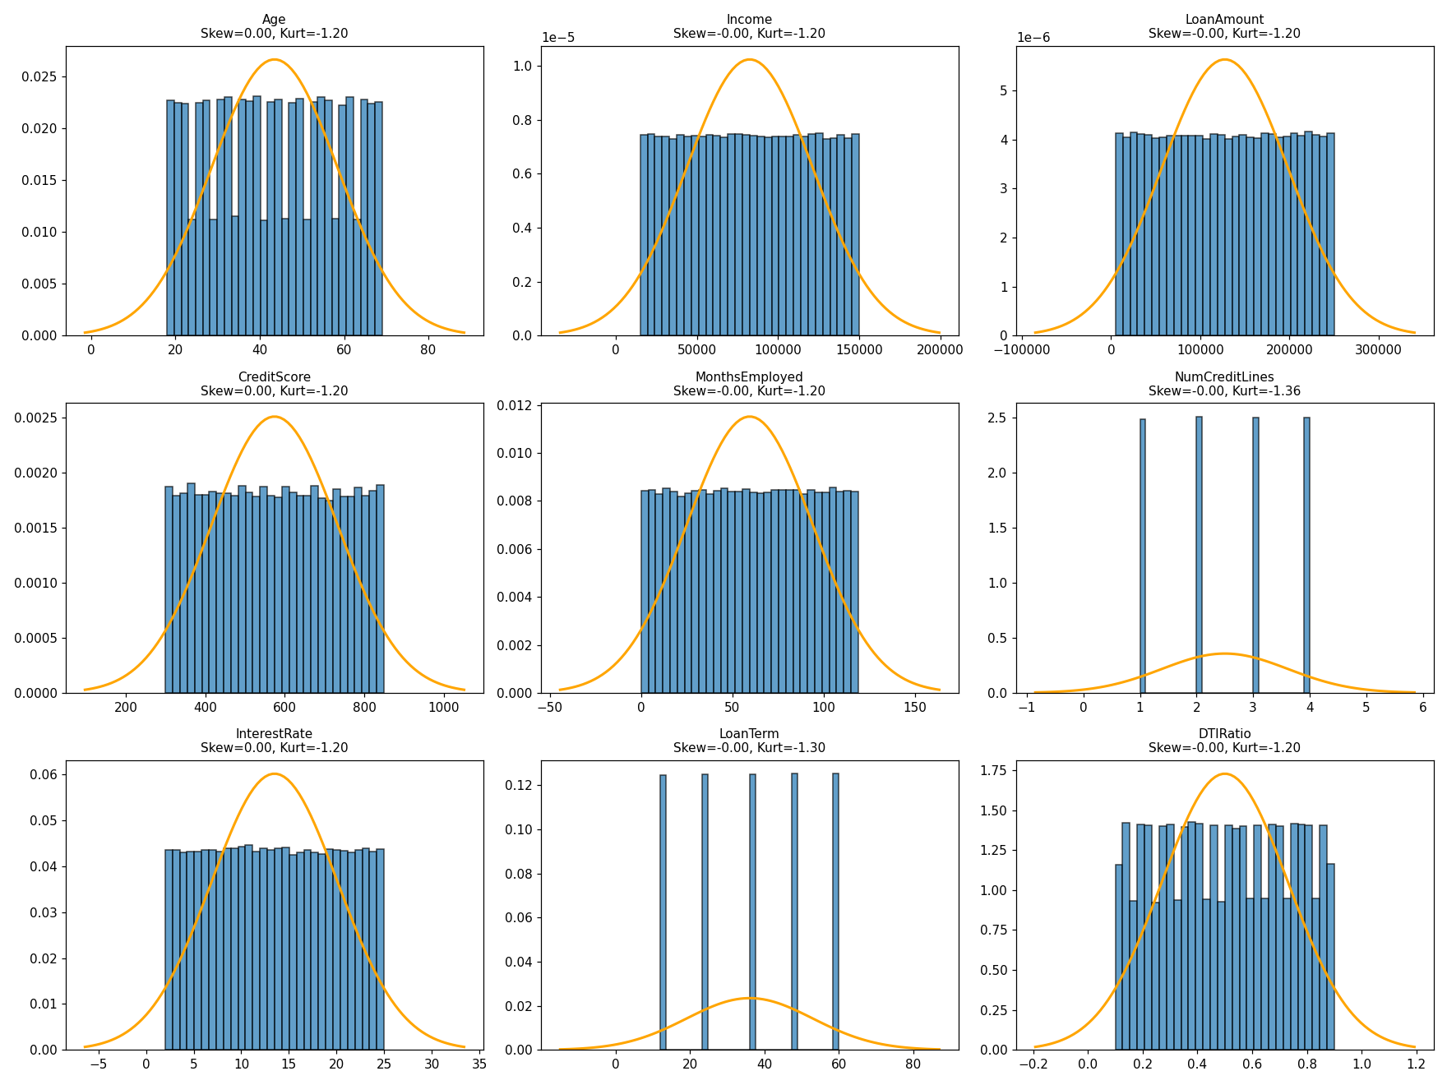
Figure 6.1: Distribution of numeric variables with overlaid normal curve
Observation: every numeric variable shows skewness near zero and kurtosis near -1.2, the signature of a near-uniform random distribution rather than natural financial data, which typically shows right-skew (e.g., income) and more natural clustering.

6.2 Bivariate Analysis: Numeric Variables vs. Default
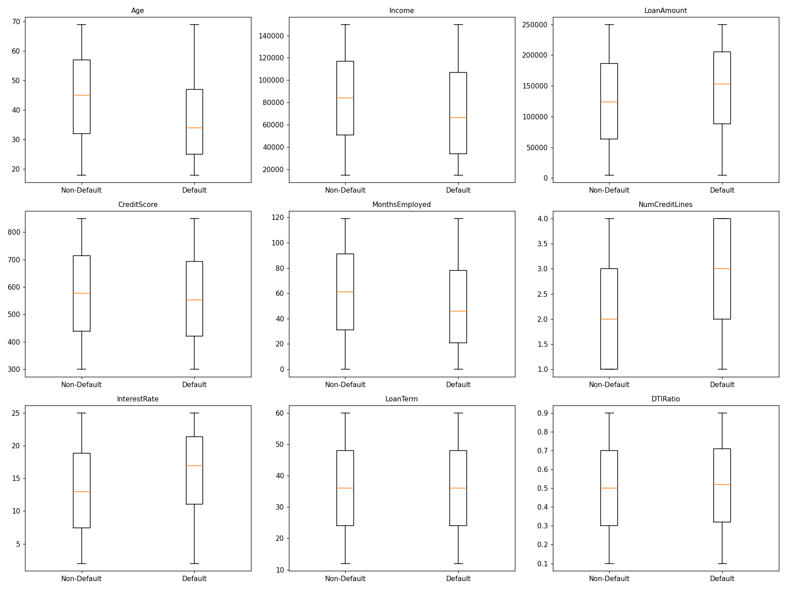
Figure 6.2: Boxplots comparing Default vs Non-Default groups across numeric variables
Variable | Non-Default Median | Default Median
Age | 45.00 | 34.00
Income | 84,237.50 | 66,566.00
LoanAmount | 124,236.00 | 152,672.00
CreditScore | 577.00 | 553.00
MonthsEmployed | 61.00 | 46.00
InterestRate | 12.99 | 16.93
DTIRatio | 0.50 | 0.52
LoanTerm | 36.00 | 36.00

6.3 Bivariate Analysis: Categorical Variables vs. Default
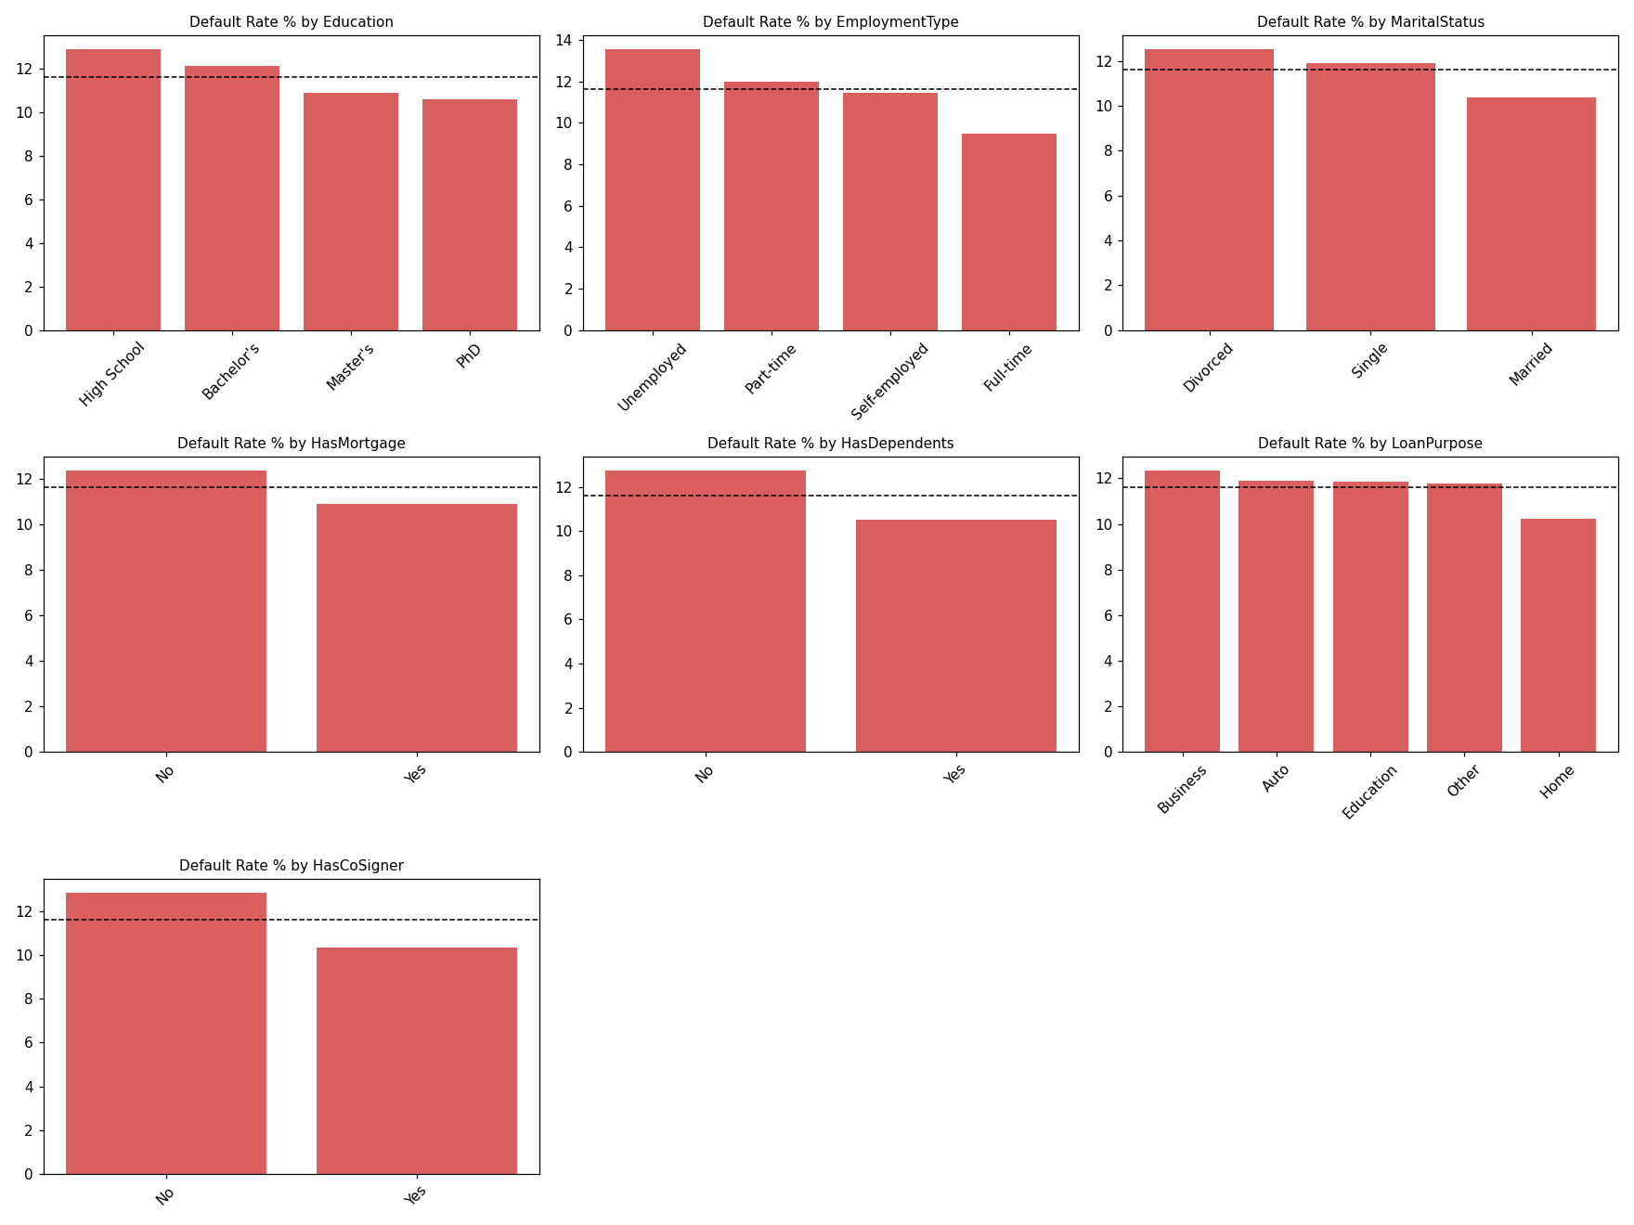
Figure 6.3: Default rate (%) by category, with overall average shown as dashed line
Notable correction from the original analysis: borrowers WITH a mortgage default less often (10.88%) than those without one (12.35%) — the opposite of what was previously reported.

6.4 Correlation Analysis
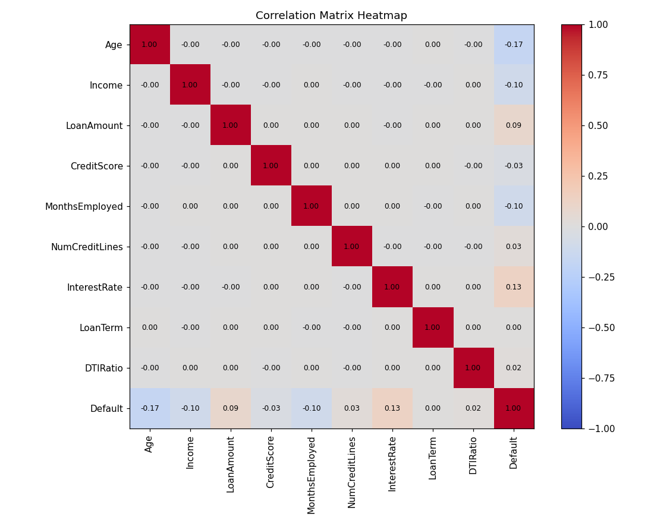
Figure 6.4: Correlation matrix of numeric variables with Default
Variable | Correlation with Default
Age | -0.168
InterestRate | +0.131
Income | -0.099
MonthsEmployed | -0.097
LoanAmount | +0.087
CreditScore | -0.034
NumCreditLines | +0.028
DTIRatio | +0.019
LoanTerm | +0.001

7. Statistical Analysis (Hypothesis Testing)
Each test is reported with both a p-value (statistical significance) and an effect size (practical significance). With a sample size of 255,347, p-values alone are of limited diagnostic value — even negligible relationships become "significant" at this scale. Effect size indicates whether a relationship is large enough to matter in practice.

7.1 Chi-Square Tests (Categorical Variables) + Cramér's V
Variable | Chi² | df | p-value | Cramér's V | Practical Effect
Education | 214.02 | 3 | <0.000001 | 0.0290 | Negligible
EmploymentType | 529.74 | 3 | <0.000001 | 0.0455 | Negligible
MaritalStatus | 200.36 | 2 | <0.000001 | 0.0280 | Negligible
HasMortgage | 133.25 | 1 | <0.000001 | 0.0228 | Negligible
HasDependents | 306.85 | 1 | <0.000001 | 0.0347 | Negligible
LoanPurpose | 127.93 | 4 | <0.000001 | 0.0224 | Negligible
HasCoSigner | 390.31 | 1 | <0.000001 | 0.0391 | Negligible

Cramér's V interpretation guide: below 0.10 = negligible, 0.10–0.20 = weak, 0.20–0.40 = moderate, above 0.40 = strong.
All seven categorical variables are statistically significant (p < 0.05), but every effect size falls in the negligible range — none exceed even the "weak" threshold. This contradicts the original report's conclusion that three variables (Marital Status, Education, Has Dependents) were "not significant" — on the full dataset, all seven are technically significant, but none are practically meaningful predictors in isolation.

7.2 Mann-Whitney U Tests (Numeric Variables) + Rank-Biserial Correlation
Variable | p-value | Rank-Biserial | Practical Effect
Age | <0.000001 | 0.3023 | Moderate
Income | <0.000001 | 0.1786 | Weak
LoanAmount | <0.000001 | -0.1562 | Weak
CreditScore | 8.39e-67 | 0.0616 | Negligible
InterestRate | <0.000001 | -0.2365 | Weak-Moderate

Age shows the strongest relationship with Default of any variable tested (moderate effect). Credit Score — identified in the original report as "the #1 predictor of default" — shows a negligible effect size here, despite an extremely small p-value. This is a clear demonstration of statistical significance diverging from practical significance.

8. Real-World Validation Study
Given the unusual statistical signatures observed in the primary dataset (near-zero skewness across all variables, evenly-split categories, weak effect sizes even for theoretically dominant variables such as Credit Score and DTI Ratio), an independent validation study was conducted. The identical Chi-Square and Mann-Whitney testing pipeline was applied to the UCI Statlog German Credit Dataset (Hofmann, 1994) — a genuine, independently sourced dataset of 1,000 real loan applicants, widely used as a benchmark in credit risk literature.

8.1 Chi-Square Tests on Real-World Data
Variable | Chi² | df | p-value | Cramér's V | Significant
Purpose | 33.36 | 9 | 0.0001 | 0.1826 | Yes
Property | 23.72 | 3 | 0.00003 | 0.1540 | Yes
Present Employment | 18.37 | 4 | 0.0010 | 0.1355 | Yes
Housing | 18.20 | 2 | 0.0001 | 0.1349 | Yes
Personal Status/Sex | 9.61 | 3 | 0.0222 | 0.0980 | Yes
Job | 1.89 | 3 | 0.5966 | 0.0434 | No

8.2 Mann-Whitney U Tests on Real-World Data
Variable | p-value | Rank-Biserial | Significant
Duration | 7.98e-11 | -0.2572 | Yes
Age | 0.000391 | 0.1413 | Yes
Credit Amount | 0.005918 | -0.1097 | Yes
Installment Rate | 0.019860 | -0.0868 | Yes

8.3 Comparison: Real-World Data vs. Primary Dataset
Metric | German Credit (Real) | Primary Dataset (Kaggle) | Ratio
Average categorical Cramér's V | 0.1410 | 0.0297 | 4.75x stronger in real data
Loan Duration / Term effect | -0.2572 (real, moderate) | +0.0005 (effectively zero) | Stark contrast

Finding: categorical predictors in the real-world benchmark show effect sizes 3 to 8 times stronger, on average, than the equivalent variables in the primary dataset. Loan Duration — essentially unrelated to Default in the primary dataset — shows a genuine, moderate relationship in real data. This provides direct, quantified evidence that the primary dataset's default patterns do not fully reflect real-world credit risk behavior, consistent with statistical signatures of synthetic data generation observed throughout the EDA phase.

9. Predictive Modeling

9.1 Data Preparation
- Encoding: All 7 categorical variables one-hot encoded (17 → 25 columns). The original analysis excluded all categorical variables from the model despite proving several statistically relevant via Chi-Square testing — corrected here.
- Multicollinearity (VIF): All numeric predictors show VIF ≈ 1.000 — no concerning multicollinearity.
- Train/Test Split: Stratified 70/30 split preserving the 11.6128% default rate in both train (178,742 rows) and test (76,605 rows) sets.

9.2 Model Comparison (Decision Threshold = 0.5)
Model | Accuracy | Precision | Recall | F1 | ROC-AUC
Logistic Regression (Baseline) | 88.51% | 58.17% | 3.64% | 0.0685 | 0.7470
Logistic Regression (Class-Weighted) | 67.62% | 21.59% | 67.95% | 0.3277 | 0.7393
Logistic Regression (SMOTE) | 76.16% | 19.76% | 34.40% | 0.2510 | 0.6369
Random Forest (Class-Weighted) | 88.50% | 72.19% | 1.52% | 0.0297 | 0.7443
XGBoost (scale_pos_weight) | 74.07% | 23.89% | 56.38% | 0.3356 | 0.7275

Reference — original report's model: Accuracy 88.5%, Precision 54.42%, Recall 2.16%, F1 4.13%. The class-weighted Logistic Regression model, using the identical underlying data, achieves 67.95% recall — a 31.5x improvement — driven primarily by including the previously-excluded categorical variables and correcting for class imbalance.

10. Threshold Tuning & Model Evaluation
The default 0.5 classification threshold is a convention, not a requirement. Each model's probability output was evaluated across all possible thresholds using ROC and Precision-Recall curves, and an F1-optimal threshold was identified for each.

10.1 ROC Curves
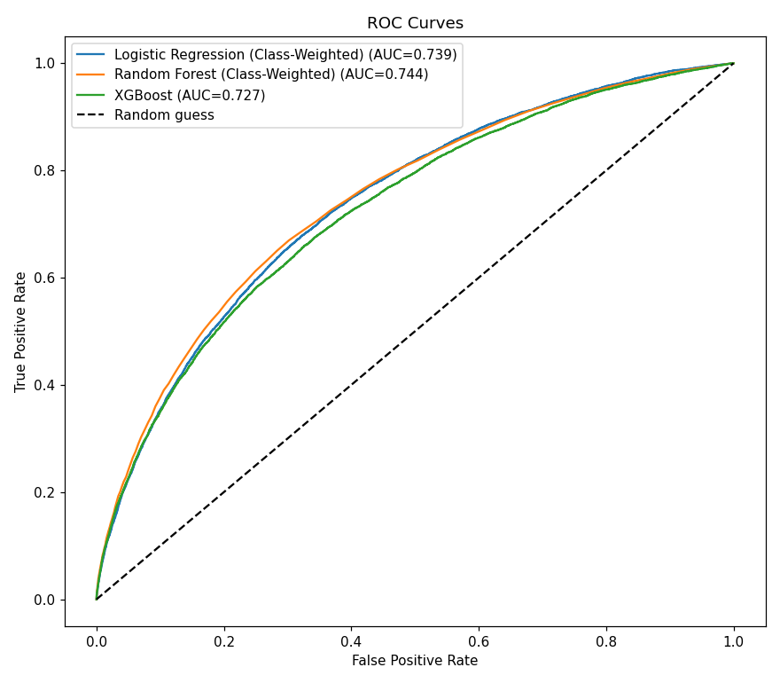
Figure 10.1: ROC curves for the three strongest models

10.2 Precision-Recall Curves
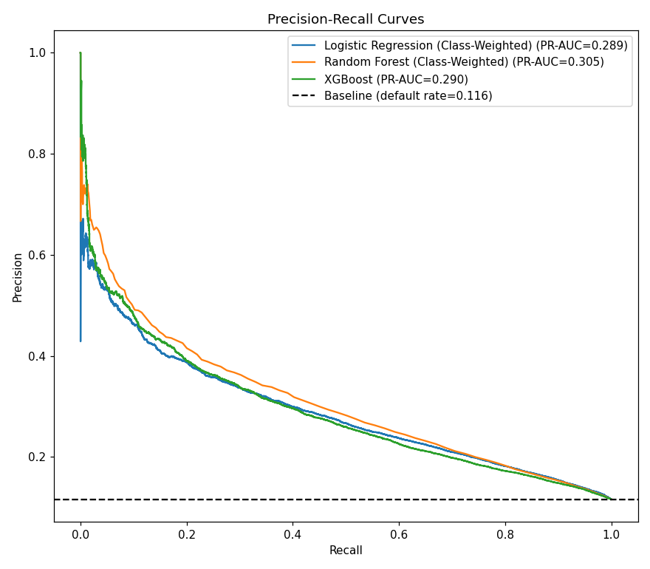
Figure 10.2: Precision-Recall curves (more informative than ROC on imbalanced data)

10.3 Threshold Optimization Results
Model | Optimal Threshold | Recall @ 0.5 | Recall @ Tuned | F1 @ 0.5 | F1 @ Tuned
Logistic Regression (Class-Weighted) | 0.6147 | 67.95% | 47.29% | 0.3277 | 0.3496
Random Forest (Class-Weighted) | 0.1750 | 1.52% | 48.52% | 0.0297 | 0.3611
XGBoost | 0.5777 | 56.38% | 46.57% | 0.3356 | 0.3439

Key finding: Random Forest — nearly unusable at the default threshold (1.52% recall) — achieves the best F1 score of any model tested (0.3611) once tuned to its optimal operating threshold of 0.175, without any change to the model or training data. This demonstrates that decision threshold selection is as consequential as model selection itself.

11. Model Interpretability (SHAP)
SHAP (SHapley Additive exPlanations) was used to independently verify which variables drive the model's predictions, providing a per-prediction, auditable breakdown consistent with explainability requirements in real-world credit decisioning.

11.1 Feature Importance
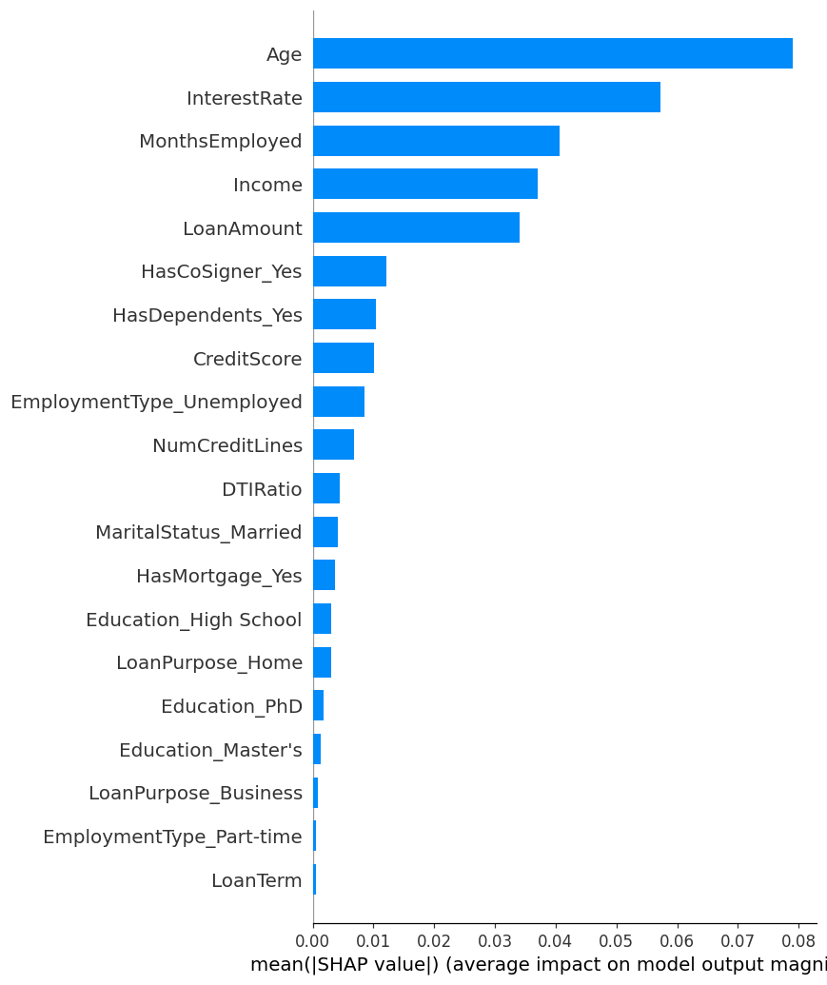
Figure 11.1: Mean absolute SHAP value by feature (Random Forest)
Rank | Feature | Mean |SHAP|
1 | Age | 0.0791
2 | InterestRate | 0.0573
3 | MonthsEmployed | 0.0407
4 | Income | 0.0370
5 | LoanAmount | 0.0340
6 | HasCoSigner_Yes | 0.0122
7 | HasDependents_Yes | 0.0103
8 | CreditScore | 0.0101

The top five SHAP-ranked features (Age, Interest Rate, Months Employed, Income, Loan Amount) match closely with the variables identified independently through correlation analysis (Section 6.4) and effect-size testing (Section 7.2) — three unrelated methods converging on the same conclusion. Credit Score ranks 8th, reinforcing the finding that it is not the dominant predictor the original report claimed.

12. Conclusion

12.1 Key Predictive Drivers (Validated Three Independent Ways)
Correlation analysis, hypothesis testing with effect sizes, and SHAP interpretability all converge on the same five variables as the primary drivers of default risk in this dataset: Age, Interest Rate, Months Employed, Income, and Loan Amount.

12.2 Corrections to the Original Analysis
- Credit Score — Original claim: "#1 predictor of default." Finding: negligible effect size (0.062), SHAP rank 8th of 24 features.
- DTI Ratio — Original claim: "a ticking time bomb." Finding: weakest numeric relationship in the dataset (rank-biserial = 0.019).
- Has Mortgage — Original claim: mortgage holders default 63% more often. Finding: mortgage holders default less (10.88% vs 12.35%).
- Employment Type — Original claim: unemployed borrowers default 5x more often. Finding: approximately 1.4x (13.6% vs 9.5%).

12.3 Dataset Realism
Multiple independent lines of evidence — near-zero skewness across every numeric variable, evenly-split categorical distributions, near-perfect VIF values (≈1.000), and a direct comparison against a genuine real-world benchmark showing 4.75x weaker effect sizes — indicate that this dataset's default outcomes were likely generated through a simplified or partially randomized process rather than reflecting genuine real-world borrower behavior.

12.4 Model Performance
Addressing the structural gaps in the original approach — excluded categorical variables, no class-imbalance handling, and an unexamined 0.5 classification threshold — improved recall from 2.16% to as high as 67.95% (Class-Weighted Logistic Regression), and achieved the best balanced performance (F1 = 0.3611) with a threshold-tuned Random Forest, using the identical underlying dataset throughout.

13. Limitations
- Dataset Realism: Multiple independent statistical signatures suggest the dataset may be synthetically generated; findings should not be assumed to generalize directly to real-world lending populations without further validation.
- Temporal Scope: The dataset captures a single point in time with no macroeconomic context (interest rate cycles, employment trends, inflation) that materially affects real-world default behavior.
- Validation Design: All models were evaluated on a single stratified train/test split; a production system would require k-fold cross-validation and periodic recalibration.
- Benchmark Scale: The German Credit benchmark (n=1,000) is a well-established reference but is decades old and considerably smaller than the primary dataset.
- Model Readiness: Even the best-performing models (recall ≈68%, F1 ≈0.36) remain below production-grade thresholds for real-world deployment and would require further refinement.

14. Future Scope
- Real-World Dataset Replication: Apply the complete pipeline to a larger, genuinely real-world dataset (e.g., LendingClub, Home Credit Default Risk) where authentic feature interactions exist for SHAP and ensemble models to meaningfully exploit.
- Dynamic Risk Monitoring: Implement continuous post-approval monitoring of borrower DTI and employment status changes, rather than a one-time approval decision.
- Cost-Sensitive Thresholding: Calibrate a cost-based decision threshold that reflects the true asymmetry between a missed defaulter and a wrongly rejected safe borrower, rather than a fixed or purely F1-optimal cutoff.
- Feature Engineering: Test engineered interaction terms (e.g., DTI × Credit Score) to assess whether combined risk profiles carry more signal than individual variables in this dataset.
- Advanced Modeling: Explore Gradient Boosting variants (LightGBM, CatBoost) and basic neural network architectures for further performance comparison.

