Sinhgad Technical Education Society,  Sinhgad College of Engineering , Pune-41  Department of Computer Engineering | 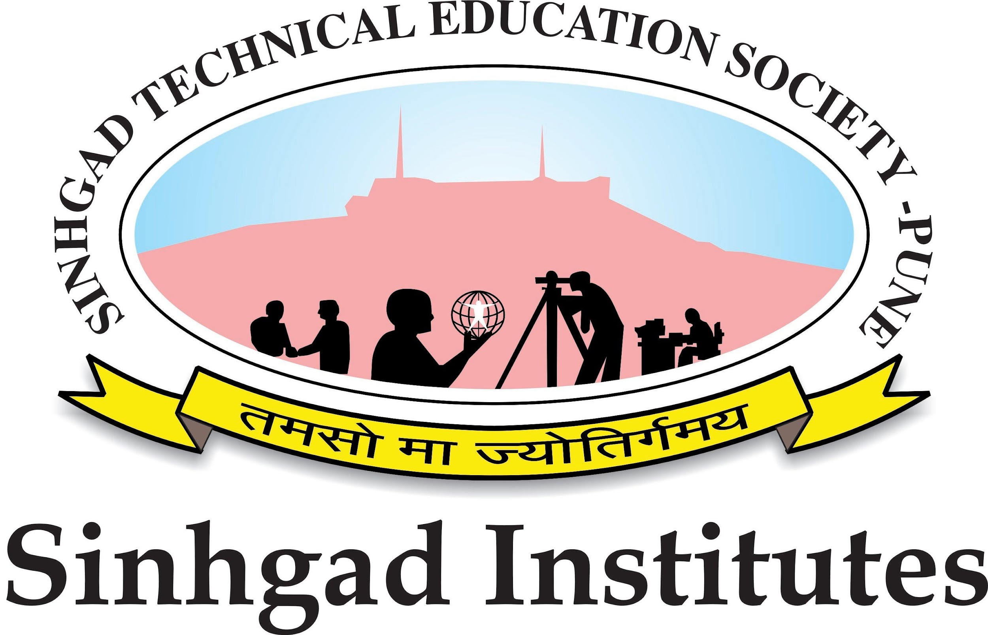
(ii) Date:
CERTIFICATE
This is to certify that the preliminary project report entitled

VIDHAN : A GAMIFIED APPROACH TO LEARNING THE INDIAN CONSTITUTION WITH AI ASSISTANCE.
Submitted by

YASHKUMAR SHAMKANT PATIL Exam Seat No: 405B046

DHANASHREE SANJAY LOMTE Exam Seat No: 405B007

TEJAS KAILAS PATIL Exam Seat No: 405B047

ADITI AMBADAS KHEDKAR Exam Seat No: 405B006

is a bonafide work carried out by him-her under the supervision of Prof. R. A.Vasmatkar and it is approved for the partial fulfillment of the requirements of Savitribai Phule Pune University, Pune for the award of the degree of Bachelor of Engineering (Computer Engineering) during the year 2025-26.

Prof R.A.Vasmatkar Dr. R. H. Borhade
Guide Head, Computer Engineering
Department of Computer Engineering & Vice Principal, SCOE

Dr. S. D. Lokhande
Principal
Sinhgad College of Engineering

