Assignment No : 11
Title : WTL Mini-Project
“Krushi mitra : Bridging Farmers with
Markets and Buyers”
Problem statement of Mini-Project
In India and many other agricultural economies, farmers often face difficulties in reaching out directly to potential buyers such as hotels, restaurants, and large-scale consumers. Most of their sales rely on intermediaries or brokers, which not only reduces their profit margin but also delays the selling process. The lack of a centralized digital system creates a communication gap between producers (farmers) and buyers, resulting in inefficiency, waste of perishable goods, and unfair price practices.
Furthermore, farmers do not always have easy access to up-to-date market prices, making them vulnerable to exploitation. Meanwhile, hotels and restaurants seeking fresh produce have no streamlined method to directly reach out to farmers, verify available stock, or negotiate prices.
There is also a need for brokers and market authorities to have a role in ensuring fair practices and facilitating trade. Without a unified platform, there is no transparency, traceability, or accountability in the agricultural transaction ecosystem.
This project aims to solve these issues by developing an integrated online marketplace where:
- Farmers can list their products like they do on social media platforms.
- Hotels and restaurants can browse products and contact farmers directly.
- Markets can post current rates, improving price awareness.
- Brokers can act as intermediaries, visible to all parties for transparency.
Objective
The main objective of this mini-project is to design and develop a dynamic, role-based web application that enhances the connection between farmers and potential buyers (such as hotels and restaurants), while also integrating market visibility and broker participation. The platform aims to provide a digital solution to traditional inefficiencies in the agricultural supply chain.
Specifically, the objectives include:
- To develop a multi-user platform where different stakeholders—farmers, hotel/restaurant buyers, market authorities, and brokers—can interact within a centralized system.
- To implement secure user authentication for each type of user (farmer, hotel, broker, market) using Passport.js and session handling to ensure role-based access and functionality.
- To enable farmers to showcase their products with detailed listings, including images, product information, quantity, and pricing—similar to a social media feed.
- To allow hotels and restaurants to browse product listings posted by farmers and directly contact them for bulk or regular purchases.
- To provide market authorities a way to list daily or seasonal product prices to increase transparency and help farmers make informed pricing decisions.
- To integrate brokers into the system so they can support negotiations or deals where required, without compromising transparency.
- To use MongoDB for managing user and listing data, allowing for scalable and efficient data storage and retrieval.
- To use EJS as the templating engine to dynamically render views based on user roles and actions.
- To apply Bootstrap and Google Fonts to build a responsive and visually appealing front-end interface that works well on mobile and desktop devices.
- To promote digital literacy and accessibility for farmers, offering them a tool that can be accessed easily to improve their business operations and visibility.
- To build a modular, scalable backend using Express.js, following the MVC pattern and RESTful API principles for better code organization and maintainability.

Technologies Used
Software (S/W)
Technology | Purpose
HTML5 | To structure the web pages with semantic elements.
CSS3 | For styling the website and enhancing the UI aesthetics.
Bootstrap 5 | To make the website responsive and mobile-friendly with prebuilt styles.
JavaScript | For adding interactivity on the client side.
Google Fonts | To enhance the typography and visual design of the site.
Node.js | JavaScript runtime used for running the backend server.
Express.js | To handle routing, middleware, and server-side logic in Node.js.
MongoDB | As a NoSQL database to store users, listings, and market data.
Mongoose | To simplify MongoDB interactions with schemas and models.
EJS (Embedded JavaScript Templates) | To render dynamic HTML pages based on user data.
Passport.js | To manage user authentication securely using sessions.
Method-Override | To support HTTP verbs like PUT and DELETE through forms.
Express-session | To store user session information on the server.
Connect-mongo | To store session data in MongoDB for persistent login sessions.
Connect-flash | To show temporary messages like login errors or success alerts.
EJS-Mate | To enable layout inheritance in EJS templates, simplifying view management.
Git | Version control to manage and track changes in the project.
Hardware (H/W)
- A personal computer/laptop
- Stable internet connection
Introduction of Topic/Project
Agriculture is the backbone of many economies, yet farmers often face major challenges in marketing and selling their produce. The lack of direct access to buyers, absence of real-time market information, and reliance on middlemen result in reduced profits and inefficiencies. In today’s digital age, there is an urgent need for a unified, accessible online platform that bridges the gap between farmers and potential bulk buyers like hotels, restaurants, and retail markets. By digitizing the communication process, farmers can showcase their products, update availability, and gain visibility beyond their local reach.
This project proposes a role-based web application that acts as a virtual marketplace. It allows farmers to register, log in, and post details of their products in a user-friendly interface. Buyers (like hotels and restaurants) can browse listings and connect directly with the farmers for procurement. Market authorities can regularly update current rates for crops, helping all stakeholders make informed decisions. Brokers can also interact within the platform to facilitate transparent negotiations. This digital solution aims to empower farmers, modernize agricultural trade, and promote fair pricing and efficient supply chain communication using modern web technologies.
With the integration of modern web technologies such as Node.js, Express.js, MongoDB, and EJS, this platform ensures scalability, security, and real-time responsiveness. It promotes digital inclusion for rural farmers by offering a simple and intuitive interface while maintaining advanced backend logic for seamless data handling and user role management. The modular design also allows the application to be extended in the future—for example, to support payment gateways, language localization, or mobile app versions. This project not only highlights technical proficiency but also addresses a socially impactful real-world problem.
Project design/functionalities/features
- Farmer Module:
  - Register/login system
  - Post products with details and images
  - View market rates
  - See which hotels/buyers have contacted them
- Hotel/Buyer Module:
  - Login and browse farmer listings
  - Contact farmers directly through the platform
  - Filter products based on type/availability
- Market Module:
  - List current market rates for different products
  - Help farmers and buyers stay updated with trends
- Broker Module:
  - Facilitate communication between farmers and buyers
  - View listings and reach out to both parties
- Static Pages:
  - home.ejs: Homepage with feature highlights
  - about.ejs: Project mission and vision
  - contact.ejs: Contact form and information
  - farmer.ejs: Dashboard and product posting for farmers
  - broker.ejs: Broker access and communication features
  - hotels.ejs: Buyer dashboard to explore and contact farmers
Working/flowchart/algorithms
- User Journey:
  - Visit homepage
  - Select role (Farmer/Hotel/Broker/Market)
  - Register/Login
  - Access respective dashboard
  - Perform operations (Post/View/List/Contact)
- Backend Workflow:
  - RESTful routing using Express.js
  - Role-based rendering of pages using EJS
  - Data storage and retrieval via MongoDB
  - Authentication using Passport.js with sessions
  - Flash messaging for alerts/notifications
  - Error handling using ExpressError.js
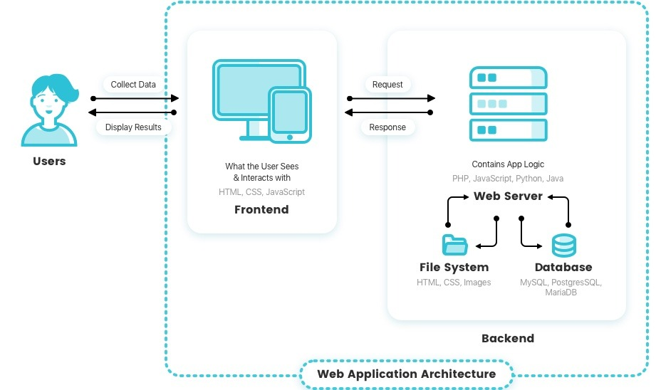
Other information
- Utilizes Google Fonts for visual enhancement
- Mobile-friendly layout with Bootstrap
- Cloud-compatible for future deployment
- Modularized routing system for scalability (/routes/user.js, /routes/listing.js, /routes/market.js)
- EJS-Mate used for layout templating
Conclusion
This project bridges the gap between farmers and potential buyers using technology. It enhances the agricultural supply chain by digitizing communication, product showcasing, and market awareness. The use of scalable web technologies ensures adaptability and future expansion, making it a robust solution for agricultural commerce.
