**Part One Skill Questions:**

**Designing Test Cases**

The mailbox binding function,the requirements are designed as follows:

1. Mailbox input box, the format requirements conform to the mailbox format

2. Captcha get button

3. Verification code input box, the verification code is pure 6 digits

4. Submit button

Please design test cases according to requirements



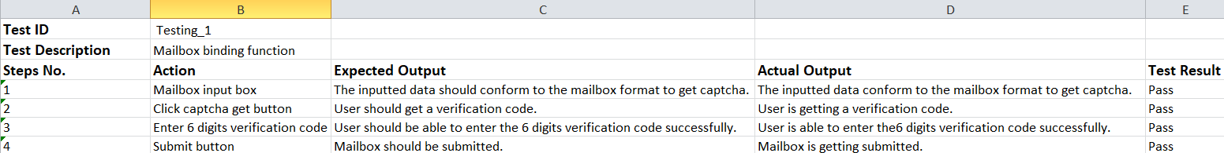

**SQL interview questions:**

student (s_id, name, sex, score, address)

class (c_id, c_name)

student_class (s_id, c_id)

1. query the name of the student whose address is empty and whose surname is Zhang

2. Query a class of students whose scores are above 80 or equal to 60, 61, 62

1. SELECT name

FROM students;

WHERE name LIKE ‘Zhang’;

2. SELECT s_id, name, score

FROM student

WHERE score > 80 OR score = 60,61,62;

**Part Two Logic Questions:**

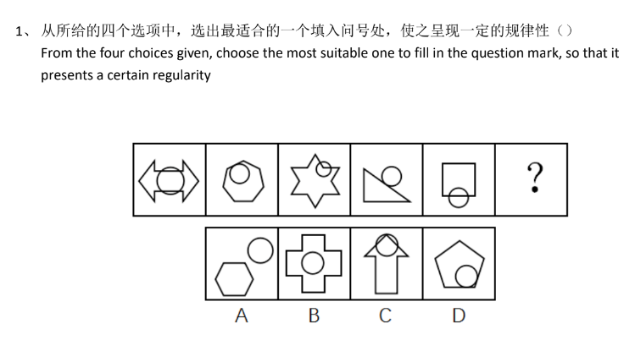

Answer: D

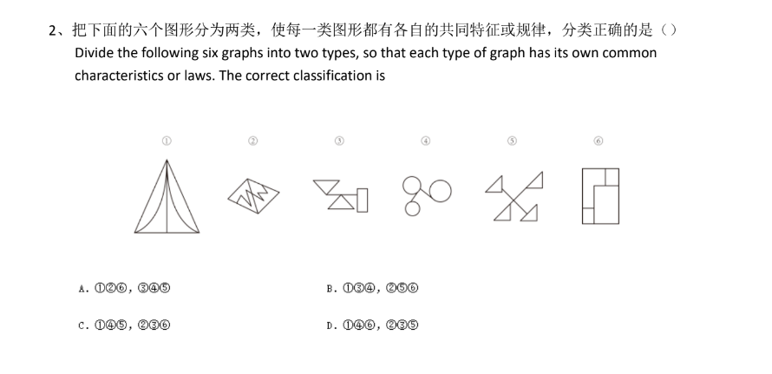

Answer: A

1、A plane can fly 75 kilometers in 5 minutes. How many kilometers can it fly in 10 minutes if it flies

an extra 3 kilometers per minute

A.750 B. 183 C. 180 D. 153

Answer: C [180]

2 The sum of a and b is 18. The sum of b and c is 26, so?

A.a-c=8 B. c-a=8 C. a=c D. a>c

Answer: B [c-a=8]

1、There are a 5L bottle and a 6L bottle, how to get 3L water?

Answer:

Step-1: Fill the 6L bottle with a tap. Pour it into 5L bottle.

Step-2: 6L bottle will have 1ltr water remaining, Pour the 1 ltr water into 5L bottle.

Step-3: Fill the 6L bottle again and Pour it into 5L bottle, as the 5L bottle already has 1Ltr in it, 2ltr water will remain in the 6ltr bottle after filling the 5ltr bottle completely.

Step-4: Pour the 2ltr water in the 5ltr bottle and Fill the 6ltr bottle again and pour it into 5ltr bottle.

Step-5: As the 5ltr bottle already has 2ltr water so it will accommodate only 3ltr of water after filling it completely and 3ltr water will remain in 6ltr bottle.

2.

1

1 1

2 1

1 2 1 1

1 1 1 2 2 1

What's the next line?

Answer: 3 1 2 2 1 1