FDR Making Tool - Step-by-Step Workflow Guide
ETABS Live Connector | Project: WAKAD T1 & T2 | FDR_WAKAD_T1_ULS.EDB

Overview
This document provides a real-time, screenshot-based walkthrough of the FDR (Flexural Design Review) workflow using the ETABS Live Connector tool. Screenshots were captured live during analysis of the WAKAD T1 project.
Model file: D:\00 Project Data\26 Pune\03 WAKAD - Copy\T 01 & T02\02 ETABS Model\02 UPDATED consultant model\fdr\FDR_WAKAD_T1 _ULS.EDB

Step 0: ETABS Open with Active Model
ETABS 23 is open with the WAKAD project model (FDR_WAKAD_T1_ULS.EDB) loaded. All structural analysis and shear wall design runs have been completed in ETABS prior to launching the FDR tool. The model is in a locked (post-analysis) state.
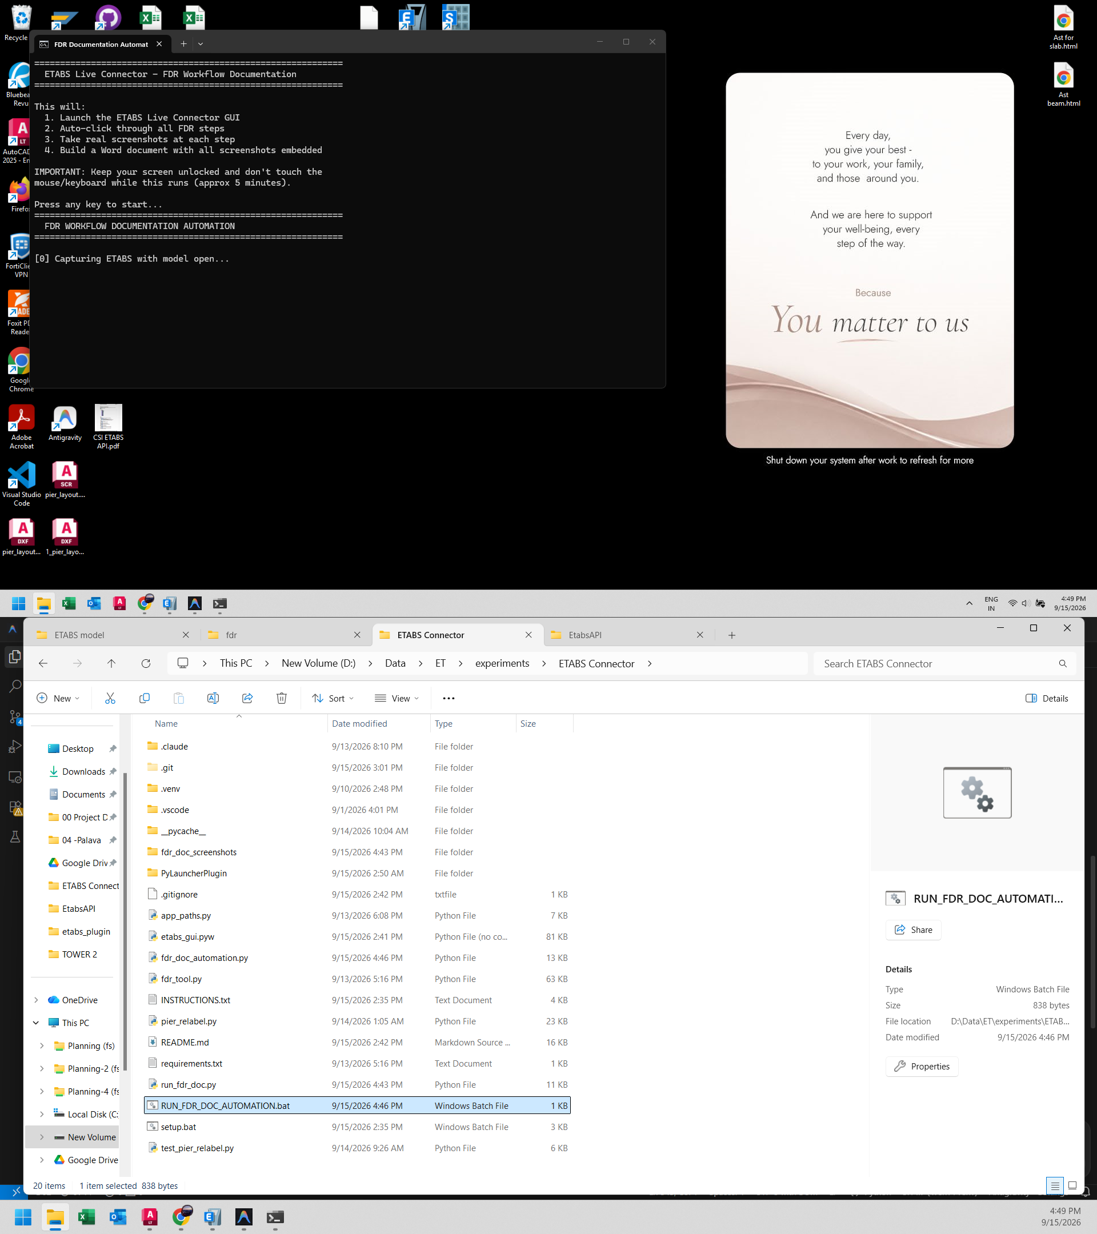
Figure 0: ETABS Open with Active Model

Step 1: Launch ETABS Live Connector
The ETABS Live Connector (etabs_gui.pyw) GUI is launched. The main window shows four panels: (01) Connect, (02) Active File, (03) Model Inventory, and the FDR configuration card on the right. The status indicator shows 'Not connected'.
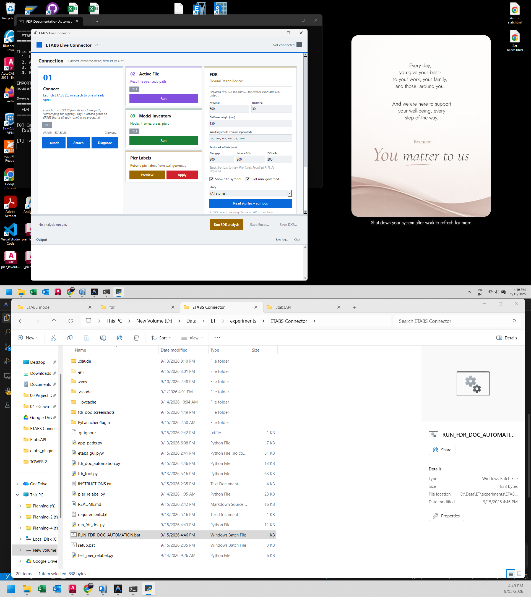
Figure 1: Launch ETABS Live Connector

Step 2: Attach to Running ETABS Instance
Click 'Attach' in Card 01 (Connect). The tool scans running processes, finds ETABS (PID 33000), and establishes a COM API connection. Status bar turns green showing 'ETABS connected'. Card 01 badge changes from IDLE to DONE.
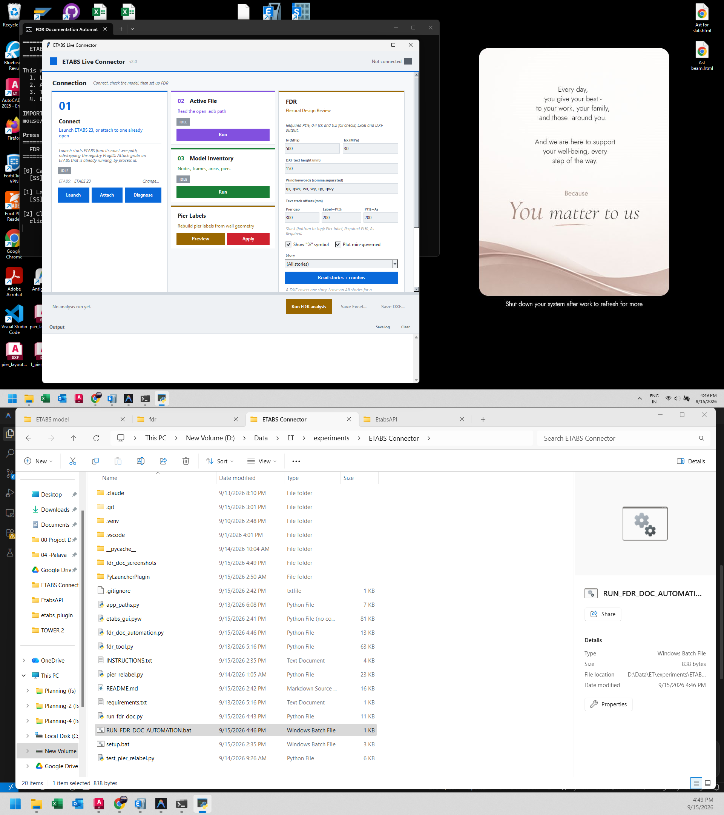
Figure 2: Attach to Running ETABS Instance

Step 3: Verify Active Model File
Click 'Run' on Card 02 (Active File). The output console displays the full path of the currently loaded ETABS model, confirming the correct project is connected: FDR_WAKAD_T1_ULS.EDB.
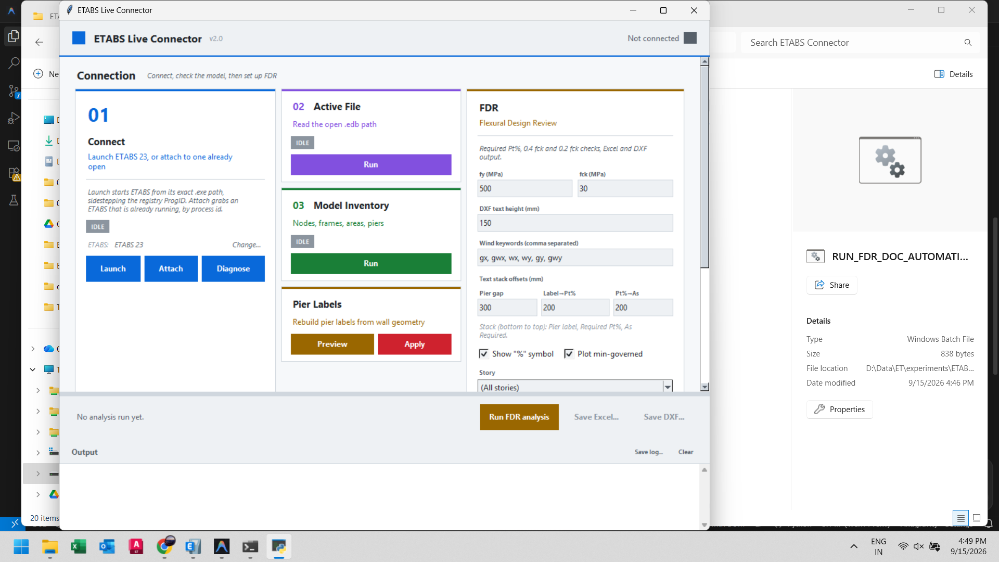
Figure 3: Verify Active Model File

Step 4: Model Inventory Check
Click 'Run' on Card 03 (Model Inventory). The console lists total nodes, frames, area (shell) elements, and pier labels in the model - confirming proper meshing and pier labelling.
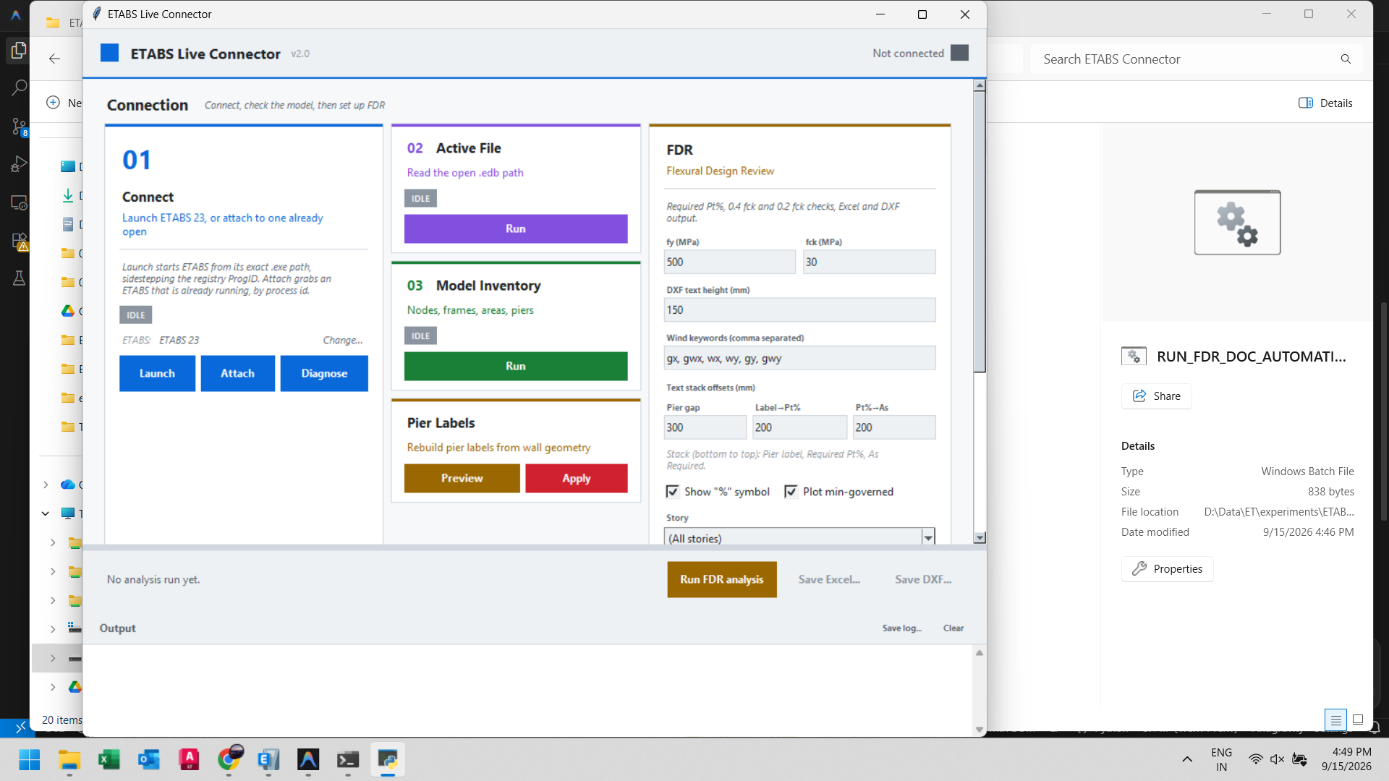
Figure 4: Model Inventory Check

Step 5: Read Stories and Load Combinations
In the FDR card click 'Read stories + combos'. The tool queries ETABS for all story names and load combination names, populating the Story dropdown and the Load Combinations listbox automatically.
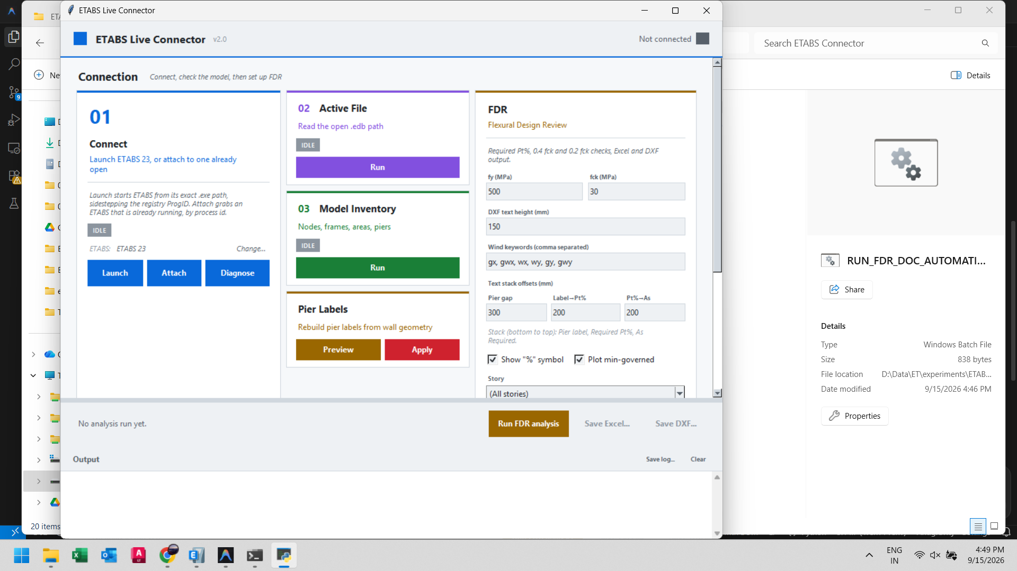
Figure 5: Read Stories and Load Combinations

Step 6: Select All Load Combinations
Click 'All' above the combinations list to select every load combination. All combinations are highlighted in blue. This includes gravity, wind (gx, gy, gwx, gwy, wx, wy), and seismic envelope combinations.
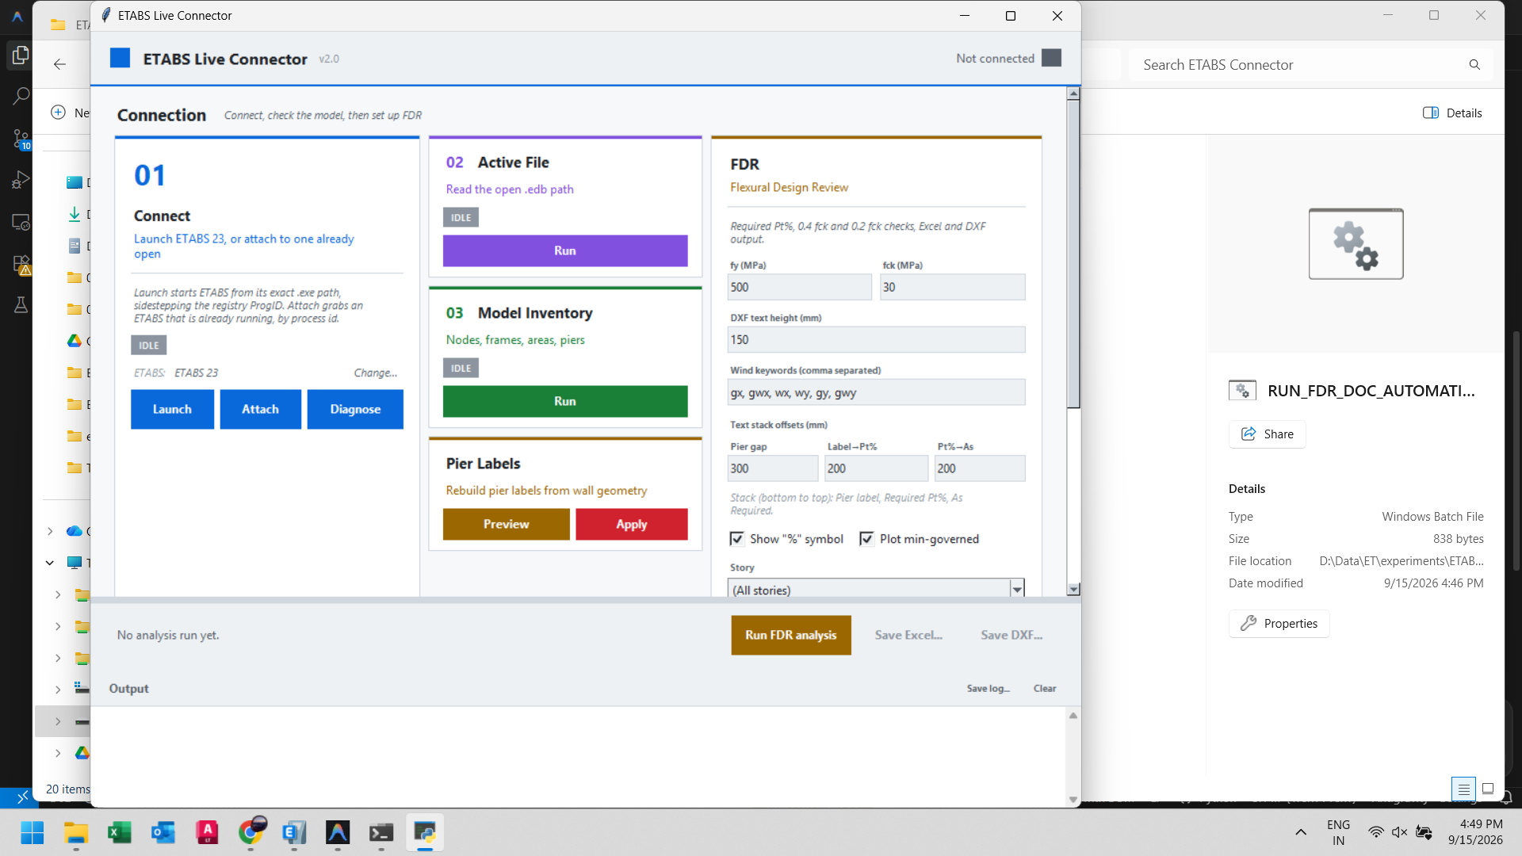
Figure 6: Select All Load Combinations

Step 7: FDR Panel - Full Configuration
The complete FDR panel with all parameters configured:
fy = 500 MPa (steel yield strength)
fck = 30 MPa (concrete grade)
DXF text height = 150 mm
Wind keywords: gx, gwx, wx, wy, gy, gwy
Text stack offsets: Pier gap 300 mm | Label to Pt% 200 mm | Pt% to As 200 mm
Story: (All stories) for a full-building Excel report
Show % symbol: ON | Plot min-governed: ON
Figure 7: FDR Panel - Full Configuration

Step 8: Run FDR Analysis
Click 'Run FDR analysis' (amber action bar button). The engine:
1. Reads pier forces across all selected load combinations
2. Extracts pier geometry (X1,Y1 to X2,Y2 coordinates)
3. Computes Pmax and Pmin per pier with governing load combo
4. Calculates Required Pt% for each pier
5. Evaluates 0.4 fck C/D ratio (special ductile detailing)
6. Evaluates 0.2 fck C/D ratio (boundary element checks)
7. Generates AutoCAD DXF entity strings and Excel data
Live progress is shown in the Output console.
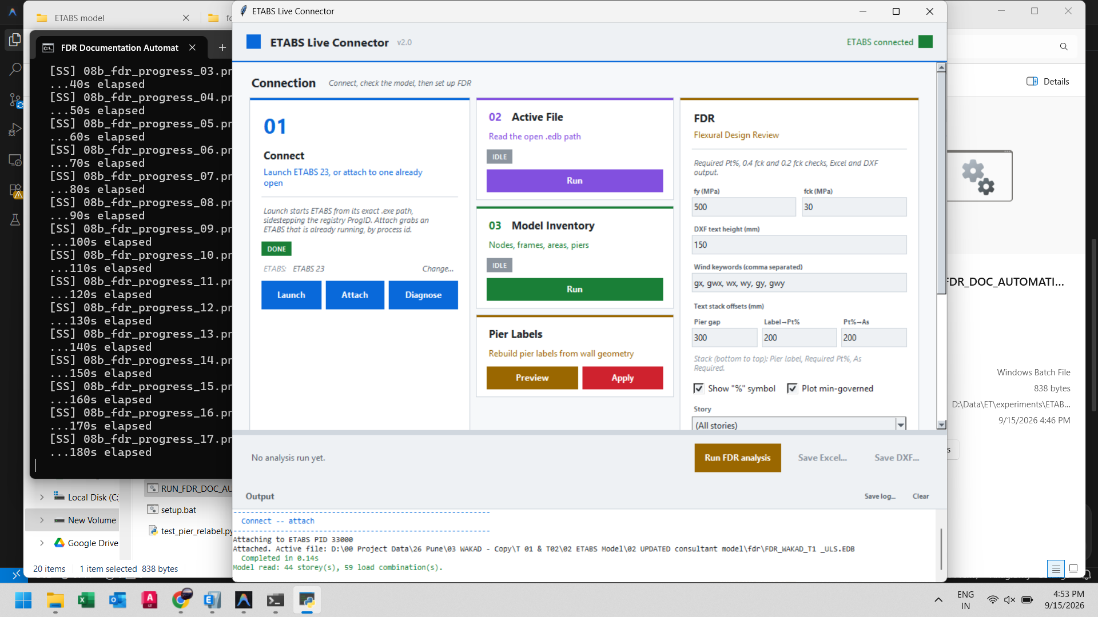
Figure 8: Run FDR Analysis

Step 9: Save Excel Report
Click 'Save Excel...' (green button). A file save dialog appears. The Excel workbook contains:
Sheet: Pier forces with Pmax/Pmin pivot tables
Sheet: Required reinforcement percentage (Pt%) per pier
Sheet: 0.4 fck Special Ductile Detailing evaluation
Sheets: 0.2 fck Boundary Element checks at Base, H/10, H/4, H/2
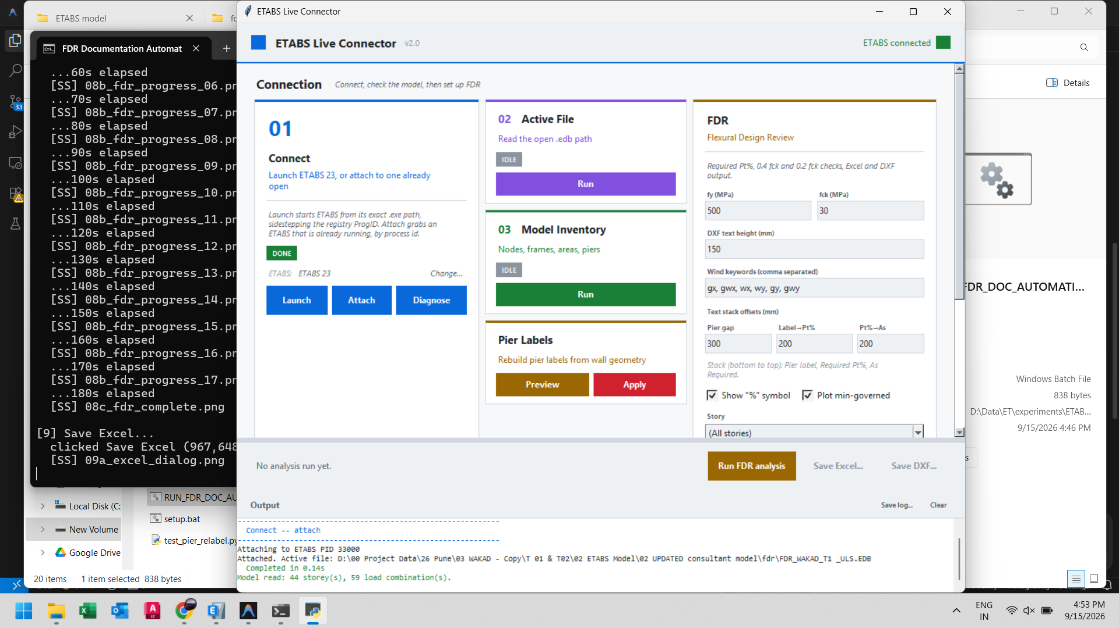
Figure 9: Save Excel Report

Step 10: Save DXF AutoCAD Output
Click 'Save DXF...' (purple button). Six DXF layouts are generated in one file:
Sheet 1: 0.2 fck C/D Ratio - Ground Floor (Base)
Sheet 2: 0.2 fck C/D Ratio - H/10 Level
Sheet 3: 0.2 fck C/D Ratio - H/4 Level
Sheet 4: 0.2 fck C/D Ratio - H/2 Level
Sheet 5: Reinforcement Pt% Sheet (piers >= 0.25% only annotated)
Sheet 6: 0.4 fck C/D Ratio Sheet
TEXT entities are positioned with configured offsets above each pier label.
[Screenshot not captured for this step: 10b_dxf_savedialog]

Step 11: Completed Workflow
The ETABS Live Connector GUI after the full FDR workflow is complete. The action bar label shows a summary of the analysis results. Both 'Save Excel...' and 'Save DXF...' buttons remain active for re-export.
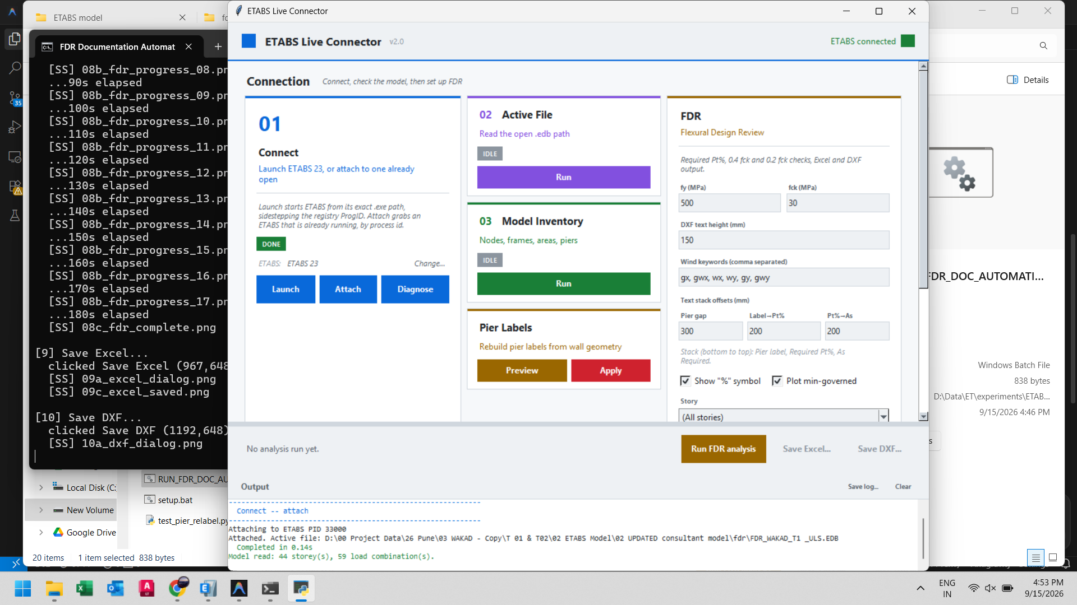
Figure 11: Completed Workflow

Output Files Summary
File | Format | Contents
FDR_WAKAD_T1_ULS_output.xlsx | Excel .xlsx | Pier forces, Pmax/Pmin, Required Pt%, 0.4 fck C/D, 0.2 fck Boundary Element checks
FDR_WAKAD_T1_ULS_output.dxf | AutoCAD DXF | 6 drawing sheets: C/D ratios at 4 levels + Pt% annotation + 0.4 fck sheet

Key Engineering Parameters Used
fy = 500 MPa | fck = 30 MPa
Wind keywords: gx, gwx, wx, wy, gy, gwy
Story filter: All Stories (full building)
Pt% annotation threshold: >= 0.25% only
DXF text height: 150 mm | Offsets: 300 / 200 / 200 mm

