Lab-3: UML Class Diagram for Hospital Management System
1. Class Diagram
Figure 1: UML Class Diagram of the Hospital Management System
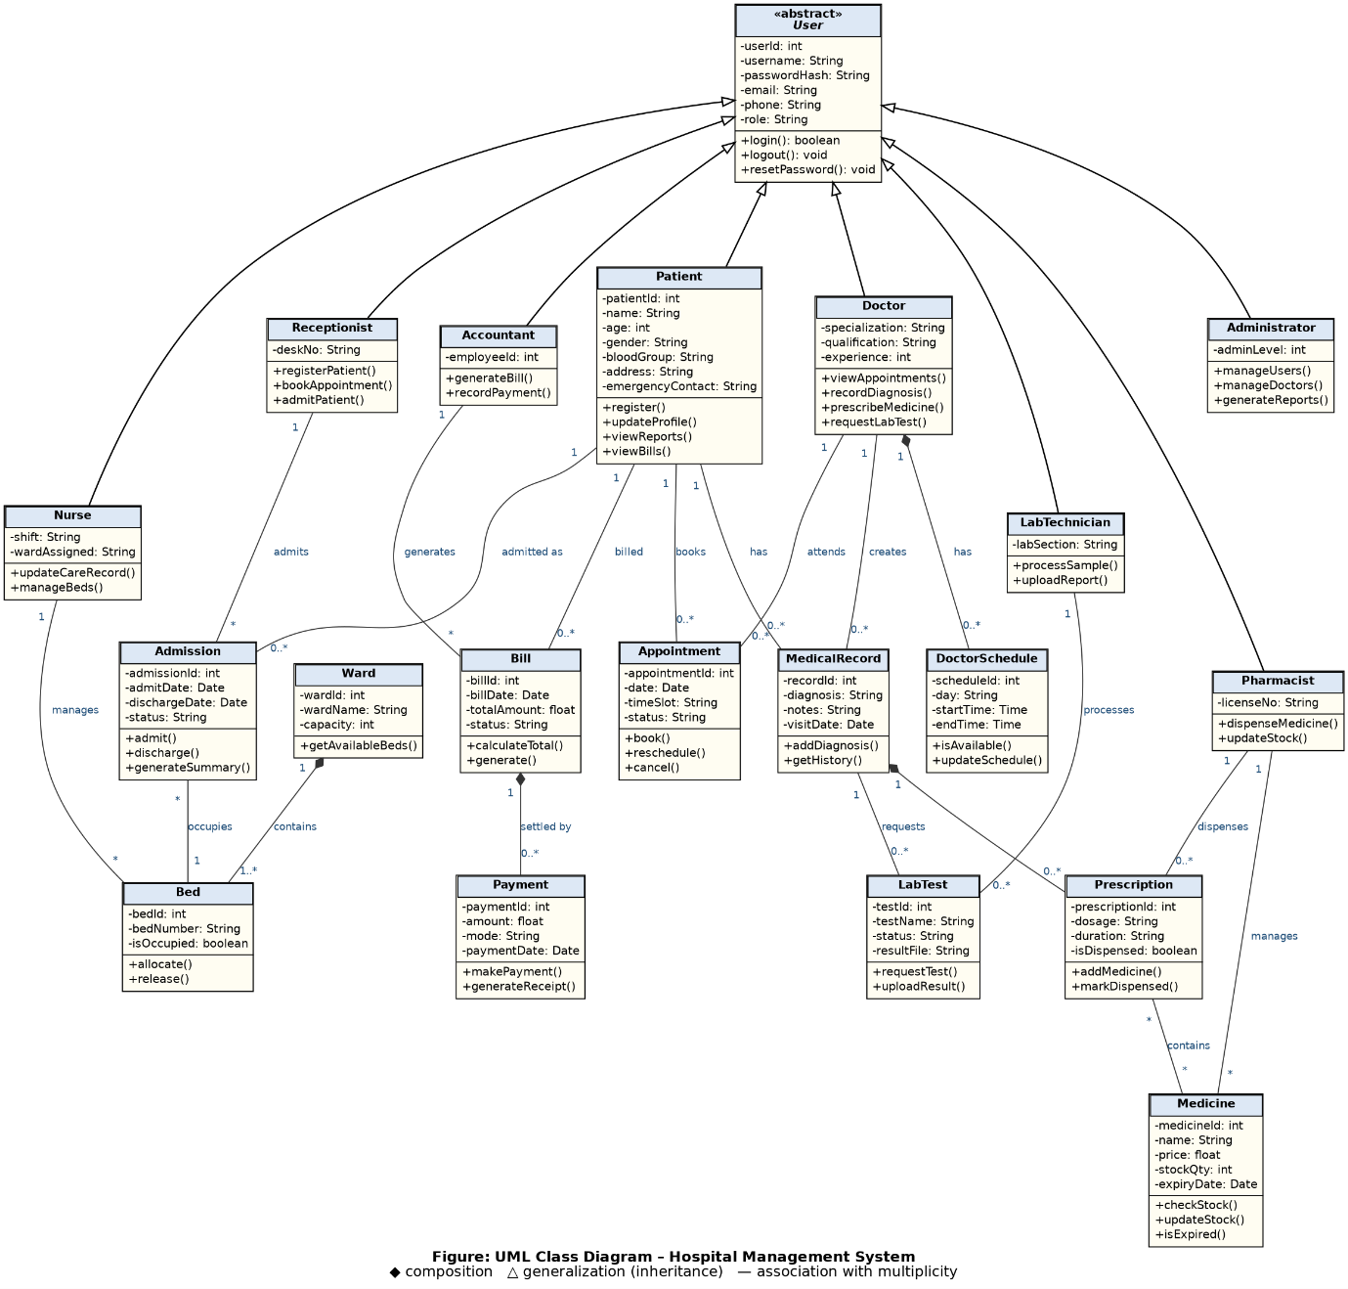
2. Identification of Classes
The classes were identified from the nouns in the SRS (Lab-1) and the actors and use cases (Lab-2). Actors with their own data and behaviour became user classes, and the main records they handle became domain classes.
2.1 User Classes
Class | Attributes | Methods
User (abstract) | userId, username, passwordHash, email, phone, role | login(), logout(), resetPassword()
Patient | patientId, name, age, gender, bloodGroup, address, emergencyContact | register(), updateProfile(), viewReports(), viewBills()
Doctor | specialization, qualification, experience | viewAppointments(), recordDiagnosis(), prescribeMedicine(), requestLabTest()
Nurse | shift, wardAssigned | updateCareRecord(), manageBeds()
Receptionist | deskNo | registerPatient(), bookAppointment(), admitPatient()
Pharmacist | licenseNo | dispenseMedicine(), updateStock()
LabTechnician | labSection | processSample(), uploadReport()
Accountant | employeeId | generateBill(), recordPayment()
Administrator | adminLevel | manageUsers(), manageDoctors(), generateReports()
2.2 Domain Classes
Class | Attributes | Methods
Appointment | appointmentId, date, timeSlot, status | book(), reschedule(), cancel()
DoctorSchedule | scheduleId, day, startTime, endTime | isAvailable(), updateSchedule()
MedicalRecord | recordId, diagnosis, notes, visitDate | addDiagnosis(), getHistory()
Prescription | prescriptionId, dosage, duration, isDispensed | addMedicine(), markDispensed()
Medicine | medicineId, name, price, stockQty, expiryDate | checkStock(), updateStock(), isExpired()
LabTest | testId, testName, status, resultFile | requestTest(), uploadResult()
Admission | admissionId, admitDate, dischargeDate, status | admit(), discharge(), generateSummary()
Ward | wardId, wardName, capacity | getAvailableBeds()
Bed | bedId, bedNumber, isOccupied | allocate(), release()
Bill | billId, billDate, totalAmount, status | calculateTotal(), generate()
Payment | paymentId, amount, mode, paymentDate | makePayment(), generateReceipt()
Visibility notation: - means private attribute and + means public method.
3. Relationships
3.1 Generalization (Inheritance)
Patient, Doctor, Nurse, Receptionist, Pharmacist, LabTechnician, Accountant and Administrator all inherit from the abstract class User. They share the common login attributes and methods and add their own role-specific ones.
3.2 Association and Composition
Relationship | Type | Multiplicity | Description
Patient – Appointment | Association | 1 : 0..* | A patient books many appointments.
Doctor – Appointment | Association | 1 : 0..* | A doctor attends many appointments.
Doctor – DoctorSchedule | Composition | 1 : 0..* | A doctor has schedules, and a schedule cannot exist without the doctor.
Patient – MedicalRecord | Association | 1 : 0..* | A patient has many medical records.
Doctor – MedicalRecord | Association | 1 : 0..* | A doctor creates many medical records.
MedicalRecord – Prescription | Composition | 1 : 0..* | A record contains prescriptions, which depend on the record.
Prescription – Medicine | Association | * : * | A prescription has many medicines, and a medicine appears in many prescriptions.
MedicalRecord – LabTest | Association | 1 : 0..* | A record can have many lab tests requested.
LabTechnician – LabTest | Association | 1 : 0..* | A lab technician processes many tests.
Pharmacist – Prescription | Association | 1 : 0..* | A pharmacist dispenses many prescriptions.
Pharmacist – Medicine | Association | 1 : * | A pharmacist manages the medicine stock.
Patient – Admission | Association | 1 : 0..* | A patient can be admitted many times.
Receptionist – Admission | Association | 1 : * | A receptionist admits many patients.
Admission – Bed | Association | * : 1 | Each admission occupies one bed.
Ward – Bed | Composition | 1 : 1..* | A ward contains beds, and a bed belongs to one ward.
Nurse – Bed | Association | 1 : * | A nurse manages many beds.
Patient – Bill | Association | 1 : 0..* | A patient is billed many times.
Accountant – Bill | Association | 1 : * | An accountant generates many bills.
Bill – Payment | Composition | 1 : 0..* | A bill is settled by one or more payments.
4. Design Notes
- User is abstract, so it cannot be instantiated directly. Every real user is one of the eight role classes.
- Composition (filled diamond) is used where the child cannot exist without the parent, for example Bill and Payment.
- The class diagram is consistent with the Lab-2 use cases. For example, Record Payment maps to Accountant.recordPayment() and Payment.makePayment().
- The diagram does not show Receptionist–Appointment, because it would clutter the layout. That link exists through Receptionist.bookAppointment().

