SOFTWARE ENGINEERING LAB – 5
Sequence Diagram for Hospital Management System (HMS)
1. Aim
To draw the UML Sequence Diagram for the Hospital Management System (HMS) to represent the chronological interaction between the Patient, Receptionist, Appointment, DoctorSchedule, and Doctor during the appointment booking process.
2. Theory
A Sequence Diagram is a UML interaction diagram that illustrates how objects or actors communicate with one another in a particular sequence over time.
It represents:
- Actors: External users who interact with the system.
- Lifelines: The participating objects or entities.
- Messages: Requests and responses exchanged between participants.
- Activation Bars: The period during which an object performs an operation.
- Alternative Fragments (alt): Conditional interactions based on a decision.
For the Hospital Management System, the Sequence Diagram is based on the existing use case:
UC-2: Book / Manage Appointment
The diagram demonstrates how an appointment is booked after verifying patient details and checking the Doctor's availability.
Precondition: The user is logged in to the Hospital Management System.
Postcondition: The appointment is booked, its status is updated, and confirmation is provided to the user.
3. Sequence Diagram
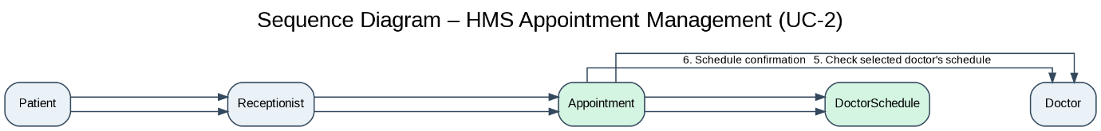
Figure 5.1: Sequence Diagram – HMS Appointment Management (UC-2)
Download the Sequence Diagram (PNG)
4. Explanation of the Sequence Diagram
The sequence diagram illustrates the chronological interaction between the Patient, Receptionist, Appointment, DoctorSchedule, and Doctor during appointment booking.
Step-by-step interaction
1. Request Appointment: The Patient requests an appointment from the Receptionist.
2. Book Appointment: The Receptionist invokes the book() method of the Appointment class by providing the patient ID, doctor ID, preferred date, and time slot.
3. Check Availability: The Appointment object interacts with the DoctorSchedule object and invokes the isAvailable() method to verify the availability of the selected appointment slot.
4. Availability Response: The DoctorSchedule object returns the availability result to the Appointment object.
5. Verify Doctor Schedule: The Appointment object checks the selected Doctor's schedule to ensure that the requested appointment can be scheduled.
6. Schedule Confirmation: The Doctor provides the schedule confirmation to the Appointment object.
7. Booking Result: The Appointment object returns the booking result and appointment status to the Receptionist.
8. Display Confirmation: The Receptionist communicates the appointment confirmation to the Patient.
The sequence of messages ensures that the appointment is scheduled only after the required availability checks have been completed.
5. Relationship with Existing HMS Classes
The sequence diagram uses the classes defined in Lab-3.
Class | Relevant Method | Purpose
Patient | register() | Registers a patient when required
Receptionist | bookAppointment() | Initiates appointment booking
Appointment | book() | Books the appointment
Appointment | reschedule() | Reschedules an existing appointment
Appointment | cancel() | Cancels an appointment
DoctorSchedule | isAvailable() | Checks doctor availability
Doctor | viewAppointments() | Views scheduled appointments
No new domain classes have been introduced.
6. Functional Requirement Mapping
Requirement ID | Requirement | Supported Functionality
FR-2 | Patient Registration & Management | Patient identification and registration
FR-3 | Appointment Management | Appointment booking, schedule verification, and prevention of double booking
7. Conclusion
The Sequence Diagram for the Hospital Management System was successfully designed to represent the chronological interaction between the Patient, Receptionist, Appointment, DoctorSchedule, and Doctor.
The diagram demonstrates the appointment booking process, including the exchange of messages, checking of doctor availability, and confirmation of appointment status.
It maintains consistency with the existing use case diagram (Lab-2), class diagram (Lab-3), and functional requirements specified in the SRS (Lab-1).
