SOFTWARE ENGINEERING LAB – 6
Sequence Diagram for Hospital Management System (HMS)
1. Aim
To draw the UML Sequence Diagram for the Hospital Management System (HMS) to represent the interaction between the Patient, Accountant, Bill, and Payment during the bill generation and payment process.
2. Theory
A Sequence Diagram is a UML behavioral diagram that represents the chronological exchange of messages between actors and objects in a system.
It describes how different components collaborate to perform a specific operation. The vertical lifelines represent participating objects, while horizontal arrows represent messages exchanged between them.
For this lab, the Sequence Diagram is based on the existing use cases:
- UC-7: Generate Bill
- UC-8: Record Payment
The diagram represents the process of generating a hospital bill, calculating the total amount, recording the payment, and generating a payment receipt.
Precondition: The user is logged in, and the Patient has billable hospital services.
Postcondition: The bill is generated, the payment is recorded, and a receipt is generated after successful payment.
This lab uses a different HMS workflow from Lab-5, which covered appointment booking. All actors and classes remain consistent with the existing project documentation.
3. Sequence Diagram
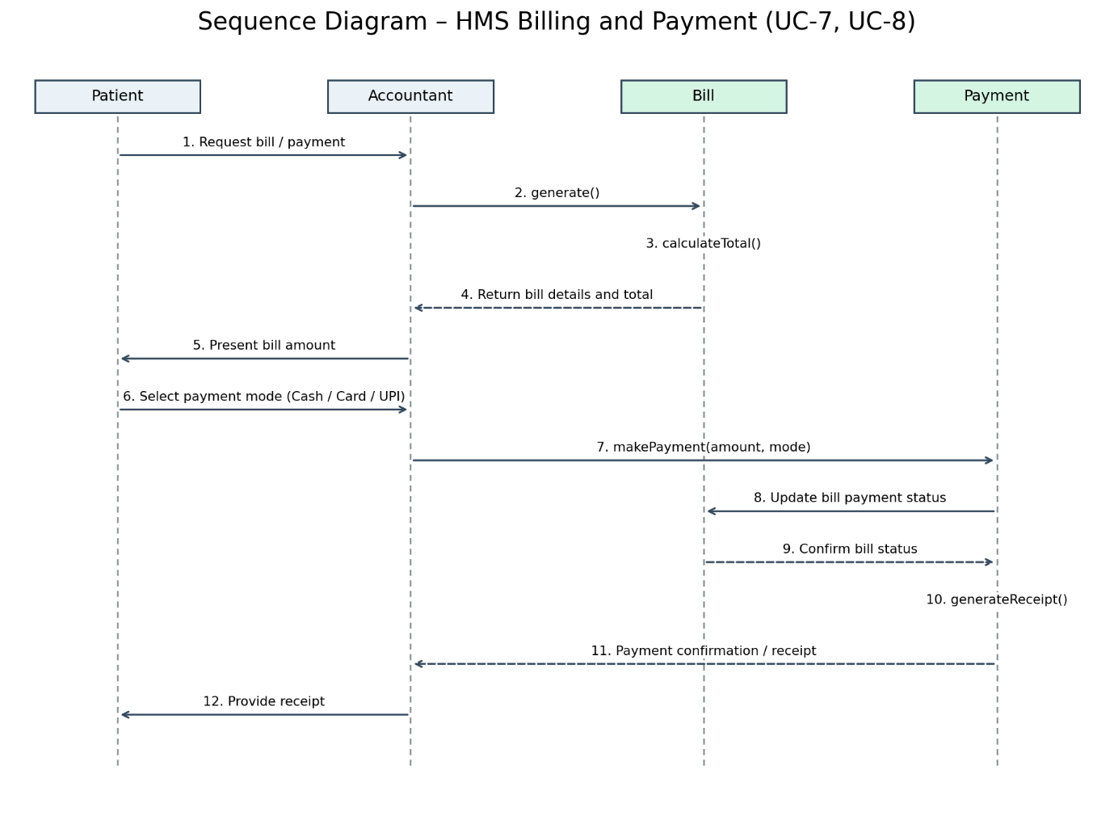
Figure 6.1: Sequence Diagram – HMS Billing and Payment (UC-7, UC-8)
Download Sequence Diagram – Lab 6 (PNG)
4. Explanation of the Sequence Diagram
The sequence diagram represents the interaction between the Patient, Accountant, Bill, and Payment during the billing and payment process.
Step-by-step interaction
1. Request Bill: The Patient requests the bill from the Accountant.
2. Generate Bill: The Accountant invokes the generate() method of the Bill class.
3. Calculate Total: The Bill object invokes calculateTotal() to calculate the total amount payable for hospital services, including consultation, laboratory tests, medicines, and room charges, where applicable.
4. Return Bill Details: The Bill object returns the calculated amount and bill details to the Accountant.
5. Present Bill: The Accountant presents the bill amount to the Patient.
6. Select Payment Mode: The Patient selects a payment mode from the supported options: Cash, Card, or UPI.
7. Record Payment: The Accountant invokes the makePayment() method of the Payment class, providing the payment amount and mode.
8. Update Bill Status: The Payment object updates the payment status associated with the Bill.
9. Confirm Payment Status: The Bill object confirms the updated payment status.
10. Generate Receipt: The Payment object invokes generateReceipt() to generate the payment receipt.
11. Return Payment Confirmation: The Payment object returns the payment confirmation and receipt details to the Accountant.
12. Provide Receipt: The Accountant provides the generated receipt to the Patient, completing the payment process.
5. Relationship with Existing HMS Classes
The sequence diagram uses the classes defined in Lab-3.
Class | Relevant Attributes | Relevant Methods
Patient | patientId | viewBills()
Accountant | employeeId | generateBill(), recordPayment()
Bill | billId, billDate, totalAmount, status | calculateTotal(), generate()
Payment | paymentId, amount, mode, paymentDate | makePayment(), generateReceipt()
No new classes or actors have been introduced.
6. Functional Requirement Mapping
Requirement ID | Functional Requirement | Supported Functionality
FR-6 | Billing & Payment | Automatic bill generation, payment recording, supported payment modes, and receipt generation
FR-1 | User Authentication & Authorization | Ensures that only authenticated users can access billing operations
7. Conclusion
The Sequence Diagram for the Hospital Management System was successfully designed to represent the billing and payment workflow.
The diagram illustrates the chronological exchange of messages between the Patient, Accountant, Bill, and Payment. It demonstrates bill generation, total amount calculation, payment recording, status updating, and receipt generation.
The diagram is consistent with the existing use case diagram (Lab-2), class diagram (Lab-3), and functional requirements defined in the SRS (Lab-1).

