SOFTWARE ENGINEERING LAB – 8
State Transition Diagram for Hospital Management System (HMS)
1. Aim
To draw the UML State Transition Diagram for the Hospital Management System (HMS) to represent the different states of an Appointment object and the transitions that occur in response to appointment-related events.
2. Theory
A State Transition Diagram, also known as a State Machine Diagram, is a UML behavioral diagram that represents the different states of an object during its lifecycle.
It illustrates how an object changes from one state to another in response to events or operations.
The main elements of a State Transition Diagram are:
- Initial State: Represents the starting point of the state machine.
- State: Represents a condition or status of an object.
- Transition: Represents a change from one state to another.
- Event: Triggers a state transition.
- Final State: Represents the completion of the object's lifecycle.
For this lab, the State Transition Diagram is based on the existing class:
Appointment
The diagram represents the lifecycle of an appointment using the existing methods book(), reschedule(), and cancel().
Precondition: The user is logged in, and the appointment booking process has been initiated.
Postcondition: The appointment reaches an appropriate final state, such as Completed or Cancelled.
3. State Transition Diagram
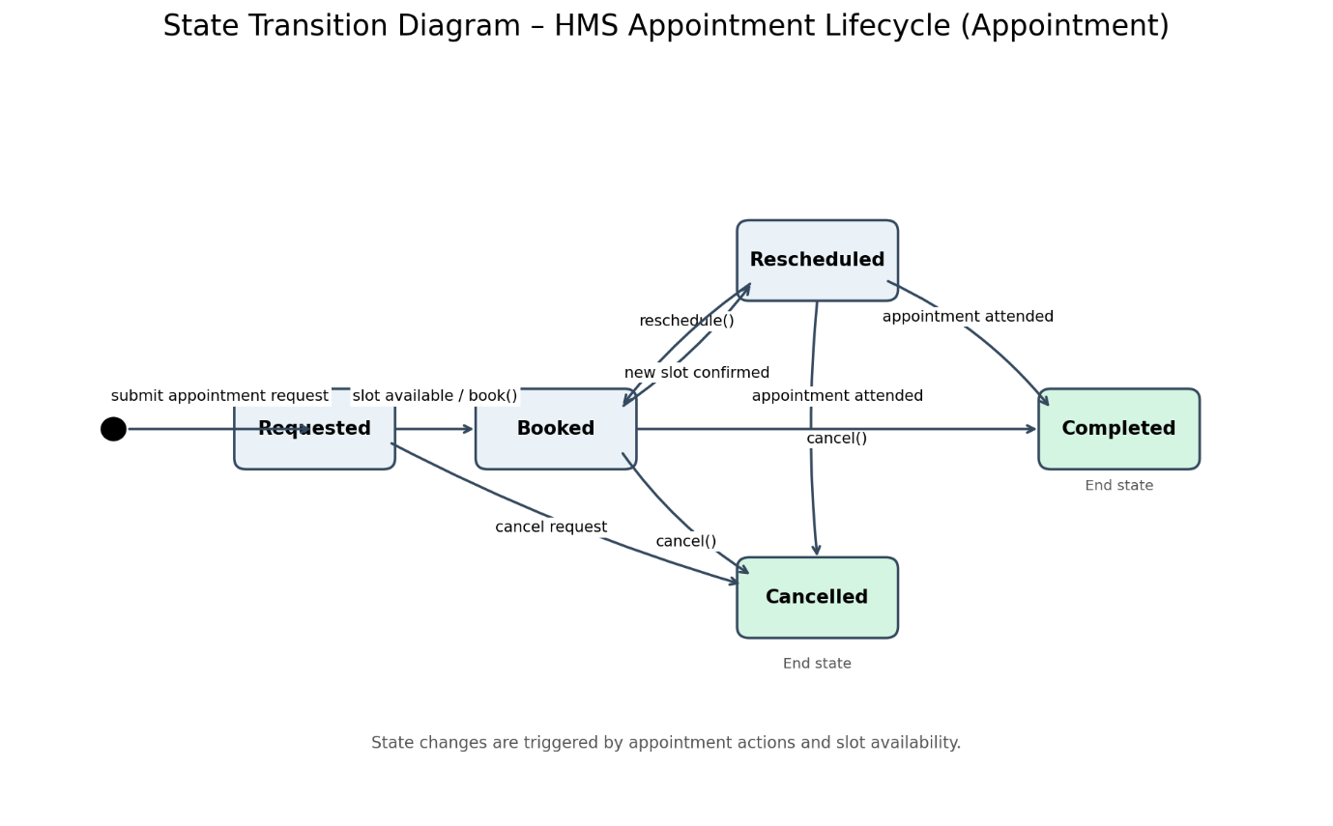
Figure 8.1: State Transition Diagram – HMS Appointment Lifecycle
Download Lab 8 State Transition Diagram (PNG)
4. Explanation of the State Transition Diagram
The diagram represents the lifecycle of an Appointment object in the Hospital Management System.
States of Appointment
State | Description
Requested | The appointment request has been submitted.
Booked | The appointment has been successfully scheduled.
Rescheduled | The appointment date or time has been changed.
Cancelled | The appointment has been cancelled.
Completed | The patient has attended the appointment, and the appointment process is complete.
State Transitions
1. Initial → Requested: The Patient or Receptionist submits an appointment request.
2. Requested → Booked: The system checks doctor availability and books the appointment using book().
3. Booked → Rescheduled: The appointment date or time is changed using reschedule().
4. Rescheduled → Booked: The newly selected time slot is confirmed, and the appointment becomes booked.
5. Requested → Cancelled: An appointment request is cancelled before booking.
6. Booked → Cancelled: A booked appointment is cancelled using cancel().
7. Rescheduled → Cancelled: A rescheduled appointment is cancelled.
8. Booked → Completed: The patient attends the appointment, and the appointment is marked as completed.
9. Rescheduled → Completed: The patient attends the appointment at the newly confirmed time.
The diagram shows how the Appointment object changes its state based on the operations performed by the Patient or Receptionist.
5. Relationship with Existing HMS Classes
Class | Relevant Attributes | Relevant Methods
Appointment | appointmentId, date, timeSlot, status | book(), reschedule(), cancel()
Patient | patientId, name | viewReports(), viewBills()
Doctor | specialization, qualification, experience | viewAppointments()
DoctorSchedule | scheduleId, day, startTime, endTime | isAvailable(), updateSchedule()
The state transitions are associated with the existing status attribute of the Appointment class.
6. Functional Requirement Mapping
Requirement ID | Requirement | Supported Functionality
FR-3 | Appointment Management | Booking, rescheduling, cancellation, and appointment status management
FR-4 | Doctor Management | Doctor schedule management and appointment handling
7. Conclusion
The State Transition Diagram for the Hospital Management System was successfully designed to represent the lifecycle of an Appointment object.
It illustrates the different appointment states, the events that trigger state transitions, and the conditions under which an appointment is booked, rescheduled, cancelled, or completed.
The diagram is consistent with the existing SRS (Lab-1), Use Case Diagram (Lab-2), and Class Diagram (Lab-3).

