SOFTWARE ENGINEERING LAB – 9
Component Diagram for Hospital Management System (HMS)
1. Aim
To draw the UML Component Diagram for the Hospital Management System (HMS) to represent the system's software components, their dependencies, and their interactions within the client-server architecture.
2. Theory
A Component Diagram is a UML structural diagram that represents the organization and dependencies of software components within a system.
It describes how a system is divided into independent modules and how these modules interact with one another through interfaces.
The main elements of a Component Diagram are:
- Components: Independent software modules that perform specific functions.
- Interfaces: Define the services provided or required by a component.
- Dependencies: Represent relationships between components.
- Connectors: Represent communication between components.
The Hospital Management System follows a client-server architecture in which the frontend communicates with the backend through REST APIs using HTTPS and JSON. The backend components interact with a relational database to store and retrieve hospital information.
The component diagram is based on the functional requirements FR-1 to FR-9 defined in Lab-1.
3. Component Diagram
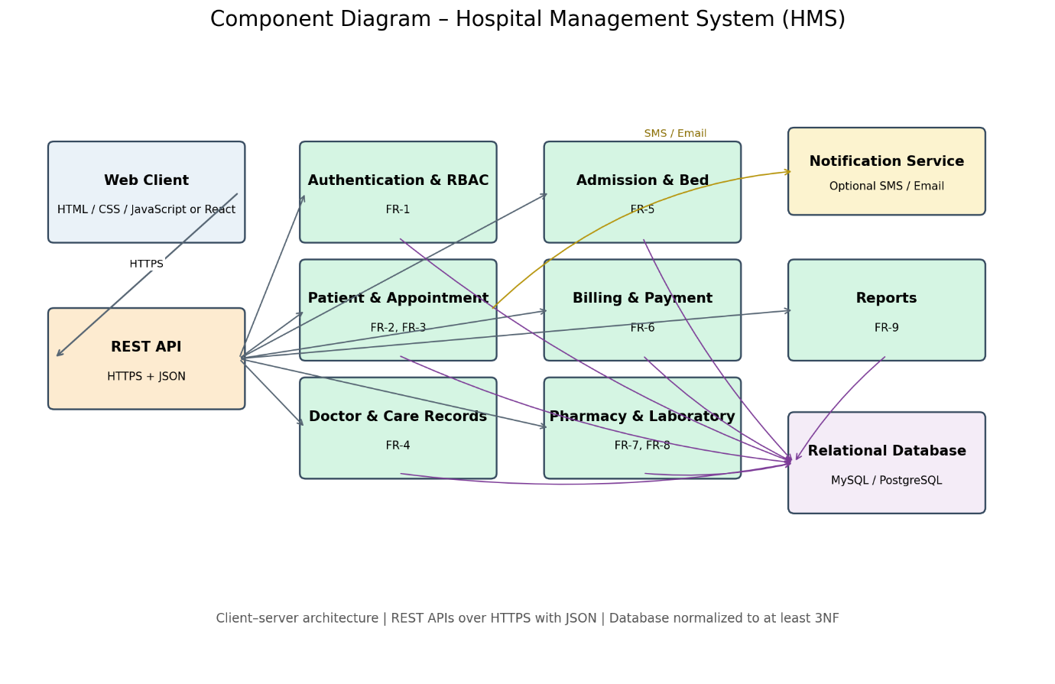
Figure 9.1: Component Diagram – Hospital Management System
Download Lab 9 Component Diagram (PNG)
4. Explanation of the Component Diagram
The Component Diagram represents the modular architecture of the Hospital Management System.
The system is divided into the following major components.
4.1 Web Client Component
The Web Client provides the user interface through which Patients, Receptionists, Doctors, Nurses, Pharmacists, Lab Technicians, Accountants, and Administrators interact with the system.
Technologies:
- HTML
- CSS
- JavaScript
- React (optional)
The Web Client communicates with the backend using HTTPS requests.
4.2 REST API Component
The REST API component acts as the communication layer between the frontend and backend.
It receives user requests, processes API calls, and returns responses in JSON format.
The API provides access to the different HMS functional modules.
4.3 Authentication and Authorization Component
This component implements FR-1.
Its responsibilities include:
- User authentication
- Role-Based Access Control (RBAC)
- Password reset
- Account lock after five failed login attempts
- Session management
It ensures that users can access only the operations permitted by their roles.
4.4 Patient and Appointment Component
This component implements FR-2 and FR-3.
Its responsibilities include:
- Patient registration
- Patient profile management
- Appointment booking
- Appointment rescheduling
- Appointment cancellation
- Doctor availability checking
It uses the existing Patient, Appointment, and DoctorSchedule classes.
4.5 Doctor and Care Records Component
This component implements FR-4.
Its responsibilities include:
- Doctor profile management
- Doctor schedule management
- Diagnosis recording
- Prescription entry
- Patient care record management
It uses the existing Doctor, MedicalRecord, and Prescription classes.
4.6 Admission and Bed Component
This component implements FR-5.
Its responsibilities include:
- Patient admission
- Patient discharge
- Bed allocation
- Ward-wise bed availability
- Discharge summary generation
It uses the existing Admission, Ward, and Bed classes.
4.7 Billing and Payment Component
This component implements FR-6.
Its responsibilities include:
- Automatic bill generation
- Consultation charge calculation
- Laboratory test charge calculation
- Medicine charge calculation
- Room charge calculation
- Payment recording
- Receipt generation
It uses the existing Bill and Payment classes.
4.8 Pharmacy and Laboratory Component
This component implements FR-7 and FR-8.
The Pharmacy functionality includes:
- Medicine stock management
- Low-stock alerts
- Expiry alerts
- Medicine dispensing against prescriptions
The Laboratory functionality includes:
- Laboratory test requests
- Sample processing
- Test status updates
- Laboratory result uploads
It uses the existing Medicine and LabTest classes.
4.9 Reports Component
This component implements FR-9.
Its responsibilities include:
- Patient count reports
- Revenue reports
- Bed occupancy reports
- Doctor performance reports
- PDF and Excel report export
The Reports component retrieves information from the database and generates management reports.
4.10 Relational Database Component
The Relational Database component stores the information required by all HMS modules.
Suggested database technologies:
- MySQL
- PostgreSQL
The database maintains patient information, appointment details, doctor profiles, medical records, prescriptions, laboratory tests, admissions, beds, bills, and payments.
The database is designed to maintain at least Third Normal Form (3NF).
4.11 Notification Service Component
The Notification Service is an optional component that supports SMS and email notifications.
It can be used for:
- Appointment reminders
- Appointment confirmations
- Password reset notifications
This component uses the optional SMS/Email integration specified in the HMS project summary.
5. Component and Requirement Mapping
Component | Functional Requirement
Authentication and Authorization | FR-1
Patient and Appointment | FR-2, FR-3
Doctor and Care Records | FR-4
Admission and Bed | FR-5
Billing and Payment | FR-6
Pharmacy and Laboratory | FR-7, FR-8
Reports | FR-9
Notification Service | Supports FR-3 and FR-1
6. Technologies Used
Layer | Suggested Technology
Frontend | HTML, CSS, JavaScript / React
Backend | Java Spring Boot / PHP Laravel / Python
Communication | REST APIs, HTTPS, JSON
Database | MySQL / PostgreSQL
Notifications | Optional SMS / Email service
The component organization is a logical architectural representation of the existing HMS project. It does not introduce any new domain classes or change the established actors and use cases.
7. Conclusion
The Component Diagram for the Hospital Management System was successfully designed to represent the system's modular software architecture.
It illustrates the organization of the frontend, REST API, authentication, patient management, appointment management, doctor management, admission, billing, pharmacy, laboratory, reporting, and database components.
The diagram demonstrates how the system follows a modular client-server architecture and maintains consistency with the functional requirements defined in the SRS (Lab-1), Use Case Diagram (Lab-2), and Class Diagram (Lab-3).

