Week 3 Task: Exploratory Data Analysis and Visualization for Agribusiness Insights
Agribusiness Crop Performance Analysis

1. Objective
The objective of this Week 3 analysis is to perform exploratory data analysis (EDA) on cleaned public agribusiness data and identify useful patterns related to crop performance. The analysis uses descriptive statistics and visualizations to examine cultivated area, production, yield, crop differences, and seasonal production. The findings are intended to demonstrate how basic data analysis can support agribusiness planning and further analytical work.

2. Dataset Description and Selection
The analysis continues the cleaned agribusiness dataset prepared during Week 2. The dataset contains district-level observations for crops grown in different seasons. The selected variables are District, Crop, Season, Area_Ha, Production_Tonnes, and the derived Yield_Tonnes_Per_Ha. The dataset was selected because these variables directly represent important crop-production measures and allow meaningful comparison between crops and seasons.
The cleaned working dataset contains 5 observations covering Wheat, Rice, Cotton, and Groundnut across Rabi and Kharif seasons. Yield was calculated as production divided by cultivated area.

3. Data Preparation
- Used the cleaned output from the Week 2 preprocessing task.
- Checked the data structure and numeric fields before analysis.
- Used Area_Ha and Production_Tonnes as the main quantitative variables.
- Calculated Yield_Tonnes_Per_Ha = Production_Tonnes / Area_Ha.
- Grouped observations by Crop and Season for comparative analysis.
- No additional missing-value imputation was required in the final working dataset.

4. Tools and Methodology
Python was used for the EDA. Pandas was used for data manipulation, grouping, aggregation, and descriptive calculations. Matplotlib was used to create charts and a scatter plot. The analysis follows an exploratory workflow: inspect the cleaned data, calculate descriptive measures, compare groups, visualize relationships, and interpret the results from an agribusiness perspective.
- Programming language: Python
- Data analysis library: Pandas
- Visualization library: Matplotlib
- Document/report preparation: Microsoft Word-compatible DOCX
- EDA techniques: aggregation, descriptive statistics, comparison, scatter analysis, and interpretation

5. Descriptive Statistics
Statistic | Area (Ha) | Production (t) | Yield (t/Ha)
Count | 5.00 | 5.00 | 5.000
Mean | 1496.63 | 2965.94 | 1.900
Std | 1175.44 | 3416.09 | 1.109
Min | 381.64 | 100.00 | 0.083
Max | 3501.49 | 8795.78 | 2.876
The dataset contains 5 observations. Total cultivated area is 7,483.13 hectares and total production is 14,829.72 tonnes. The area-weighted overall yield is 1.982 tonnes per hectare. These measures provide a baseline for comparing crop performance.

6. Crop-wise Production Analysis
Crop-level aggregation was used to compare total cultivated area, total production, and average observed yield. This helps identify which crops contribute most to output and which show stronger production efficiency per hectare.
Crop | Area (Ha) | Production (t) | Avg Yield (t/Ha)
Cotton | 1200.00 | 100.00 | 0.083
Groundnut | 1200.00 | 1977.98 | 1.648
Rice | 1200.00 | 2858.25 | 2.382
Wheat | 3883.13 | 9893.49 | 2.694
Wheat has the highest total production in the dataset at 9893.49 tonnes, mainly because the Banaskantha observation has a comparatively large cultivated area. Wheat has the highest average observed yield at 2.694 tonnes per hectare, while Cotton has the lowest observed yield at 0.083 tonnes per hectare.
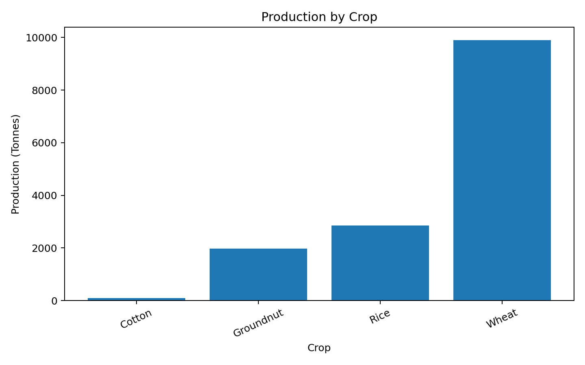
Figure 1. Production by crop.
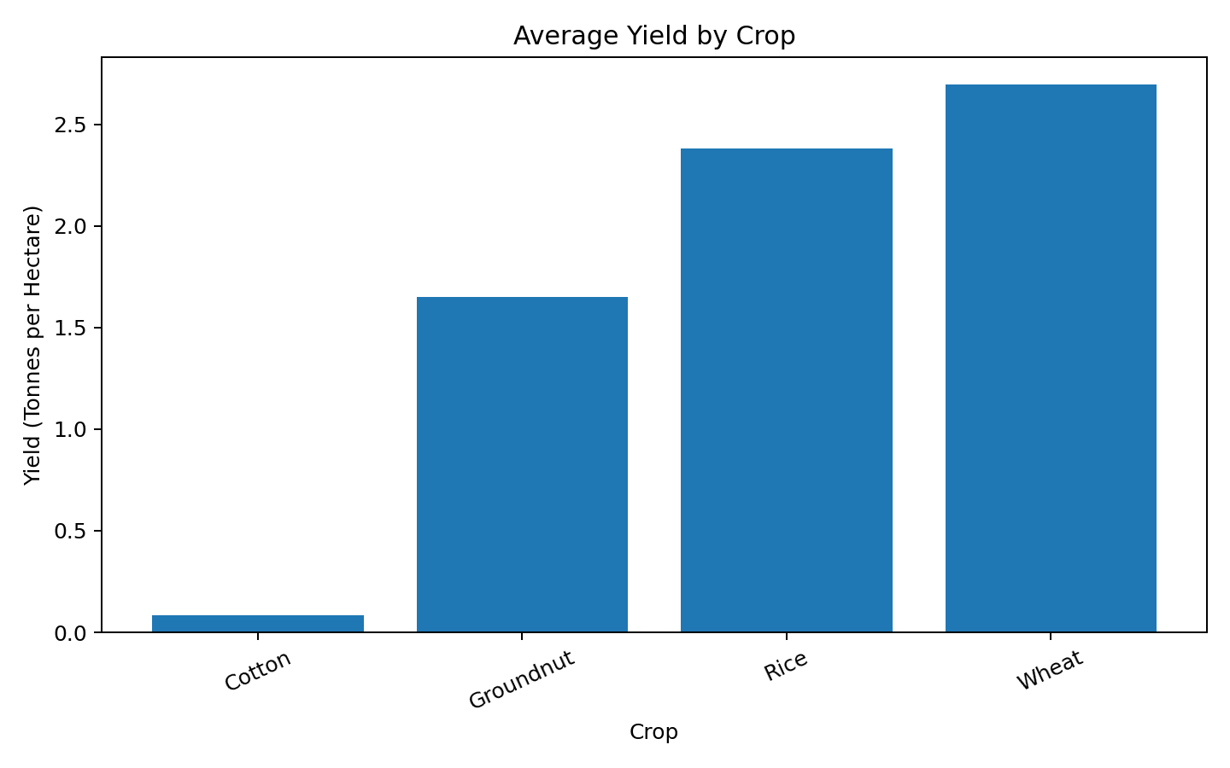
Figure 2. Average observed yield by crop.

7. Area and Production Relationship
A scatter plot was used to examine whether larger cultivated area is associated with higher production in the small sample. The Pearson correlation between area and production is approximately 0.931. The relationship appears positive in this dataset, but the sample is very small, so the correlation should not be treated as a general agribusiness rule. Production can also depend on yield, weather, soil, irrigation, crop variety, and management practices.
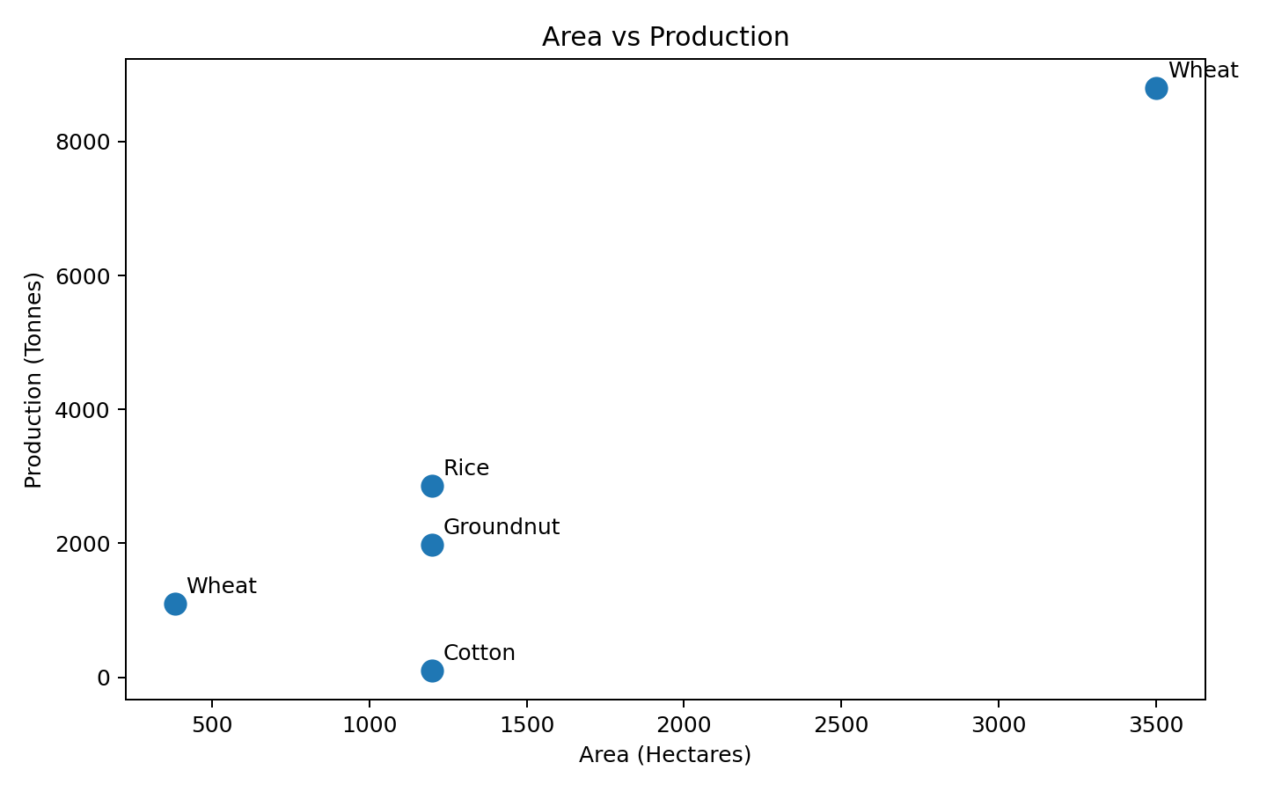
Figure 3. Relationship between cultivated area and production.

8. Seasonal Analysis
Season-wise grouping was used to compare production between Rabi and Kharif observations. This provides a simple view of how crop output is distributed across growing seasons.
Season | Area (Ha) | Production (t) | Avg Yield (t/Ha)
Kharif | 3600.00 | 4936.23 | 1.371
Rabi | 3883.13 | 9893.49 | 2.694
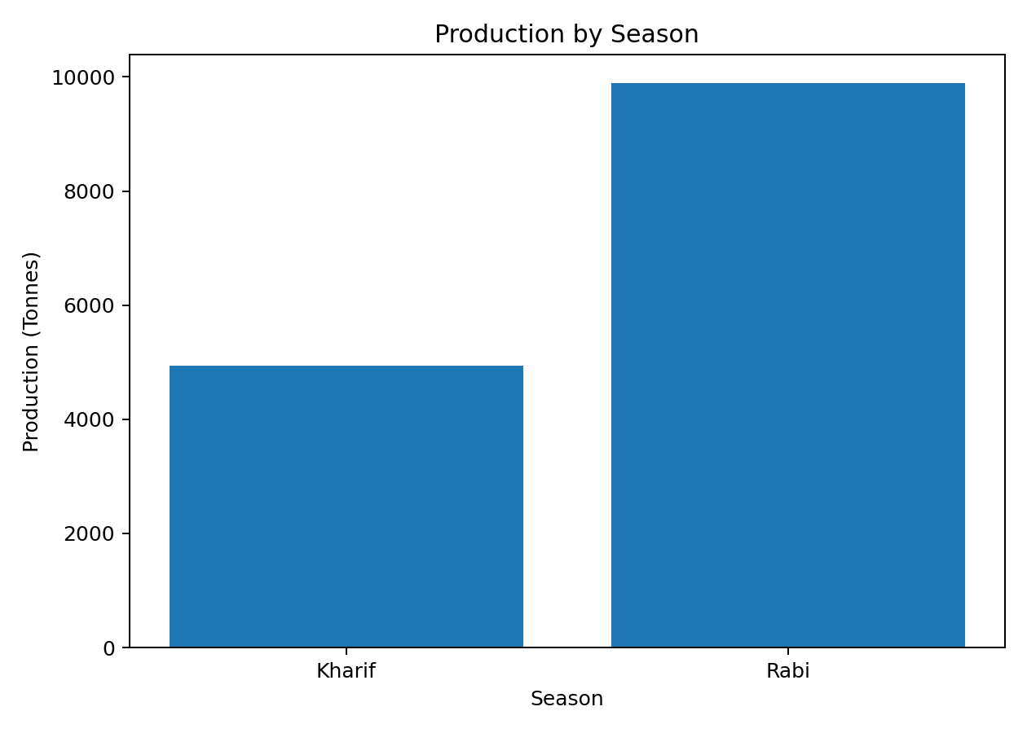
Figure 4. Production by agricultural season.

9. Key Agribusiness Insights
- Crop output varies substantially across the observations. Wheat contributes the largest total production (9893.49 tonnes).
- Yield differences are important: the highest observed crop-level average yield is 2.694 t/ha, while the lowest is 0.083 t/ha.
- A larger cultivated area generally contributes to higher total production, but area alone does not measure productivity.
- The very low observed cotton yield indicates a crop observation that deserves further investigation for data quality, production conditions, or agronomic factors.
- Season-wise analysis can help agribusiness stakeholders organize crop planning and compare production patterns across growing seasons.
- For stronger decision-making, a larger multi-year and multi-district dataset should be analyzed with additional variables such as rainfall, irrigation, input use, prices, soil conditions, and market demand.

10. Limitations
- The working dataset is small, so the findings are exploratory rather than statistically generalizable.
- The dataset does not contain enough time-series observations to establish long-term market or production trends.
- Input utilization, crop prices, rainfall, irrigation, soil quality, and weather variables were not available in the working dataset.
- Correlation does not establish causation.
- The results should therefore be treated as a demonstration of the EDA process and a basis for further analysis.

11. Conclusion
The Week 3 EDA demonstrates how a cleaned agribusiness dataset can be transformed into practical insights using descriptive statistics and visualizations. Crop-wise and season-wise comparisons highlight differences in production and yield, while the area-versus-production scatter plot provides an initial view of the relationship between cultivated area and output. The analysis also shows the importance of examining yield rather than production alone. Future work can extend this analysis using larger public datasets and additional agronomic and market variables to build predictive models and support evidence-based agribusiness decisions.

12. Project / GitHub
GitHub repository: https://github.com/tejasree-bondla/agribusiness-data-science--internship
The repository contains the agribusiness internship work, including the Week 2 data cleaning/preprocessing work and the continuing Week 3 EDA analysis.

