1. mail

Creating Account

Open URL <https://accounts.google.com/> in Browser

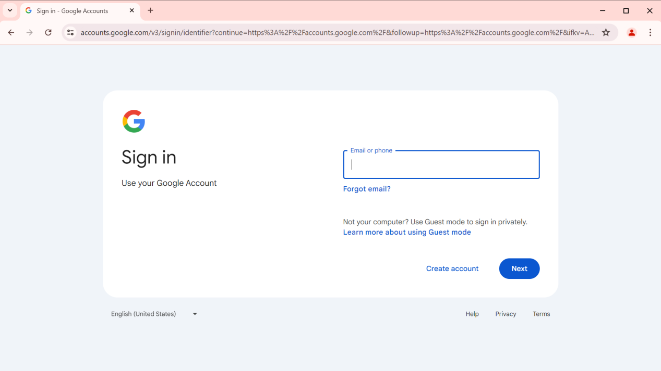

Click on Create Account.

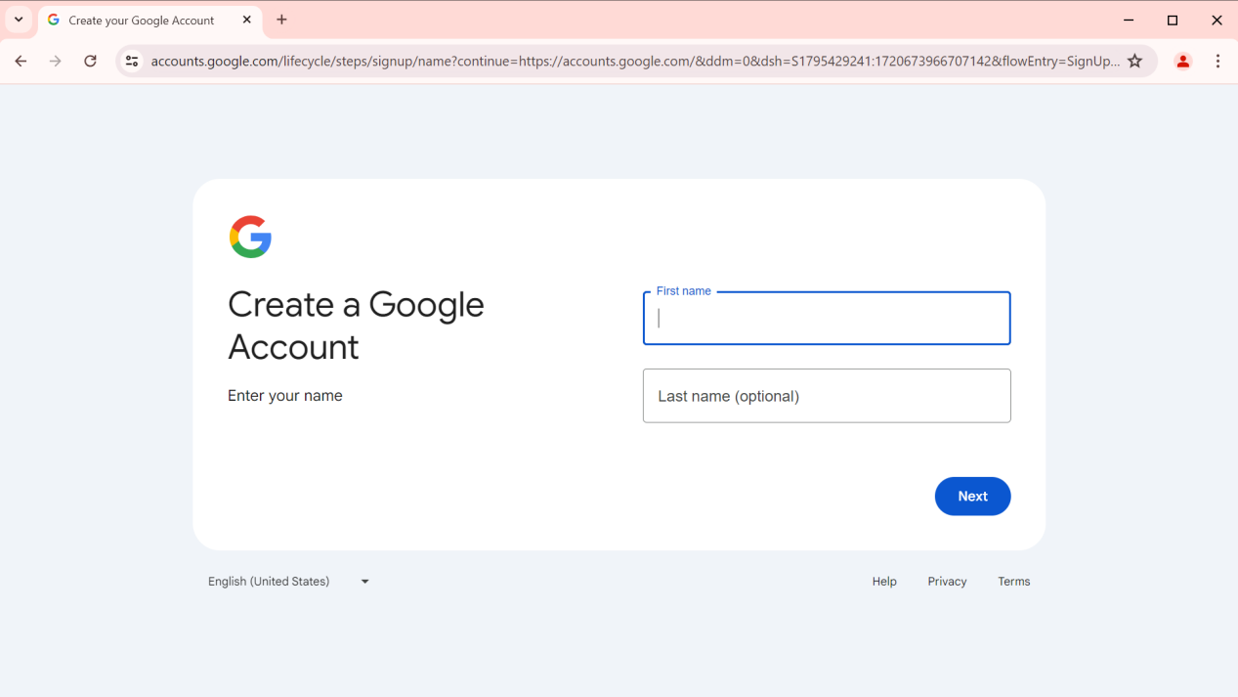

TC_001:

Validating Enter your name by giving invalid inputs.

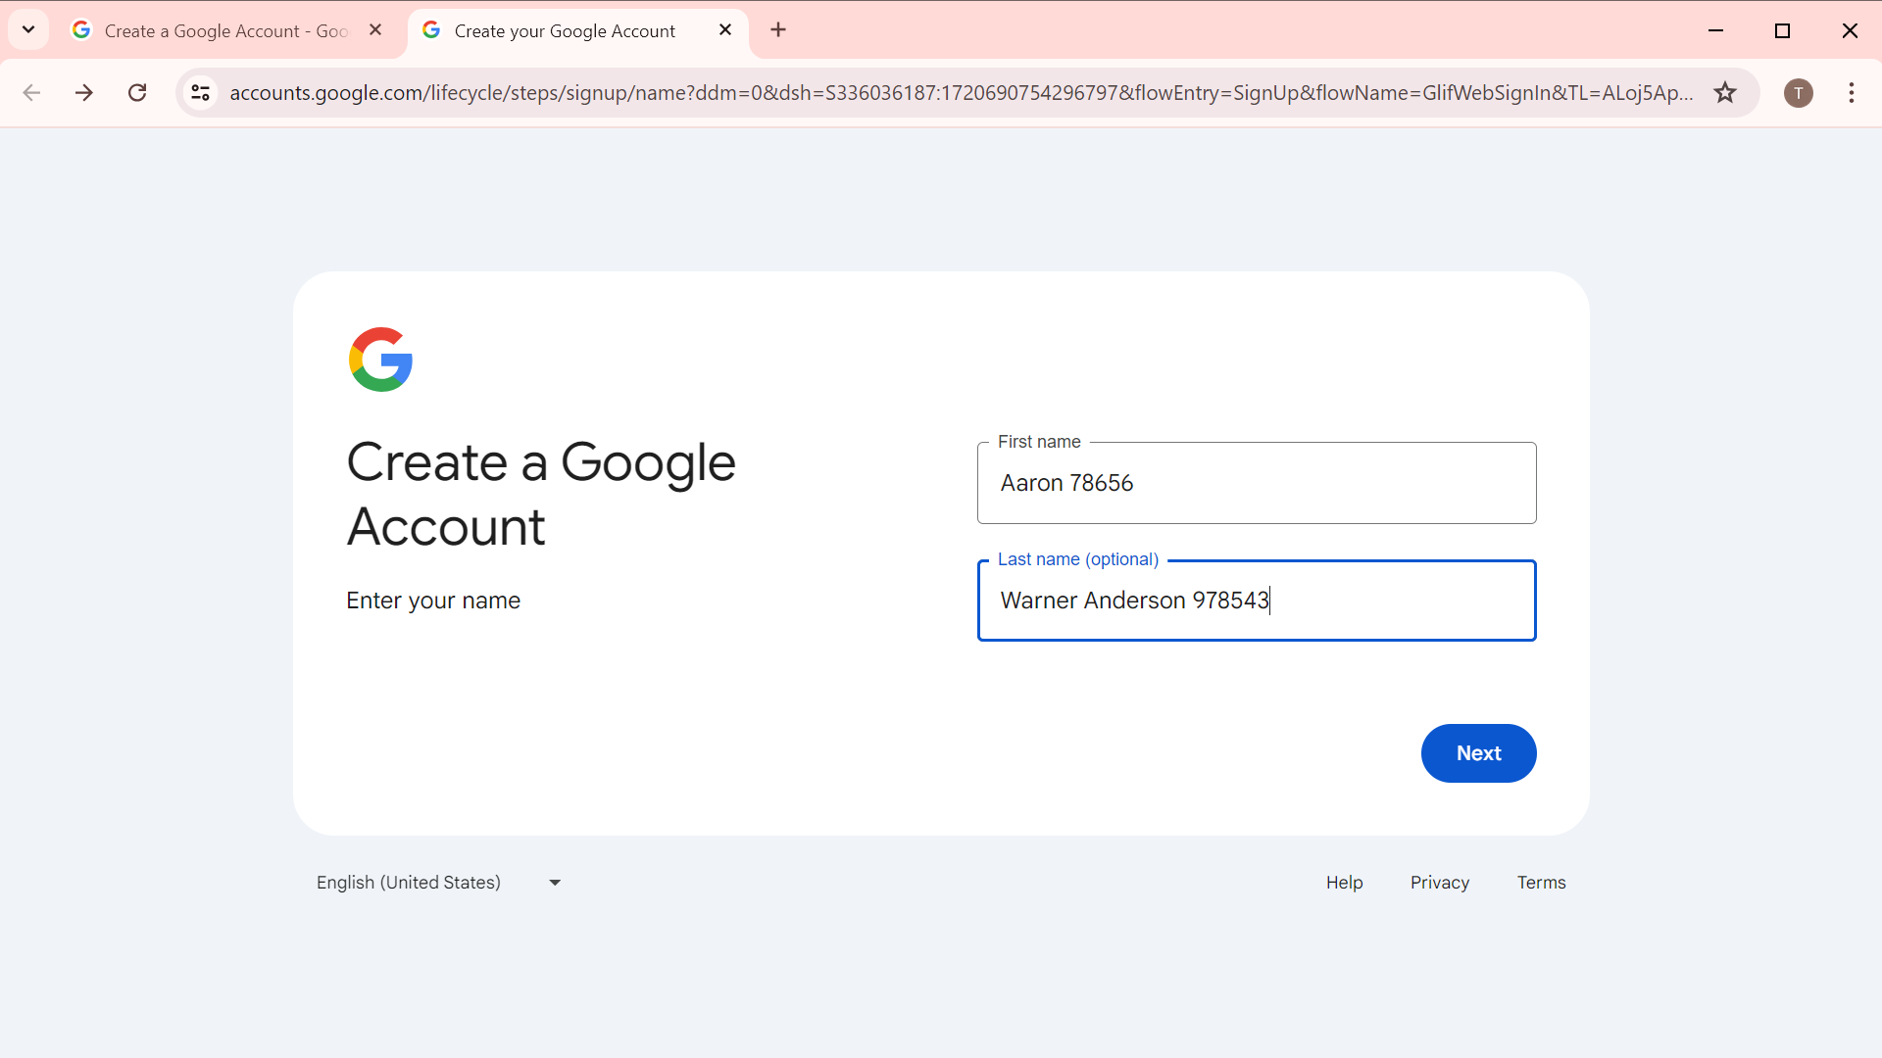

Click on NEXT.

Expected Result:

Next page shouldn't be displayed

Actual Result:

Next page hasn't displayed

Error Message:

Are you sure you entered your name correctly?

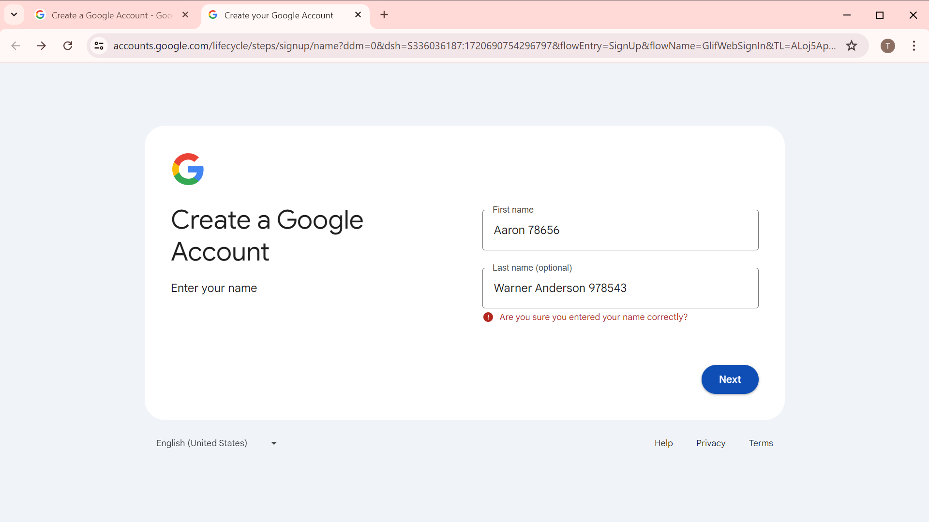

TC_002:

Validating Enter your name by giving valid inputs.

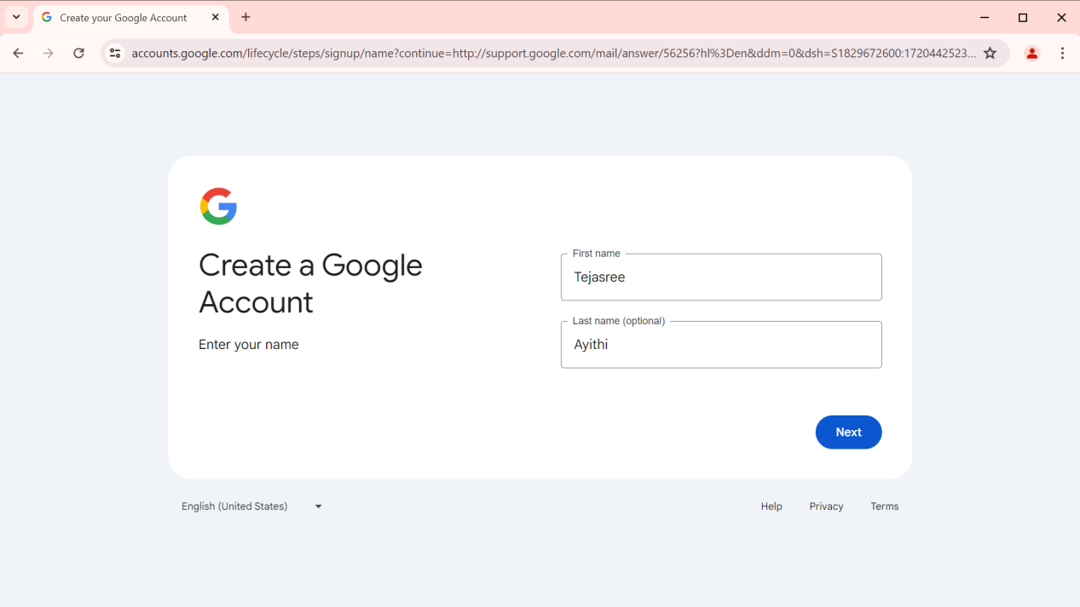

Click on NEXT.

Expected Result:

Next page should be displayed about Date of Birth and Gender.

Actual Result:

Next page got displayed(I.e., date of birth and gender).

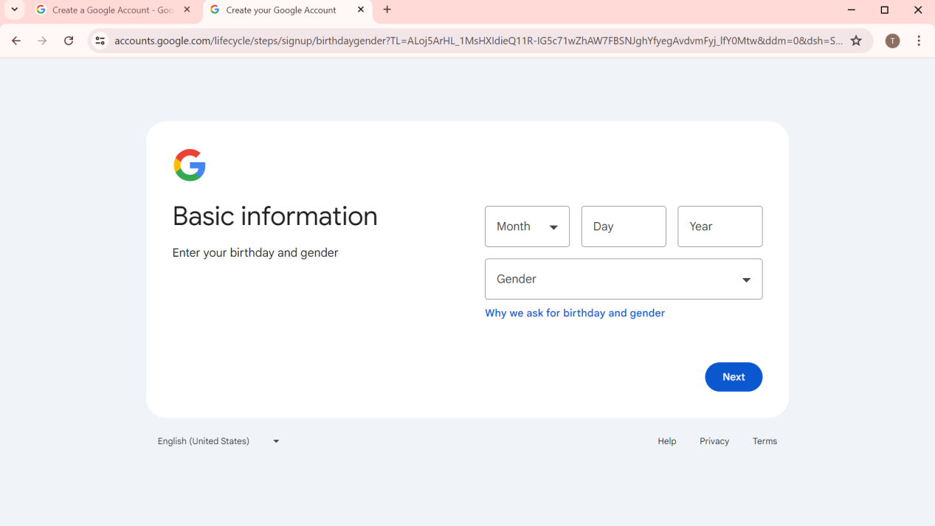

TC_003:

Validating Enter your birthday by giving invalid inputs.

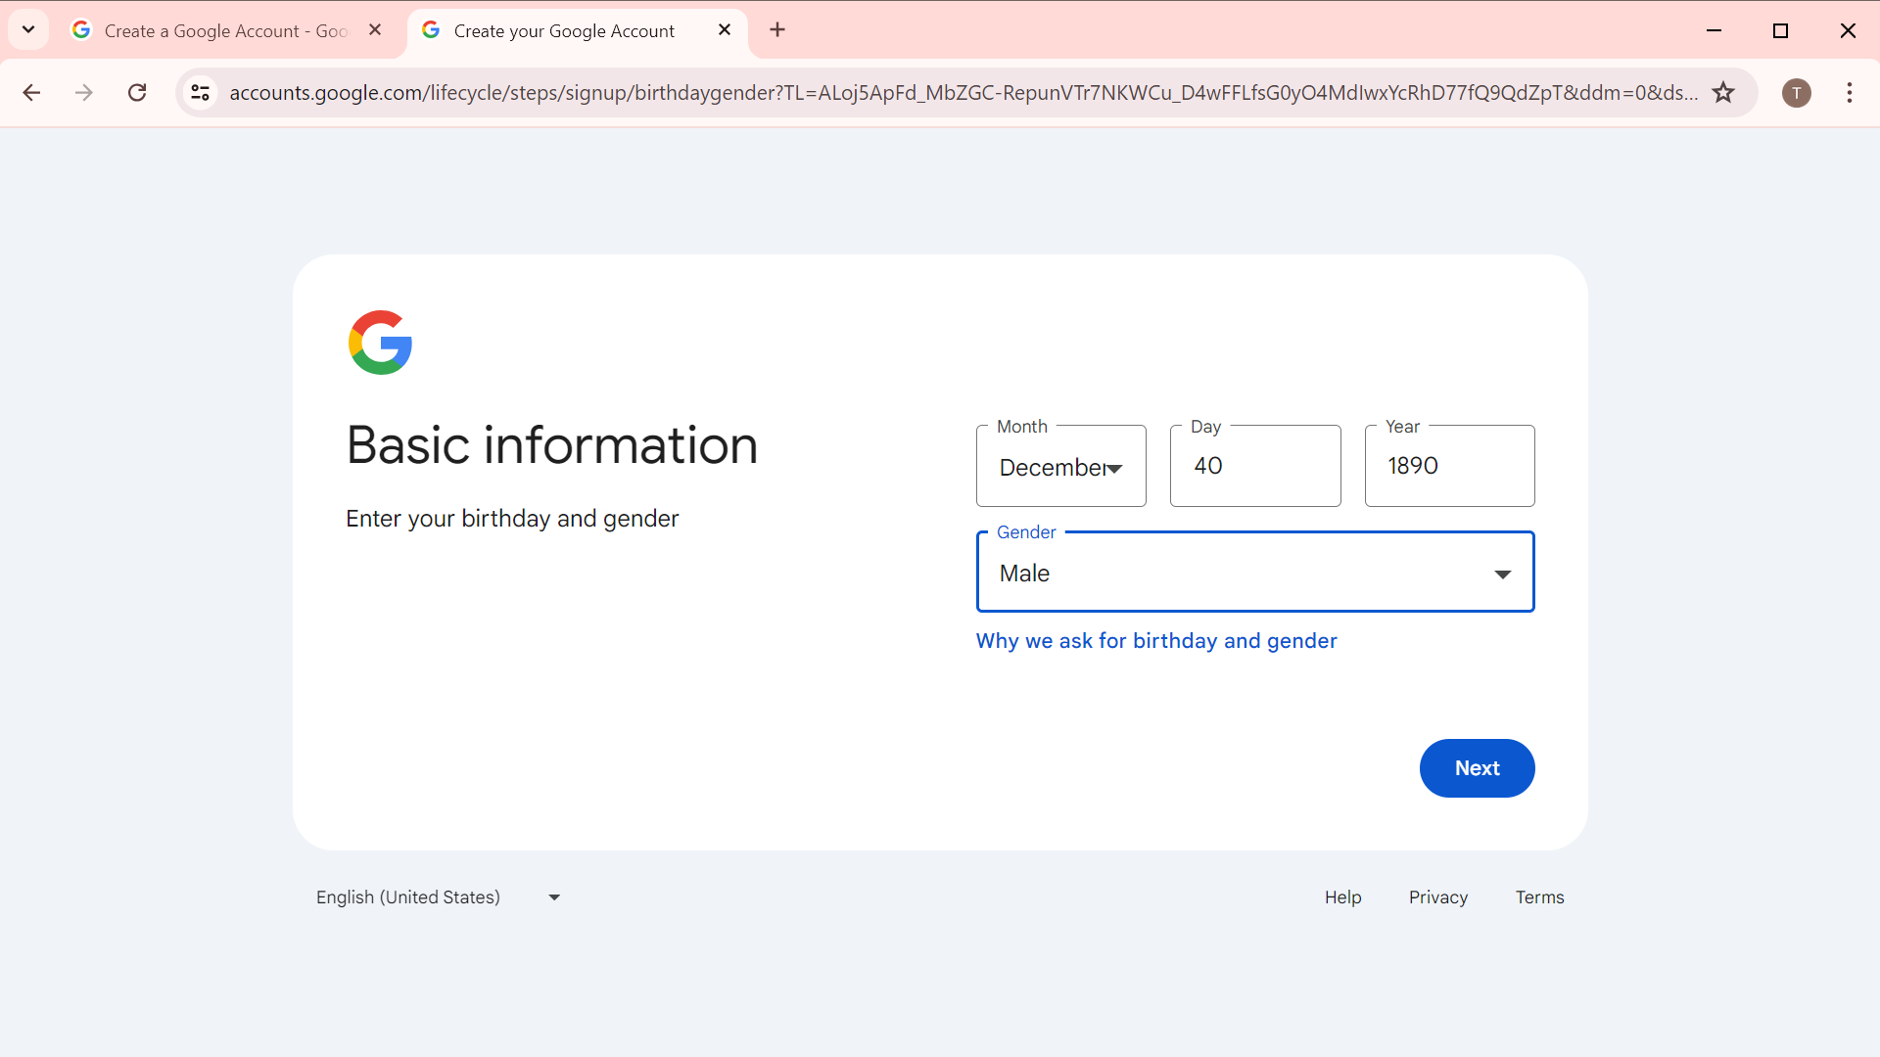

Click on NEXT.

Expected Result:

Next page shouldn’t be displayed about g-mail Address.

Actual Result:

Error message got displayed.

ERROR MESSAGE:

Please enter a valid date

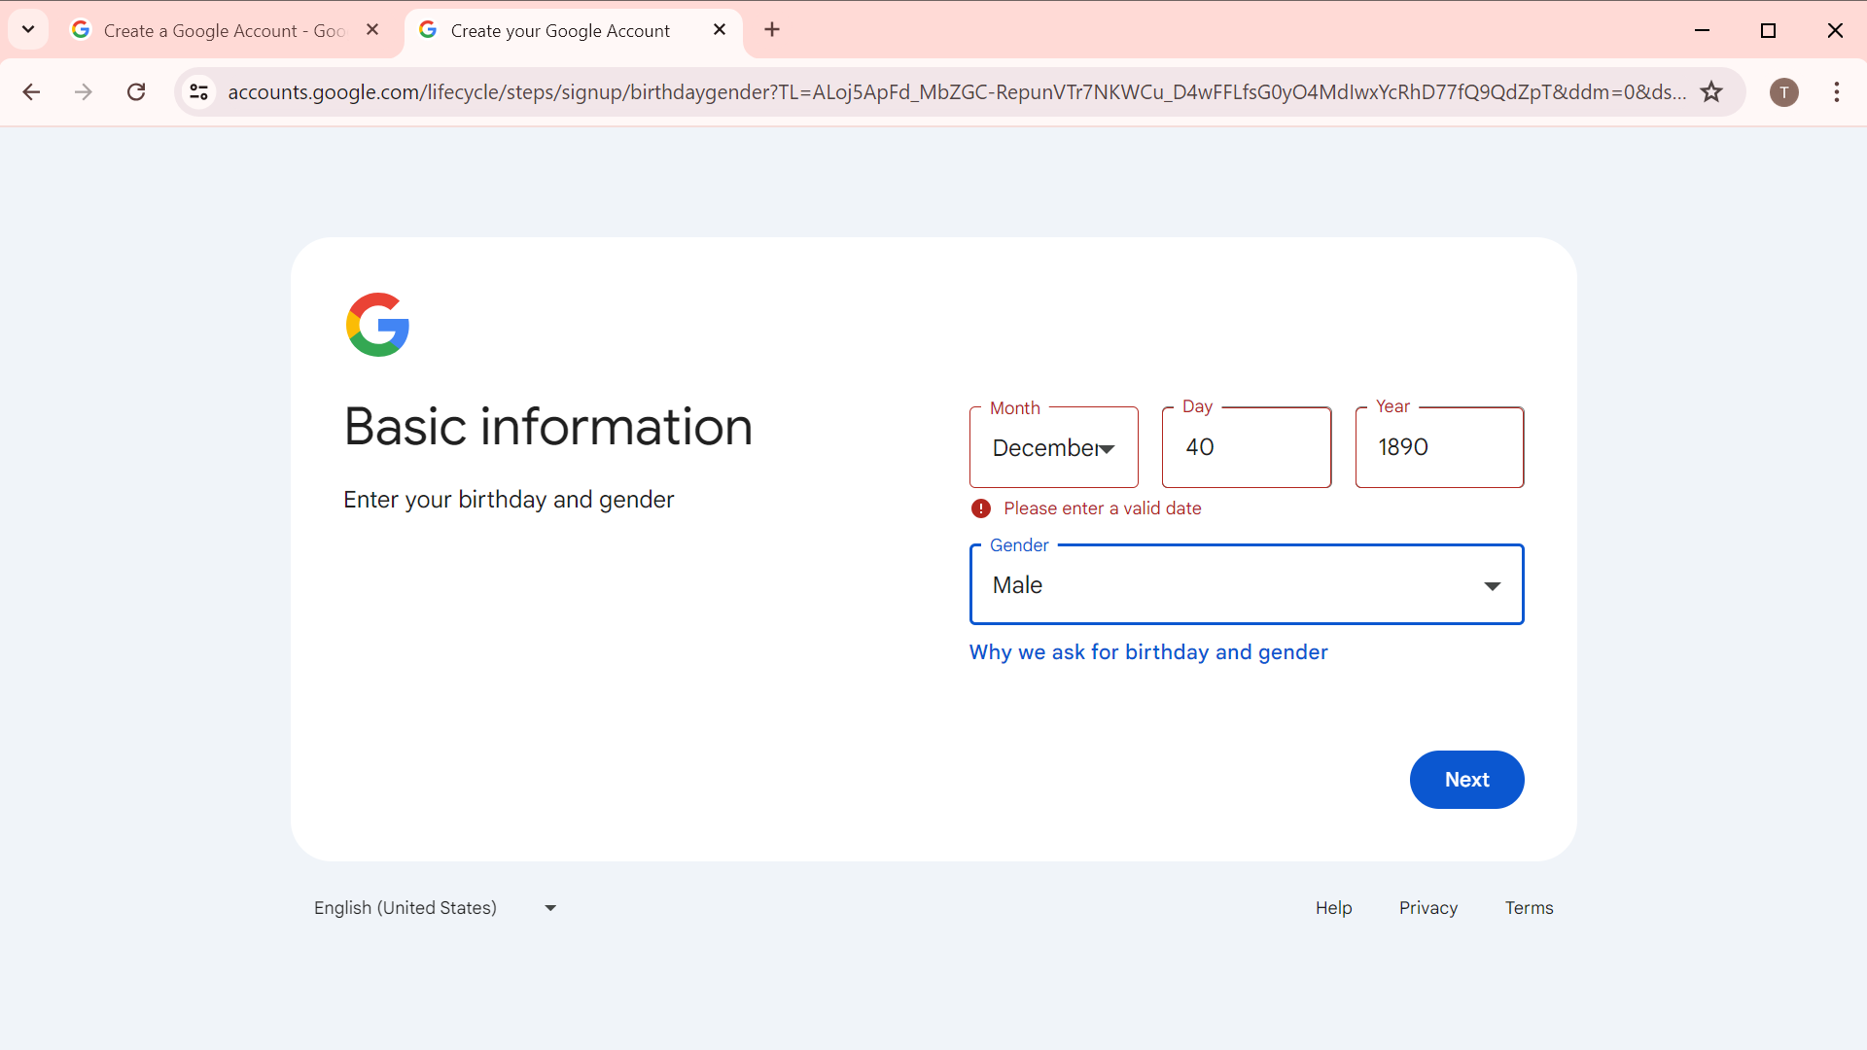

TC_004:

Validating Enter your birthday and gender by giving valid inputs.

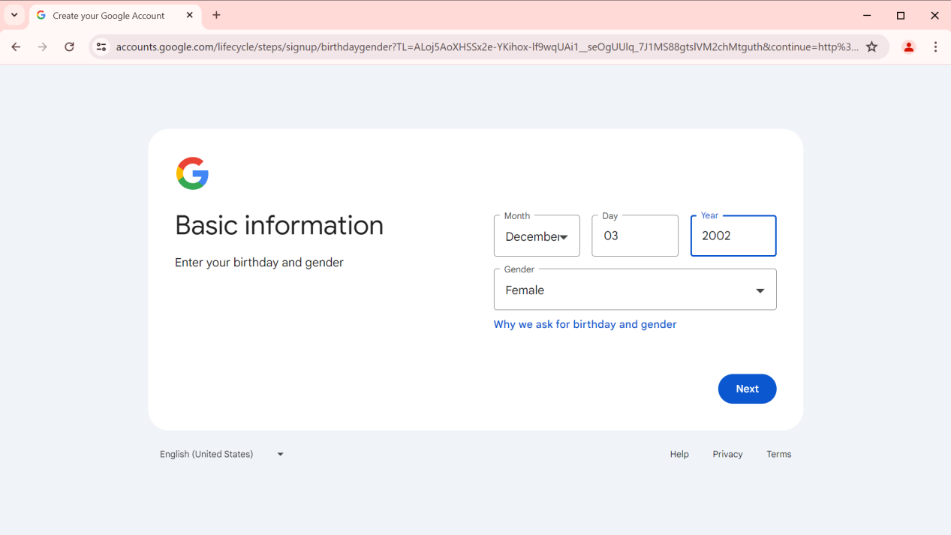

Click on NEXT.

Expected Result:

Next page should be displayed about g-mail Address.

Actual Result:

Next page got displayed(I.e., choose your g-mail address).

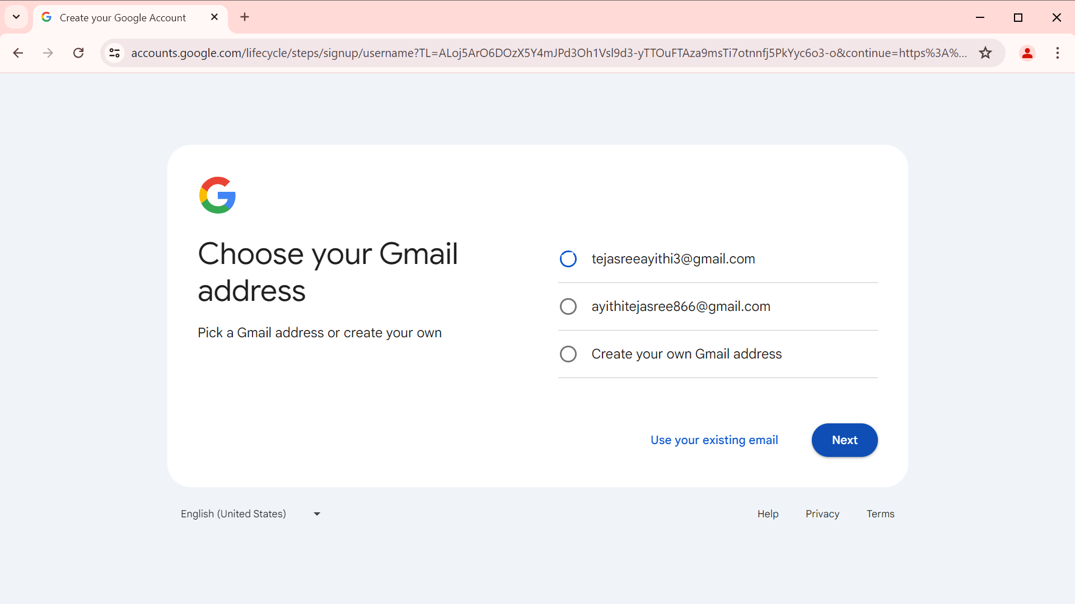

TC_005:

Validating G-mail address by creating your own address .

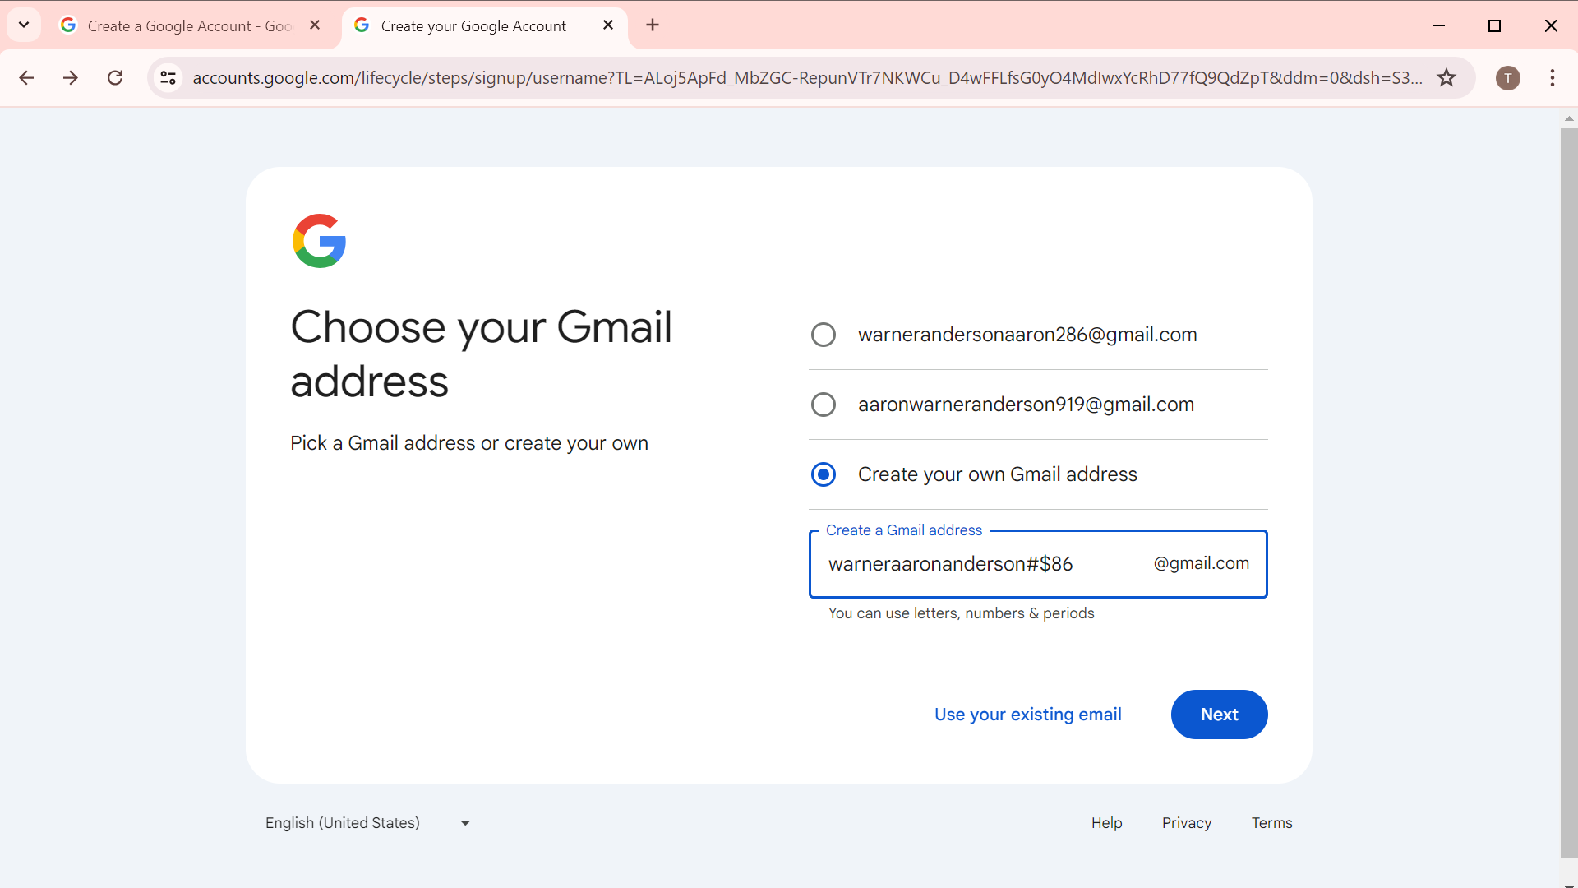

Click on NEXT.

Expected Result:

Error Message should be displayed

Actual Result:

Error message got displayed.

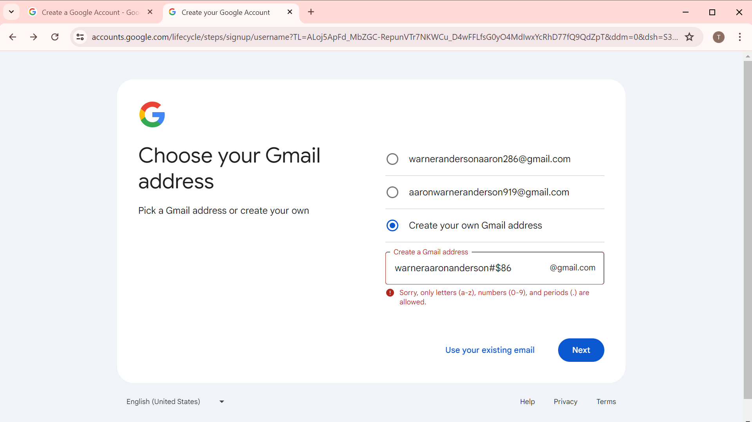

Error Message:

Sorry, only letters(a-z), numbers(0-9), and periods(.) are allowed.

TC_006:

Validating choose your g-mail address by giving valid inputs.

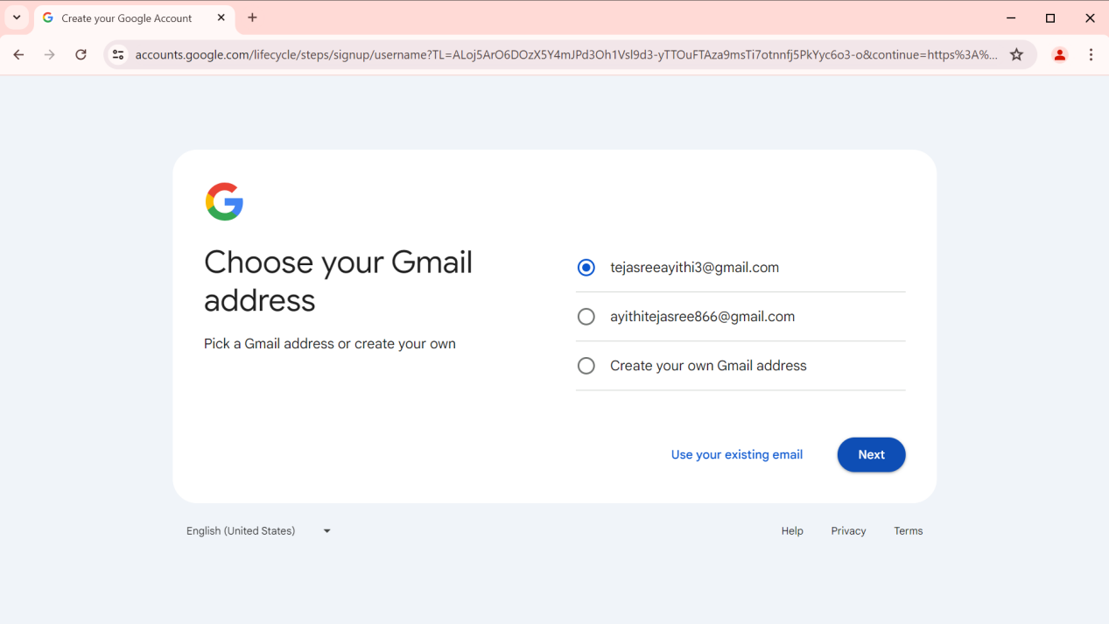

Click on NEXT.

Expected Result:

Next page should be displayed about Password set-up.

Actual Result:

Next page got displayed(I.e., create strong password).

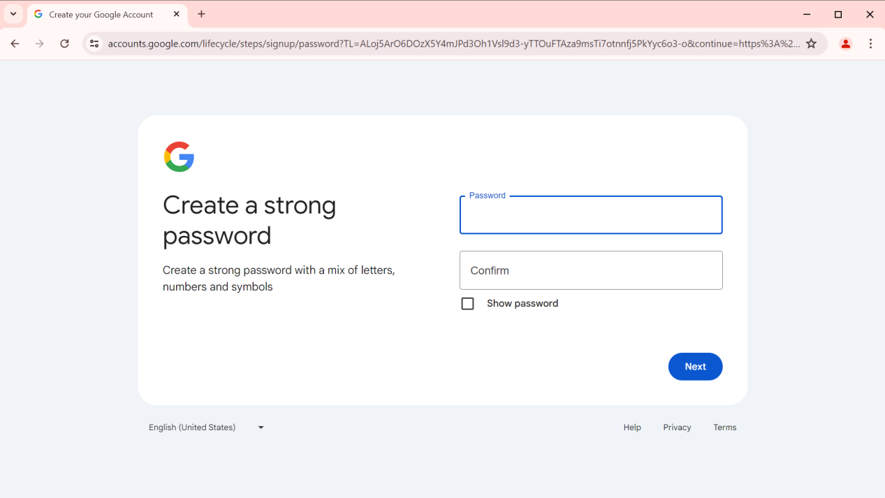

TC_007:

Validating Password by giving valid inputs.

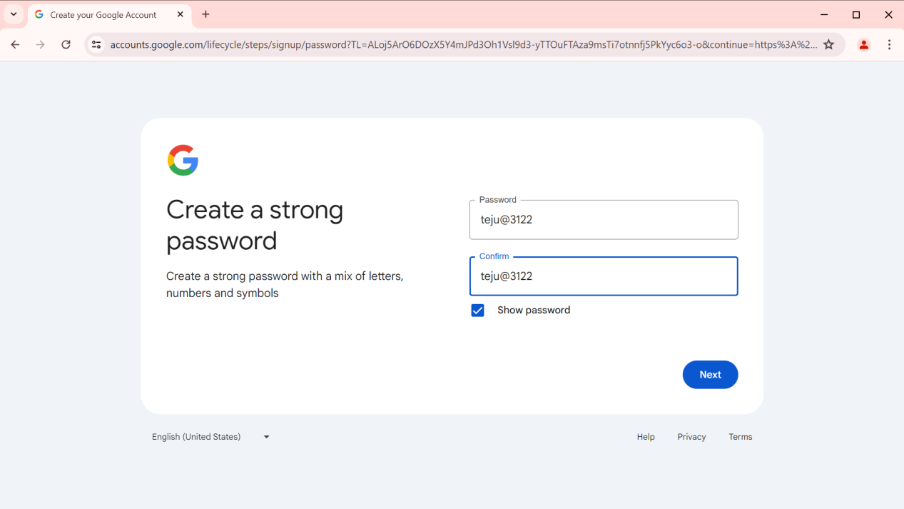

Click on NEXT.

Expected Result:

Next page should be displayed about confirmation through Phone number.

Actual Result:

Next page got displayed(I.e., phone number).

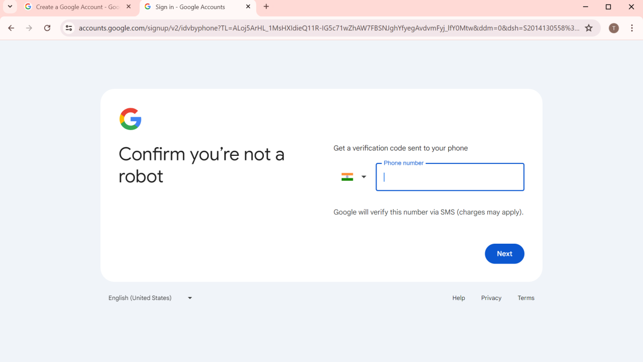

TC_008:

Verifying by giving invalid phone number .

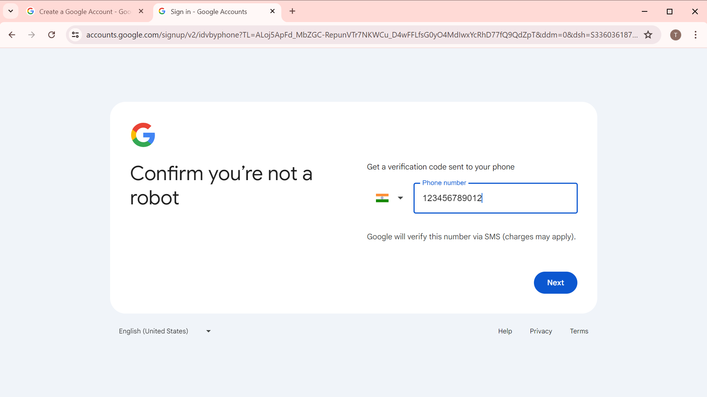

Click on NEXT.

Expected Result:

Error message should be displayed

Actual Result:

Error message got displayed

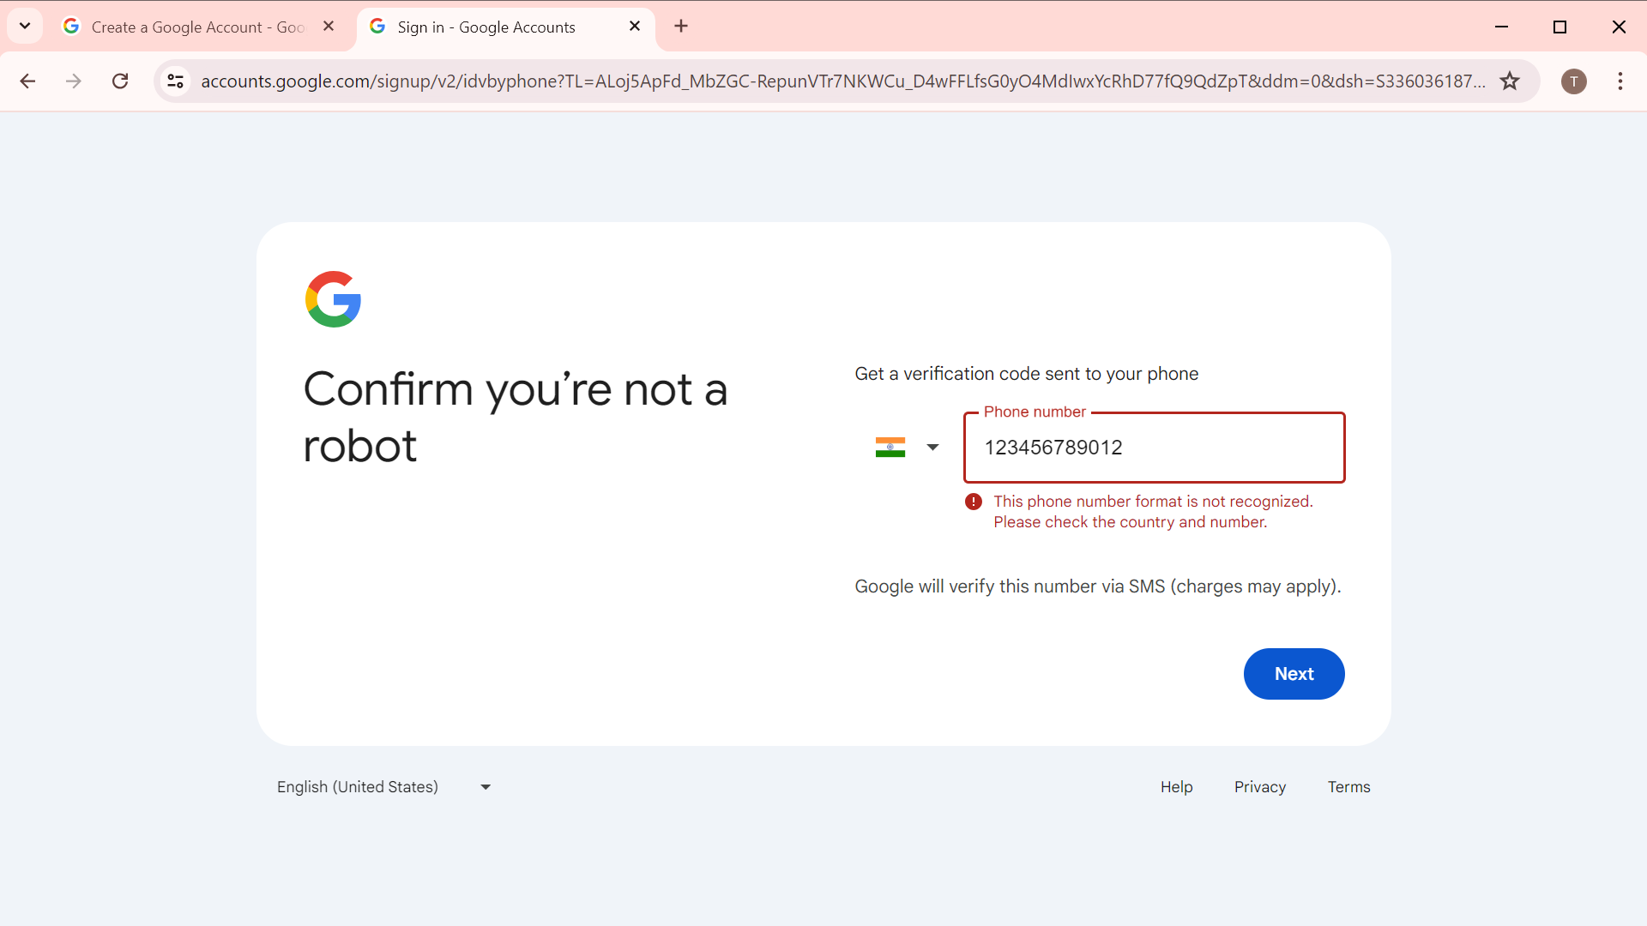

Error message:

This phone number format isn’t recognized

TC_009:

Verifying by giving valid Phone number .

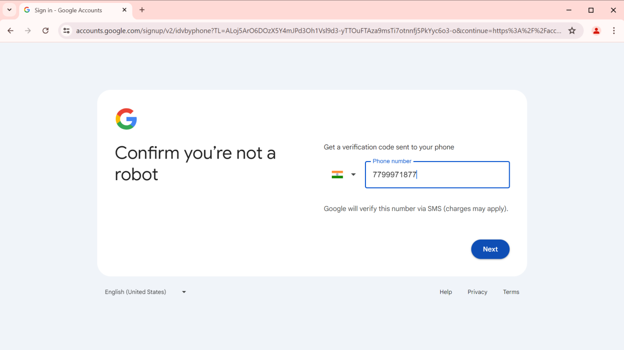

Click on NEXT.

Expected Result:

Next page should be displayed about confirmation code.

Actual Result:

Next page got displayed(I.e.,verification code).

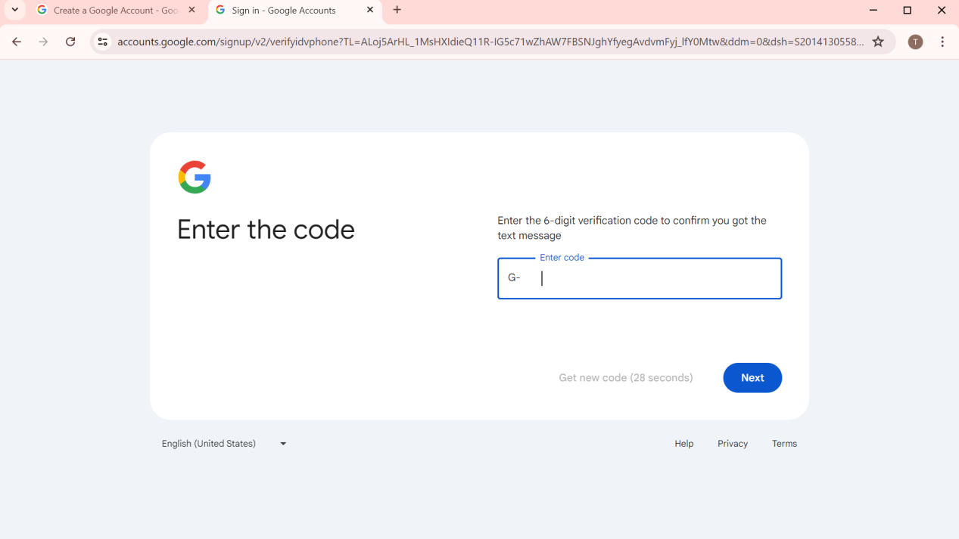

TC_010:

Verifying by giving valid verification code .

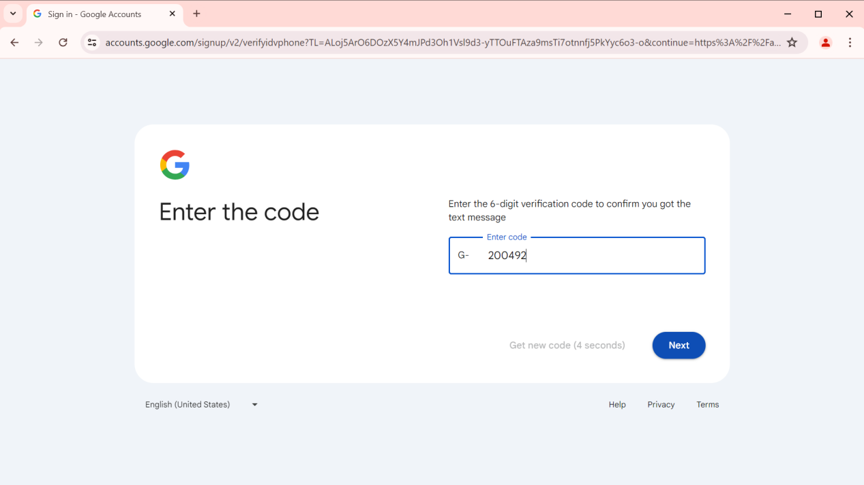

Click on NEXT.

Expected Result:

Next page should be displayed about recovery mail.

Actual Result:

Next page got displayed(I.e.,recovery mail).

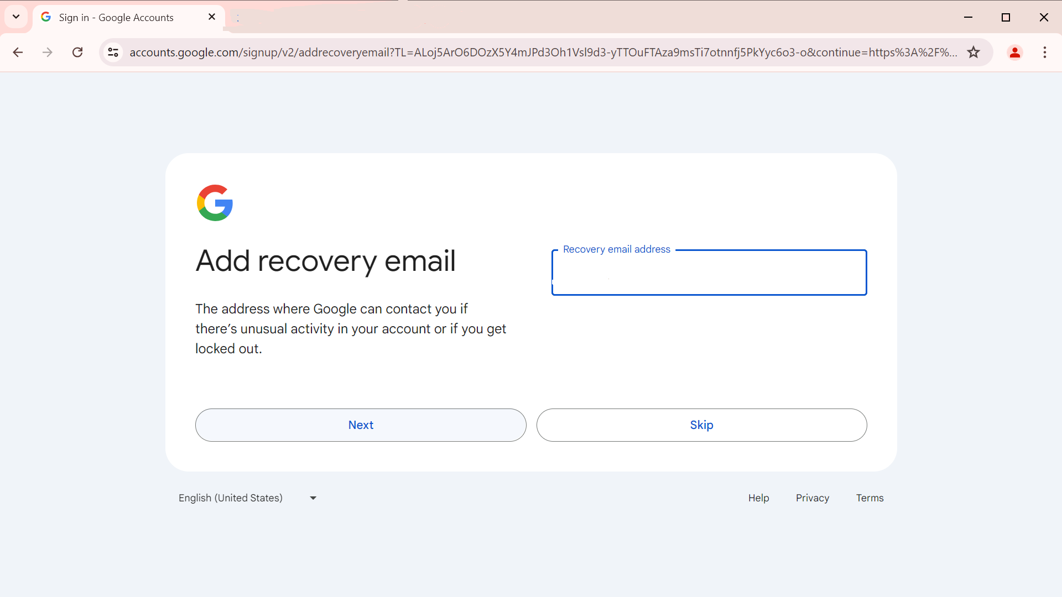

TC_011:

Giving valid Mail for Recovery purpose.

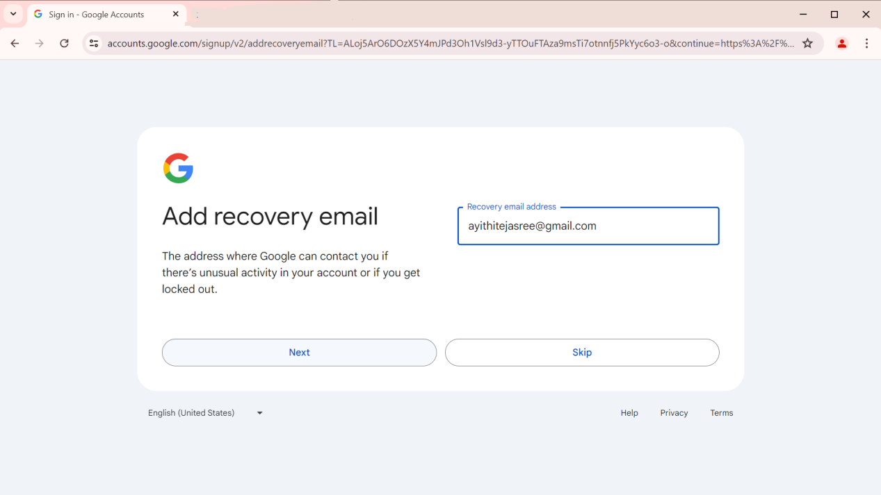

Click on NEXT.

Expected Result:

Next page should be displayed about Account information.

Actual Result:

Next page got displayed(I.e.,account information).

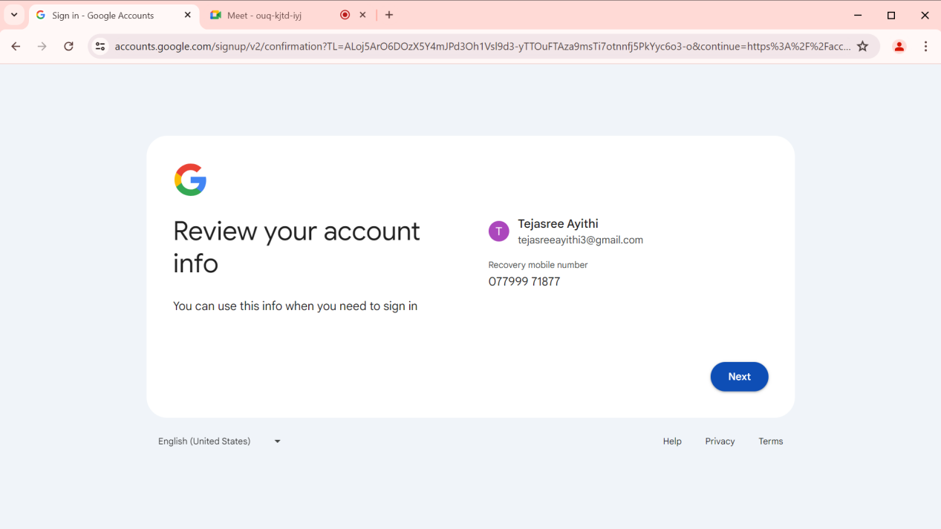

Click on NEXT.

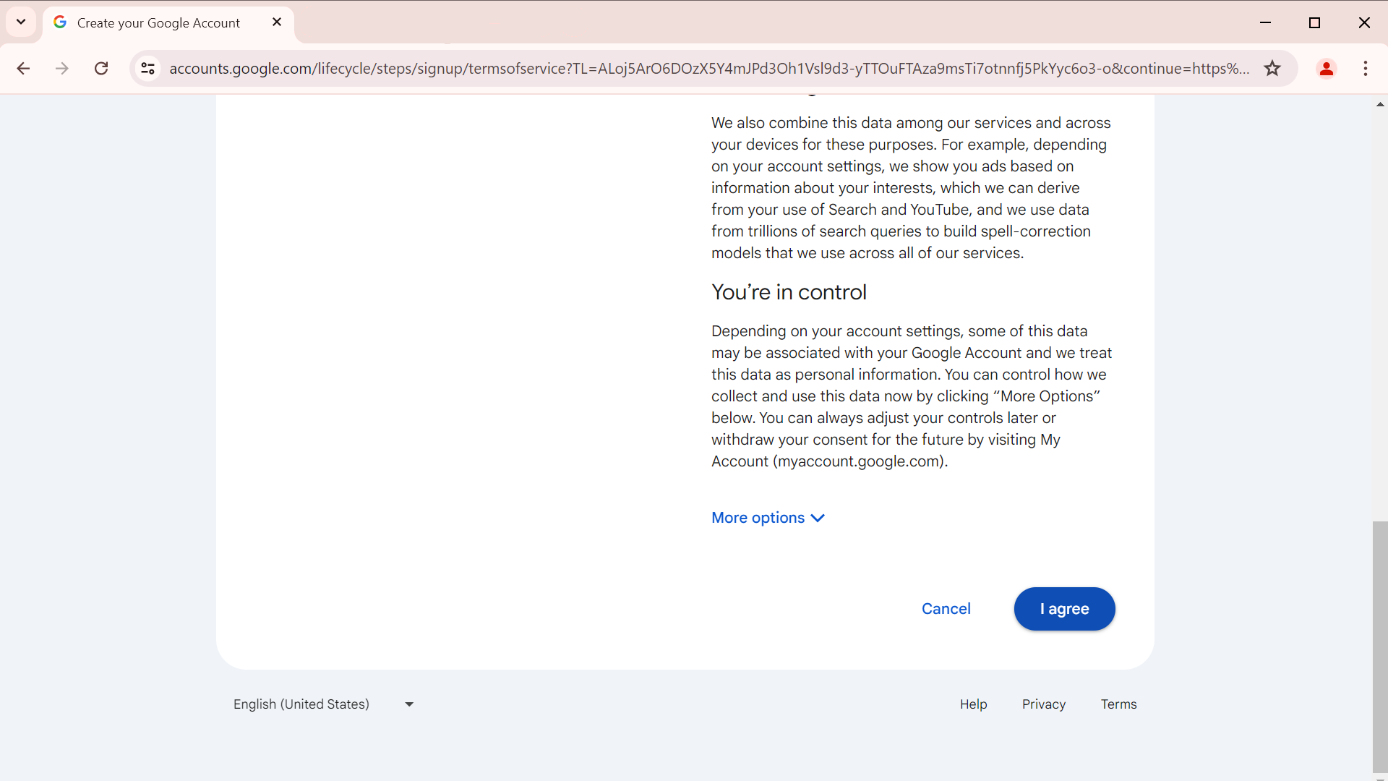

Click on I AGREE.

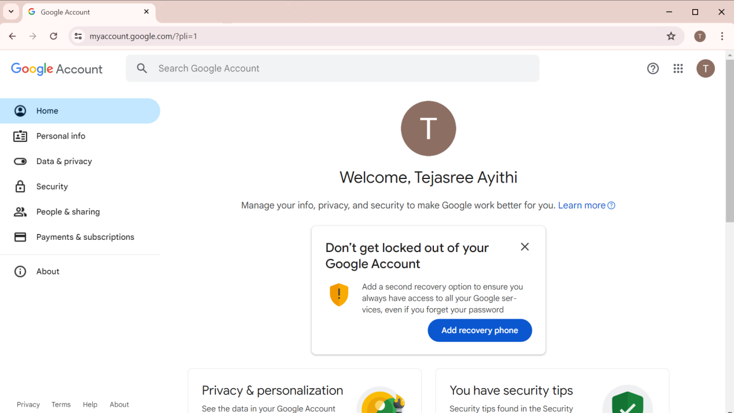

G_MIAL ACCOUNT IS CREATED.