

DEPARTMENT OF CSE

PROJECT SYSTEM DESIGN SUBMISSION
COURSE: Adaptive Software Engineering – (24CI3201)

A.Y. 2026 - 2027
TITLE OF THE PROJECT | AI-Based Smart Food Redistribution and Waste Reduction System
S. No. | University ID | Name
1 | 2420030284 | Shalini . Ch
2 | 2420030330 | Thirumala Reddy Sagar Mounitha
3 | 2420030441 | S.Tejasree
4 | 2420030484 | Kongara Deepthi
Name of the Guide |  | Dr.Archana Kalidindi

Modules: User authentication & role management; food donation and inventory tracking; AI-based demand prediction and donor–receiver matching; route optimization and delivery tracking; automated notifications and admin monitoring.
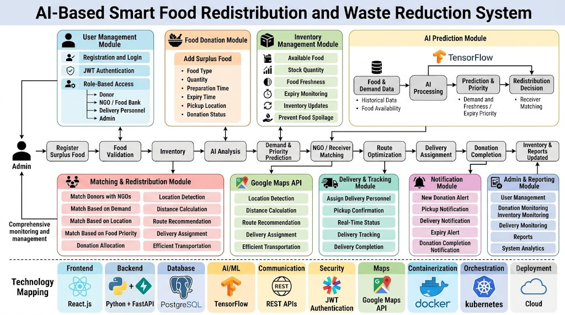

Signature of the Guide HOD

