India’s Income Evolution effecting on various factors in power BI

**The domain of the Project:**

SQL AND POWER BI

Under the guidance of

Ms. Siddhika Shah Software Engineer At HCL Technologies Prof. Radha kumari Executive Director & Founder SURE Trust

By

Teja Sri Paluri(B.Tech)

Period of the project

May 2025 to August 2025

SURE TRUST PUTTAPARTHI, ANDHRA PRADESH

Declaration

The project titled “India’s Income Evolution effecting on various factors using power BI” has been mentored by Ms. Siddhika Shah, organised by SURE Trust, from May 2025 to August 2025, for the benefit of the educated unemployed rural youth for gaining hands-on experience in working on industry relevant projects that would take them closer to the prospective employer. I declare that to the best of my knowledge the members of the team mentioned below, have worked on it successfully and enhanced their practical knowledge in the domain.

**By: Signature**

Teja Sri Paluri Teja Sri Paluri

(Pursuing B.Tech)

**Mentors: Signature**

Ms Siddhika Shah Software Engineer At HCL Technologies

Seal & Signature

Prof. Radha kumari Executive Director & Founder

SURE Trust

**India’s Income Evolution**

**Capstone Project**

###### Table of Contents

1. Introduction
2. Project Objectives
3. Methodology
4. Findings and Analysis
   * 4.1. Economic Growth Overview (GDP, Per Capita Income, Inflation)
   * 4.2. Tourism Contribution Analysis (Temple Tourism & Hill Stations)
   * 4.3. Startup Ecosystem Insights (Startups, Employment, Investment)
   * 4.4. Stock Market Analysis
5. Conclusion and Recommendations
6. Appendix: Project Dashboard

###### Introduction

India is one of the fastest-growing economies in the world, driven by industry, services, tourism, and startups. This project visualizes India’s economic evolution from 2016 to 2024 using Power BI, focusing on key indicators such as GDP, per capita income, inflation rate, and employment trends.

The project also highlights the role of tourism, especially temple tourism, in generating revenue, using Andhra Pradesh as an example for better understanding. In addition, it shows the impact of startups on employment and investment growth across different sectors.

The main goal is to present economic data in a simple and interactive dashboard, allowing easy exploration of India’s economic development for decision-makers and researchers.

**Abstract:**

This project presents an interactive Power BI dashboard that visualizes India’s economic evolution from 2016 to 2024. It focuses on key economic indicators such as GDP, per capita income, inflation rate, employment, tourism revenue, startup growth, and stock market impact. The dashboard provides clear, easy-to-understand visualizations that highlight the steady growth of India’s economy, the major contribution of temple tourism, and the rising importance of startups—particularly in sectors like AgriTech. Additionally, it includes a dedicated analysis of how stock market trends affect economic development over time.

State-level insights, with Andhra Pradesh as an example, demonstrate how individual regions contribute to the national economy. The project aims to help decision-makers, researchers, and analysts explore trends, understand sector-wise contributions, and make informed decisions. The interactive dashboard serves as a comprehensive tool for analyzing India’s economic structure, identifying patterns, and supporting strategic economic planning.

###### Project Objectives

The core objectives of this project were to:

* To analyze India’s economic growth using key indicators such as GDP, per capita income, inflation rate, and employment trends from 2016 to 2024.
* To show the contribution of tourism, especially temple tourism, in India’s revenue generation, using Andhra Pradesh as an example.
* To highlight the role of startups in driving employment and attracting investments, focusing on different startup types like AgriTech.
* To provide state-wise and category-wise insights for better understanding of regional and sectoral economic contributions.
* To present all findings in a simple, interactive Power BI dashboard that enables easy data exploration and interpretation.
* To help users easily identify trends, patterns, and key sectors driving India’s economic development over time.
* To include a dedicated page analyzing the **impact of stock market trends on India’s economy**, giving further economic perspective.

**Methodology:**

**Data Acquisition and Sourcing:** The data used in this project was collected from various trusted sources related to India’s economy, including government reports and public datasets. The data covers the period from 2016 to 2024 and includes key fields such as GDP, per capita income, inflation rate, employment figures, tourism revenue, startup counts and investments, and stock market indicators.

**Data Processing and Analysis:** The raw data was processed in several steps to prepare it for visualization in Power BI:

* **Aggregation**: Summed up total GDP, per capita income, employment numbers, total revenue from tourism, number of startups, and investment amounts over time.
* **Filtering by State and Category**: For the tourism data, Andhra Pradesh was selected as an example to demonstrate how state-level contributions are presented.
* **Categorization**: Tourism data was categorized into Temple Tourism and Hill Stations. Startups were grouped by type (e.g., AgriTech), and stock market trends were processed over the time period.
* **Normalization**: All financial figures (GDP, tourism revenue, investments) were converted into Crores of INR for uniformity and easier comparison.

**Data Visualization:** A comprehensive Power BI dashboard was created to present the key findings in an interactive and easy-to-understand way. The dashboard includes:

* **Card Metrics**: Displayed key figures such as  
   • GDP (₹223 Crores in 2024)  
   • Per Capita Income (₹1 Million)  
   • Inflation Rate (65%)  
   • Total Tourism Revenue (₹1.53K Crores)  
   • Total Employment (4.08 Crores)  
   • Total Startups (701)  
   • Startup Investment (₹17K Crores).
* **Line Charts**: Showed trends of GDP growth, per capita income, inflation rate, and employment evolution from 2016 to 2024.
* **Bar Charts**: Illustrated tourism revenue by type, with Temple Tourism contributing ~78%, and startup distribution by type (AgriTech as an example with 28.54% share).
* **State-Level Visualization**: Andhra Pradesh was used as an example to show state contribution in tourism and economic data.
* **Interactive Filters**: Users can filter by year range, state, and startup type to explore specific data points.
* **Stock Market Impact Page**: A dedicated page was created to show how stock market trends affect India’s economy over time, visualized with line charts.

#### Findings and Analysis

#### The analysis of India’s Income Evolution Power BI dashboard revealed several important insights into the country’s economic structure and growth patterns over time.

#### 3.1. Overall Economic Summary

#### The dashboard provides a high-level overview of India’s economic development from 2016 to 2024. In 2024, India’s GDP reached ₹223 Crores, while the per capita income rose to ₹1 Million, reflecting significant economic progress over the period. However, the inflation rate increased to 65%, indicating rising costs of living. Employment also grew steadily, reaching a total of 4.08 Crores employed individuals. These trends demonstrate sustained economic growth but also highlight areas such as inflation that require attention.

#### 3.2. Tourism Contribution Analysis

#### The tourism sector plays a notable role in India’s economy. The dashboard shows that total tourism revenue reached ₹1.53K Crores, driven primarily by temple tourism, which contributed approximately 78.46% of the total, while hill stations contributed around 21.54%. Andhra Pradesh was showcased as an example state, generating ₹1.5K Crores in tourism revenue, illustrating how individual states contribute significantly to national tourism income. This suggests that temple tourism is a major revenue driver and key for future tourism strategy.

#### 3.3. Startup Ecosystem Insights

#### Startups are a critical factor in India’s economic development. The dashboard revealed a total of 701 startups contributing to ₹17K Crores in investments and providing employment to 4.08 Crores people. Among the various startup types, AgriTech accounted for 28.54% of the total, showing the importance of innovation in agriculture. This indicates that startups are not only supporting job creation but also attracting substantial investment, particularly in sectors aligned with India’s economic priorities.

#### 3.4. Stock Market Impact on Economy

#### A dedicated page in the dashboard analyzed the relationship between stock market trends and India’s economy over time. The visualization showed a general correlation where periods of strong stock market performance aligned with GDP growth and increased startup investment. This indicates that the stock market plays a key role in investor confidence and economic expansion, but volatility can have noticeable effects on economic indicators.

#### 3.5. State-Level Economic Insights

#### The dashboard enabled state-wise analysis to better understand regional economic contributions. Andhra Pradesh was used as an example to highlight how specific states contribute to India’s overall economy, especially through tourism revenue and state-level employment. The state contributed ₹1.5K Crores in tourism revenue, demonstrating its significant role in the national economy. Such state-level insights help identify key areas for policy focus and economic planning.

#### 

#### 

#### 

#### Conclusion:

The analysis of the India’s Income Evolution Power BI dashboard has successfully met all project objectives, providing valuable insights into India’s economic growth, the role of tourism, the startup ecosystem, and stock market influence over time.

The key takeaways are:

* India’s economy is steadily growing, with GDP reaching ₹223 Crores and per capita income rising to ₹1 Million by 2024.
* Temple tourism is a major contributor to tourism revenue, with Andhra Pradesh contributing significantly as an example, showing the importance of cultural tourism.
* The startup ecosystem is playing an increasingly important role, with AgriTech startups making up a large share of the total, driving both employment and investments.
* The stock market shows a clear correlation with economic growth trends, indicating its importance in investor confidence and economic expansion.
* State-level analysis highlights how specific regions contribute to the economy, helping identify targeted areas for policy and investment focus.

Based on these findings, we recommend:

* **Deeper Analysis of Sector Contributions**: Perform a more detailed study of individual sectors like AgriTech startups or specific types of tourism (temple vs hill station) to discover emerging opportunities.
* **State-Specific Economic Strategies**: Expand analysis to other states beyond Andhra Pradesh to better understand regional strengths and weaknesses, enabling more tailored policy decisions.
* **Stock Market vs Economic Indicators**: Further investigate the relationship between stock market performance and economic indicators to predict future economic shifts and support investment decisions.
* **Inflation Control Measures**: Given the sharp rise in inflation (65% in 2024), it is important to explore targeted policies to manage inflation while supporting economic growth.

This interactive Power BI dashboard serves as a useful tool for decision-makers, researchers, and anyone interested in exploring India’s economic evolution in a clear and intuitive way.

**Project Report: Personal Expense Tracker using Power BI**

Submitted by:

*Teja Sri Paluri*

## Project for:

*Sure Trust Internship*

**

## Project Report: Personal Expense Tracker using Power BI

**A Power BI Project Report**

###### Abstract

The **Personal Finance Tracker** is an interactive Power BI dashboard that helps individuals monitor and analyze their expenses over time. It visualizes key financial data such as total expenses, item quantities, expense breakdown by product and subcategory, monthly spending trends, payment methods, and top contributing states. By presenting clear charts and graphs, the dashboard highlights important patterns like high rent costs, dominant use of cash and debit cards, and significant spending in states like Tamil Nadu and West Bengal. This tool enables users to understand their spending habits, manage budgets more effectively, and make informed financial decisions through an intuitive, easy-to-use interface.

#### Introduction

###### Background

This project is a **Personal Finance Tracker Dashboard** built using Power BI. The goal of this dashboard is to provide a clear, visual representation of personal expenses, payment habits, and spending patterns across different categories, time periods, and locations.

The dashboard consolidates expense data and presents it through interactive charts and visuals. It highlights:

* Total spending and transaction volume
* Expense distribution by product items and subcategories
* Monthly expense trends and peak spending periods
* Payment mode preferences (Cash, UPI, Debit, Credit)
* Quantity insights by category
* Top states with highest spending

By analyzing this data, users can quickly identify major expense contributors, seasonal trends, and regional patterns, which can help in making smarter financial decisions, improving budgeting, and tracking overall money management.



***Innovation & Entrepreneurship Hub for Educated Rural Youth (SURE Tru–stIERY)***

#### Methodology and Tools

**2.1 Primary Tool: Microsoft Power BI**

Microsoft Power BI was the exclusive tool used for this project. It is a powerful business intelligence platform that supports end-to-end data analysis, including connecting to data sources, transforming data, and creating interactive dashboards. For this project, Power BI’s **Power Query** was used for data cleaning and transformation, **data modeling** was applied for structuring relationships, and a variety of **visualizations** were developed to present expense insights clearly.

**2.2 Data Source**

The project utilized a dataset containing details of **personal expenses**. The key data fields included:

* **Date**: The date of the transaction.
* **State/Region**: The geographical location of the expense.
* **Product Item**: The main category of expense (e.g., Rent, Broadband, Petrol).
* **Subcategory**: A more detailed breakdown of the expense (e.g., Office Supplies, Vegetables, Water).
* **Quantity**: The count or number of items purchased.
* **Payment Mode**: The method of transaction (e.g., Cash, UPI, Debit Card, Credit Card).
* **Amount**: The total expense value (INR).

**2.3 Project Workflow**

1. **Data Loading and Cleaning**
   * The raw expense dataset was imported into Power BI.
   * Power Query Editor was used to handle missing values, ensure consistency in categories (e.g., payment methods, product names), and remove duplicates.
2. **Data Transformation**
   * New measures were created to calculate **Total Expense**, **Quantity**, and **Percentage Contribution** of each category.
   * Calculated columns were added for grouping (e.g., Expense Buckets, Monthly Summaries).
3. **Data Visualization**  
   A variety of visuals were created to represent spending insights, including:
   * **KPI Cards**: To display Total Expense and Total Quantity.
   * **Bar and Column Charts**: To show expenses by product item, subcategory, and states.
   * **Pie/Donut Charts**: To highlight payment mode distribution and quantity share by category.
   * **Line/Column Chart**: To show **Monthly Expense trends** across the year.
4. **Dashboard Design**  
   The visuals were organized into a **single, interactive dashboard** with multiple filters (State, Region). The design emphasizes clarity, allowing users to quickly identify:
   * Major expense contributors.
   * Peak spending months.
   * Preferred payment methods.
   * Regional spending patterns.

**3. Data Analysis and Findings**

The analysis of the **personal expense dataset** yielded several important findings, which are presented across the interactive dashboard.

**3.1 Overall Expense Overview**

The dashboard highlights the overall financial picture:

* **Total Expense**: ₹92,000
* **Total Quantity of Transactions**: 195

This gives a consolidated view of spending across different categories and time periods.

**3.2 Expense by Product Item**

The analysis of expenses by product item shows that certain categories dominate overall spending:

* **Apartment Rent**: ₹27,000 (largest single contributor).
* **House Rent**: ₹18,000.
* **Broadband Recharge**: ₹10,000.
* **Petrol**: ₹8,000.  
  These top items collectively account for the majority of expenses, emphasizing fixed and recurring commitments.

**3.3 Expense by Subcategory**

A deeper dive into subcategories reveals:

* **Office Supplies**: ₹3,600 (highest subcategory).
* **School Supplies**: ₹3,300.
* **Vegetables**: ₹2,100.
* **Water**: ₹1,800.
* **Pantry Staples**: ₹800.  
  This breakdown helps identify smaller but regular expenditures that add up over time.

**3.4 Payment Mode Distribution**

Analysis of payment methods indicates a diverse mix, with **cash still being the most common**:

* **Cash Payments**: 30% (largest share).
* **Debit Card**: 27%.
* **UPI**: 25%.
* **Credit Card**: 18%.  
  This shows reliance on both traditional (cash, card) and digital (UPI) payment modes.

**3.5 Monthly Expense Trends**

The month-wise analysis highlights seasonal variations in spending:

* **August**: Highest expense (~₹38,000).
* **June**: Second-highest (~₹18,000).
* Other months remain relatively low and stable, mostly between ₹2,000–₹9,000.  
  This pattern shows that expenses spike significantly in specific months, likely due to major commitments (e.g., rent, bulk payments, or annual costs).

**3.6 Quantity by Category**

An analysis of purchased quantities by category reveals:

* **Groceries**: 28% (largest portion).
* **Stationary**: 20%.
* **Recharge**: 17%.
* **Transport**: 15%.
* **Utilities (Rent, Water, etc.)**: Remaining share.  
  This highlights that day-to-day essentials like groceries and stationary dominate transaction counts.

**3.7 Top States by Expense**

The geographical breakdown of expenses shows spending concentrated in certain states:

* **Tamil Nadu**: ₹18.5K (highest).
* **West Bengal**: ₹17.5K.
* **Punjab**: ₹13.2K.
* **Uttar Pradesh**: ₹12.3K.
* **Rajasthan**: ₹1.1K (lowest).  
  This indicates regional variation, possibly due to travel, family commitments, or cost differences.

**3. Conclusion and Key Insights**

This project successfully demonstrated the use of **Power BI** to analyze personal financial data and extract meaningful insights for better budgeting and planning. The dashboard provides a clear, multi-dimensional view of expenses across categories, payment modes, timelines, and regions.

**Key Insights:**

* **Rent-Heavy Spending**: Apartment and house rent form the largest portion of total expenses, showing that fixed commitments dominate financial outflow.
* **Spending Peaks in August**: The month of August records the highest expense (~₹38K), while most other months remain comparatively stable, indicating seasonal or one-time large payments.
* **Cash Still Dominant**: Despite the growing adoption of UPI and cards, cash payments account for 30% of transactions, making it the most used mode.
* **Groceries & Essentials Drive Volume**: Groceries (28%) and stationary (20%) form the largest share in terms of quantity, highlighting the role of day-to-day essentials in overall financial activity.
* **Regional Spending Variations**: Tamil Nadu and West Bengal show the highest expenses, while Rajasthan records the lowest, suggesting differences based on travel, family, or regional commitments.

**4. Future Scope**

This project can be expanded in several ways to provide deeper financial insights and improved personal finance management:

* **Time-Series Analysis**: Incorporate year-on-year data to analyze long-term spending habits and detect recurring seasonal trends.
* **Budget vs. Actual Tracking**: Add income and savings data to compare planned budgets with actual expenses for better financial control.
* **Category Forecasting**: Use predictive modeling to estimate future expenses in key categories (e.g., groceries, rent, utilities).
* **Savings & Investment Insights**: Extend the dataset to include savings, investments, and liabilities to provide a holistic financial health overview.
* **Mobile-Friendly Dashboards**: Optimize the dashboard for mobile use, allowing real-time personal finance tracking on the go.

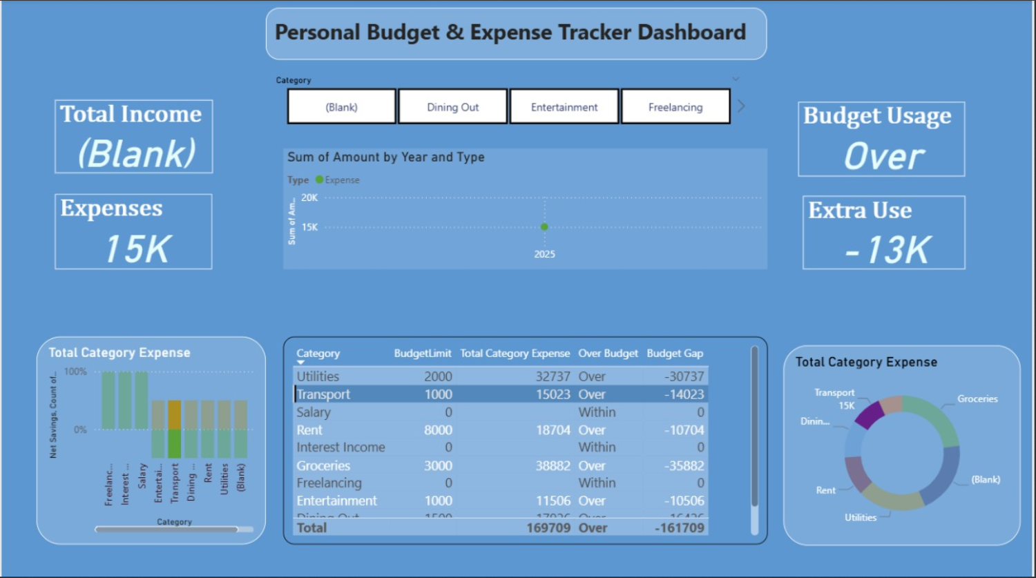



## Attendance Management System using MySQL

Submitted To:

SureTrust

Submitted By:

*Teja Sri Paluri*

*G18 POWER BI & SQL*

**Date:**

03-09-2025

/

# Abstract

This project implements an automated **Attendance Management System** that integrates **QR code scanning** and **face recognition** with a **MySQL database**. The main objective is to ensure that only students who are physically present in the class are marked as present, thereby reducing errors and preventing proxy attendance.

The process involves:

* Generating a unique QR code for each class session by the teacher
* Students scanning the QR code and submitting a live selfie
* Verifying the selfie against registered face embeddings using deep learning
* Recording attendance in MySQL if verification succeeds

A **stored procedure** in MySQL ensures that only verified attendance entries are marked as valid, while mismatched or invalid attempts are logged for auditing. The system maintains a detailed **attendance history** for transparency and accountability.

By combining **real-time QR-based data collection** and **backend verification via face recognition**, this project demonstrates efficient database design, SQL programming, data validation, and reporting. This approach can be extended for large-scale educational institutions and corporate training programs, improving **accuracy, efficiency, and transparency** in attendance management.

**Keywords:** Attendance System, QR Code, Face Recognition, MySQL, Data Validation, Automation

Introduction:

Accurate attendance tracking is crucial for educational institutions, training programs, and organizational sessions. Traditionally, attendance is recorded manually, which is time-consuming, error-prone, and susceptible to proxy entries.

In this project, we address these challenges by designing a *database-driven system* that automates attendance using **QR code scanning** and **face recognition**. The workflow is as follows:

1. Teachers generate a unique QR code for each class session.
2. Students scan the QR code and submit a live selfie.
3. Face data is verified against registered embeddings.
4. Attendance is recorded in a **MySQL database** only if verification succeeds.
5. Logs and reports are generated for monitoring and auditing.

This approach ensures that:

* Attendance is marked only for students who are physically present. Invalid or mismatched attempts are flagged and logged for review.
* Teachers and administrators can access real-time attendance reports.

The project demonstrates how **SQL databases** can be leveraged for **data validation, automation, and reporting**, providing a secure and efficient solution for modern attendance management.

### Content:

##### System Requirements

##### Hardware Requirements

* Processor: Intel i5 or higher
* RAM: Minimum 4 GB
* Storage: 100 MB free space

Software Requirements

* MySQL Workbench 8.0 or above
* MySQL Server 8.0 or above
* Python 3.10+ (for face recognition and automation)
* Django 4.x or above (for web application)
* Google Chrome or any modern web browser (for QR scanning and dashboards)
* OpenCV & face recognition libraries (for live webcam capture and face verification)

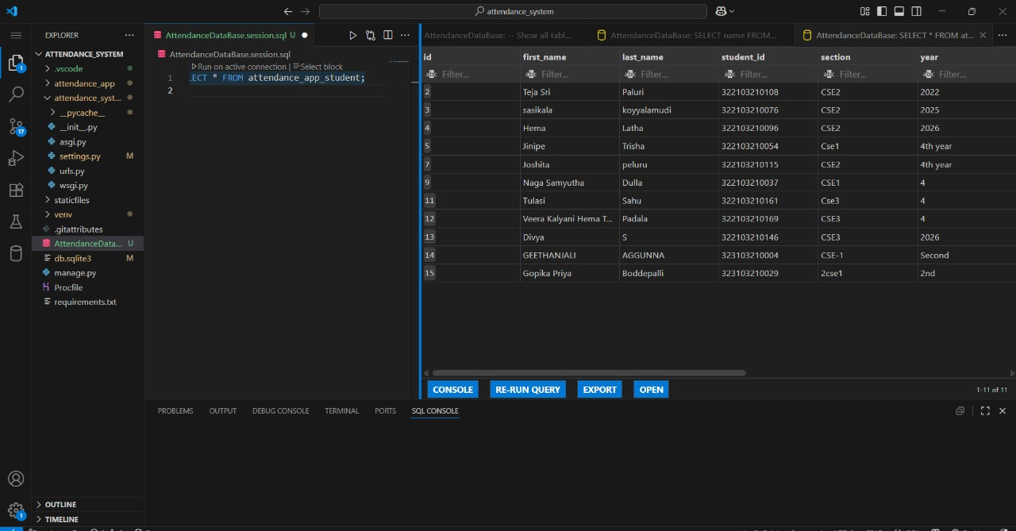

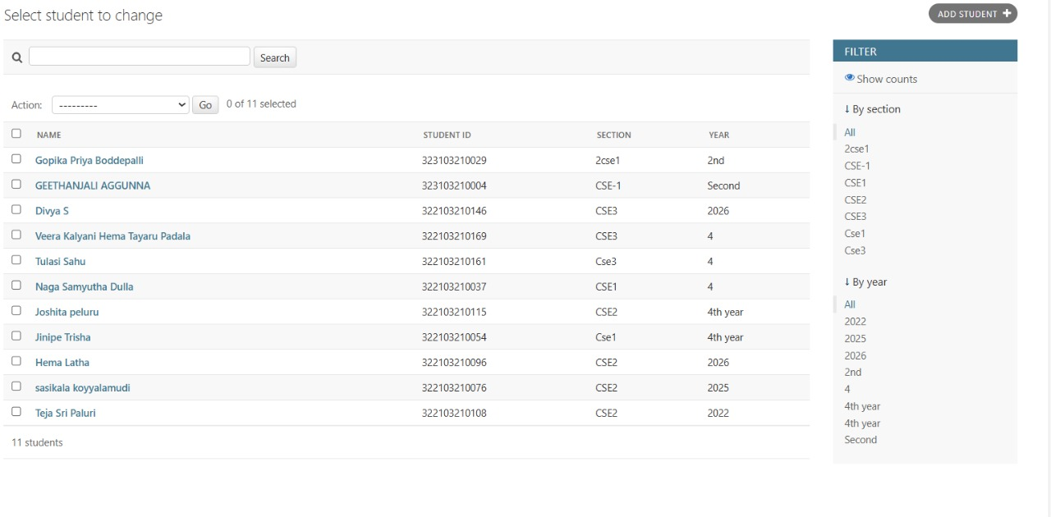

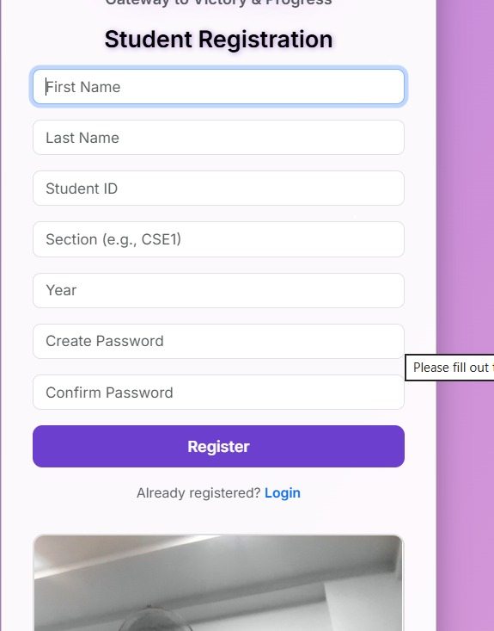

**Database Schema**

**The system consists of 5 main tables:**

**1. Student**  
Stores student info and face encoding.

* Attributes: Student ID, Name, Roll No, Password, Section, Year, Face Encoding.
* Relation: One student → Many attendance records.

**2. Teacher**  
Stores teacher info.

* Attributes: Teacher ID, Name, Email, Password.
* Relation: One teacher → Many classes.

**3. Class**  
Represents a subject and section.

* Attributes: Class ID, Subject, Section, Teacher ID.
* Relation: One class → Many QR codes.

**4. QRCode**  
Daily QR code generated for a class.

* Attributes: QR ID, Class ID, QR Data, Date Generated.
* Relation: One QR code → Many attendance records.

**5. Attendance**  
Records student attendance per class session.

* Attributes: Attendance ID, Student ID, QR ID, Status (Present/Absent), Marked At.

**Data Insertion:**

-- Students Table

CREATE TABLE students (

student_id VARCHAR(20) PRIMARY KEY,

first_name VARCHAR(50),

last_name VARCHAR(50),

section VARCHAR(20),

year INT,

password VARCHAR(100),

face_encoding BLOB

);

-- Teachers Table

CREATE TABLE teachers (

teacher_id VARCHAR(20) PRIMARY KEY,

name VARCHAR(100),

password VARCHAR(100)

);

-- QR Codes Table

CREATE TABLE qr_codes (

qr_id INT AUTO_INCREMENT PRIMARY KEY,

class_id VARCHAR(20),

subject VARCHAR(50),

qr_data VARCHAR(255),

date DATE

);

-- Attendance Table

CREATE TABLE attendance (

attendance_id INT AUTO_INCREMENT PRIMARY KEY,

student_id VARCHAR(20),

qr_id INT,

status VARCHAR(10), -- Present / Absent

timestamp DATETIME DEFAULT CURRENT_TIMESTAMP,

FOREIGN KEY (student_id) REFERENCES students(student_id),

FOREIGN KEY (qr_id) REFERENCES qr_codes(qr_id)

);

**Insertion :**

-- Add Students

INSERT INTO students (student_id, first_name, last_name, section, year, password)

VALUES ('S101', 'Teju', 'Patel', 'A', 2, 'password123');

-- Add Teacher

INSERT INTO teachers (teacher_id, name, password)

VALUES ('T101', 'Mr. Sharma', 'teachpass');

-- Add QR Code

INSERT INTO qr_codes (class_id, subject, qr_data, date)

VALUES ('CSE201', 'Math', 'QRCODE123', '2025-09-10');

-- Mark Attendance

INSERT INTO attendance (student_id, qr_id, status)

VALUES ('S101', 1, 'Present');

**Fetch Data:**

-- Get all students

SELECT * FROM students;

-- Get all attendance records for a student

SELECT a.attendance_id, a.status, q.subject, q.date

FROM attendance a

JOIN qr_codes q ON a.qr_id = q.qr_id

WHERE a.student_id = 'S101';

-- Get all students present for a class on a particular date

SELECT s.student_id, s.first_name, s.last_name

FROM attendance a

JOIN students s ON a.student_id = s.student_id

JOIN qr_codes q ON a.qr_id = q.qr_id

WHERE q.class_id = 'CSE201' AND q.date = '2025-09-10' AND a.status = 'Present';

**Delete Data:**

-- Remove a QR code (and cascade attendance if needed)

DELETE FROM qr_codes

WHERE qr_id = 1;

-- Remove a student

DELETE FROM students

WHERE student_id = 'S101';

## Data Retrieval

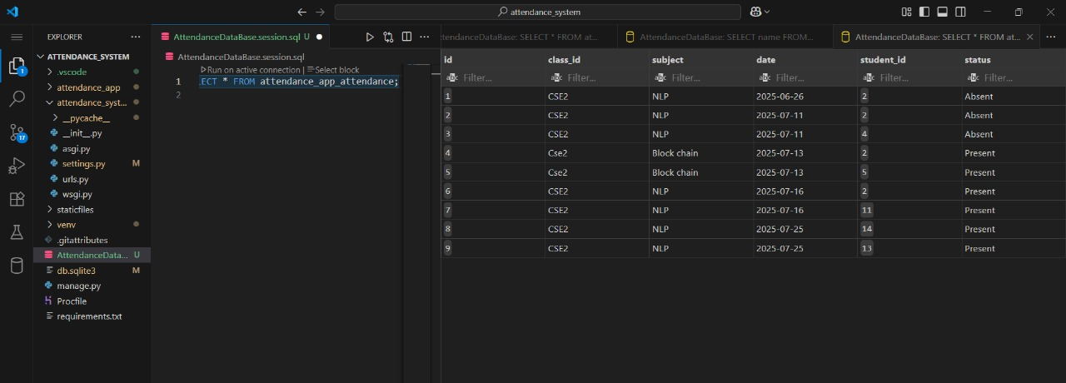

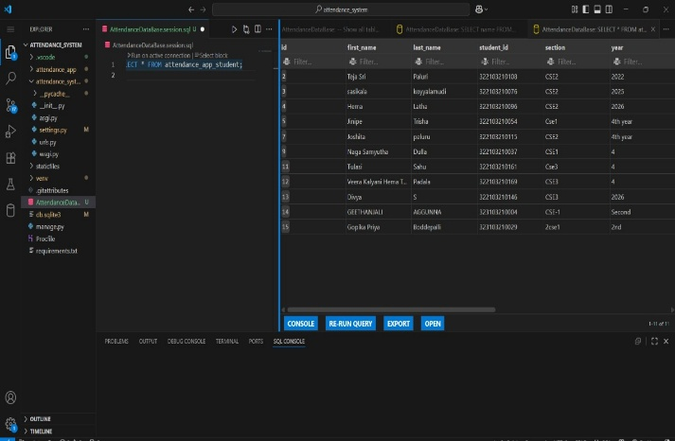

### Importing Google Form Data

**Steps for SQL Project Data Handling**

1. **Student Registration Data**
   * Collect responses via Google Form.
   * Store in Google Sheet automatically.
   * Export sheet as CSV (student_registration.csv).
   * Import CSV into MySQL using **Table Data Import Wizard** into a table like student_registration_raw.
   * Clean and process data, then insert into main Student table.
2. **Teacher Data**
   * Teachers register manually or via form.
   * Stored in Teacher table with login credentials and class assignment.
3. **Class and QR Code Data**
   * Classes are defined in the Class table.
   * Teachers generate **daily QR codes** for each class, stored in the QRCode table.
4. **Attendance Marking**
   * Students scan the QR code and submit a live photo.
   * System verifies identity using **face recognition**.
   * If verified, an attendance record is created in the Attendance table with status and timestamp.



**Stored Procedure for Processing Responses**

* Start the procedure and prepare to process responses.
* Select all unprocessed responses from the form_responses table (where processed = FALSE).
* For each unprocessed response:  
  a. Take note of the student, class, subject, and date related to that response.  
  b. Check the attendance table to see if the student was marked present for that class, subject, and date.
* If the student attended the class:
* Update the form_responses table to mark this response as processed (processed = TRUE).
* Insert a success log into the response_logs table with a message like "Processed successfully".
* If the student did NOT attend the class:
* Do not mark the response as processed.
* Insert an error log into the response_logs table with a message like "No .

# Results and Reports

# 

# 

# 

## 

**Conclusion and Future Scope**

**Conclusion**  
This project successfully demonstrates how attendance tracking can be automated using a MySQL database and SQL queries. By integrating QR code scanning and face recognition, the system ensures that only registered students can mark their attendance, thereby increasing accuracy and reducing manual errors.

**Key achievements:**  
• Designed a relational database with Students, Teachers, QR Codes, and Attendance tables.  
• Implemented student registration with secure credentials and face encoding storage.  
• Automated attendance marking through QR code scan and live selfie verification.  
• Generated reports for student attendance history, daily class attendance, and attendance percentage.  
• Ensured data integrity by linking QR codes and attendance records via foreign keys.

The solution shows that SQL-based attendance systems can efficiently replace manual attendance processes, improve transparency, and provide analytical insights for academic management.

Future Scope:  
• Integrate notifications to students and teachers for attendance status.  
• Add analytics dashboards using Power BI or similar tools for detailed attendance trends.  
• Extend the system for multi-class and multi-section management.  
• Introduce mobile app support for easier QR scanning and attendance marking.  
• Implement AI-powered face recognition improvements for higher accuracy in diverse environments.

**Future Scope**

**Future Scope**

The project can be further extended with:

1. **Automation via Python** – Automatically fetch attendance data from QR scans and integrate with MySQL.
2. **Dashboard Integration** – Create a real-time dashboard (using Power BI, Tableau, or Flask Web App) to visualize attendance trends.
3. **Email/SMS Notifications** – Notify students and teachers about attendance status or irregularities.
4. **Scalability** – Extend the system to handle multiple classes, sections, or institutions with larger datasets.

Limitations

Students need an active internet connection to use the QR scanning and live face verification features for attendance. The accuracy of attendance is dependent on proper face recognition, and issues like extreme lighting or camera problems can impact the matching process.