VELALAR COLLEGE OF ENGINEERING AND TECHNOLOGY

DATABASE MANAGEMENT SYSTEM
ASSIGNMENT -3

ASSIGNMENT TITLE :
SQL QUERY PRACTICE

STUDENT DETAILS :

NAME : TEJASRI D
REG NO : 732924CSR172

- Write an SQL query to display all student records from the Student table.

QUERY :
create table tejasri(StudentID int,Name varchar(20),Department varchar(20),Marks int,City varchar(20));
insert into tejasri values(201,'Anu','CSE',85,'Chennai');
insert into tejasri values(202,'bala','ECE',78,'coimbatore');
insert into tejasri values(203,'divya','CSE',92,'NULL');
insert into tejasri values(204,'kiran','IT',74,'chennai');
insert into tejasri values(205,'rahul','ECE',88,'madurai');
select * from tejasri;
OUTPUT :
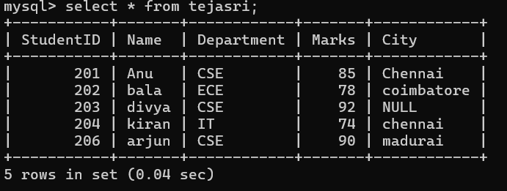

- Write a query to display the Name and Marks of all students.

QUERY :

select Name,Marks from tejasri;

OUTPUT :

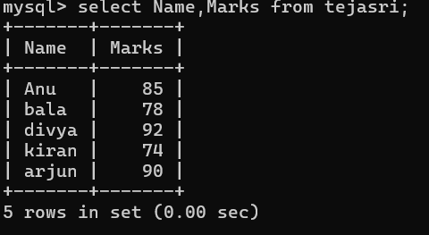

- Write a query to display students who scored more than 80 marks.

QUERY :

select Name from tejasri where Marks>80;

OUTPUT :

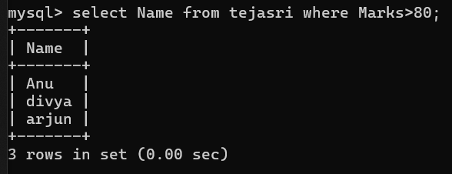

- Write a query to display students belonging to the CSE department.

QUERY :
select Name from tejasri where Department = 'CSE';

OUTPUT :

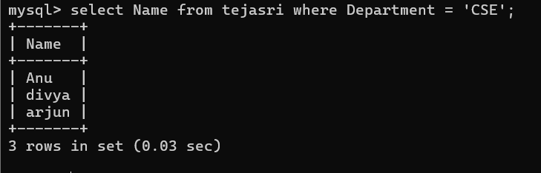
- Write a query to display students whose city is Chennai.

QUERY :
select Name from tejasri where city = 'chennai';

OUTPUT :
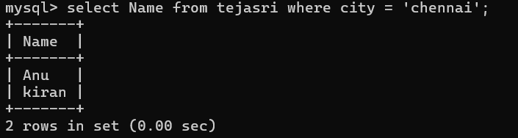

- Write a query to display students whose marks are between 70 and 90.

QUERY :

select Name from tejasri where Marks > 70 AND Marks < 90;

OUTPUT :

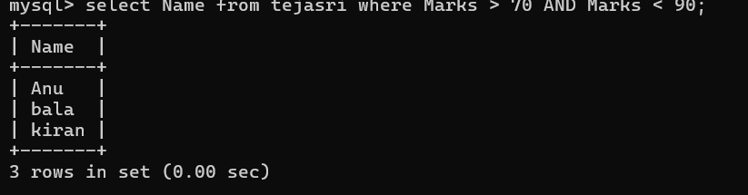

- Write a query to display student names that end with the letter ‘a’ using the LIKE operator.
QUERY :
Select name from tejasri where name like ‘%a’;

OUTPUT :

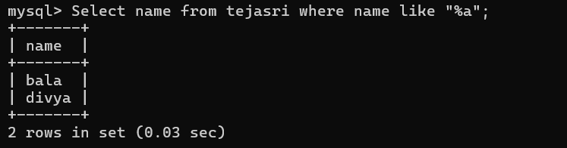

- Write a query to display distinct departments from the Student table.

QUERY :
Select distinct department from tejasri ;

OUTPUT :

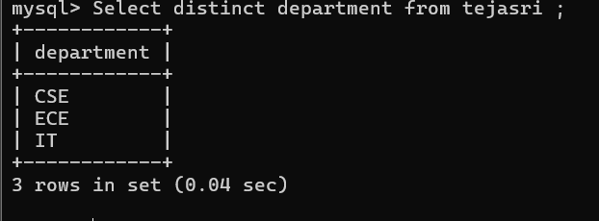

- Write a query to display students whose City value is NULL.

QUERY :

Select * from tejasri where city = ‘NULL’;

OUTPUT :

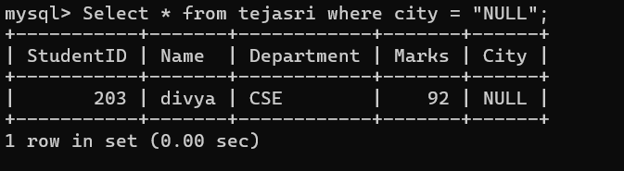

- Write a query to find the highest marks obtained by a student using an aggregate function.
QUERY :
Select max(Marks) as highest_Marks from tejasri;

OUTPUT :

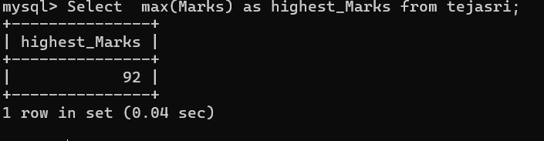

- Write a query to find the average marks of students in the ECE department.

QUERY :
Select avg(Marks) as average_Marks from tejasri where department =’ECE’;

OUTPUT :

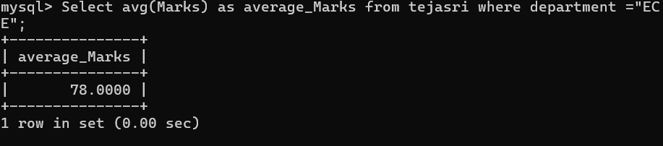

- Write a query to count the number of students in each department using GROUP BY.
QUERY :
Select department,count(*) as number_of_students from tejasri group by department;
OUTPUT :

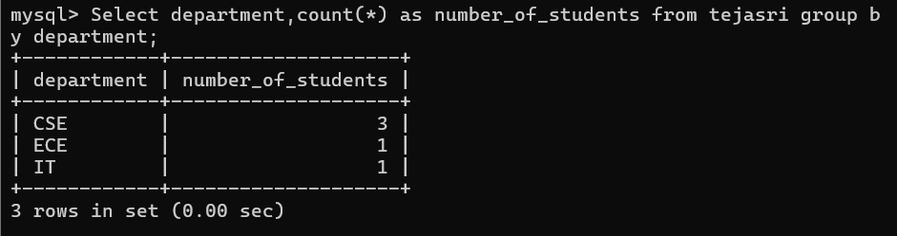
- Write a query to display students whose marks are greater than the average marks of all students (nested subquery).

QUERY :
Select * from tejasri where marks >(select avg(Marks) from tejasri);
OUTPUT :

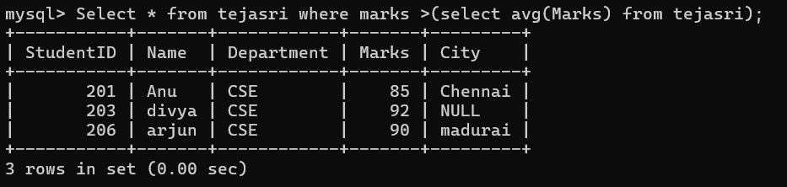

- Write an SQL statement to insert a new student record into the Student table.

QUERY :

insert into tejasri values(205,'rahul','ECE',88,'madurai');
select * from tejasri;

OUTPUT :

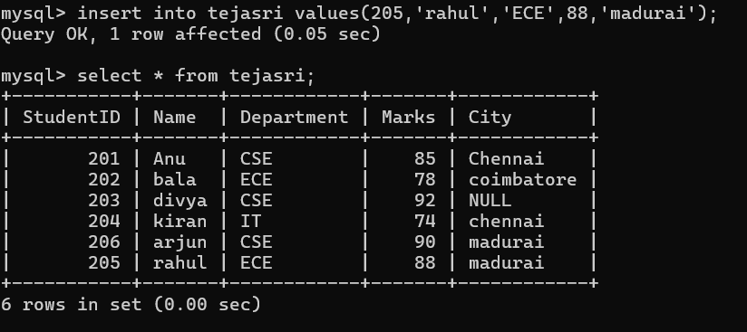

- Write an SQL query to delete the student with StudentID = 205.

QUERY :

Delete from tejasri where studentID = 205 ;
Select * from tejasri;

OUTPUT :

