FREELANCER PLATFORM
A Report on
Mini Project Submitted
In the partial fulfilment of the requirements for the award of the degree of

BACHELOR OF TECHNOLOGY
In
COMPUTER SCIENCE & ENGINEERING

By
M.GANESH 21281A0568
P.KARTHIK 22285A0515
N.DRUVA 21281A05A5
CH.AJAY 21281A0586
PROJECT GUIDE
Mrs BHARATHI
(Assistant Professor)
DEPARTMENT OF COMPUTER SCIENCE & ENGINEERING
KAMALA INSTITUTE OF TECHNOLOGY AND SCIENCE
(Approved by AICTE, New Delhi and Affiliated to JNTU, Hyderabad, Accredited with
‘A++’ Grade by NAAC, Accredited by NBA) Singapur, Huzurabad, Karimnagar, Telangana-505468.
2023–2024

FREELANCER PLATFORM

CERTIFICATE
This is to certify that M.GANESH (21281A0568), P.KARTHIK (22285A0515), N.DRUVA (21281A05A5), CH.AJAY(21281A0586)
students of B. Tech (CSE) Kamala Institute of Technology and Science, Singapur, Huzurabad. They have continuously interacted with the management in gathering the requirements for the
development of the “FREELANCER PLATFORM”.They had developed a website which satisfied all
our requirements. We are satisfied with the work done by the students. We wish all the success for their
future.

Place:

Date: Signature:


KAMALA INSTITUTE OF TECHNOLOGY & SCIENCE
(Approved by AICTE, New Delhi and Affiliated to JNTU, Hyderabad, Accredited with ‘A++’ Grade by NACC, Accredited by NBA)
SINGAPUR, HUZURABAD, KARIMNAGAR, TELANGANA, INDIA-505468


CERTIFICATE

This is to certify that M. GANESH (21281A0568), P. KARTHIK (22285A0515), N. DRUVA (21281A05A5), CH. AJAY (21281A0586) of the B. Tech Computer Science & Engineering has satisfactorily completed the dissertation work for Industrial Oriented mini project entitled “FREELANCER PLATFORM” towards the partial fulfilment of B. Tech degree in this academic year i.e., 2024-2025.

Project Guide Head of the Department

Principal External Examiner

INDEX

Title Page No
Acknowledgement i
Abstract ii
List of figures iii
List of tables v
List of Abbreviations vi
Chapter 1 Introduction 1
1.1 About Project 1
1.2 Existing System 1
1.3 Proposed System 2
Chapter 2 Analysis 3
2.1 Hardware Requirements 3
2.2 Software Requirements 3
2.3 Functional Requirements 4
2.4 Non-Functional Requirements 4
2.5 Module Description 5
Chapter 3 Design 6
3.1 Block Diagram 6
3.2 Data Flow Diagram 8
3.2.1 DFD Symbols 8 3.2.2 Context Diagram 9
3.3 ER Diagram 11
3.4 UML Diagrams 12
3.4.1 Use case Diagram 13
3.4.2 Class Diagram 17
3.4.3 Sequence Diagram 21
3.4.4 Collaboration Diagram 24
3.4.5 Activity Diagram 25
3.5 Database Dictionary 26
3.5.1 Database Tables 27

Chapter 4 Implementation 30
4.1 Maintenance and Environment 30
4.1.1 Correction 31
4.1.2 Adaption 31
4.1.3 Enhancement 3
4.1.4 Prevention 31
Chapter 5 Overview of Tools and Technologies Used 32
5.1 Tools Used 32
5.1.1 Brackets 32
5.2 Languages Used 32
5.2.1 About Python 32
5.2.2 About HTML 33
5.2.3 About MYSQL 34
5.2.4 About JavaScript 34
5.2.5 Bootstrap 35
5.2.6 Django 36
Chapter 6 Testing 37
6.1 Testing Member login page 37
6.2 Test Strategy 39
6.3 Black box testing 40
6.4 White box testing 41
6.5 Database Testing 42
6.6 Performance Testing 42
6.7 Test Results 43
Chapter 7 Result 44
Chapter 8 Conclusion and Future Enhancements 52
Chapter 9 Bibliography 53

ACKNOWLEDGMENT

The success on any course depends mostly on the teachers who teach us. Only good teaching can interpret the syllabus and produce desirable changes and competent citizens. This was a team effort and many people whose names do not appear on the cover deserve credit. First, we God all mighty for his manifold mercies in carrying out of our project successfully.
We heartfully thank our principal Dr. K.ESWARAIAH, for providing all the resources in completing our project.
We sincerely thank our Head of the Department of Computer Science & Engineering Dr. MAJOR RAVINDRA BABU KALLAM for encouraging us in doing real time projects, for his guidance and support.
We thank our project coordinators Mr. K. BHASKAR PRAKASH, Mrs. R. BHARATHI, Assistant Professors in CSE department for their continuous support in completion of this project.
We would like to thank our project guide Mr. R. BHARATHI, Assistant Professor in CSE for the valuable guidance and constant encouragement at each stage of this project.
We also thank other teaching and non-teaching staff of Kamala Institute of Technology and Science, for supporting us in every stage of our mini project, entitled “FREELANCER PLATFORM”. We also thank our parents and friends for their moral support throughout the project work that helped to strengthen our will.

M.GANESH 21281A0568
P.KARTHIK 22285A0515
N.DRUVA 21281A05A5
CH.AJAY 21281A0586

ABSTRACT

The Freelancer Portal is an online platform designed to connect freelancers with businesses or individuals looking for specific skills and services. The portal facilitates the process of hiring professionals for short-term projects or long-term contracts across various industries like IT, design, writing, marketing, and more. By enabling freelancers to showcase their skills, apply for jobs, and collaborate with clients globally, this platform fosters a dynamic marketplace for independent professionals and employers.
This abstract outlines the key modules and functionalities that such a Freelancer Portal should offer to effectively connect freelancers and clients while ensuring transparency, security, and efficiency in the workflow.

LIST OF FIGURES
Figure.no Name of the figure Page no
3.1 Block Diagram 7
3.2 DFD Symbols 8
3.3 Level Zero DFD 10
3.4 Level One DFD 10
3.5 ER Diagram 12
3.6 Member Use Case Diagram 13
3.7 Admin Use Case Diagram 16
3.8 Sports Club Class Diagram 18
3.9 Admin Sequence Diagram 22
3.10 Member Sequence Diagram 23
3.11 Collaboration Diagram 24
3.12 Admin Activity Diagram 25
3.13 Member Activity Diagram 26
6.1 Screenshot of Member Login Failed 38
6.2 Screenshot of Member Login Successful 38
6.3 Screenshot of Admin Login Failed 40
6.4 Screenshot of Admin Login Successful 41
6.5 Database Testing is Successful 42
6.6 Performance Testing 42
7.1 Screenshot of Home Page 44
7.2 Screenshot of Admin Dash board Page 44
7.3 Screenshot of Admin Viewing slot Details 45
7.4 Screenshot of Admin viewing feedbacks 45
7.5 Screenshot of Member Registration page 46
7.6 Screenshot of Registration Form with filled details 47
7.7 Screenshot of Member Login page 47
7.8 Screenshot of Member dash board 48
7.9 Screenshot of Member Profile Page 48
7.10 Screenshot of Contact Page 49
7.11 Screenshot of Slot Booking page 50
7.12 Screenshot of Member viewing booked slot page 51
7.13 Screenshot of Member Feedback page 51

LIST OF TABLES
Table.no Name of the Table Page no
2.1 Hardware Requirements 3
2.2 Software Requirements 3
3.1 Admins Database Table 27
3.2 Members Database Table 28
3.3 Booked slot Details Database Table 28
3.4 Feedback viewing Database Table 29

LIST OF ABBREVIATIONS

HTML Hypertext Markup Language
CSS Cascading Style Sheets
MySQL My Structured Query Language
UML Unified Modelling Language
GUI Graphical User Interface

CHAPTER 1 INTRODUCTION

1.1 About project
Welcome to the Freelancer Platform Documentation. This guide is designed to provide a comprehensive overview of our platform, outlining its features, functionalities, and the roles of both freelancers and project uploaders. Our platform aims to connect skilled professionals with clients seeking expert services, facilitating seamless collaboration across various projects and industries.
Platform Overview
Our Freelancer Platform is an advanced digital marketplace designed to bridge the gap between freelancers and clients. It offers a robust environment where clients can post projects and freelancers can showcase their skills and bid for opportunities. With an intuitive interface and powerful tools, our platform streamlines the process of finding, managing, and completing freelance work.
For Project Uploaders
Project uploaders, or clients, are integral to the platform. They are individuals or organizations seeking freelance services to accomplish specific tasks or projects. The platform allows uploaders to create detailed project listings, specify requirements, set budgets, and communicate their expectations clearly. They can review freelancer profiles, assess their skills and previous work, and select the most suitable candidates for their projects. The platform supports a variety of project types, from short-term tasks to long-term collaborations, ensuring that clients can find the right talent to meet their needs.
For Freelancers
Freelancers are the heart of our platform. They are skilled professionals across a wide range of industries, including writing, design, programming, marketing, and more. Freelancers can create detailed profiles showcasing their skills, experience, and portfolios. They have the opportunity to browse project listings, submit proposals, and negotiate terms with clients. The platform offers tools to manage projects efficiently, track progress, and communicate with clients, ensuring a smooth workflow from start to finish.

1.2 Existing System with Drawbacks:
Freelancer platforms have revolutionized the way work is done, connecting skilled professionals with clients across the globe. However, despite their benefits, these platforms often exhibit several common drawbacks that impact user experience and efficiency.
Drawbacks:
- A significant drawback of existing platforms is their fee structure. Both freelancers
and clients are frequently subject to high service fees, which can reduce the overall
value of the transactions and discourage participation from either party.
- Current platforms often provide inadequate communication tools, making it
challenging for freelancers and clients to discuss project details, negotiate terms,
or provide feedback effectively. This can lead to misunderstandings and project
delays.

1.3 Proposed System with Features:
To address the limitations of existing freelancer platforms, we propose a new and enhanced system designed to optimize the user experience for both freelancers and clients. This system integrates advanced technologies and user-centric features to improve matching efficiency, communication, transparency, and overall satisfaction.
Features:
- Transparent fee structure with detailed breakdowns.
- Reduced fees and tiered pricing options for cost-effectiveness.
- Robust verification processes for authentic freelancer profiles.
- Detailed project histories, client feedback, and skill endorsements.
- Dedicated support team available around the clock.
- Fast, secure payment processing.
- Milestone-based tracking with automated payment releases.
CHAPTER 2

Analysis

2.1 Hardware Requirements (Preferable):
The selection of hardware is very important in the existence and proper working of any software. In the selection of hardware, the size and the capacity requirements are also important and are shown in table 2.1.

Table: 2.1 Hardware Requirements

PROCESSOR | RYZEN 5
RAM CAPACITY | 8GB
HARD DISK | 128GB OR MORE

2.2 Software Requirements:
One of the most difficult tasks is the selection of the software, once system requirements are known that determine whether a particular software package fits the requirements are shown in table 2.2.

Table: 2.2 Software Requirements

OPERATING SYSTEM | WINDOWS 10 OR HIGHER
SCRIPTING LANGUAGE | PYTHON
FRONT END | HTML, CSS
BACK END | FLASK
WEB SERVER | XAMp

2.3 Functional Requirements:

The functional requirements of a freelancer platform include user registration and secure
authentication, allowing freelancers to create and manage profiles with detailed professional
information and verified credentials. The platform must support advanced project search and
proposal submission, with a real-time messaging system for effective communication and
secure file sharing. Essential features include a comprehensive project dashboard for task and
milestone management, secure payment processing with milestone tracking, and a feedback
system for ratings and reviews. Additionally, the platform should offer notifications,
performance analytics, a robust support and help center, stringent security measures for data
protection, and mobile compatibility to ensure accessibility and usability across devices.
The following are the functional requirements of our project. They are:
- Advanced search filters for project discovery.
- Real-time messaging system for client-freelancer communication.
- Accessible customer support through email, phone.

2.4 Non-Functional Requirements:
Non-functional requirements for a freelancer typically encompass aspects such as reliability, performance, and security. Freelancers should ensure that their work processes are dependable, with minimal downtime and consistent delivery. They need to manage their time effectively, providing timely updates and meeting deadlines to maintain client trust. Security is also crucial, as freelancers must protect sensitive client information and adhere to best practices for data privacy. Additionally, they should be adaptable and responsive to client needs, demonstrating strong communication skills and the ability to handle unforeseen challenges efficiently.following non-functional requirements:
Security:Protection of sensitive client data and adherence to best practices for confidentiality and data privacy.
Reliability:Consistent delivery of work as promised, with minimal delays or errors
Scalability:Capacity to manage varying workloads and adjust to project demands without compromising quality or timelines.
Availability:As System provides the member to login the application and view the content so he/she can access it 24x7 remotely.

2.5 Module Description:
The Freelancer Platform Module provides a comprehensive system for connecting clients with freelance professionals. This module facilitates the creation and management of freelancer profiles, job postings, and project assignments. It includes features for bidding on projects, contract management, and payment processing, enabling seamless interactions between freelancers and clients. The platform supports various functionalities such as skill verification, feedback and ratings, and secure communication, ensuring a reliable and efficient marketplace for freelance work.

CHAPTER 3

Design

3.1 Block Diagram:
A block diagram is a diagram of a system in which the principal parts or functions are represented by blocks connected by lines that show the relationships of the blocks [1]. They are heavily used in engineering in hardware design, electronic design, software design, and process flow diagrams.
Block diagrams are typically used for higher level, less detailed descriptions that are intended to clarify overall concepts without concern for the details of implementation. Contrast this with the schematic diagrams and layout diagrams used in electrical engineering, which show the implementation details of electrical components and physical construction.
The block diagram of the SPORTS CLUB shows the process, abilities of contents involved in implementation. Principally the two members of website are admin and member. There are various objects present in the block diagram they are connected with each other using unidirectional arrow they show about the next stages. In this block diagram the member and admin have separate path. Each and every object of admin is connected to database in the last.
The fig 3.1 represents about the block diagram of SLOT BOOK. In this the beginning object is SLOT BOOK which further divided into 2 paths one is represented by member and admin which are crucial elements.
The admin has objects which contains about the operations that can be done by the admin after his login. After login the admin can access slots and view feedbacks.
The member has objects which contains information about the slots and feedbacks which can be viewed by every member.

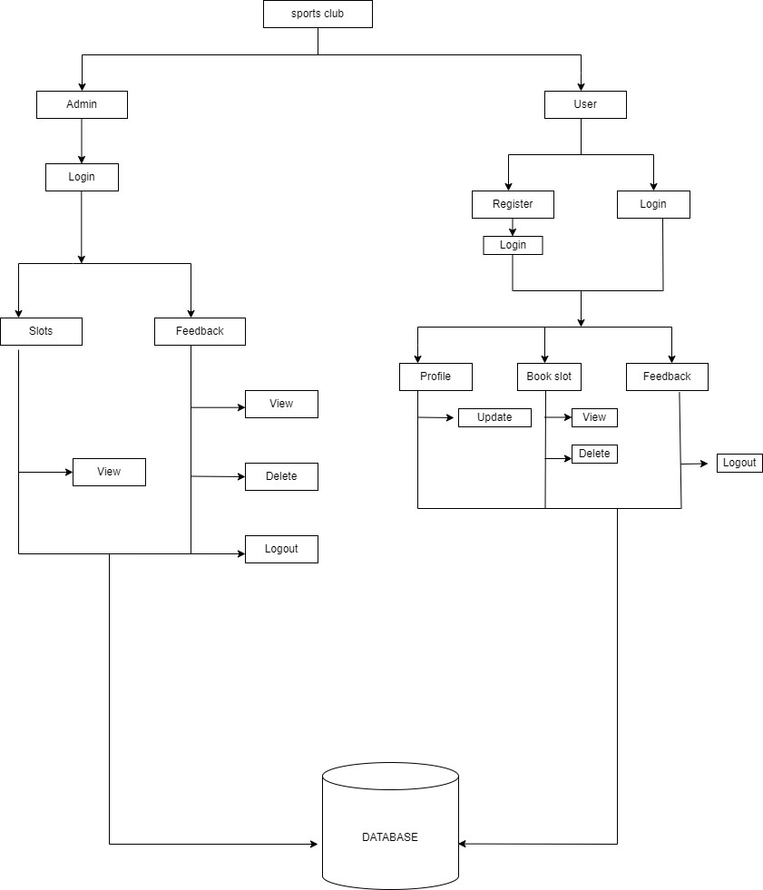
Member

Figure 3.1 Block Diagram

3.2 Data Flow Diagram:
A data flow diagram is graphical tool used to describe and analyse movement of data through a system. These are the central tool and the basis from which the other components are developed. The transformation of data from input to output, through processed, may be described logically and independently of physical components associated with the system. This is known as the logical data flow diagrams. The physical data flow diagrams show the actual implements and movement of data between people, departments and workstations. Each component in a DFD is labelled with a descriptive name. Process is further identified with a number that will be used for identification purpose. Each process in lower-level diagrams can be broken down into a more detailed DFD in the next level. The top-level diagram is often called a “context diagram”.
3.2.1 DFD Symbols:
In the DFD, there are four symbols:
- Square defines a source (originator) or destination of system data.
- An arrow identifies data flow. It is the pipeline through which the information flows. Data move in a specific direction from an origin to a destination.
- A circle or a bubble represents a process that transforms incoming data flow into outgoing data flows.
- An Open Rectangle is a data store, data at rest or a temporary repository of data.
The following figure 3.2 shows the symbols of DFD.
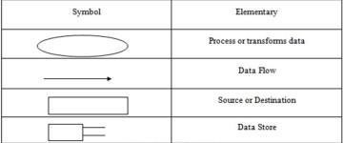
Figure 3.2 DFD Symbols
Constructing a DFD:
Several rules of thumb are used in drawing DFD’S:
- Process should be named and numbered for an easy interface. Each name should be representative of the process.
- The direction of flow is from top to bottom and from left to right. Data traditionally flow from source to the destination although they may flow back to the source. One
way to indicate this is to draw long flow line back to a source.
- An alternative way is to repeat the source symbol as the destination. Since it is used more than once in the DFD it is marked with a short diagonal.
- When a process is exploded into lower-level details, they are numbered.
- The names of data stores and destinations are written in capital letters. Process and dataflow names have the first letter of each work capitalized.
3.2.2 Context Diagram:
It contains a single process, but it plays a very important role in studying the current system. The context diagram defines the system that will be studied in the sense that it determines the boundaries. Anything that is not inside the process identified in the context diagram will not be part of the system study. It represents the entire software element as a single bubble with input and output data indicated by incoming and outgoing arrows respectively.
A DFD is also known as a “bubble chart” has the purpose of clarifying system requirements and identifying major transformations that will become programs in system design. So, it is the starting point of the design to the lowest level of detail. A DFD consists of a series of bubbles joined by data base system.
This website has two-levels of DFDs. Fig 3.3 represents Level Zero DFD. This figure represents the login and logout of both admin and member to the website. In the website the details entered will be stored in database and can be retrieved at required time.
Identically, the Fig 3.4 represents Level One DFD. The figure gives the detailed information about the actions performed by the admin on the website along with login and log out. The actions include view feedback. Every action performed is stored to database.

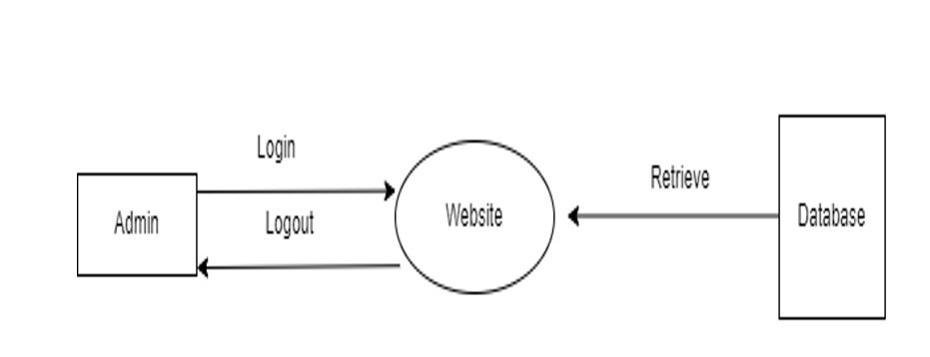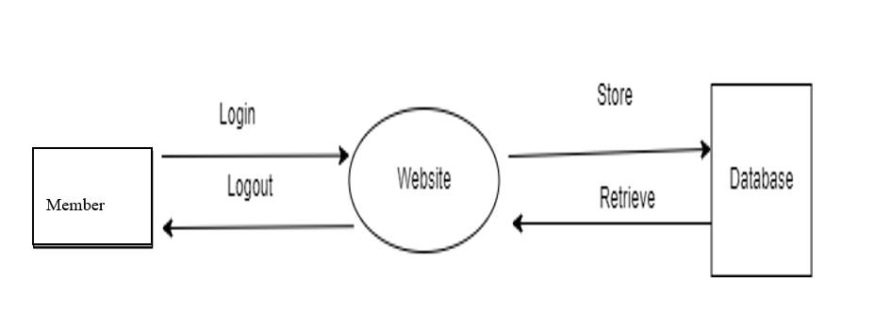

Fig:3.3 Level Zero DFD

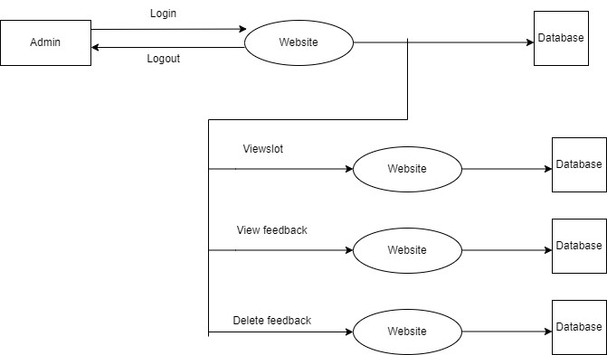

Fig:3.4 Level One DFD

3.3 ER Diagram:
The Entity-Relationship Data Model (ERD) perceives the real world as consisting of basic objects, called entity & relationship among these objects.
It was developed to facilitate database design by allowing specification of an enterprise schema, which represents overall logical structure of a database. The ERD model is very useful in mapping the meaning & interactions of the outside world enterprises onto a conceptual schema. The ERD model consists of the following major components.

Elements in ER diagram:
There are three basic elements in an ER Diagram
- Entity
- Attribute
- Relationship
There are more elements which are based on the main elements. They are weak entities, multi valued attributes, derived attributes, weak relationships and recursive relationships.
Entity: An entity can be a person, place, event or object that is relevant to a given system. They are represented by a rectangle and named using nouns.
Weak Entity: A weak entity is an entity that depends on the existence of another entity. It can be defined as an entity that cannot be identified by its own attributes.
Attribute: An attribute is a property, or characteristic of an entity, relationship, or another attribute.
Multi valued Attribute: If an attribute can have more than one value.
Derived Attribute: An attribute derived from another attribute.
Relationship: A relationship describes how entities interact.
Cardinality: Cardinality specifies how many instances of an entity relate to one instance of another entity. Cardinality specifies the maximum number of relationships.

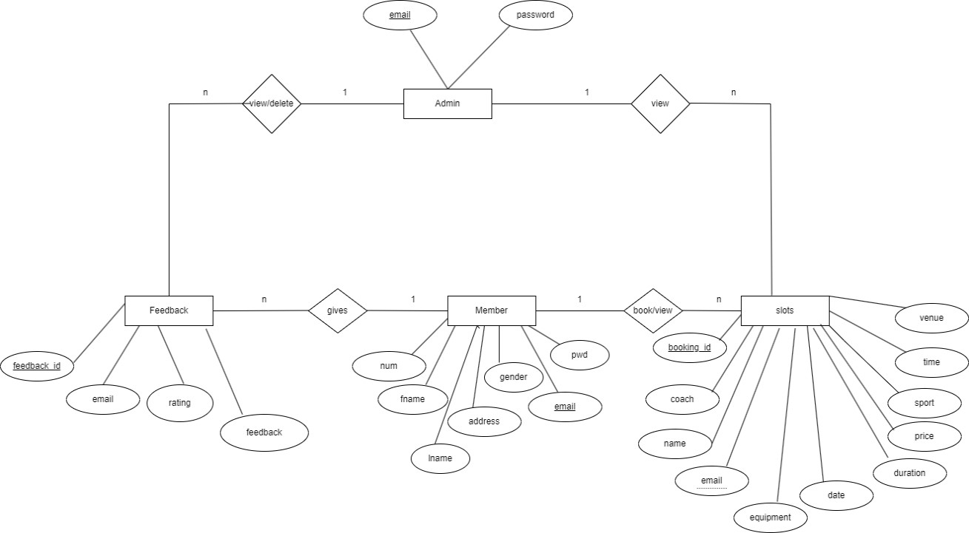

Figure 3.5 ER Diagram
The fig 3.5 represents the Entity Relationship Diagram of SPORTS CLUB. Entity is an object, the entities in the figure are admin, Member, feedback, slots. Each entity has its own primary key as an attribute by which the entity is identified. For Admin and Member entities email is considered as its primary key. For Feedback entity feedback_id and for slots entity booking_id is primary key respectively. Here admin can view booked slots and also view and delete the feedbacks. Whereas member can book slots, update profile, view slots and give feedback.
As the slots can also be selected or viewed email is a foreign key for slots entity.
3.4 UML Diagrams:
UML stands for Unified Modelling Language. UML is a language for specifying, visualizing and documenting the system. This is the step while developing any product after System analysis [1]. The goal from this is to produce a model of the entities involved in the project which later need to be built. The representation of the entities that are to be used in the product being developed need to be designed. There are various kinds of methods in software design:
They are as follows:
- Use Case Diagram
- Class Diagram
- Sequence Diagram
- Collaboration Diagram
- Activity Diagram

3.4.1 Use Case Diagram:
Use case diagrams model behaviour within a system and helps the developers understand of what the member require. The stick man represents what’s called an actor. Use case diagram can be useful for getting an overall view of the system and clarifying who can do and more importantly what they can’t do. Use case diagram consists of use cases and actors and shows the interaction between the use case and actors.
- The purpose is to show the interactions between the use case and actor.
- To represent the system requirements from member’s perspective.
- An actor could be the end-member of the system or an external system.

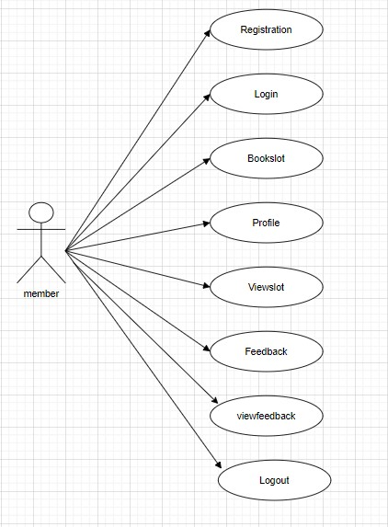

Figure 3.6 Member Use Case Diagram

The main use cases of figure 3.6 are:
- Registration: A new member can create an account and provide their personal information.
- Login: An existing member can log in to their account.
- Book slot: A member can book a slot that may be either gym or any other resources available in sports club.
- View slot: A member can view the slots that they have booked.
- View feedback: A member can view the feedback that other members have left about them.
- Leave feedback: A member can leave feedback about another member.
- Logout: A member can log out of their account.
The actors in the use case diagram are:
- Member: A person who has created an account on the web application.
The system is the web application itself.
The use cases are connected by lines, which show the sequence of steps that a member must go through in order to achieve their goal. For example, in order to book a slot, a member must first be logged in.
The use case diagram can be used to help identify the requirements for the web application, and to ensure that all of the different needs of the members are met.
Here is a more detailed explanation of each use case:
Registration:
- The member provides their personal information, such as their name, email address, and phone number.
- The system creates an account for the member and sends them a confirmation email.

Login:
- The member enters their email address and password.
- The system verifies the member's credentials and logs them in to their account.
Book slot:
- The member selects the resource that they want to book and the date and time that they want to book it for.
- The system checks to see if the slot is available.
- If the slot is available, the system books it for the member.
- If the slot is not available, the system displays a message to the member.
View slot:
- The member selects the resource that they want to view their bookings for.
- The system displays a list of the member's booked slots.
View feedback:
- The system displays a list of the feedback that has been left about the member.
Leave feedback:
- The member enters their feedback.
- The system saves the feedback.
Logout:
- The member clicks on the "Logout" button.
- The system logs the member out of their account.

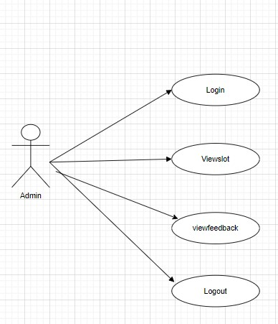
Figure 3.7 Admin Use Case Diagram
The main use cases of figure 3.7 are:
- Login: The admin logs in to the system.
- View slots: The admin views a list of all the slots booked by the members of club.
- View feedback: The admin views a list of all the feedback that has been left by members of the sports club.
- Delete feedback: The admin may also delete the feedbacks in case in verbal abuse is present in feedback.
- Logout: The admin logs out of the system.
The actors in the use case diagram are:
- Admin: The administrator of the sports club.
The system is the sports club management system itself.

The use cases are connected by lines, which show the sequence of steps that the admin must go through in order to achieve their goal.
The use case diagram can be used to help identify the requirements for the sports club management system, and to ensure that all of the different needs of the admin are met.
Here is a more detailed explanation of each use case:
Login:
- The admin enters their username and password.
- The system verifies the admin's credentials and logs them in to the system.
View slots:
- The admin clicks on the "View slots" button.
- The system displays a list of all the slots booked by members.
View feedback:
- The admin clicks on the "View Feedback" button.
- The system displays a list of all the feedback that has been left by users of the sports club.
Logout:
- The admin clicks on the "Logout" button.
- The system logs the admin out of the system.
3.4.2 Class Diagram:
Class is nothing but a structure that contains both variables and methods. The Class Diagram shows a set of classes, interfaces, and collaborations and their relating ships. There is most common diagram in modelling the object-oriented systems and are used to give the static view of a system. It shows the dependency between the classes that can be used in our system. The interactions between the modules or classes of our projects are shown below.
Each block contains Class Name, Variables and Methods.

The class diagram of sports club website is shown in the figure 3.8, it contains classes which have class name, attributes, operation is to be performed. Class name includes admin, member, etc. Attributes are related features to the class name they include id, name, etc.
Operations performed by the class are create (), update ().
Consider member class the attributes include name, gender, phone, email, password etc.

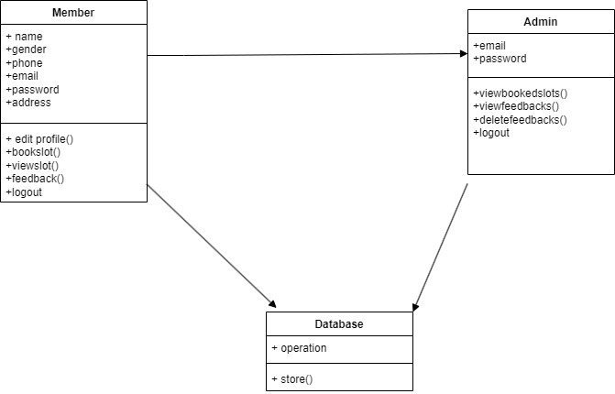
Figure 3.8 Sports Club Class Diagram.

The class diagram (figure 3.8) of the sports club shows the following classes:
- Member
- Admin
- Database
The classes are connected by the following relationships:
- Member has a one-to-many relationship with Database. This means that one member can have multiple database entries, but each database entry can only belong to one member.
- Admin has a one-to-many relationship with Member. This means that one admin can perform their operations.
- Database has a bidirectional many-to-many relationship with Admin. This means that many database entries can be managed by many admins, and many admins can manage many database entries.
The classes have the following attributes:
Member
- name
- gender
- phone
- email
- password
- address
Admin
- email
- password
Database
- operation
The Member class has the following operations:
- editprofile ()
- bookslot ()
- viewslot ()
- feedback ()
- logout ()
The admin class has the following operations:
- viewbookedslots ()
- viewfeedbacks ()
- deletefeedbacks ()
- logout ()
The Database class has the following operations:
- store ()
The class diagram shows the static structure of the sports club system. It shows the different classes that make up the system and the relationships between them. The class diagram can be used to help understand the system and to identify the requirements for the system.
Here is an example of how the class diagram could be used:
- The Member class could be used to store information about the members of the sports club. This information could include the member's name, gender, phone number, email address, password, and address.
- The admin class could be used to store information about the administrators of the sports club. This information could include the administrator's email address and password.
- The Database class could be used to store all of the data about the sports club. This data could include information about the members, the admins, and the events at the sports club.
The operations in the class diagram could be used to implement the functionality of the sports club system. For example, the bookslot () operation in the Member class could be used to allow members to book slots for events. The viewbookedslots () operation in the admin class could be used to allow admins to view the slots that have been booked by members.
3.4.3 Sequence Diagram:
Sequence diagram and collaboration diagram are called INTERACTION DIAGRAMS. An interaction diagram shows an interaction, consisting of set of objects and their relationship including the messages that may be dispatched among them. A sequence diagram is an introduction that empathizes the time ordering of messages. Graphically a sequence diagram is a table that shows objects arranged along the X-axis and messages ordered in increasing time along the Y-axis.

Sequence diagram represents the process of website working in a certain sequence order. In sequence diagram verification is displayed for every login. The figure 3.9 represents the Admin Sequence Diagram and the figure 3.10 represents the Member Sequence Diagram.

In Admin Sequence Diagram the lifelines are Admin, Website, Database. Admin firstly, login to the website and the website verifies the login details i.e., email and password from the database. At his convenient the admin can logout from the website, database shows that logout was successful.

In Member Sequence Diagram the lifelines are Member, Website, Database. Member firstly, login to the website and the website verifies the login details i.e., email and password from the database.

3.4.3.1 Sequence Diagram for Admin

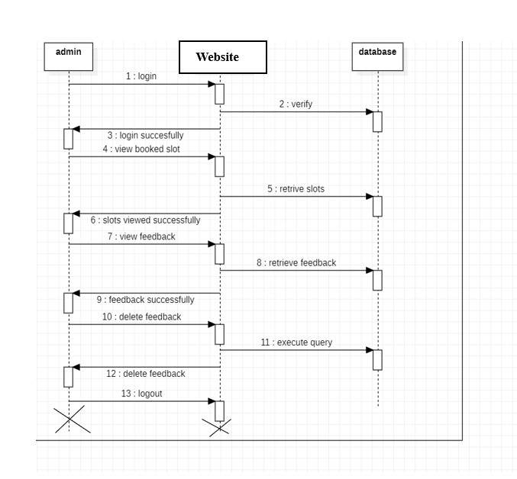
Figure 3.9 Admin Sequence Diagram

The first step is for the admin to log in to the sports club management system. The admin enters their email address and password, and the system verifies the admin's credentials and logs them in.
Once the admin is logged in, they can click on the "View Feedback" button. The system will then display a list of all the feedback that has been left by members of the sports club.
The admin can then view the feedback for any member by clicking on the member's name. The system will then display all of the feedback that has been left about that member.
The admin can also delete feedback by clicking on the "Delete" button next to the feedback. The system will then delete the feedback. The admin can then log out of the sports club management system.

3.4.3.2 Sequence Diagram for Member

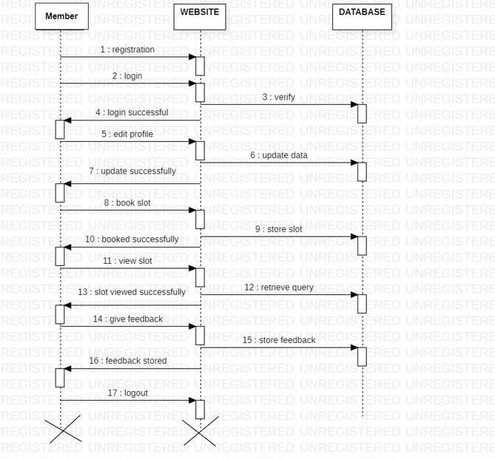
Figure 3.10 Member Sequence Diagram

The first step is for the member to log in to the sports club website. The member enters their email address and password, and the system verifies the member's credentials and logs them in.
Once the member is logged in, they can click on the "Give Feedback" button. The system will then display a form that allows the member to leave feedback. The member can also rate the other member on a scale of 1 to 5 stars.
Once the member is finished entering their feedback, they click on the "Submit" button.
The system will then save the feedback.
The member can then log out of the sports club website.

Here is a more detailed explanation of each step:
- Member logs in to the sports club website.
- The system verifies the member's credentials and logs them in.
- The member clicks on the "Give Feedback" button.
- The system displays a form that allows the member to give feedback.
- The member enters their feedback in the form and rates it on a scale of 1 to 5 stars.
- The member clicks on the "Submit" button.
- The system saves the feedback.
- The member logs out of the sports club website.
Similarly, member can book slots, view and delete slots.

3.4.4 Collaboration Diagram:
A collaboration diagram is an introduction diagram that emphasizes the structural organization of the objects that send and receive messages. Graphically a collaboration diagram is a collection of vertices and arcs.

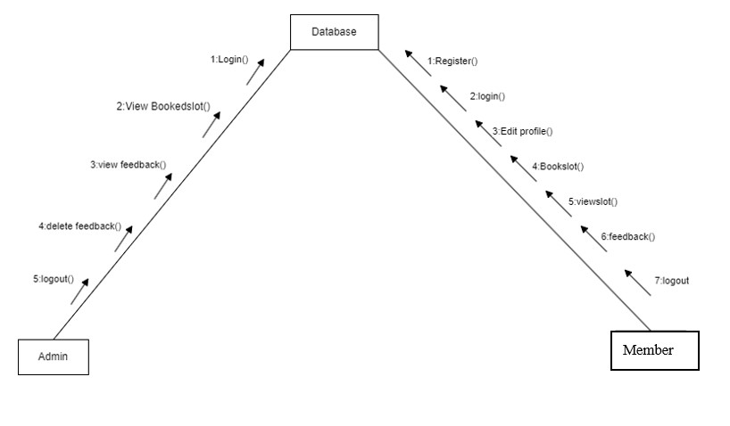
Figure 3.11 Collaboration Diagram
SPORTS CLUB collaboration diagram fig 3.11 shows the objects involved in the
process. In our case Admin, Database, Member are the main objects. Admin login to the website and login information is stored to database. The actions performed by the member are stored by database, member can retrieve the information from database.

3.4.5 Activity Diagram:
An Activity Diagram is a behavioural diagram that shows the flow or sequence of activities through a system. The terms activity diagram and process flow are often used interchangeably. However, the term activity diagram is typically more restrictive as it refers to one of thirteen standard Unified Model Language (UML) diagrams. Activity Diagrams are one of the most commonly used diagrams since its notation and origin are based on the widely known flowchart notation.

The activity diagram in SPORTS CLUB shows the actions performed by admin, member after login every action performed is mentioned in the diagram. The below fig 3.12 represents the Admin Use Case Diagram and fig 3.13 represents the Member Use Case Diagram.

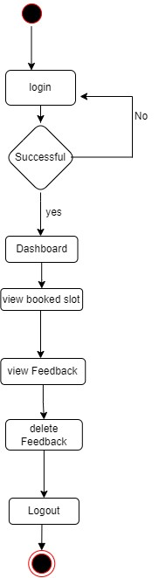

Figure 3.12 Admin Activity Diagram
Admin initially login to the website, then he has authentication of accessing website. Where he can perform operations, such as view booked slots, view feedbacks given by members and he can also delete negative i.e., abuse feedbacks.

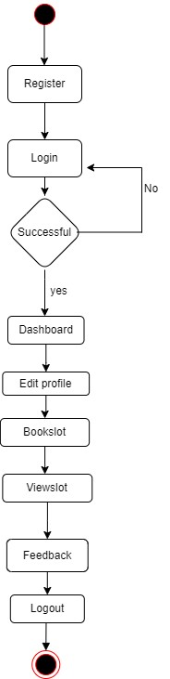

Figure 3.13 Member Activity Diagram

Member initially login to the website after verification of member details. Then he can update his / her profile in the website. Further can member can book the slot or he may also view the previously booked slots. Member can also give feedback to club.

3.5 Database Dictionary: A data dictionary, or Metadata Repository, as defined in the IBM Dictionary of Computing, is a "centralized repository of information about data such as meaning, relationships to other data, origin, usage, and format. The term can have one of several closely related meanings pertaining to databases and database management systems (DBMS)
- A document describing a database or collection of databases.
- An integral component of a DBMS that is required to determine its structure.
- A piece of middleware that extends or supplants the native data dictionary of a
DBMS.

The terms data dictionary and data repository indicate a more general software utility than a catalogue. A catalogue is closely coupled with the DBMS software. It provides the information stored in it to the member and the DBA, but it is mainly accessed by the various software modules of the DBMS itself, such as DDL and DML compilers, the query optimizer, the transaction processor, report generators, and the constraint enforcer [2]. On the other hand, a data dictionary is a data structure that stores metadata, i.e., (structured) data about information. The software package for a stand-alone data dictionary or data repository may interact with the software modules of the DBMS, but it is mainly used by the designers, members and administrators of a computer system for information resource management.

If a data dictionary system is used only by the designers, members, and administrators and not by the DBMS Software, it is called a passive data dictionary. Otherwise, it is called an active data dictionary or data dictionary. When a passive data dictionary is updated, it is done so manually and independently from any changes to a DBMS (database) structure. With an active data dictionary, the dictionary is updated first and changes occur in the DBMS automatically as a result.

3.5.1 Database Tables:

Table name: admin
Table Description: Stores the information about the admin.

Table 3.1 Admin Database Table

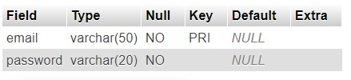

Table Name: member
Table Description: Stores the information about members.

Table 3.2 Members Database Table

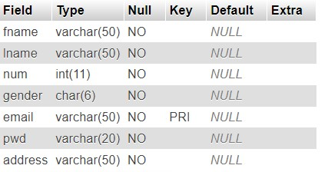

Table Name: slot
Table Description: It contains details about booked slots.

Table 3.3 Booked slot Details Database Table

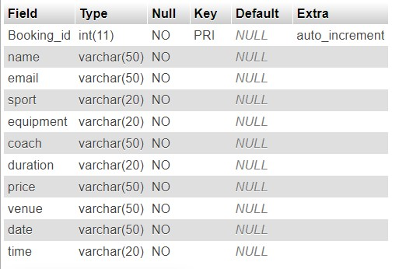

Table Name: feedback
Table Description: It contains details about booked slots.

Table 3.4 Feedback viewing Database Table

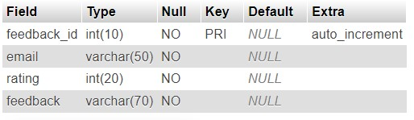

CHAPTER 4

Implementation
Implementation is the stage where the theoretical design is turned into a working system. The most crucial stage in achieving a new successful system and in giving confidence on the new system for the members that it will work efficiently and effectively.
The system can be implemented only after thorough testing is done and if it is found to work according to the specification.
It involves careful planning, investigation of the current system and its constraints on implementation, design of methods to achieve the changeover and an evaluation of change over methods a part from planning. Two major tasks of preparing the implementation are education and training of the members and testing of the system.
The more complex the system being implemented, the more involved will be the systems analysis and design effort required just for implementation. The implementation phase comprises of several activities. The required hardware and software acquisition is carried out. The system may require some software to be developed. For this, programs are written and tested. The member then changes over to his new fully tested system and the old system is discontinued.
4.1 Maintenance and Environment:
As the number of computer-based systems, increase libraries of computer software began to expand. In house developed projects produced tones of thousand software program source statements. Software products purchased from the outside added hundreds of thousands of new statements. A dark cloud appeared on the horizon. All of these programs, all of those source statements had to be corrected when errors were detected, modified as member requirements changed, or adapted to new hardware that was purchased. These activities were collectively called software Maintenance. The maintenance phase focuses on change that is associated with error correction, adaptations required as the software’s environment evolves, and changes due to enhancements brought about by changing customer requirements.

Four types of changes are encountered during the maintenance phase.
4.1.1 Correction:
Even with the best quality assurance activities is lightly that the customer will uncover defects in the software. Corrective maintenance changes the software to correct defects. Maintenance is a set of software Engineering activities that occur after software has been delivered to the customer and put into operation. Software configuration management is a set of tracking and control activities that began when a software project begins and terminates only when the software is taken out of the operation.
Only about 20 percent of all maintenance work are spent “fixing mistakes”. The remaining 80 percent are spent adapting existing systems to changes in their external environment, making enhancements requested by members, and re-engineering an application for use.
4.1.2 Adaption:
Over time, the original environment (E.G., CPU, operating system, business rules, external product characteristics) for which the software was developed is likely to change. Adaptive maintenance results in modification to the software to accommodate change to its external environment.
4.1.3 Enhancement:
As software is used, the customer/member will recognize additional functions that will provide benefit. Perceptive maintenance extends the software beyond its original function requirements.
4.1.4 Prevention:
Computer software deteriorates due to change, and because of this, preventive maintenance, often called software reengineering, must be conducted to enable the software to serve the needs of its end members. In essence, preventive maintenance makes changes to computer programs so that they can be more easily corrected, adapted, and enhanced. Software configuration management (SCM) is an umbrella activity that is applied throughout the software process.

CHAPTER 5

Overview of Tools and Technologies Used
5.1 Tools Used:
Below is the list of tools used:

5.1.1 Brackets:

Quick edit enables inline editing of CSS, Colour Property, and JavaScript elements for developers. This built-in feature can be applied to multiple functions or properties simultaneously and all updates are applied directly to the file associated with the changed elements.
HTML file:
Applying quick edit to HTML elements will display all corresponding CSS properties in a box beneath the selected element. Members can choose to create new CSS rules directly within the editor and edit a tag’s CSS properties inline without leaving the context of the HTML file.
JavaScript file:
On JavaScript functions, quick edit performs the same procedure as with HTML elements, but it displays the selected function’s body within the drop-down box. All updates to the function’s body will propagate and update directly within the corresponding JavaScript file. Files containing hex or RGB colour properties. For colour properties, quick edit will return an inline colour picker for previewing and colour adjustment functionality.

5.2 Languages Used:
5.2.1 About Python:

Python is a high-level, versatile, and widely-used programming language known for its simplicity, readability, and extensive standard library.[4] Here are a few key descriptions of Python:

- General-purpose: Python is a general-purpose programming language, which means it can be used for a wide range of applications, including web development, data analysis, scientific computing, artificial intelligence, machine learning, automation, and more.

- Readability: Python's syntax is designed to be easily readable and straightforward, making it an excellent choice for both beginners and experienced developers. Its use of indentation to define code blocks (instead of curly braces or keywords) enforces clean and readable code.

- Interpreted Language: Python is an interpreted language, which means that you don't need to compile your code before running it. This makes development and debugging more accessible and faster.

- Cross-Platform: Python is available on multiple platforms, including Windows, macOS, and various Unix-like operating systems, making it highly portable.

- Large Standard Library: Python comes with a comprehensive standard library that provides modules and functions for various tasks, such as file handling, network communication, regular expressions, and more. This library reduces the need for developers to write code from scratch and enhances productivity.

5.2.2 About HTML:
HTML, which stands for Hyper Text Markup Language, is the predominant markup language for web pages. It provides a means to create structured documents by denoting structural semantics for text such as headings, paragraphs, lists etc as well as for links, quotes, and other items. It allows images and objects to be embedded and can be used to create interactive forms
It is written in the form of HTML elements consisting of “tags” surrounded by angle brackets within the web page content. [3] It can include or can load scripts in languages such as JavaScript which affect the behaviour of HTML processors like Web browsers; and Cascading Style Sheets (CSS) to define the appearance and layout of text and other material. The W3C, maintainer of both HTML and CSS standards, encourages the use of CSS over explicit presentational markup.
Hyper Text Markup Language (HTML) is the encoding scheme used to create and format a web document. A member need not be an expert programmer to make use of HTML for creating hypertext documents that can be put on the internet. Most graphical e-mail clients allow the use of a subset of HTML (often ill-defined) to provide formatting and semantic markup not available with plain text. This may include typographic information like coloured headings, emphasized and quoted text, inline images and diagrams. Many such clients includes both a GUI editor for composing
HTML e-mail messages and a rendering engine for displaying them. Use of HTML in e mail is controversial because of compatibility issues, because it can help disguise phishing attacks, because it can confuse spam filters and because the message size is larger than plain text.

5.2.3 About MYSQL:
There are a large number of database management systems currently available, some commercial and some free. Some of them: Oracle, Microsoft Access, MySQL and PostgreSQL. These database systems are powerful, feature rich software, capable of organizing and searching millions of records at very high speeds. Understanding Databases, Records, and Primary Keys Every Database is composed of one or more tables.[5] These Tables, which structure data into rows and columns, Impose organization on the data. The records in a table (below) are not arranged in any particular order. To make it easy to identify a specific record, therefore, it becomes necessary standing Relationships and Foreign Keys (RDBMS) You already know that a single database can hold multiple tables. In a Relational database management system (RDBMS), these tables can be linked to each other by one or more common fields, called foreign keys.
Database administrator is the super member of database; he/she has unrestricted rights and privileges to access database, grant permission to other database members.
5.2.4 About JavaScript:
- JavaScript is very easy to implement. All you need to do is put your code in the
HTML document and tell the browser that it is JavaScript.[7]
- JavaScript works on web member’s computers — even when they are offline.
JavaScript allows you to create highly responsive interfaces that improve the member experience and provide dynamic functionality, without having to wait for the server to react and show another page.
- JavaScript can load content into the document if and when the member needs it, without reloading the entire page — this is commonly referred to as Ajax.
- JavaScript can help fix browser problems or patch holes in browser support — for example fixing CSS layout issues in certain browsers. That is a lot for a language that until recently was laughed at by programmers favouring “higher programming languages”. One part of the renaissance of JavaScript is that we are building more and more complex web applications these days, and high interactivity either requires Flash (or other plug-in) or scripting. JavaScript is arguably the best way to go, as it is a web standard, it is supported natively across browsers (more or less — some things differ across browsers, and these differences are discussed in appropriate places in the articles that follow this one), and it is compatible with other open web standards.

5.2.5 Bootstrap:
Bootstrap is a free open-source development framework for the creation of websites and web apps. The Bootstrap framework is built on HTML, CSS, and JavaScript (JS) to facilitate the development of responsive, mobile-first sites and apps. Responsive design makes it possible for a web page or app to detect the visitor's screen size and orientation and automatically adapt the display accordingly; the mobile-first approach assumes that smart phones, tablets, and task specific mobile apps are employees' primary tools for getting work done and addresses the requirements of those technologies in design.
Bootstrap includes member interface components, layouts, and JS tools along with the framework for implementation. The software was formerly known as Twitter Blueprint and is sometimes referred to as Twitter Bootstrap.

5.2.6 Django:
Django is a high-level, open-source web framework that is built on top of python. It was first released in 2005 and is maintained by the Django Software Foundation.[8] Django provides developers with a set of tools and libraries that simplify the process of building wed applications.
Here are some key features of Django:
1. Admin interface: Django provides a built- in admin interface that allows developers to manage the content of their web applications. The admin interface is customizable and provides a wide range of features such as filtering, search, and sorting.
2.URL routing: Django provides a powerful URL routing system that allows developers to map
URLs to views. This makes it easy to create clean and user-friendly URLs for web applications.

CHAPTER 6

Testing

Introduction:
Testing is a process of executing a program with the intent of finding an error. Testing is a crucial element of software quality assurance and presents ultimate review of specification, design and coding. System Testing is an important phase.[10] Testing represents an interesting anomaly for the software. Thus, a series of testing are performed for the proposed system before the system is ready for member acceptance testing. A good test case is one that has a high probability of finding an as undiscovered error. A successful test is one that uncovers an as undiscovered error.
Testing is a process, which reveals errors in the program. It is the major quality measure employed during software development.[11] During testing, the program is executed with a set of conditions known as test cases and the output is evaluated to determine whether the program is performing as expected. Software testing is the process of testing the functionality and correctness of software by running it. Process of executing a program with the intent of finding an error. Verification:
Verification is the process to make sure that product satisfies the conditions imposed at the tester of the development phase. In other words, to make sure the product behaves the way we want it to. Validation:
Validation is the process to make sure the product satisfies the specified requirements at the end of the development phase. In other words, to make sure the product is built as per customer requirements. Testing
6.1 Testing Member Login Page:
- Figure 6.1 represents “Member Login Failed” when he enters the wrong password.
The expected output is to show “Invalid login details”.
- Figure 6.2 shows “Successful Login of member”.


Figure 6.1 Screenshot of Member login failed

Figure 6.1 shows attempting login by leaving username, password fields empty. The expected output is to show “Invalid login details”. Similarly, shows trying to login with username and leaving the password empty. The expected output is to show “Invalid login details”.
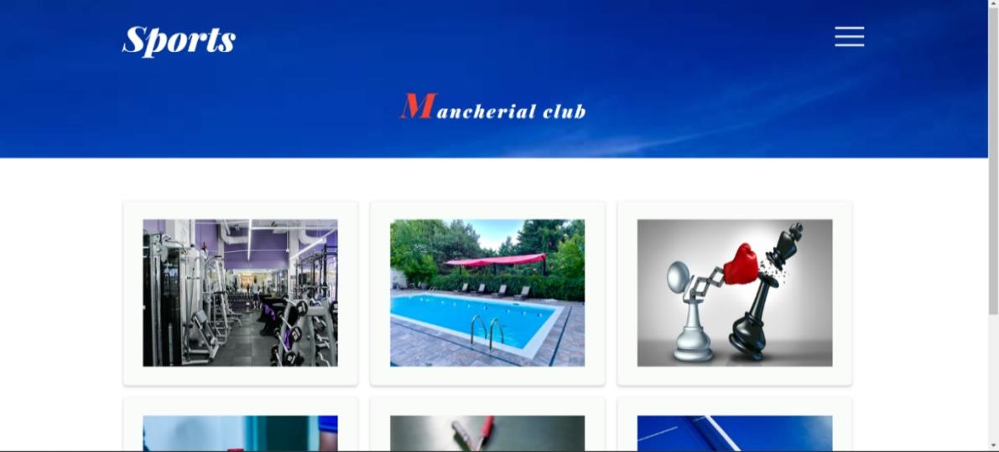

Figure 6.2 Screenshot of Member login successful

Figure 6.2 shows trying to login with username and password. The expected output is showing if username and password are valid.
Test  No | Data  Input | Expected  Output | Actual  Output | Pass/Fail
1 | All empty fields | Please fill out this field | Please fill out this field | Pass
2 | Username and leaving password empty | Please fill out this field | Please fill out this field | Pass
3 | Correct username and password | Successful login | Successful login | Pass
4 | Incorrect password | Invalid login details | Invalid login details | Pass

6.2 Test Strategy:
Field-testing is performed manually, and functional testing is written in detail.
Test Objectives
- All field entries must work properly.
- Pages must be activated from the identified link.
- The entry screen, messages and responses must not be delayed.
- Features to be tested
5.Verify that entries are in correct format.
6.No duplicate entries should be allowed.
7.All links should take the member to the correct page.

6.3 Black Box Testing:
The base of the black box testing strategy lies in the selection of appropriate data as per functionality and testing it against the functional specifications in order to check for normal and abnormal behaviour of the system. Now a days, it is becoming to route the testing work to a third party as the developer of the system knows too much of the internal logic and coding of the system which makes it unfit to rest application by the developer.

Advantages of Black Box Testing
- Used to verify contradictions in actual system and specifications.
- Test cases can be designed as soon as the functional specifications are complete.
- Well suited and No need of technical knowledge.
- Efficient for large code segments.
- There is no need for the tester to have detailed functional knowledge of the system.

Disadvantages of Black Box Testing
- The test input needs to be from a large sample space.
- Chances of having unidentified paths during this testing.
- Test cases are challenging to design without having clear functional specifications.
- It is a high probability of repeating tests already performed by the programmer.
- There are chances of having unidentified paths during the testing process.
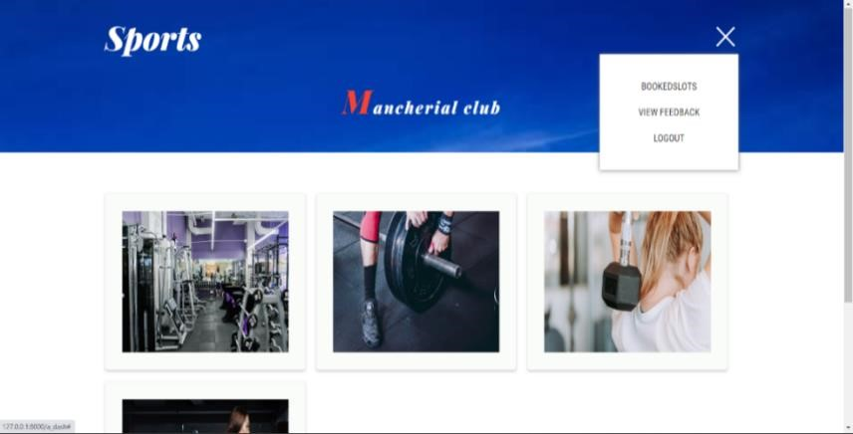

Figure 6.
3

Screenshot of
Admin

Login Successful

6.4 White Box Testing:
White box testing requires access to source code. Though white box testing can be performed any time in the life cycle after the code is developed, it is a good practice to perform white box testing during unit testing phase.
In designing of database, the flow of specific inputs through the code, expected output and the functionality of conditional loops are tested.
- Guarantee that all independent paths have been executed.
- Executed all logical decisions on their true and false sides.
- Executed all loops at their boundaries and within their operational bounds.
- Executed internal data structures to ensure their validity.

Advantages of White Box Testing
- Testing can commence even before the GUI is ready.
- Code optimization by finding hidden errors.
- White box test cases can be easily automated.
- It can provide stability and usability of the test cases.
- Testing can start early in SDLC even if GUI is not available. Testing is more thorough as all code paths are usually covered.

Disadvantages of White Box Testing
- White box testing can be quite complex and expensive.
- It identifies errors in the hidden code and thus makes the debugging process swift.
- White-box testing is time-consuming, bigger programming applications take the time to test fully.

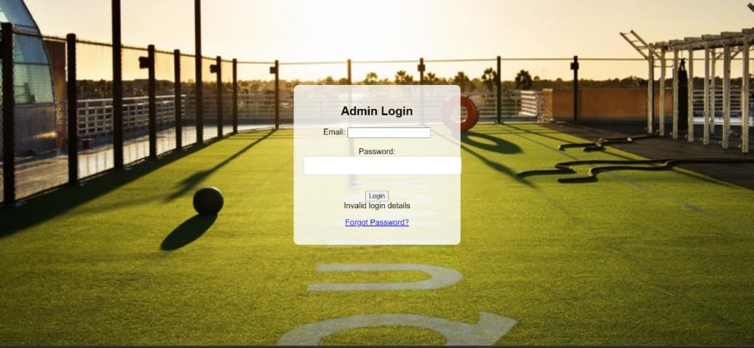
  - Screenshot of Admin login Failed
  - Database Testing:
This test involves testing whether the values entered through the form gets stored and saved in the database correctly or not.
Figure 6.5 shows that entered details are stored correctly in the database.

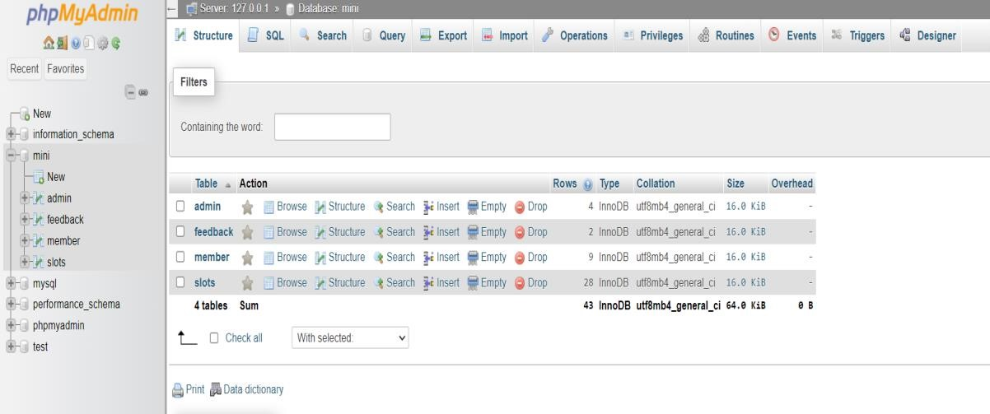

Figure 6.5 Database Testing

6.6 Performance Testing:
The performance of the application can be tested through this test. Since the number of codes is less, performance is good. The below figure 6.6 shows the performance testing of the code.

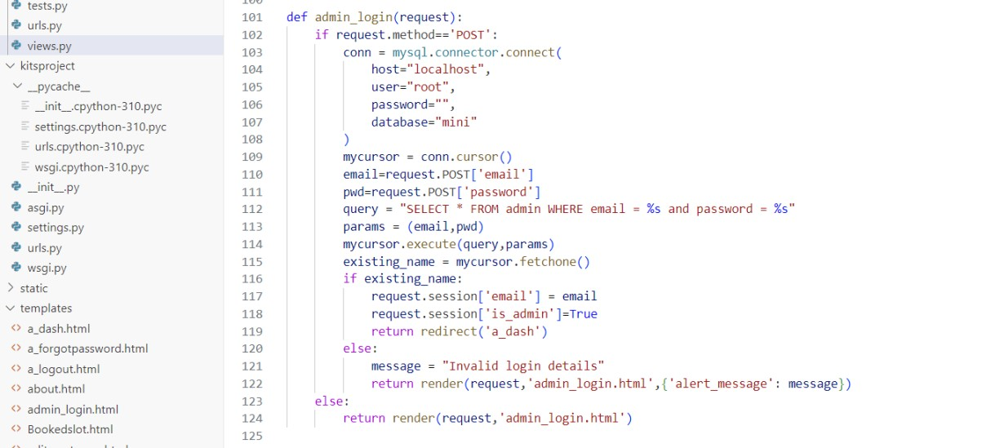 Figure 6.6 Performance Testing

6.7 Test Results

Test cases are done on every page on this website. All the test cases are passed successfully. No defects were encountered.

CHAPTER 7 Results

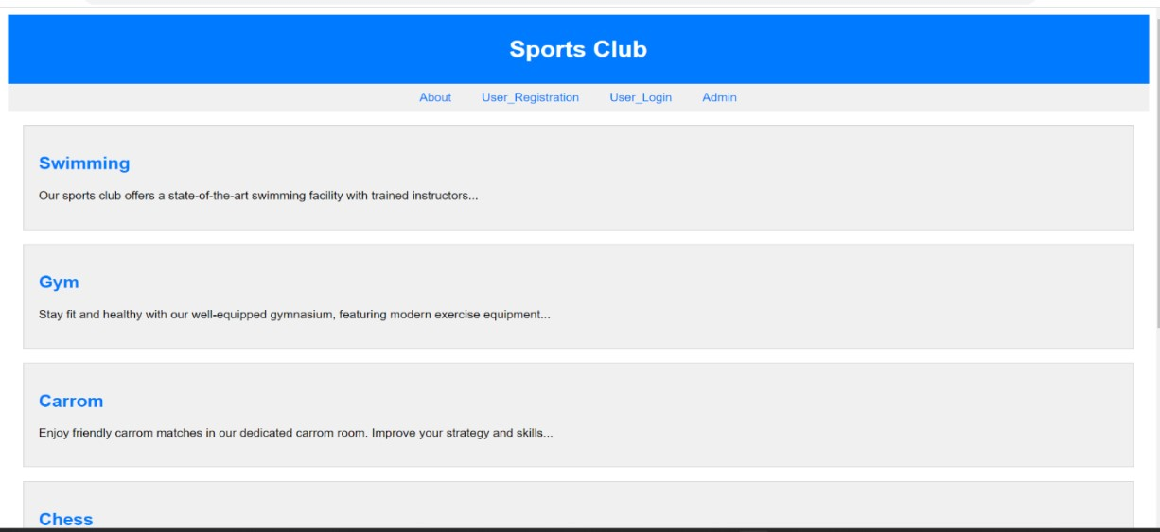

7.1

Home

Page

:

7.1 Screenshot of Home Page
The figure 7.1 is the Home Page of the website from where the member can move to about page in which he/she can get idea regarding the website and also register, login to the site. This page is also containing admin login option by which admin can login and use his services.

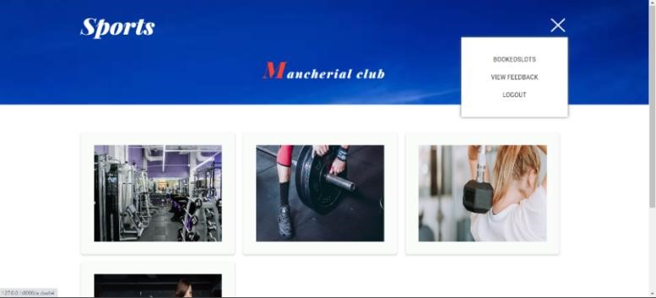
Admin Pages
7.2

Admin D
ash board
Page:

7.
2

Screenshot of
Admin

Dash board Page

The figure 7.2 is the Admin Dash board page from where he can access the services such as viewing the booked slots and viewing the feedbacks which are given by the members.
Admin Viewing slots Details:

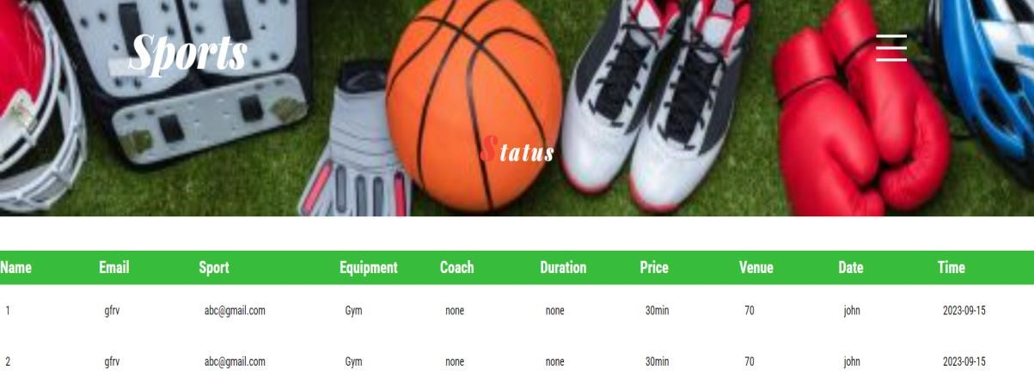

Figure 7.3 Screenshot of Admin Viewing Slots Details
The figure 7.3 is about Admin Viewing Slots Details where admin can view every information about the slot booked by the member such as sport, duration, date, time etc...

Admin viewing feedbacks:
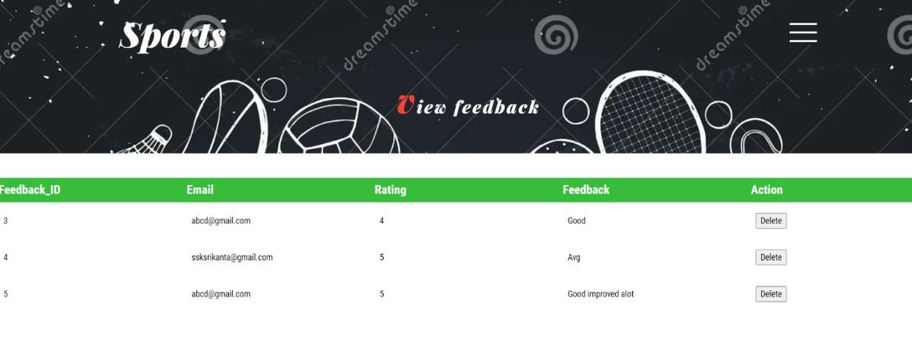

Figure 7.4 Screenshot of Admin viewing feedbacks
The figure 7.4 is the admin viewing feedbacks page. Here the admin of the site will be able to see the feedbacks which are given by members and the admin can also be able to delete the negative feedbacks if any.

7.3 Member Pages

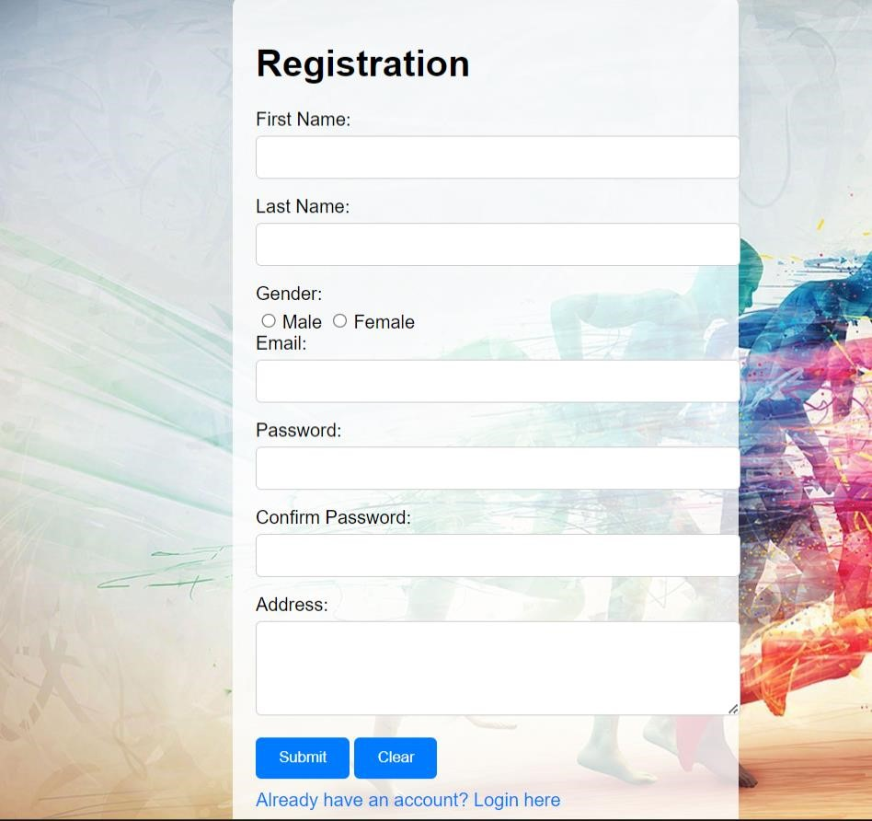

Figure 7.5 Screenshot of Member Registration page

The above figure 7.5 displays the Member Registration Form where the details like name, Email, password, address can be entered and sign up. After this Member can simply login to the website by email and password.

Member Registration Form with filled details:



Figure 7.6 Screenshot of Registration Form with filled details

The above figure 7.6 displays the Member Registration Form with filled details. Here our member is Harshitha who filled all her details and ready to register.
Member Login page:


Figure 7.7 Screenshot of Member Login page
The above figure 7.7 is the Member Login Form. Here, the member is supposed to provide his email and password so that he can access the further services. It also provides the service for forgot password where it directs to other page whenever the member forgets his password.
Member dash board:
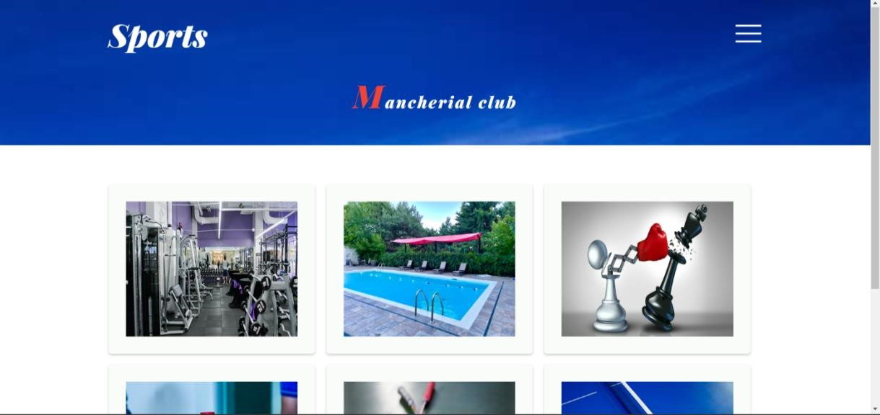

Figure 7.
8

Screenshot of
Member dash board

The above figure 7.8 shows the Member dash board after he/she logins into the site. This page opens only when the member is verified. This page provides services to access his profile page, book/view slot and also it provides the service of giving feedback.

7.3.5 Member Profile page
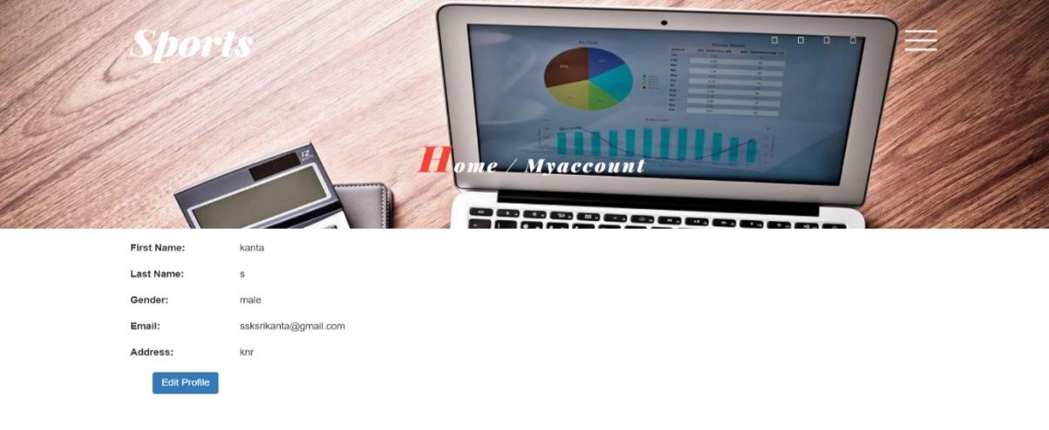
Figure 7.9 Screenshot of Member Profile Page
The above figure 7.9 is the Profile page of member. Where, he can see the details provided during the registration and he can also update his details.

7.4 Contact Page:
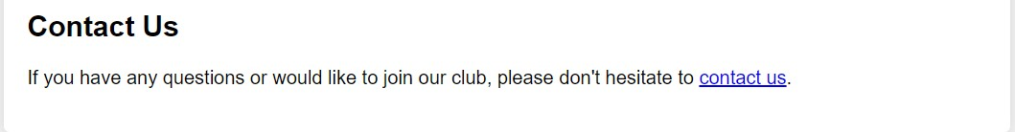

Figure 7.
10

screenshot of
Contact Page

The above figure 7.10 is the Contact Page of the website. Here, the contact details of the Sports Club Admin are displayed. They include Email id of admin.

7.5 Slot Booking page:

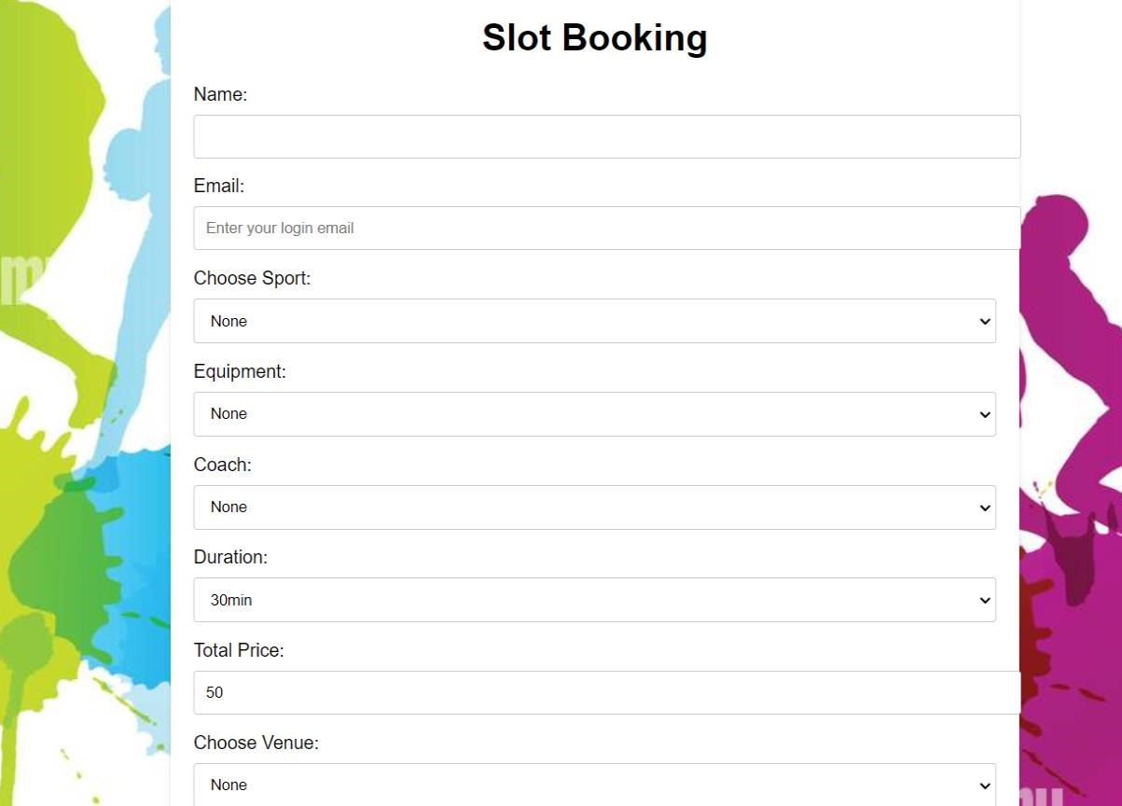

Figure 7.11 Screenshot of Slot Booking Page

The above figure 7.11 is Slot booking Page of the website. where the member can book his slot and where can also select the sport, equipment’s if any, coach and time duration. He can also choose venue for the sport from this page.

7.6 Member viewing booked slot Page:

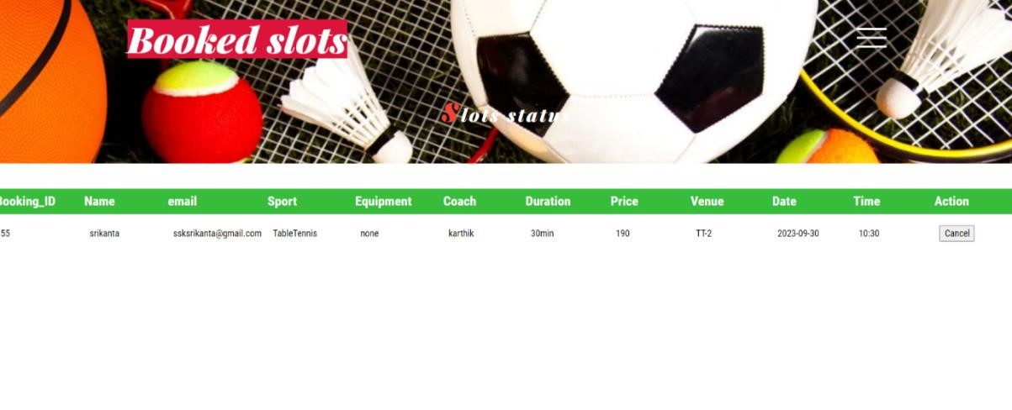

Figure 7.12 Screenshot of Member viewing booked slot Page

The above figure 7.12 is the Member viewing booked slot page. Members of the club can view their recently booked or previously booked slots in this Page. There is also a feature of cancelling their slot.

7.7 Member Feedback page

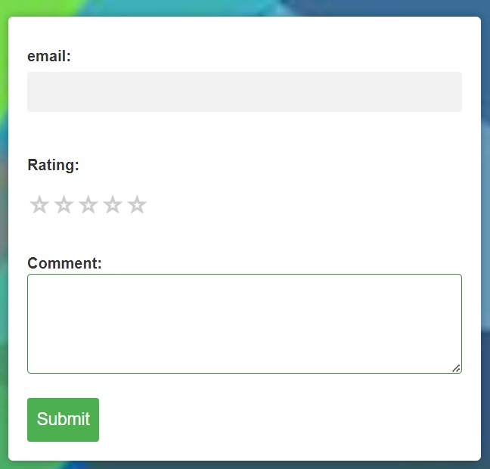

Figure 7.13 Screenshot of Member Feedback Page

The figure 7.13 is the Form of Member giving the Feedback. He can give his feedback on services provided in the sports club.
CHAPTER 8

Conclusion and Future Enhancement

8.1 Conclusion:
The project we have developed is a web application for SPORTS CLUB. This application helps in maintaining the details of members and their slot details. The applications give solutions to most of the problems that were identified when performing the tasks like maintaining the data manually. Handling the data manually may not have the data security, and may have the data redundancy which can be overcome by this automation developed by us. The application that is going to be handed over to the admin where he can manage the data regarding slots and feedback. This application can be viewed by the member where they book slot through online. That will reduce the manual work of a member. Those features of introducing the system will call upon the problems that we have encountered from the current system that exists in the SPORTS CLUB now to make the tasks done at that organization comfortably and much more efficiently.

8.2 Future Enhancement:

To add online payment:

In the current project, we have only added the option of slot booking, further payment
gateways can be added to the project. Further, court reservation can be included to the website.

To display slots:
In this current project, we have only option of booking the slots, further we can also display the slots on screen so that member can easily identify the slots which are free and can book those slots accordingly.

To add memberships:

In this current project, we have only had the option of booking slots and further in this project we can also add the membership (monthly, yearly), so that the members of the club can take memberships.

CHAPTER 9

Bibliography:
[1]. Applying UML and patterns: An Introduction to object-oriented Analysis and Design by Craig Larman; PHI; Third Edition; ISBN-10:0131489062, ISBN-13:978-0131489066.

[2]. Database Modelling and Design, by Toby J. Teorey, Sam S. Lightstone, Tom Nadeau;5th Edition; Morgan Kaufmann; ISBN-10:0123820200, ISBN-13:978-0123820204.

[3]. HTML & CSS: The Complete Reference, Fifth Edition: ISBN-10: 0071496297, ISBN-
13: 978-0071496292

[4]. Python Crash Course: A Hands-On, Project-Based Introduction to Programming by Eric
Matthes 2nd Edition; ISBN-10 680505422, ISBN-13 978-1680505422

[5]. Database Design using Entity-Relationship Diagrams by Richard Earp;2nd Edition, April 16,2007; Auerbach Publications; ISBN-10:1439861765, ISBN-13:978-1439861769.

[6]. Head First CSS3 and Web Standards by Eric Freeman and Elisabeth Robson, 3rd Edition; ISBN-10: 0598409442, ISBN-13: 978-0598409442.

[7]. Eloquent JavaScript: A Modern Approach by Marijn Haverbeke: 3rd Edition: ISBN-10
9781633439300, ISBN-13 1633439300

[8]. Django 4.0 Web Development Cookbook by Andrei Neagoie; Third Edition; ISBN-10 9781617295603, ISBN-13 1617295603.

[9]. Structured systems Analysis and Design: Data flow Approach, by V.B Kaujalgi, 2ndEdition; Orient Black swan; ISBN-10:0863113230, ISBN-13:978-0863113239.

[10]. Black Box and White Box Testing Techniques by Boris Beizer; 3rd Edition; ISBN-10
9780471508530

[11]. Software Testing concepts and Tools, by Nageshwar Rao Pusuluri; 2nd Edition; Dream tech press; ISBN-10:8177227122.

