PROJECT REPORT

RENTzen

NAME : TEJAS SHARMA
REG. NO. : 25BAI10335
COURSE NAME : BTECH [ AI / ML ]
FACULTY NAME: DR. SANDEEP MONGA
DATE OF SUBMISSION: 15/09/2026

1. Introduction
Rentzen is a Java-based peer-to-peer device rental marketplace that connects people who want to rent devices with individuals who want to rent out their own equipment. Users can browse available devices, list their own devices, manage rentals, track earnings, and complete returns through a simple and user-friendly interface. The platform supports Owner, Renter, and Owner & Renter account types with role-based access to features.
The project is developed using Java and Java Swing, focusing on object-oriented programming, rolebased access control, and clear user workflows. Rentzen provides a convenient way to access devices for short-term use while allowing owners to earn from unused equipment. Future enhancements can include database integration, online payments, ratings and reviews, image uploads, location-based search, and advanced availability management.

2. Problem Statement
- People need expensive devices for short-term use without purchasing them.
- Device owners have unused equipment that could generate extra income.
- Users lack a simple platform to find and rent devices from others.
- Managing listings, rentals, confirmations, and returns can be difficult manually.

3. Functional Requirements

a. User Account Management
- The system shall allow users to select an account type such as Renter, Owner, or Owner & Renter.
- The system shall allow users to log in using their account details.
- The system shall provide role-based access to features according to the selected account type.

b. Device Listing Management
- The system shall allow owners to add their devices with details such as name, category, price, and availability.
- The system shall allow owners to view and manage their listed devices.
- The system shall display listed devices on the marketplace for other users to discover.

c. Device Browsing and Rental
- The system shall allow renters to search and browse available devices.
- The system shall allow renters to view device details and rental information.
- The system shall allow renters to select and confirm a rental for an available device.

d. Rental and Return Management
- The system shall allow users to view their active and previous rental records.
- The system shall update the device status when a rental is confirmed.
- The system shall allow renters to mark a rented device as returned and update its availability.

e. Dashboard / Summary

The system shall display available devices, active rentals, listings, and earnings based on the user's

account type.
- The system shall display clear confirmation messages for actions such as device listing, rental
confirmation, and return completion.
- The system shall provide quick access to major features such as Find Devices, My Listings, My Rentals,
Earnings, and Saved Devices.

4. NON FUNCTIONAL REQUIREMENTS

a. Performance
- The system shall respond to user actions within 1–2 seconds.
- Device listings and rental records should load within 3 seconds. b. Usability
- The interface shall be simple, clear, and easy to use.
- The system should provide clear navigation for browsing devices, listing devices, and managing rentals.
- Error and confirmation messages shall be clear and user-friendly. c. Reliability
- The system shall maintain rental, listing, and user data without unexpected data loss during normal operation.
- The system shall handle incorrect or incomplete user inputs safely. d. Security
- The system shall restrict features according to the user's account type and role.
- User information and rental details shall not be accessible through unauthorized features. e. Scalability
- The system should support multiple users, devices, and rental records.
- The system should handle increasing numbers of device listings and rental transactions without significant performance degradation.

5. System Architecture

The application follows a three-tier architecture :

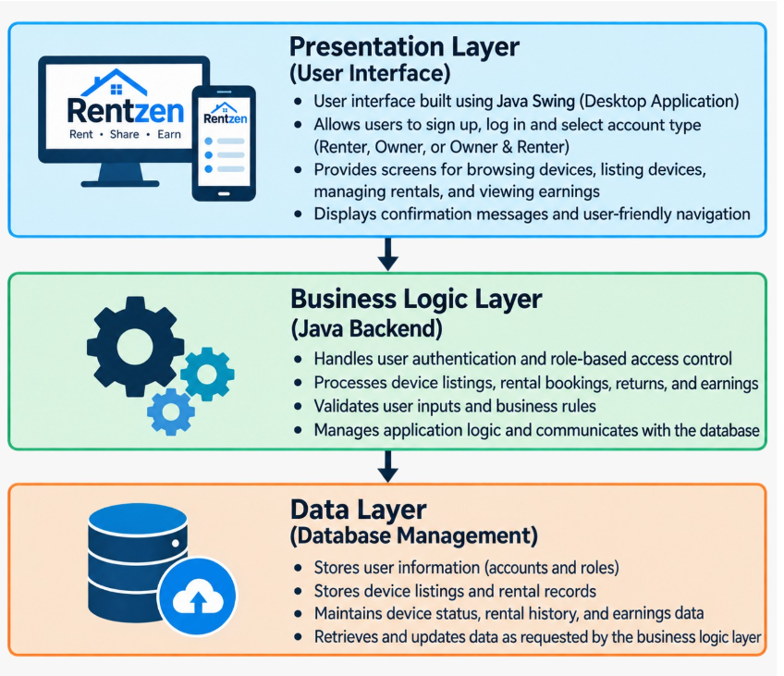

6. Design Diagram
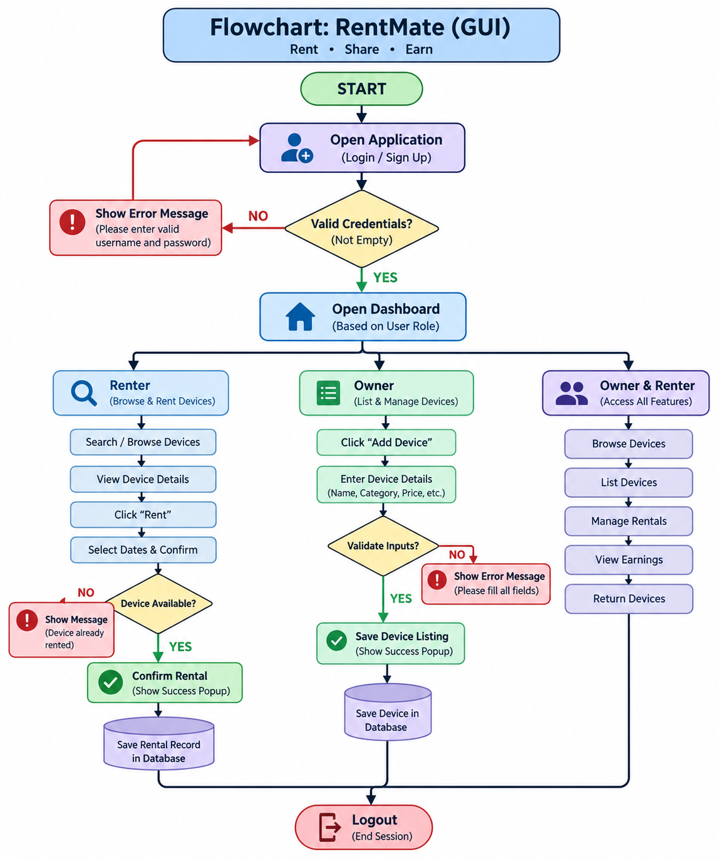

7. Features and Functionality

Core Features

1. User Management
- User login with account type selection.
- Support for Renter, Owner, and Owner & Renter accounts.
- Role-based access to marketplace features.
- User profile and account information management.

2. Device Listing Management
- Add personal devices for rental.
- Enter device details such as name, category, price, and availability.
- View and manage listed devices.
- Make listed devices available for other users to rent.

3. Rental Management
- Browse and search available devices.
- View device details and rental information.
- Confirm rentals for available devices.
- View active and previous rental records.
- Mark rented devices as returned.

4. Earnings and Rental Tracking
- View rental-related earnings for listed devices.
- Track completed and ongoing rentals.
- Display rental status such as Available, Rented, Confirmed, Pending, and Returned.
- Maintain rental history for users.

5. Dashboard
- Overview of available devices and personal listings.
- Quick access to major marketplace features.
- Display active and previous rentals.
- Provide quick actions for browsing, listing, renting, and managing devices.

Additional Features
- Search and Filter: Search devices based on name, category, price, and availability.
- Saved Devices: Save devices for quick access later.
- Role-Based Access: Show features according to the selected account type.
- Rental Confirmation: Display a clear confirmation message with rental details and rental ID.
- Return Management: Allow renters to complete the return process and make the device available again.
- User-Friendly Alerts: Display clear success and error messages for important actions.

8. Implementation Details

1. Login / Account Type Screen
- Simple login form.
- Account type selection.
- Role-based access to RentZen features.

2. Dashboard
- Marketplace overview.
- Quick action buttons.
- Summary of listings and rentals.
- Easy navigation to major features.

3. Find Devices Screen
- Searchable device listing.
- Device name, category, price, owner, and availability.
- Rent or View Device action based on account type.

4. My Listings Screen
- Display devices listed by the current owner.
- Add new device listing.
- View listing details and availability status.

5. My Rentals Screen
- Display current user's rental records.
- Rental ID, device, owner, dates, amount, and status.
- Mark Selected Rental Returned option.

6. Earnings / Saved Devices Screen
- View rental earnings from listed devices.
- Access saved devices for future rental.
- Provide quick access to frequently used marketplace features.

Design Principles
- Minimalist: Clean and uncluttered interface.
- Intuitive: Simple navigation with clearly labelled buttons and sections.
- User-Friendly: Clear forms, confirmation messages, and error handling.
- Role-Based: Different features are displayed according to the user's account type.
- Consistent: Common layout, buttons, cards, and navigation throughout the application.

9. Screenshot-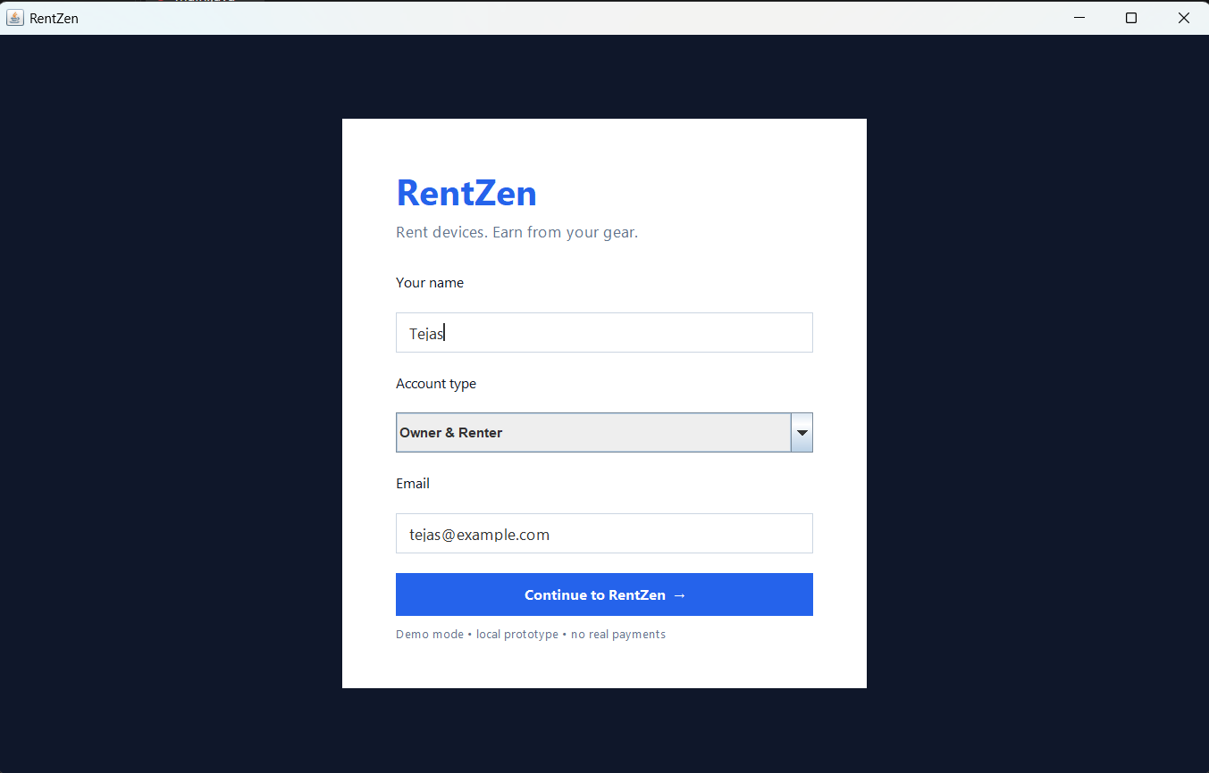
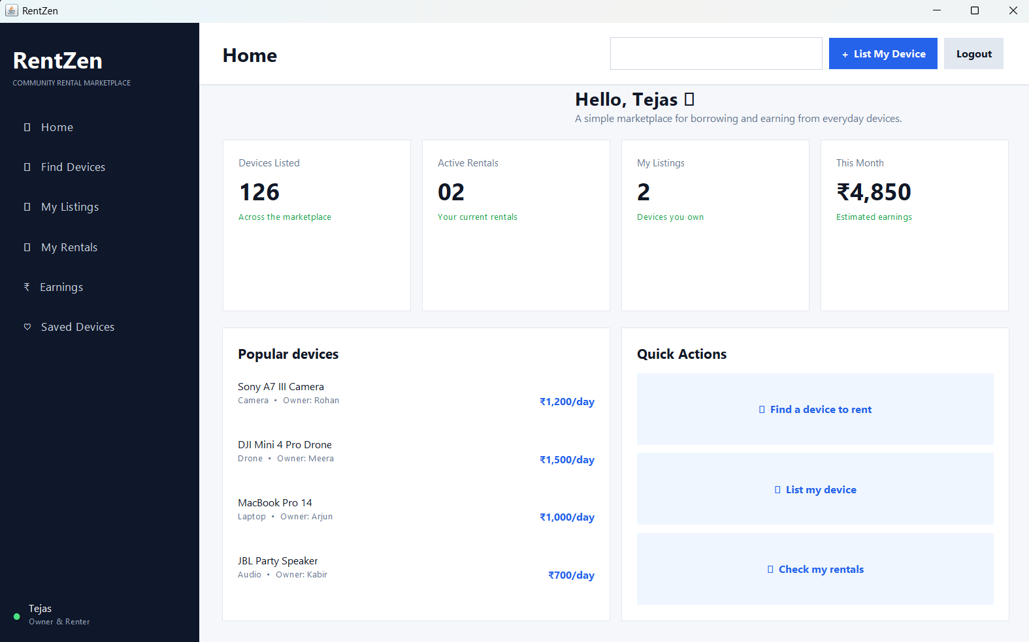
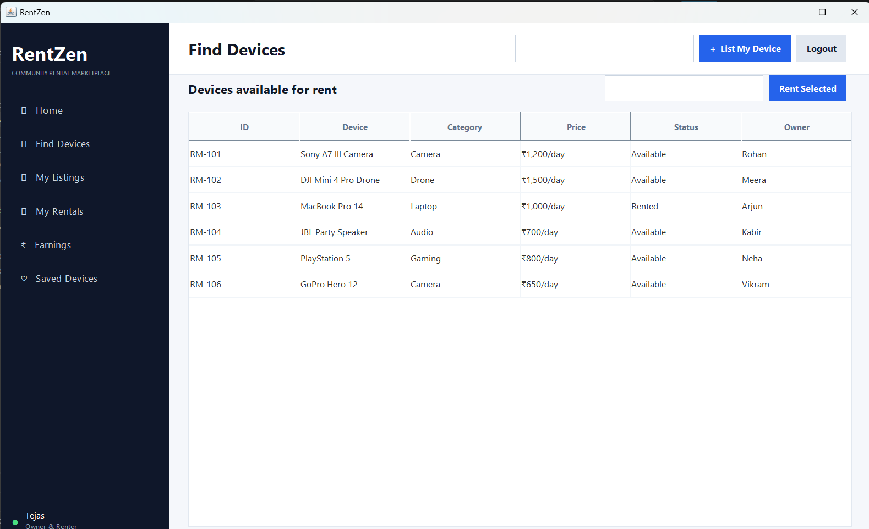
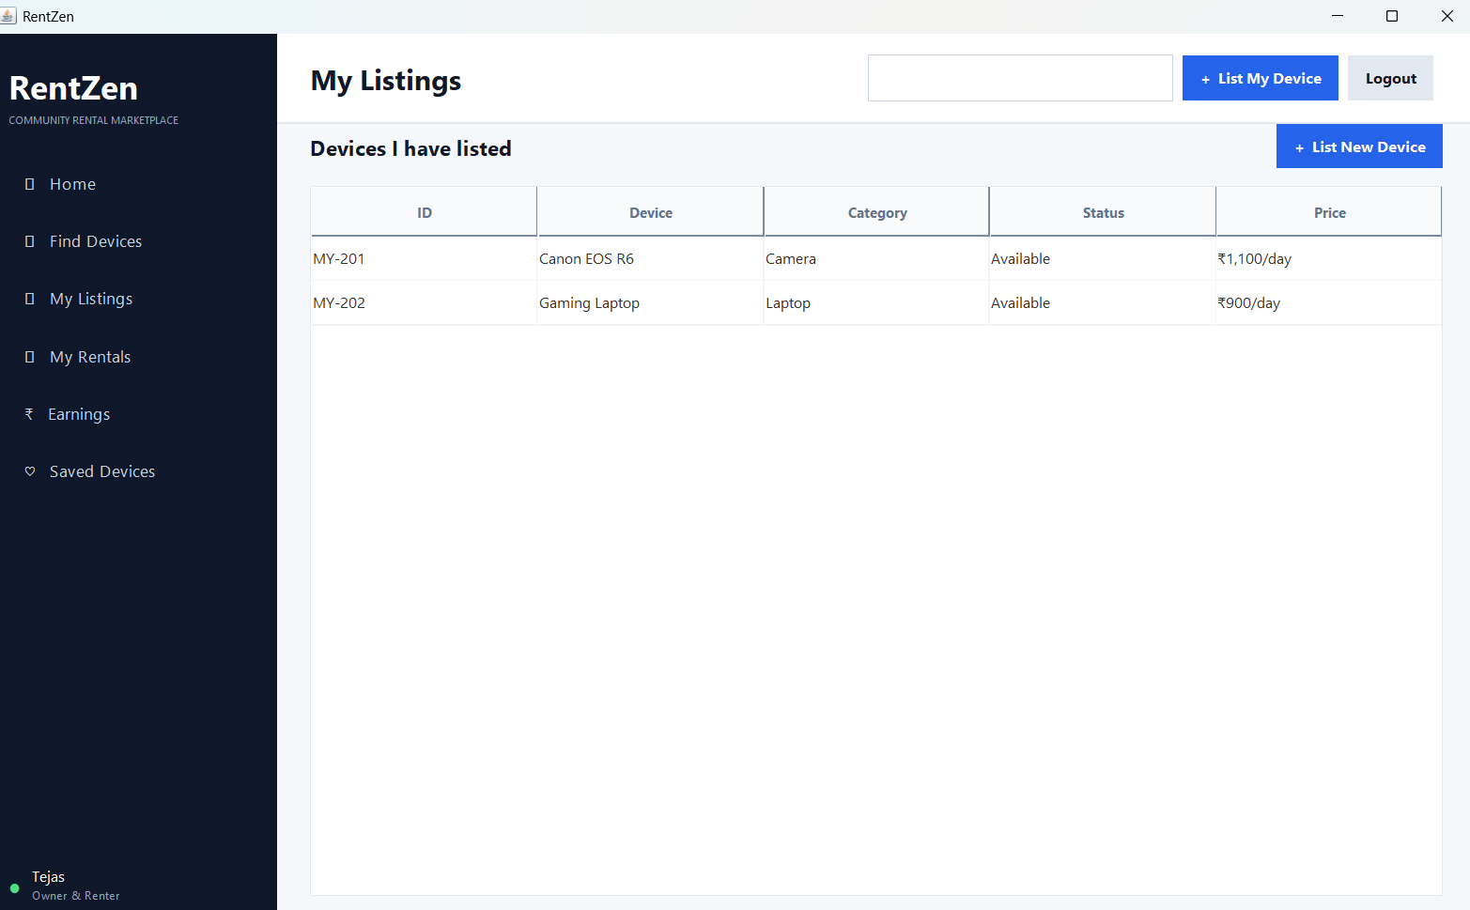
10. TestingApproach 1. Unit Testing
• Test individual methods such as device listing, rental confirmation, and return processing.
2. Integration Testing
• Test interaction between user actions, device listings, rental records, and application logic.

3. Functional Testing
• Test complete workflows such as login, browsing, listing a device, renting a device, and returning a device.
4. User Interface Testing
• Verify buttons, navigation, tables, forms, confirmation messages, and error messages work correctly.
11. Challenges Faced
- Designing a simple and user-friendly rental interface.
- Implementing role-based access for different users.
- Managing device availability and rental status.
- Handling invalid inputs and rental conditions.
- Testing different user flows and fixing interface issues.

12. Learnings & Key Takeaways
- Learned practical Java and Object-Oriented Programming concepts.
- Gained experience in Java Swing GUI development.
- Understood role-based access control and rental management.
- Improved skills in Git, GitHub, testing, and project documentation.
- Learned how to design a simple, user-friendly software workflow.

13. Future Enhancements
- Database Integration: Store users, devices, and rental records in MySQL or another database.
- Online Payment: Add secure payment processing for rental transactions.
- Image Upload: Allow owners to upload images of their devices.
- Ratings and Reviews: Allow renters to review devices and owners.
- Advanced Availability: Support date-based availability and prevent overlapping rentals.
- Notifications: Add rental reminders and booking/return notifications.

14. Conclusion
RentZen successfully addresses the need for a convenient peer-to-peer device rental platform. The application allows users to list their own devices, discover equipment from other users, manage rentals, track earnings, and complete returns through a simple and user-friendly Java GUI.

15. References
- Java Documentation – Oracle
- Java Swing Documentation – Oracle
- Git & GitHub Documentation
- VITyarthi Project Guidelines

