Lab 1: Requirements Engineering & UML Use-Case Modelling – Academic Elective Bidding & Allocation System

1. Requirements Table
Problem Statement #05 | Actors: Student, Academic Registrar
Req ID | Type | Description | Priority | Acceptance Criteria | Rationale
FR-001 | Functional | The system shall allow students to distribute 100 bidding credits across their ranked elective preferences and validate prerequisite course completions. | High | Pass: Credits deduct accurately and prerequisites validated. Fail: Total allocated credits exceed 100 or unmet prerequisites bypassed. | Core mechanism for fair, preference-based seat allocation; prevents invalid bids from entering the allocation pool.
FR-002 | Functional | The system shall allow the Academic Registrar to configure the bidding window (open and close date/time) and seat capacity for each elective course. | High | Pass: Bids submitted before open or after close are rejected, and allocated seats per course never exceed configured capacity. Fail: any bid accepted outside the window or any course over-allocated. | Administrative control is required to run multiple bidding cycles and prevent late or invalid submissions.
FR-003 | Functional | The system shall detect and prevent timetable collisions so that no student is allocated two electives with overlapping time slots. | High | Pass: 0% of finalized allocations contain overlapping time slots for any student, verified across all test allocations. Fail: any student's final schedule contains an overlap. | Collision-free allocation is the core value proposition distinguishing this system from manual registration.
FR-004 | Functional | The system shall notify each student of their final elective allocation result via email and the student portal within 24 hours of the bidding window closing. | Medium | Pass: 100% of students have a notification logged (email + portal) within 24 hours of window close. Fail: any student without a logged notification in that window. | Timely notification reduces registrar helpdesk queries and lets students plan add/drop actions promptly.
FR-005 | Functional | The system shall allow a student to submit a withdrawal or swap request for an allocated elective before the add/drop deadline, subject to Academic Registrar approval. | Medium | Pass: Swap/withdrawal request is recorded and the seat is released or updated only after explicit Registrar approval and before the deadline. Fail: seat changes without approval, or a request is accepted after the deadline. | Gives students flexibility for genuine scheduling conflicts while keeping the Registrar as approval authority.
NFR-001 | Nonfunctional – Performance & Security | The final elective allocation solver shall process 5,000 student bids and resolve schedule conflicts in under 30 seconds. | High | Pass: Benchmarking tests confirm target latency and security standards under simulated peak load. Fail: solver exceeds 30 seconds or security checks fail under the same test. | Allocation runs once per cycle for the whole university; solver speed and security determine whether results publish on schedule.
NFR-002 | Nonfunctional – Reliability & Scalability | The system shall remain available with at least 99.5% uptime during each bidding window and support at least 500 concurrent students submitting bids without failure. | High | Pass: Load testing shows ≤ 1% request error rate at 500 concurrent users, and uptime logs show ≥ 99.5% availability across the bidding window. Fail: error rate exceeds 1% under load or uptime drops below 99.5%. | Bidding windows are short and high-traffic (all students bid within a few days); downtime directly blocks participation and is hard to remediate mid-cycle.
FR-001 and NFR-001 were provided in the problem statement; FR-002–FR-005 and NFR-002 were authored for this lab.

2. UML Use-Case Diagram
Actors: Student, Academic Registrar, Notification Service | Includes two «include» and one «extend» relationship.
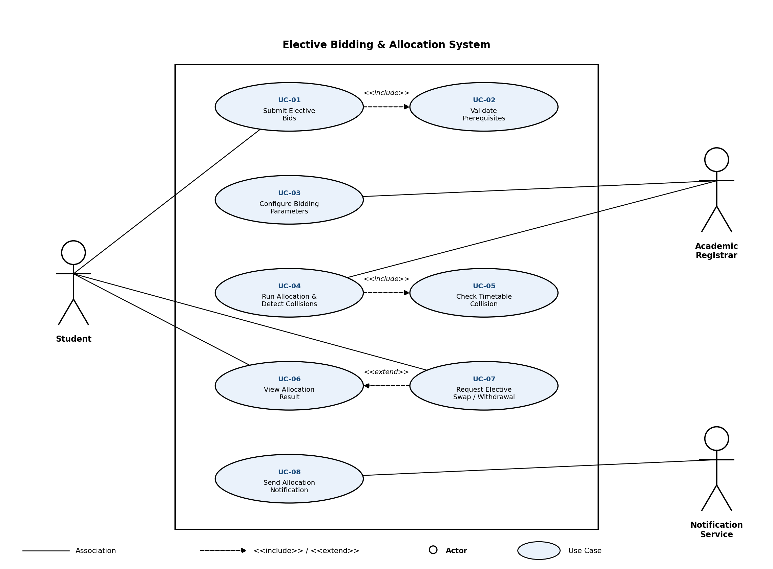

3. Use-Case Flow Specification
Problem Statement #05: Academic Elective Bidding & Allocation System
Use Case: UC-01 – Submit Elective Bids
Primary Actor: Student Secondary Actor: Academic Registrar (owns bidding-window and capacity configuration this use case depends on)
Preconditions
- Student is authenticated on the Elective Bidding portal.
- The bidding window configured by the Academic Registrar (UC-03) is currently open.
- The list of elective courses, their seat capacities, and prerequisite rules have been published.
Postconditions
- Success: The student's 100-credit bid distribution across ranked electives is recorded and locked in for the allocation engine, with prerequisite-validation status stored against the bid.
- Failure: No bid is recorded; the student's prior bid state (if any) is unchanged.
Main Success Scenario
- Student logs into the Elective Bidding portal.
- System verifies the bidding window is currently open and displays the list of available electives with seat capacity and prerequisite requirements.
- Student ranks their preferred electives.
- Student distributes their 100 bidding credits across the ranked preferences.
- Student submits the bid. System validates that allocated credits total exactly 100 and executes the «include» use case “Validate Prerequisites” to confirm the student meets the prerequisite for every selected elective.
- System confirms all prerequisites are satisfied and locks the bid for the allocation engine.
- System displays a confirmation summary with a bid reference number.
- Use case ends successfully.
Alternate Flow – 5a. Invalid Credit Distribution or Unmet Prerequisite
- If total allocated credits are not exactly 100, system rejects the submission and highlights the discrepancy.
- If a selected elective's prerequisite is not met, system flags that course as ineligible and removes it from the ranking.
- Student revises the credit distribution and/or ranking and resubmits (return to Main Success Scenario, step 4).
- If the bidding window closes before a valid resubmission is made, system cancels the attempt and notifies the student that no bid was recorded.

