Project 2
Amazon RDS High Availability and Read Scaling
Design-focused AWS database architecture and operational notes
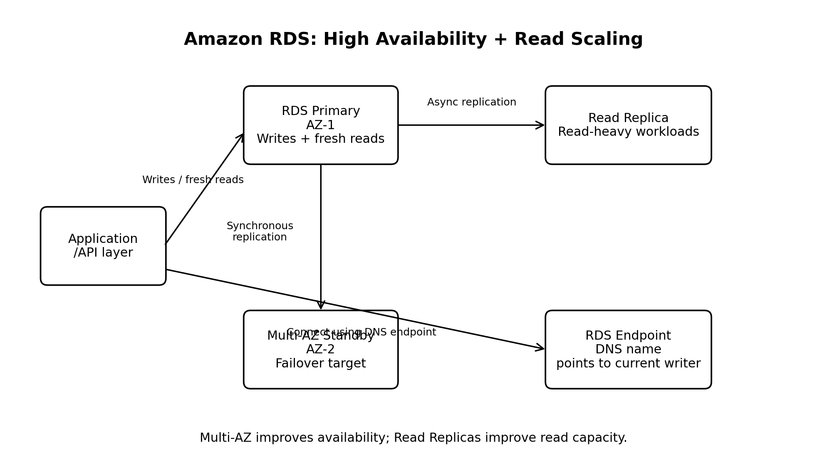

1. Project purpose
This project explains how Amazon RDS can be designed for two different operational goals: high availability through Multi-AZ deployment and read scalability through Read Replicas. The project is intentionally documentation-focused so the architecture can be understood without leaving potentially billable database resources running.

2. Business scenario
Consider an application that stores customer accounts, orders, payments, and product information in an RDS database. As usage grows, the application needs protection from database-instance or Availability Zone failures. At the same time, read traffic increases and begins to place pressure on the primary database.
The design therefore addresses two separate questions:
- How can the database remain available if the primary instance fails?
- How can read-heavy traffic be distributed without sending every request to the primary?

3. Architecture components

Application layer
The application produces write requests and read requests. It decides which reads require the newest data and which reads can tolerate replication lag.

RDS primary
The primary instance handles normal write traffic and consistency-sensitive reads.

Multi-AZ standby
The standby is maintained in another Availability Zone for failover. It is not a normal read target for the application.

Read Replica
The Read Replica receives changes asynchronously and can serve suitable read-only workloads.

RDS endpoint
The application uses the RDS DNS endpoint rather than a hard-coded IP address. This allows AWS to redirect the endpoint during a managed failover.

4. Multi-AZ: high availability
A Multi-AZ deployment maintains a primary database instance and a standby instance in a different Availability Zone. RDS maintains the standby so it can be promoted if the primary becomes unavailable.
Key characteristics:
- The primary handles normal application traffic.
- The standby exists mainly for availability and failover.
- Replication between the primary and standby is synchronous.
- The standby is not intended to provide ordinary application read capacity.
- RDS can perform a managed failover when supported failure conditions occur.
- The application should reconnect through the same RDS endpoint after failover.
Multi-AZ primarily improves availability; it should not be described as a read-scaling mechanism.

5. Read Replicas: read scaling
A Read Replica is a separate database instance that receives changes from a source database through asynchronous replication. It can serve read-only workloads and reduce pressure on the primary.
Key characteristics:
- The source database continues to handle writes.
- The replica can serve read-heavy workloads.
- Replication is asynchronous, so replication lag is possible.
- Read Replicas are suitable only for reads that can tolerate some delay.
- A replica can be promoted into an independent writable database.
- A Read Replica is not automatically equivalent to a Multi-AZ standby.

6. Example request flows

Write request
1. A user creates an order.
2. The application sends the write to the RDS primary endpoint.
3. The primary commits the transaction.
4. RDS maintains the Multi-AZ standby synchronously.

Read request
1. A user opens an order-history page.
2. The application checks whether slightly stale data is acceptable.
3. If yes, the request may be routed to a Read Replica.
4. If fresh data is required, the request is sent to the primary.

7. Failover sequence
1. RDS detects a failure affecting the primary.
2. RDS promotes the standby instance.
3. The standby becomes the new primary.
4. The RDS endpoint is redirected to the new writer.
5. The application reconnects using the same endpoint.
The application must still handle connection errors, retries, connection-pool refreshes, and short periods of unavailability.

8. Multi-AZ versus Read Replica
Area | Multi-AZ standby | Read Replica
Primary purpose | High availability and failover | Read scaling
Replication | Synchronous | Asynchronous
Normal reads | Not intended for application reads | Designed for suitable read workloads
Failover | Managed failover supported | Promotion is a separate operation
Lag | Designed for synchronous standby state | Replication lag is possible
Main benefit | Reduced downtime | Increased read capacity

9. Read Replica promotion
Promotion converts a Read Replica into an independent database instance. It may be used for migration, recovery, workload isolation, or creating a separate writable database. Promotion is an operational event and should be followed by connectivity, data, application, and monitoring validation.

10. Cost-aware implementation decision
Multi-AZ deployments and Read Replicas can introduce additional instance, storage, backup, and data-transfer costs. For this reason, this project focuses on architecture and operational understanding rather than leaving billable resources running.
- Check the selected engine and configuration against the current AWS pricing and Free Tier rules.
- Account for database instance hours and storage.
- Review backup storage and cross-AZ or cross-region data transfer.
- Delete test resources after hands-on validation.
- Use the AWS Billing dashboard and cost alerts when experimenting.

11. Interview-ready explanation
Multi-AZ and Read Replicas solve different problems. Multi-AZ improves availability by maintaining a standby in another Availability Zone and supporting managed failover. A Read Replica improves read scalability by asynchronously copying data to another instance that can serve read workloads. In a production design, I would use the primary endpoint for writes and consistency-sensitive reads, route suitable read-heavy operations to replicas, and use Multi-AZ to reduce downtime during infrastructure failures.

12. Final checklist
☐ I can explain the purpose of Multi-AZ.
☐ I can explain why the standby is not a normal read endpoint.
☐ I can explain synchronous and asynchronous replication.
☐ I can describe the failover sequence.
☐ I can explain why the RDS endpoint matters.
☐ I can explain when to use a Read Replica.
☐ I understand replication lag.
☐ I understand Read Replica promotion.
☐ I can distinguish high availability from read scaling.
☐ I can identify the cost risks of deploying both features.

