Project 3
Amazon Aurora High Availability & Failover
Architecture, endpoints, replication, failover, promotion and recovery
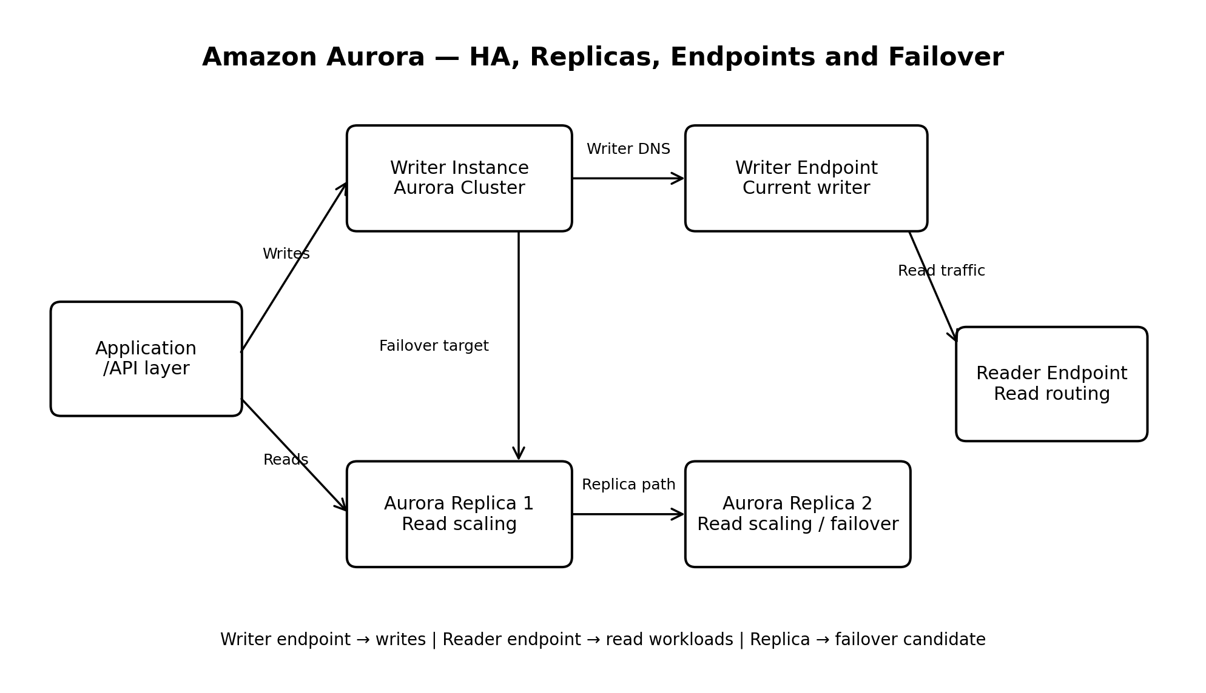

1. Project purpose
This project explains the architecture and operational behaviour of Amazon Aurora. The original plan involved an Aurora MySQL cluster with a writer and two replicas. Because Aurora resources can incur charges, the project is documented rather than deployed as a continuously running environment.

2. Aurora cluster architecture
An Aurora cluster consists of a shared distributed storage layer, a writer instance, optional Aurora Replicas, and cluster endpoints. The writer handles changes to the database. Replicas serve read workloads and can provide additional failover candidates.

3. Writer endpoint
The writer endpoint identifies the current writer instance. Applications use it for INSERT, UPDATE, DELETE, transactions, and reads that require the writer's current state. After failover, Aurora updates the endpoint to point to the new writer.

4. Reader endpoint
The reader endpoint is intended for read-only traffic. It can distribute connections across available Aurora Replicas. It should not be used for write operations. Suitable workloads include browsing, reporting, dashboards, and read-heavy APIs.

5. Aurora Replicas and read scaling
Aurora Replicas allow read traffic to be distributed across multiple database instances. This reduces pressure on the writer and provides additional capacity for read-heavy workloads. Adding replicas also creates more potential failover targets, but each instance can add cost.

6. Replication and consistency
Aurora Replicas use Aurora's storage architecture to provide read access to the cluster's data. Applications must still distinguish between reads that require the latest writer state and reads that can be handled by reader infrastructure.

7. Failover workflow
A simplified failover sequence is: Aurora detects a writer failure or receives a failover request; it selects an eligible target; the target becomes the new writer; the writer endpoint is updated; and the application reconnects. Existing connections may be interrupted.

8. Manual failover
A controlled manual failover can be used to test recovery procedures. The exercise should validate endpoint behaviour, connection-pool recovery, retry logic, monitoring, and application error handling.

9. Failover versus promotion
Failover changes the active writer within the cluster to restore availability. Promotion changes a replica or another eligible instance into a writer role. The concepts are related, but they should not be treated as identical in every operational context.

10. Backup and point-in-time recovery
Aurora supports automated backup capabilities and point-in-time recovery within the configured recovery window. Recovery testing should validate database availability, schema, data, application connectivity, permissions, and recovery duration.

11. Application design guidelines
Applications should use cluster endpoints rather than hard-coded instance addresses. They should reconnect after connection loss, refresh stale connections, use safe retry logic, and route writes only to the writer endpoint.

12. Cost considerations
Aurora can incur charges for instance usage, storage, I/O or engine-specific usage, backups, data transfer, and multiple reader instances. Aurora MySQL should not be assumed to be Free Tier eligible. This project therefore remains documentation-focused.

13. Interview-ready explanation
Aurora uses a cluster architecture with a writer and optional Aurora Replicas. The writer endpoint identifies the current writer, while the reader endpoint is used for read-oriented traffic. Replicas provide read scaling and additional failover candidates. If the writer fails, Aurora can promote an eligible replica and update the writer endpoint. Applications must reconnect through the endpoint and tolerate brief connection interruptions.

14. Validation checklist
☐ I can explain the Aurora cluster architecture.
☐ I can distinguish a writer from an Aurora Replica.
☐ I can explain the writer endpoint.
☐ I can explain the reader endpoint.
☐ I understand how replicas support read scaling.
☐ I can describe a failover sequence.
☐ I understand manual failover.
☐ I can distinguish failover from promotion.
☐ I understand backup and point-in-time recovery.
☐ I understand Aurora cost considerations.

15. Final outcome
This project provides a conceptual foundation for designing an Aurora environment that supports high availability, read scaling, endpoint-based routing, failover, and recoverability without leaving potentially billable Aurora resources running.

