Project 4: DynamoDB Design & Performance
Messaging-app data model • 1,000-item experiment • Access patterns • Performance concepts
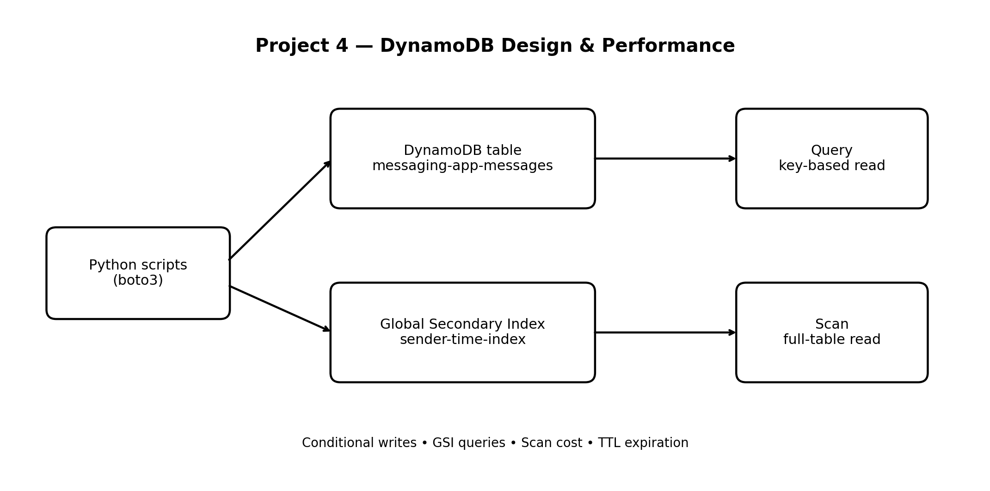

1. Project objective
The goal of this project was to understand how DynamoDB should be designed around application access patterns rather than around traditional relational-table thinking. We modelled a messaging application, inserted 1,000 message items, tested Query and Scan, performed a conditional update, created and queried a Global Secondary Index (GSI), and enabled TTL.

2. What we built
- AWS DynamoDB table: messaging-app-messages
- Partition key: conversation_id (String)
- Sort key: message_id (String)
- Billing mode: On-demand
- Local Secondary Index (LSI): conversation-time-index
- LSI sort key: created_at (String)
- Global Secondary Index (GSI): sender-time-index
- GSI partition key: sender_id
- GSI sort key: created_at
- TTL attribute: expires_at
- Python automation using boto3 from a local Windows virtual environment

3. Step-by-step record of the work

3.1 Local project setup
A project-specific Python virtual environment was created inside the project folder. PowerShell was opened in that folder and the virtual environment was activated. This keeps the project's Python packages isolated from other projects.

3.2 AWS CLI configuration
The AWS CLI was installed and configured locally with an IAM access key, secret access key, the ap-south-1 region, and JSON output. The Python scripts then used the same local AWS credential chain.

3.3 boto3 installation and credential validation
The boto3 package was installed inside the virtual environment. A connection-check script successfully confirmed access to DynamoDB and printed the table name, ACTIVE status, item count, and table ARN.

3.4 Table creation
The messaging-app-messages table was created with conversation_id as the partition key and message_id as the sort key. On-demand capacity was selected to avoid managing fixed read/write capacity for this experiment.

3.5 LSI creation
The conversation-time-index Local Secondary Index was configured with conversation_id as its partition key and created_at as its sort key. An LSI keeps the same partition key as the base table but provides another sort-key access path. LSIs must be defined when the table is created.

3.6 Data generation and insertion
A Python script inserted 1,000 synthetic messaging records. The records included fields such as message_id, conversation_id, sender_id, message_text, message_type, and created_at. Progress was printed after every 100 items.

3.7 Query experiment
A Query operation retrieved messages for one conversation. Query is efficient because it uses the table's key structure: it identifies a partition key and can optionally narrow results using the sort key.

3.8 Scan experiment
A Scan operation read the table across all partitions. The experiment scanned and returned 1,000 items and reported approximately 21 consumed capacity units. Scan is useful for small administrative tasks or controlled experiments, but it is usually unsuitable for frequent application reads on large tables.

3.9 Conditional write
A conditional update changed a message only when the specified condition was satisfied. This demonstrates optimistic protection against accidental overwrites and helps enforce business rules at the database layer.

3.10 GSI creation
The sender-time-index Global Secondary Index was created with sender_id as its partition key and created_at as its sort key. The script waited until the index became ACTIVE before continuing.

3.11 GSI query
The GSI was queried to find messages sent by a particular user. The result demonstrated how a GSI supports an access pattern that the base table's primary key cannot efficiently support.

3.12 TTL enablement
TTL was enabled using the expires_at attribute. DynamoDB can automatically remove items after their expiration timestamp. TTL deletion is asynchronous, so an item should not be expected to disappear at the exact second of expiry.

4. Key concepts learned
Partition key: Determines where an item is stored logically and groups related items. A good partition-key design distributes traffic and avoids hot partitions.
Sort key: Orders items within the same partition-key value and supports range-based access patterns.
Query vs Scan: Query uses keys and is targeted. Scan examines the table or index and can become expensive as the data grows.
LSI vs GSI: An LSI keeps the base table's partition key and changes the sort-key access path. A GSI can use a different partition key and is created separately from the base table.
Consumed capacity: Read/write capacity represents the amount of DynamoDB work consumed by an operation. Item size, consistency mode, and operation type affect consumption.
Conditional write: A write succeeds only when a condition is true. This is useful for preventing duplicate creation, protecting versions, or enforcing state transitions.
TTL: TTL is intended for automatic expiry of temporary data such as sessions, short-lived messages, or event records. Expiry is asynchronous.
Access-pattern-first design: Before creating a DynamoDB table, list the queries the application must perform. Then choose keys and indexes that support those queries directly.

5. Evidence captured during the experiment
- DynamoDB connection check: table ACTIVE, item count initially 0.
- Successful insertion of 1,000 messages.
- Query returned messages for conversation-001.
- Scan processed 1,000 items and reported approximately 21 consumed capacity units.
- Conditional update completed and returned updated values.
- GSI creation completed and the index became ACTIVE.
- GSI query returned messages for sender user-019.
- TTL verification showed TimeToLiveStatus = ENABLED and AttributeName = expires_at.

6. Important observations and limitations
- The dataset was synthetic and designed for learning rather than production traffic modelling.
- The scan-cost result is specific to this dataset, item size, and execution conditions; it is not a universal fixed cost.
- The LSI and GSI demonstrate different access paths, but a real application should create indexes only when a real query pattern requires them.
- TTL does not provide immediate deletion guarantees and should not be used as an exact-time deletion mechanism.
- On-demand capacity simplified the experiment and avoided manually provisioning fixed capacity, but production billing still depends on actual usage.

7. Suggested repository structure
04-dynamodb-design-performance/
├── README.md
├── documentation.docx
├── architecture/
│ └── architecture.png
├── src/
│ ├── check_dynamodb.py
│ ├── insert_messages.py
│ ├── query_messages.py
│ ├── scan_messages.py
│ ├── conditional_writes.py
│ ├── create_gsi.py
│ ├── query_gsi.py
│ └── enable_ttl.py
└── screenshots/
└── evidence screenshots

8. Final outcome
This project established a practical foundation in DynamoDB data modelling and operational behaviour. The main takeaway is that DynamoDB design begins with access patterns: the partition key, sort key, and secondary indexes should be selected according to how the application will read and write data. The project also demonstrated why Query is generally preferred over Scan, how conditional writes protect data, and how TTL can manage the lifecycle of temporary records.

